Annual Report: Blackbeard Island National Wildlife Refuge Loggerhead Sea Turtle Nest Monitoring
Fiscal Year Project First Funded: FY13
Project Name: Monitoring Loggerhead Sea Turtle Activity on Index Nesting Beaches on Southeastern National Wildlife Refuges: Continuation of Long-term Datasets for Landscape Management and Global Conservation
Project Manager/Primary Contact: Kimberly Hayes, Refuge Manager
Phone Number: 912.832.4608
Email: Kimberly_Hayes@fws.gov
Project Location: Blackbeard Island National Wildlife Refuge
Project Goal:
The purpose of this project is to continue long-term, consistent monitoring of loggerhead sea turtle (LST) nesting to assess changes in phenological and spatial nesting distribution on southeastern National Wildlife Refuges. The index nesting beach survey data are essential for managers to monitor sea turtle population status between and among years (currently the only means for evaluating efforts to reduce and eliminate mortality at sea and on land) and to assess progress towards meeting recovery goals, which include maintaining high productivity on nesting beaches. The data collected on these beaches is used not only internally by the US Fish and Wildlife Service but also by other Federal and State agencies and academia.
Blackbeard Island NWR in Georgia offers 8.5 miles of nesting beach, and it, too, has one of the longest sets of survey data for nesting loggerhead sea turtles in the world. It has a higher density of turtle nests per kilometer than any other Georgia beach. Funds will be used for three interns, a biological technician, boat/ATV fuel, and replacement of supplies.

Expected Conservation Outcome of the Project:
Blackbeard Island NWR has one of the longest, continuous datasets of nest monitoring for loggerhead sea turtles in the southeast. This dataset provides information on spatial distribution of nesting along the beach, hatching success, and return rates for nesting females. Throughout the southeast loggerhead sea turtle nesting habitat is threatened by numerous forces including but not limited to beach erosion, light pollution, and shoreline development, armoring, and stabilization structures. Specifically, threats to the continued success of nesting on Blackbeard Island include increased recreational use, accelerated erosion from sea level rise, and, potentially, invasive species. Sutter el al. 2013 documented an increasing level of tidal amplitude and increasing frequency of tides exceeding 9’ at the mouth of the Savannah River. The information obtained through nest monitoring and hatching success will inform managers and biologists in adapting management techniques to these short and long-term threats not only on a local scale of Blackbeard Island NWR but, also, across the range of the northwest Atlantic population of loggerhead sea turtles. Continued monitoring along index beaches is critical in informing future revisions of the Recovery Plan for the Northwest Atlantic Population of the Loggerhead Sea Turtle.
Project Measureable Objectives (Short and long-term):
Loggerhead sea turtle activity was monitored daily for crawls along the entire beach on Blackbeard Island NWR. Nests located each day were probed for nest location and, if needed, moved above the mean high tide line, screened, and marked with the date of nesting. If a nest was not found, it was recorded as a false crawl. After 50 days, ghost crab screens were replaced with raccoon “foilers” and markers painted red. Each nest past 50 days was checked daily for emergence. Once the nest emerged, it was marked with the date of emergence and excavated for nest success after five days to allow the maximum number of hatchlings to emerge naturally. Data from nests include number of hatchlings emerged as counted by eggshells that are 50% or greater intact, unhatched eggs, dead hatchlings in nest, and release of any live hatchlings still in the nest.

Final Report Summary:
The data below are taken directly from seaturtle.org and represent the best available data summarized the 2013 nesting season on Blackbeard Island NWRª.
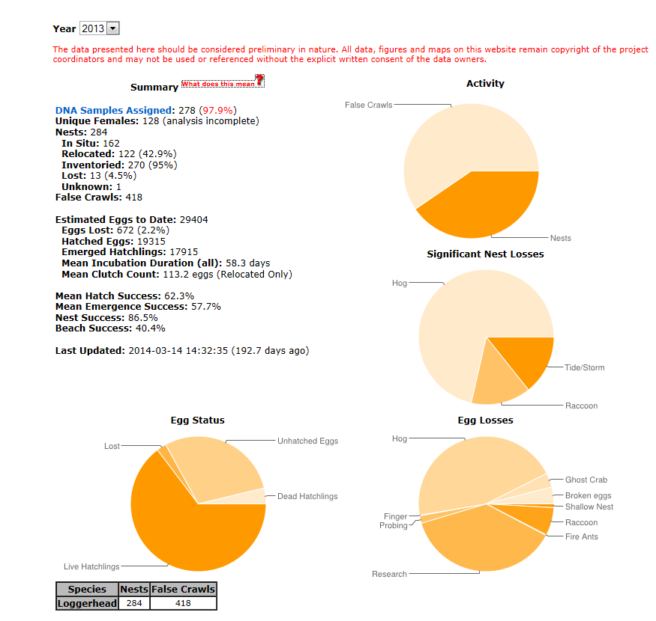
ªPie charts with losses, nest and egg losses, represent the proportion of each type of activity. For example, the greatest proportion of egg losses was to hogs. Actual numbers are not shown.
Sea Turtle Nest Monitoring System
DNA Samples Assigned: The number of samples that have been genetically coded by the University of Georgia (and the percentage out of the total samples collected).
Unique Females: The number of individual females identified from the genetic samples.
Nests - total number of nests and includes undetected nests. This does not include possible nests.
In Situ - total number of nests left in situ (not relocated or moved to a hatchery).
Relocated - total number of nests relocated regardless of reason.
Hatchery - total number of nests moved to a hatchery.
In Situ - total number of nests left in situ (not relocated or moved to a hatchery).
Relocated - total number of nests relocated regardless of reason.
Hatchery - total number of nests moved to a hatchery.
Incubating - total number of nests that have not hatched.
Emerged - total number of nests that have emerged.
Inventoried - total number of nests that have been inventoried.
Lost - total number of nests that that were marked as lost in the nest loss log.
Unknown - total number of nests that were marked as final status unknown.
False Crawls - total number of false crawls. This number is the highest number taken from the Survey Log, Activity Page or Project Report.
First Nest: this is the first nest laid for the selected year with the species indicated in parenthesis.
First Emergence: this is the first nest that emerged for the selected year with species indicated in parenthesis.
Estimated Eggs to Date - This is calculated from the clutch count from relocated nests (regardless of when loss occurred since it is an estimation) and in situ nests after they have been inventoried. This estimation will increase during the season as in situ nests are inventoried. This estimation is final after all nests are complete. It does not use an assumed clutch count for nests that are not inventoried.
Eggs Lost - This is the total number of eggs lost calculated from the loss event log. This is an underestimate because loss of in situ nests where the number of eggs is unknown is not captured in this count.
Lost to Probing - This is the total number of eggs lost to probing.
Hatched Eggs - This is the total number of shells > 50%. This number is calculated from inventory data only and continues to increase during the season.
Emerged Hatchlings - This is the total number of shells > 50% minus (live + dead hatchlings in nest). This number is calculated from inventory data only and continues to increase during the season.
Mean Incubation Duration - This is the mean incubation duration and is calculated from nests that have a date laid and an emergence date. This does not include undetected nests or any nests without both of those dates. This is the mean incubation time (days) calculated of all individual nests in the state for the season.
Mean Clutch Count - This is the mean clutch count calculated from relocated nests. Undetected nests are not included. This is the mean clutch count of all individual nests in the state for the season.
Mean Hatch Success - This is calculated by taking the weighted mean of all the individual nest hatch successes. We calculate a weighted mean for the state by multiplying each mean for a beach by the beach's total nests, then dividing the grand mean by total state nests.
Mean Emergence Success - This is calculated by taking the weighted mean of all the individual nest emergence successes.We calculate a weighted average for the state by multiplying each mean for a beach by the beach's total nests, then dividing the grand mean by total state nests.
State Nest Success - This is calculated by the total number of nests that hatched with > 10% emergence success for the entire state divided by the number of nests laid for the entire state.
State Beach Success - This is calculated by the total number of nests laid in the state divided by the total number of crawls in the state (nest crawls and false crawls).

