Fry Stocking Assessment in NY: 2021 – 2024
Authors:
Kurt Heim and Steve Smith, US Fish and Wildlife Service
Tom Shanahan, NYS Department of Environmental Conservation

Background:
Compared to stocking smolts, fry stocking is less expensive and labor intensive and is believed to produce smolts with qualities beneficial to migration, oceanic and lake survival (for landlocked salmon), and return rates to stocked rivers (Orciari et al. 1994). Rather than developing in a hatchery setting for 1-2 years before smolting, fry stocked salmon acclimate to the natural environment in which they are stocked and learn predator avoidance, must feed on natural prey items, and adjust to seasonal variation in environmental conditions. While these features are conceptually appealing, it is important to assess the efficacy of this stocking practice in terms of survival to parr, smolt production, and eventual adult returns. It is also important to evaluate how different stocking techniques (e.g., strain used, densities stocked, and stocking sites) influence survival in the context of adaptive management.

Several evaluations of fry stocking in New England provide some estimates of survival given a variety of stocking options. In a third order tributary to the Connecticut River, survival of fry to age-0 parr (i.e., stocked in April and sampled in the summer months) was 2% for a strain of salmon from Iceland and 27% for a local strain (Penobscot strain) (Orciari et al. 1994). This study highlights that different strains of salmon show variation in survival when stocked at a given location, with the local strain performing far better in this scenario. Stocking site conditions and ecological context are also an important determinant of fry survival. In a Lake Ontario tributary study focusing on landlocked salmon, stocking sites with high rock cover and low predator densities (i.e., Rainbow trout) produced the highest densities of surviving fry (Stanfield and Jones 2003). Stocking densities, often measured in fry stocked per m², is also a factor to consider with some studies suggesting lower densities lead to higher survival (McMenemy 1995), and others finding little differences across methods (Brunsdon et al. 2017). In sum, there is great variation in the results of fry stocking that is related to genetic strains, site specific characteristics, and stocking strategies.

Salmon in Lake Champlain were extirpated in the early 1800s, and in 1972 a partnership between the state of Vermont, New York, and the US Fish and Wildlife began efforts to restore salmon. This cooperative (the Lake Champlain Management Cooperative) aims to (1) provide recreational fisheries and (2) restore naturally spawning salmon to several tributaries. Since the beginning of reintroduction efforts, fry stocking has been used in addition to stocking fish of other age classes. However, the effectiveness of this strategy in contributing to program goals has not been thoroughly evaluated in NY waters. Therefore, a study was launched in 2021 to genetically tag all fry being stocked in Lake Champlain tributaries (Heim et al. 2021). Using parentage based tagging (PBT), eight distinct lots of fry are being released (Table 1). This includes two distinct strains of fish, one descended from Sebago strain salmon (Sebago Lake, Maine) that is managed to conserve genetic variation (henceforth the “MAX” strain) and another Sebago strain group developed to show high survival in the context of low thiamine conditions (henceforth “Low TT”). These groups will be stocked in 3 rivers in NY (Boquet, Ausable, Saranac) from 2021 to 2024 and the contribution of each group to adult returns will be evaluated by recapturing fish and assigning them to an experimental group via genetic parentage analysis. Thus, we will know how fry stocking contributes to adult returns in each river and how this compares to adult returns produced by smolt stocked fish. Sampling and assessment for the returning adults is covered in Heim et al. (2021a,b).

In addition to sampling adult returns, this release design provides an opportunity to evaluate additional questions related to variation in fry survival across strains, sites, rivers, and years. Therefore, the present study plan describes a 2-3 week survey to be conducted by USFWS and NYSDEC with the following objectives:
- Evaluate survival (presence/absence and relative density) of fry across rivers (Ausable River and Boquet River), sites within rivers, broodstocks and years
- Evaluate growth across rivers, sites, broodstocks and years
- Compare survival and growth metrics to abiotic (e.g., temperature, stream size) and biotic factors (e.g., composition of the fish assemblage, predator densities)
This assessment will be valuable to provide context for the adult return portion of the larger PBT study and will be useful to guide the continued use of fry stocking as a management tool in NY.

Methods

Stocking Fry

Eggs from two broodstocks at White River National Fish hatchery are organized into eight PBT groups (Table 1). Viable eggs, organized into these eight groups, are shipped to Adirondack Hatchery (in NY) and developed over winter. Upon hatching, fry are enumerated volumetrically and packaged into bags of 1500 with labels corresponding to their stocking location and genetic strain.

A list of prioritized stocking locations was developed for each PBT group in Spring 2021, and the bags of eggs are allocated based on these lists (Table 2 - 5). At each site, one bag of Low TT and one bag of Max are stocked using the ‘clumped’ stocking strategy (Brunsdon et al. 2017). This means that ~3000 fry are stocked at a single location and allowed to disperse to occupy nearby habitats. Stocking typically occurs in early May to mid-May, but will vary annually due to fry developmental rates and environmental conditions.

Each year from 2021 – 2024, this same prioritized list will be used to partition fry into locations. This will ensure the same reference sites are stocked and then evaluated for the duration of the study. If there are more than the target number of fry available because of high egg survival (i.e., higher than the allotted 15% buffer), more sites (of lower priority in Table 2) will be stocked.

Sampling

We will use a single pass backpack electrofishing survey at 16 fry stocking locations (Table 2 – Table 6). A ‘reach’ will be defined as 100 meters upstream from a stocking location (e.g., +100) to 200 m downstream of this location (-200), measured in river meters (with the stocking site defined as 0 rm). Seven sites will be designated per reach, beginning at rM (river meters) +100, + 50, 0,-25, -50, -100, -200. After arriving at the stocking location (a GPS waypoint, see Tables 2 - 6), the survey crew will walk the length of the reach and mark sampling sites with a hip chain and flagging (Figure 1). Sample sites will be 25-30 m in length and begin at the aforementioned river kilometer locations. For example, at rM 0 we will sample upstream from the 0 mark to rM + 25, for the rM -50 we will sample upstream to the rM -25 mark. If feasible, these sites will be marked by a crew of two people prior to the day that electrofishing is conducted. The target size of 25-30 meters is flexible to allow for sites to end or start at good habitat features to end on (e.g., upstream end of pool, logjam, or other features).

Several habitat metrics will be recorded, either on the day that the sites are marked or on the day that the electrofishing is conducted. The following metrics can be measured on the electrofishing day or on a day prior:
- Stream wetted width at 5 locations (every 5 meters of the 25 m site)
- Maximum depth in the 25 m site
- Percentage of substrate type (cobble, pebble, boulder, sand, estimated visually with a percentage for each)
- % LWD coverage (visual estimate of percentage of stream channel covered with large woody debris)
These metrics must be recorded on the day that the survey is conducted:
- Stream temperature
- Conductivity
- Dissolved oxygen
- Additional comments about the site or the survey
Starting at the site start location, we will use two backpack electrofishers to shock a 25 m length of stream moving in the upstream direction. All salmonids captured will be placed in a bucket of stream water and transported to the end of the site. If a small number of other species are encountered, these will be transported in the bucket as well and enumerated after the site is completed. If a high number of other species are encountered, they will be enumerated as the survey crew works upstream (i.e., keep a tally of fish caught by species, but release fish immediately after netting). All salmonids will be measured (TL), weighed, and a small tissue sample collected for genetic analysis from salmon only. If > 20 salmon are collected at a site, only collect genetic samples from the first 20 fish processed. Thus, up to 140 salmon fin clips could be collected per reach. Aqui-S at a concentration of 40mg/l will be used to sedate fish prior to handling.

Other fish species will be measured if there are few (e.g., < 20), but enumerated by length bins if there are a lot of non-salmonid fish in the sample. We expect to encounter Longnose Dace, Slimy Sculpin, Creek Chub, Brook Trout, and Brown Trout during these surveys.

Sample sites, staffing, and schedule
Using upcoming plans for 2021, this section describes the site selection and sampling schedule. The sixteen sites selected are listed in Tables 2 – 6 and prioritize safety, since some sites do not provide adequate parking and are close to the highway. They also prioritize sites that DEC has interest in visiting for wild brook trout assessments. We anticipate being able to finish two or three reaches per day, and thus anticipate a total of 8 days sampling. For 2021, we expect to sample the following dates. Dates in bold indicate days in 2021 that Tom Shanahan + Technician will help.

Week 1: Aug 23, 24, 26: Derby Brook (2 reaches) and Spruce Mills Brook (4 reaches)
Week 2: Aug 31, 32, Sept 2: Upper Boquet mainstem (2 reaches) and The Branch (three reaches).
Week 3: Sept 7, 8, 9: Ausable Tributaries (5 reaches)

Staff required to conduct this survey is 4 – 6 people. In a 4 person scenario, there are two people with backpack electro-fishers, two people with nets (one with each shocker). One netter is also carrying the bucket and sampling equipment. All personnel must stop and wait until fish are processed prior to moving onto the next sampling site. In a 6 person scenario, two people who are working up fish can stay behind as the sampling crew of four proceeds to the next site. When DEC is assisting and we have 6 + 2 staff the extra two staff will prioritize scouting and visiting other reaches to mark sites and collect habitat data.

Data analysis

Methods similar to (Brunsdon et al. 2017) will be used for data analysis. We will first evaluate data from a presence/absence perspective, and then use relative density as a second metric for evaluation.

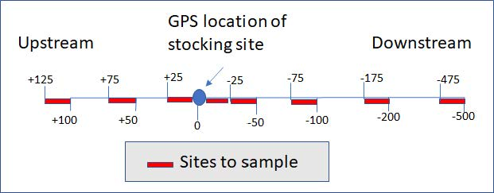
Figure 1. Sampling scheme for a location. Starting at the GPS location where fry were stocked a reach will be defined (+100 to – 500 rM) and 7 sites with a stream length of 25 meters will be designated with flagging and electrofished.

Table 1. Egg shipment plans for Adirondack hatchery in 2021 – 2024 for genetically marked groups of Atlantic salmon fry. Each group will be placed in separate incubators and stocked at locations listed. A buffer of 15% is included (i.e., 15% more eggs are shipped than the target number of fry released).
Release location | Broodstock | Life stage | Target release | Target eggs shipped | Group ID
Saranac | LowTT | Fry | 35,000 | 40,250 | TT_Sar_F
Saranac | Max | Fry | 35,000 | 40,250 | MAX_Sar_F
Boquet (upper mainstem)* | LowTT | Fry | 25,000 | 28,750 | TT_BoqMS_F
Boquet (upper mainstem)* | Max | Fry | 25,000 | 28,750 | MAX_BoqMS_F
Boquet (DB/SMB)** | LowTT | Fry | 25,000 | 28,750 | TT_BoqDBSMB_F
Boquet (DB/SMB) | Max | Fry | 25,000 | 28,750 | MAX_BoqDBSMB_F
Ausable | LowTT | Fry | 20,000 | 23,000 | TT_Aus_F
Ausable | Max | Fry | 20,000 | 23,000 | MAX_Aus_F
*Will include multiple stocking locations on the Bouqet River, upstream from Wadhams Falls in Wadham NY
**Will include multiple stocking locations in Derby Brook and Spruce Mills Brook

Table 3. Priority sites in Derby Brook and those stocked in 2021. Sites with priority listed “10” are interchangeable, and can be selected as needed and is convenient in years with extra fry. Sites stocked in 2021 have actual GPS coordinates taken when stocking was done; sites not stocked in 2021 have GPS coordinates provided by Steve Smith. RKM is the river kilometer calculated from the point where Spruce Mill Brook enters the Boquet River.
Reach | Notes | RKM | LAT | LON | Stocked 2021? | Sample 2021? | Stock Priority
DB 1-3 | Directly off 90 degree corner on Pulsifer Rd. | 17159 | 44.2986 | -73.56882 |  |  | 5
DB 3-4 | Behind house setback from Pulsifer Rd. | 17545 | 44.30029 | -73.57126 |  |  | 5
DB 4-5 | Take Johnson Rd. cross brook, take a rt. onto camp road Park at gate go dstr .9 mile to end of sec. | 18316 | 44.29794 | -73.57907 |  |  | 5
DB 5-6 | Take Johnson Rd. cross brook, take a rt. onto camp road Park at gate go dnst .5 m to end of sect. | 19071 | 44.29671 | -73.587536 | Y | N | 4
DB 6-7 | Just upstream of Johnson Road crossing. | 19882 | 44.29912 | -73.595293 | Y | Y | 2
DB 7-8 | Half the Map distance from 6-7 to 8-9 About 1840 feet. | 20591 | 44.29741 | -73.608617 | Y | N | 3
DB 8-9 | Just upstream from buildings upstream of Seney Trailer. Upstream of seventy Rd. | 21193 | 44.29719 | -73.60874 |  |  | 5
DB 9-10 | Take the camp drive from wells hill Rd. before crossing Spruce Mill Bk. go upst from camp | 21859 | 44.29748 | -73.615401 | Y | Y | 1
Up End | Upstream extent of stocking, Point from Jennie's GPS 2010 | 22004 | 44.29693 | -73.61681 |  |  | 5
DB 10 Top | About 1800 stream feet from 9-10. | 22510 | 44.29545 | -73.62168 |  |  | 5
Notes 2021:
In 2021 four sites were stocked. Site DB 9-10 was stocked and there were no stocking events upstream of this. Therefore, the reach centered on DB9-10 (i.e., US 100 m and DS 500 m) is free from the potential influence of any other stocking reach. Site DB6-7 had a stocking event 709 m upstream from it, so might be influenced by those fry dispersing downstream.

Notes to find parking:
DB9-10: Off of Seventy Rd there is a small dirt road called Brookside Way, turn here. Brookside Way is right before you go over Derby Brook. Go up a few hundred yards , keeping left on the dirt road and go by a few houses. Before you get to the end, there will be a dirt road going off the right that is flagged off. Park near here (don’t block it) and hike down through a private camp to the creek. Cross the creek and start up a clear path on the right (moving upstream) until you hit some flagging. The flagging is on a tree on the path, and then there is another piece of flagging in the creek marking the -500 starting point for sampling.

DB6-7: Off of Wells Hill road, go right (North) on Johnson Road. Park just a bit past the bridge where the road crosses Derby Brook.
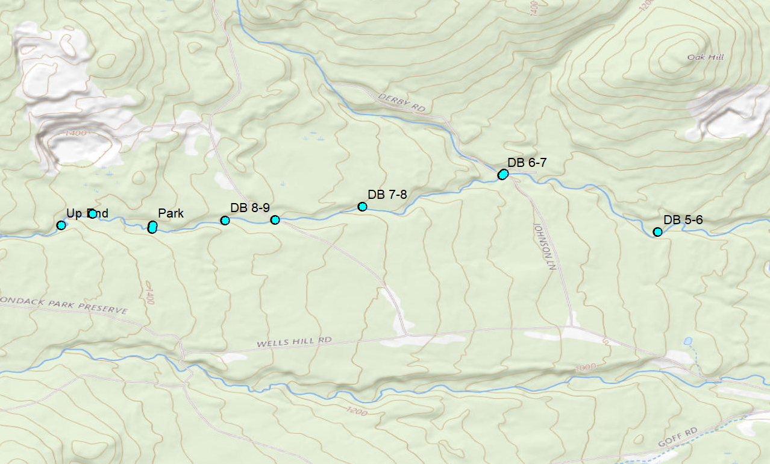
Figure 2. Derby Brook Sites (Upper)

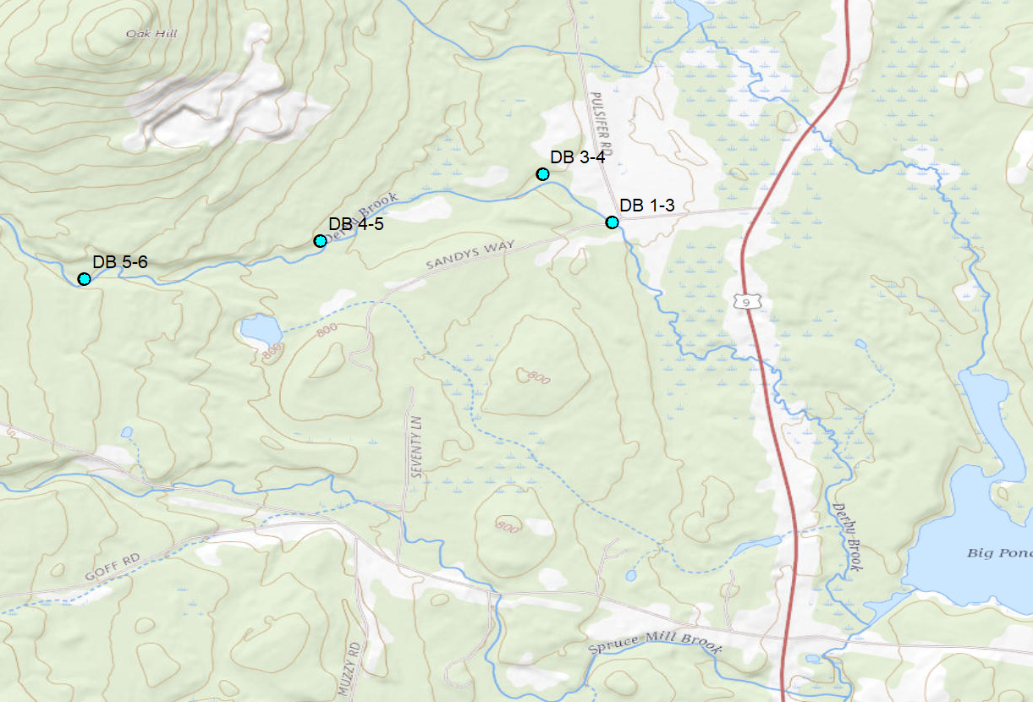

Figure 3. Derby Brook Sites (Lower)

Table 2. Priority sites in Spruce Mill Brook and those stocked in 2021. Sites with priority listed “10” are interchangeable, and can be selected as needed and is convenient in years with extra fry. GPS locations are recorded from on-site stocking events in 2021. GPS locations for other sites are available from Steve Smith or Tom Shanahan.
Name | Notes | RKM | LAT | LON | Stocked 2021? | Sample 2021? | Stock Priority
SM A Bottom | There is a road west of the bridge that is a good access to the downstream site. | 15339 | 44.28205 | -73.5702 | Y | N | 7
SM A-1 | At the first bridge on Wells Hill Rd. | 15980 | 44.28552 | -73.573 | Y | N | 6
SM 1-2 | This is directly in and slightly downstream from Pole # 20 on roadside. | 16706 | 44.28933 | -73.5804 | Y | N | 5
SM 2-3 | White pine is still marked on Roadside. Just above second bridge and below house (Smith Box) | 17459 | 44.2896 | -73.58657 | Y | Y | 4
SM 3-4 | Pole # 40 A opposite Johnson Rd. Head strait in to Brook (1000 ft) then slightly upstream. | 18004 | 44.2891 | -73.59204 |  |  | 8
SM 4-5 | Sugar Maple marked on roadside (south) before you get to 70 rd. Brook is 300 yds south of rd. | 18542 | 44.28913 | -73.59783 |  |  | 9
SM 5-6 | No Marker. We guessed in 2009. Hiked in log rd. and put out 2 bags as we went upstream | 19064 | 44.28882 | -73.60296 |  |  | 9
SM 6-7 | downstream from 3rd bridge. Hiked down from Bridge. Small maple tagged on RD down from bridge | 19625 | 44.29 | -73.61015 | Y | Y | 3
SM 7-8 | .25 road mi. from Bridge Maker on Road. Head straight in, Brook is 200 yds. | 20155 | 44.2909 | -73.61388 |  |  | 9
SM 8-9 | .4 road mi from Bridge, maple marked on Rd. Head staight in ~200 yds. | 20611 | 44.28983 | -73.61852 |  |  | 9
SM 9-10 | Marker on Rd. Follow ditch just upstream from marker to brook, head to downstream end of "bowl" | 21127 | 44.28772 | -73.62282 | Y | Y | 2
SM 10-11 | No Marker in 2009. Used GIS to adjust point for future. .25 Road mi from 9-10. | 21554 | 44.28621 | -73.62751 |  |  | 9
SM 11-12 | No Marker. Use GPS. Approx .25 road mi from 10-11. | 21981 | 44.28684 | -73.63208 |  |  | 9
SM 12 Top | To Access section 12 go .15 Rd. mi from 11-12 and head in to brook then work up and down from there | 22706 | 44.28595 | -73.63862 | Y | Y | 1
Notes 2021:
Distance between 12 top and 9-10 is 1579 m, distance between 9-10 and 6-7 is 1502 m, distance between 6-7 and 2-3 is 2166 m. If there is more time it would be interesting to sample SM A Bottom. This has three sites right upstream from it and should accumulate a lot of fish!

Notes to find parking:
SM2-3: Just past bridge, past Goff road.
SM6-7: Park at stock site and head downstream before working up. This bridge is either at the end of Wells Hill Road (then turn south) or it is at the end of Goff Road which turns into Carlott Rd, then keep going up this past Jay Mountain and you will hit it.
SM9-10: Site off of Jay Mountain road. Park and bushwhack.
SM12Top: Continue on Jay mountain road (past Burpee Rd) and keep going. Bushwack.

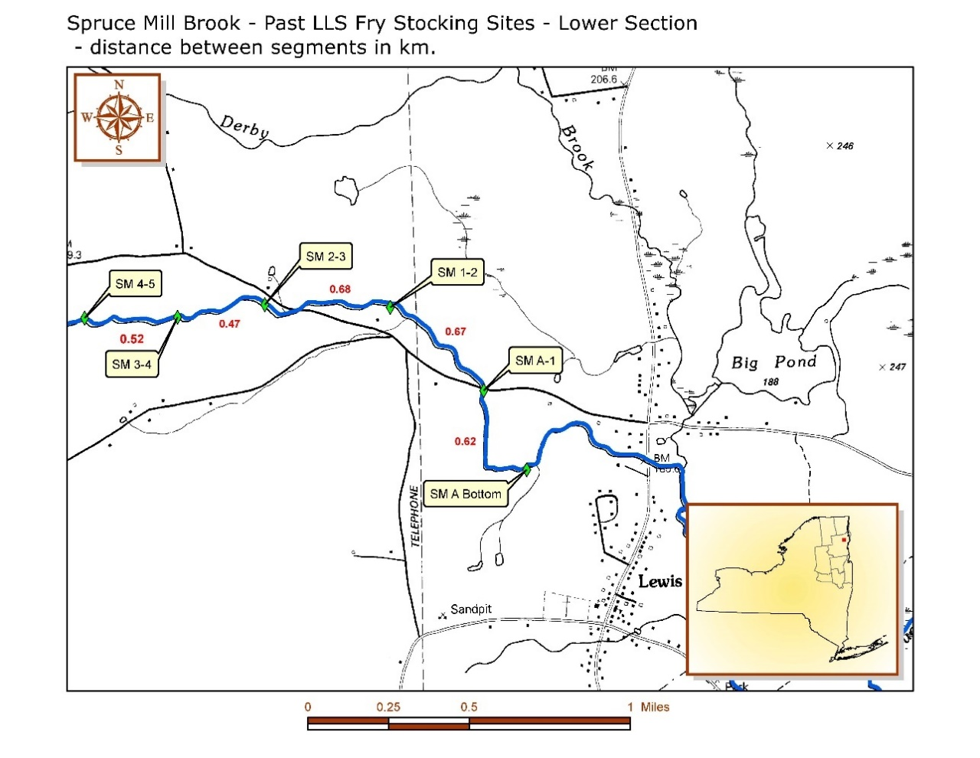

Figure 4. Spruce Mills Brook sites Lower.
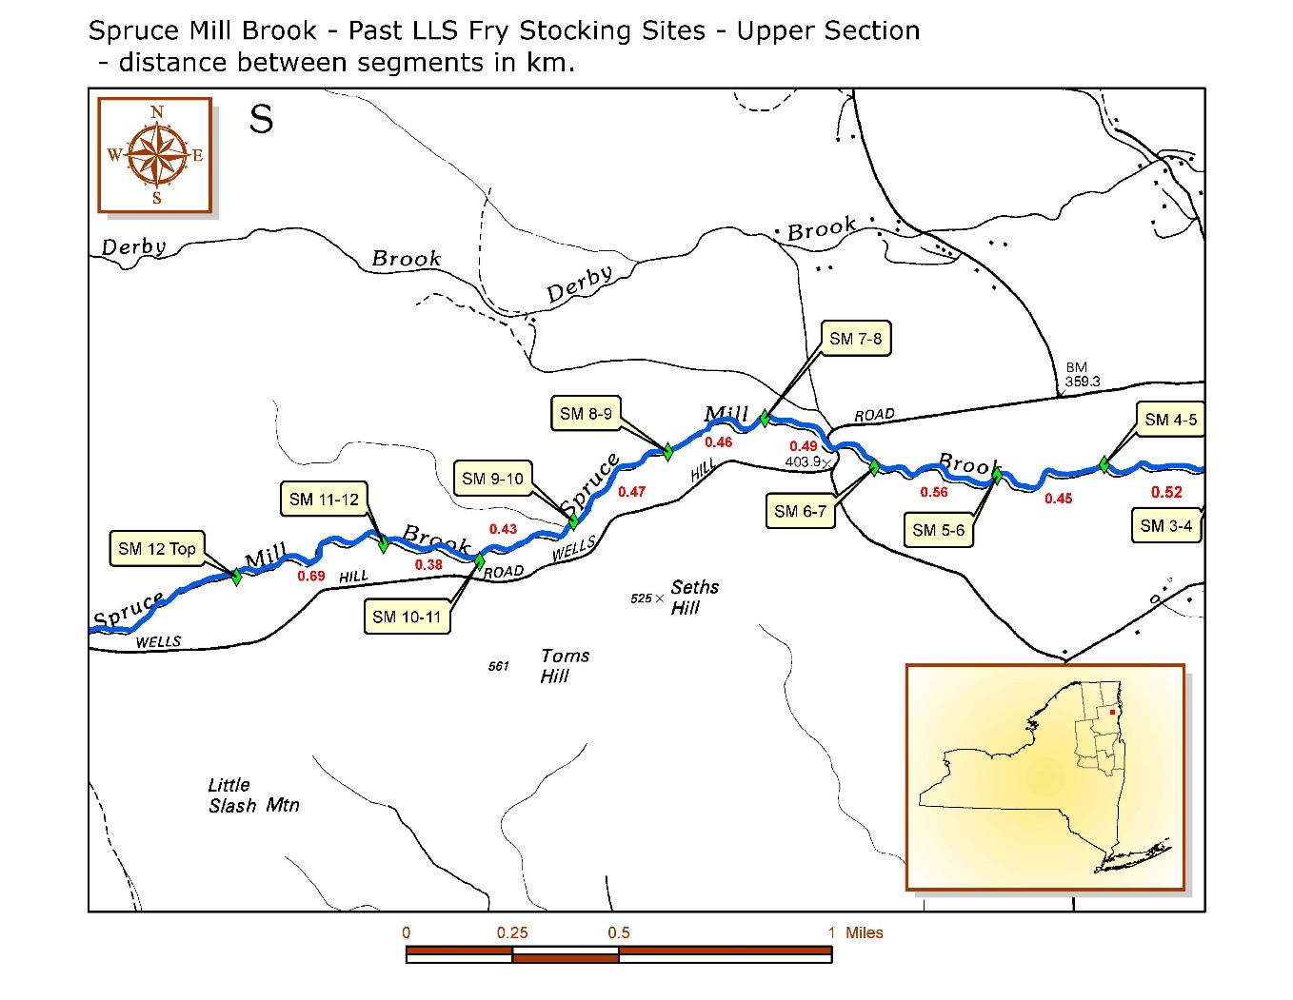
Figure 5. Spruce Mills Brook Sites, upper.

Table 4. Priority sites in The Branch and upper Mainstem, and those stocked in 2021. Sites with priority listed “10” are interchangeable, and can be selected as needed and is convenient in years with extra fry. GPS locations are recorded from on-site stocking events in 2021. GPS locations for other sites are available from Steve Smith or Tom Shanahan.

Site Name | Site Description | Priority | Lat | Lon | Stocked 2021? | Sample Fall 2021?
MS Sfork Top | Upstream end of South fork section | 1 | 44.10313 | -73.6941 | Y | Y
MS 6-7 | South Fork Confluence | 2 | 44.105 | -73.689 | Y | N
MS 1 Top | Upstream end of paking lot 2.5 rd. miles from Crazy Corner. Marker on stream on dead birch, | 3 | 44.12743 | -73.7239 | Y | Y
TB 1 Top | Pole # 119 on Road. Large Cedar marked on stream. | 4 | 44.21033 | -73.7106 | Y | Y
TB 4-5 | At Bridge in from Giant Mountain Trial sign | 5 | 44.2114 | -73.6791 | Y | Y
TB 2-3 | Pole # 102 on road. Small white pine marked on stream | 6 | 44.21128 | -73.6968 | Y | Y
MS 1-2 | Downstream end of parking lot .3 miles down from point 1 top. Marker on rd is missing | 7 |  |  | N | N
MS 5-6 | marker on Maple upstream end of parking area | 8 |  |  | N | N
TB 5 Bottom | Rt. 9N bridge. | 9 | 44.21392 | -73.6726 | Y | N
TB 6-7 | Upstream end of Bridge | 10 | 44.21407 | -73.6598 | Y | N
MS 5-6 | marker on Maple upstream end of parking area | 11 |  |  | N | N
MS 3-4 | less than .1 miles from bridge over North Fork. Can pull off road here. White birch marked | 11 |  |  | N | N
MS 7-8 | White Pine (river left) upstream end of Islands | 11 |  |  | N | N
MS 8-9 | follow culvert from Rt. 9 ~.3 road miles from C.Corner. mid Island in river | 11 |  |  | N | N
MS 9-10 | At Bridge over river. .2 road miles from culvert. | 11 |  |  | N | N
MS 10-11 on river | Just downstream from Pole 313, Maple river RT. | 11 |  |  | N | N
MS 11-12 | downstream of old Profile Motel marked hemlock river RT. | 11 |  |  | N | N
MS 12 Bottom | Below Jagged bedrock island | 11 |  |  | N | N
TB 9-10 | Concrete Bridge not marked | 11 |  |  | N | N
TB 10 Bottom | Poplar marked river left Cherry marked River Right. Use scrabble hollow RD. | 11 |  |  | N | N
TB 8-9 | Hemlock marked top of the hill between the guardrails sm. wt pine marked on river | 11 |  |  | N | N
TB 7-8 | Sm. Hemlock marked between guard rail Birch marked on stream below boulder (elephant) | 11 |  |  | N | N
TB 6-Top | Marker on Rd. Just before end of guard rail. Ash on river left Cedar on River right | 11 |  |  | N | N
TB 3-4 | Just upstream from power line crossing. Pole # 94 on rd. side. White birch marked on stream | 11 |  |  | N | N
TB 1-2 | Pole # 111 Maple marked on stream. | 11 |  |  | N | N
TB 1-2 Falls Brook | There is a small white pine marked on Hurricane Mt. RD. .2 miles from Jackson Brook crossing | 11 |  |  | N | N
TB 1 Top Falls Brook | Go to end of Culdesac in Cemetary and find marker, straight in, Beech on river left hemlock RR | 11 |  |  | N | N
MS 4-5 | opposite ""falling rock zone"" sign. No place to get off rd. Park in mid sect. 5. | No | 44.10865 | -73.6977 | Y** | N***
MS 2-3 | .4 rd miles from parking lot at 1-2. Be careful in pulling off the road here. | No | 44.11467 | -73.7097 | Y** | N

**These were stocked in 2021 but Tom does not want to prioritize these moving forward. His suggestions instead of these (MS1-2, MS5-6) are now listed as priorities for future years. For 2021, we COULD sample these sites and that would be preferable to the MS 6-7. The MS 6-7 site is going to be influenced by the MS south fork top. That is not ideal, it is only 500 m away.

Notes: The three MS sites are large, good to do these on day when Tom and DEC are helping.

TB sites: TB1 Top is 1km from TB2-3, that’s OK. TB 2-3 to TB 4-5 is 1.6 km, that’s OK.

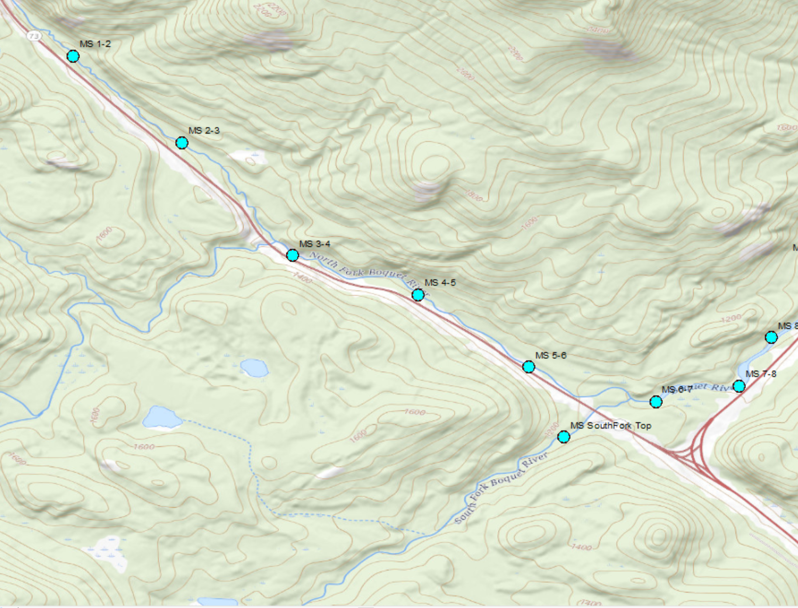

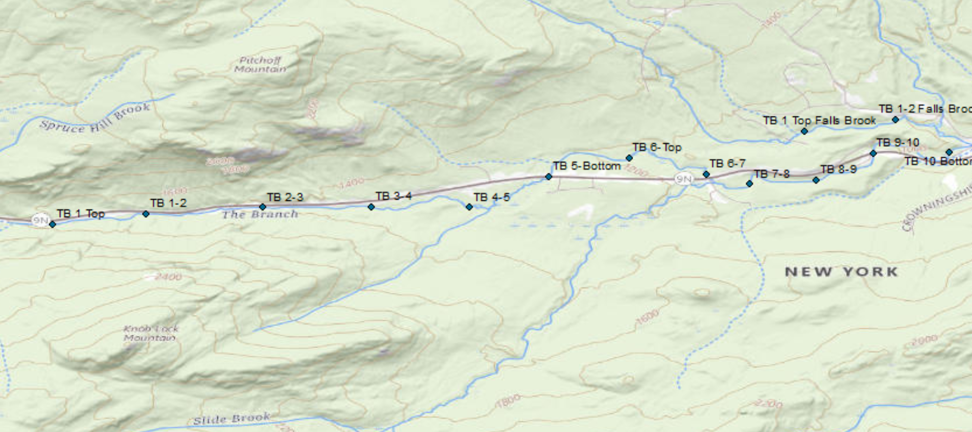

Table 5. Priority sites in the Saranac River, and those stocked in 2021. Sites with priority listed “10” are interchangeable and can be selected as needed and is convenient in years with extra fry. GPS locations are recorded from on-site stocking events in 2021. GPS locations for other sites are available from Steve Smith or Tom Shanahan. Fry assessments are not being conducted in the Saranac River.
Site Name | Site Description | Priority | Lat | Lon | Stocked 2021? | Sample Fall 2021?
SAR01 | Kent Falls section - downstream of powerhouse |  | 44.70537 | -73.5952 | Y | N
SAR02 | Kent Falls section - downstream of powerhouse |  | 44.70548 | -73.5944 | Y | N
SAR03 | Kent Falls section - downstream of powerhouse |  | 44.70562 | -73.5936 | Y | N
SAR04 | Kent Falls section - downstream of powerhouse |  | 44.70568 | -73.5928 | Y | N
SAR05 | Kent Falls section - downstream of powerhouse |  | 44.70567 | -73.592 | Y | N
SAR06 | Kent Falls section - downstream of powerhouse |  | 44.7056 | -73.5913 | Y | N
SAR17 | Aird Dorrance section |  | 44.70278 | -73.5798 | Y | N
SAR18 | Aird Dorrance section |  | 44.70258 | -73.5791 | Y | N
SAR19 | Aird Dorrance section |  | 44.7022 | -73.5786 | Y | N
SAR22 | Mill Stones monument parking area in Morrisonville |  | 44.69262 | -73.5681 | Y | N
SAR23 | Mill Stones monument parking area in Morrisonville |  | 44.69267 | -73.5674 | Y | N
SAR24 | Mill Stones monument parking area in Morrisonville |  | 44.69197 | -73.5669 | Y | N
SAR25 | Mill Stones monument parking area in Morrisonville |  | 44.69345 | -73.5665 | Y | N
SAR26 | Route 22B downstream of Morrisvillve |  | 44.69663 | -73.563 | Y | N
SAR27 | Route 22B downstream of Morrisvillve |  | 44.69663 | -73.5626 | Y | N
SAR28 | Route 22B downstream of Morrisvillve |  | 44.69663 | -73.5622 | Y | N
SAR29 | Route 22B downstream of Morrisvillve |  | 44.69658 | 44.69663 | Y | N
SAR31 | Flood buyout section |  | 44.69473 | -73.5533 | Y | N
SAR32 | Flood buyout section |  | 44.6952 | -73.5529 | Y | N
SAR33 | Flood buyout section |  | 44.69562 | -73.5524 | Y | N
SAR34 | Flood buyout section |  | 44.69595 | -73.5518 | Y | N
SAR35 | Flood buyout section |  | 44.69627 | -73.5512 | Y | N

Table 6. Priority sites in the Ausable River, and those stocked in 2021. Sites with priority listed “10” are interchangeable and can be selected as needed and is convenient in years with extra fry. GPS locations are recorded from on-site stocking events in 2021. GPS locations for other sites are available from Steve Smith or Tom Shanahan.
Site Name | Site Description | Priority | Lat | Lon | Stocked 2021? | Sample Fall 2021?
Roaring Brook | Roaring Brook trailhead parking area | 1 | 44.15027 | -73.7671 | Y | Y
Norton Brook | Hurricane Rd. crossing | 2 | 44.22277 | -73.7471 | Y | Y
Norton Brook | Schaefer Rd. crossing | 3 | 44.23433 | -73.7725 | Y | Y
Cascade Brook | Owls Head Rd. crossing | 4 | 44.24828 | -73.8329 | Y | Y
Gulf Brook | Hurricane Rd. crossing | 5 | 44.25507 | -73.7429 | Y | Y
Clifford Brook | Lacy Rd. bridge | 6 | 44.28278 | -73.7927 | Y | N
Styles Brook trib | Along Styles Brook Rd. | 7 | 44.29893 | -73.7797 | Y | N
Styles Brook trib | Along Styles Brook Rd. | 8 | 44.30053 | -73.7572 | Y | N
Gristmill Lane | Pedestrian Bridge off of Gristmill Lane | 9 | 44.2448 | -73.7979 | Y | N
Rocky Branch | Jasper Haselton Rd. crossing | 10 | 44.35657 | -73.7162 | Y | N
E. Br. Ausable trib | John Fountain Rd. crossing | 10 | 44.35657 | -73.7208 | Y | N
Johns Brook | Johns Brook Lane - new Bridge | 10 | 44.18965 | -73.7989 | Y | N

Notes: roaring brook is a very busy trailhead

