U.S. Fish and Wildlife Service  U.S. Department of the Interior  National Wildlife Refuge System  Point Blue Conservation Science |   
Site-specific Protocol for Monitoring Marsh Birds
Don Edwards San Francisco Bay and
San Pablo Bay National Wildlife Refuges

Survey ID Numbers: FF08RSFB00-003 and FF08RSNP00-008

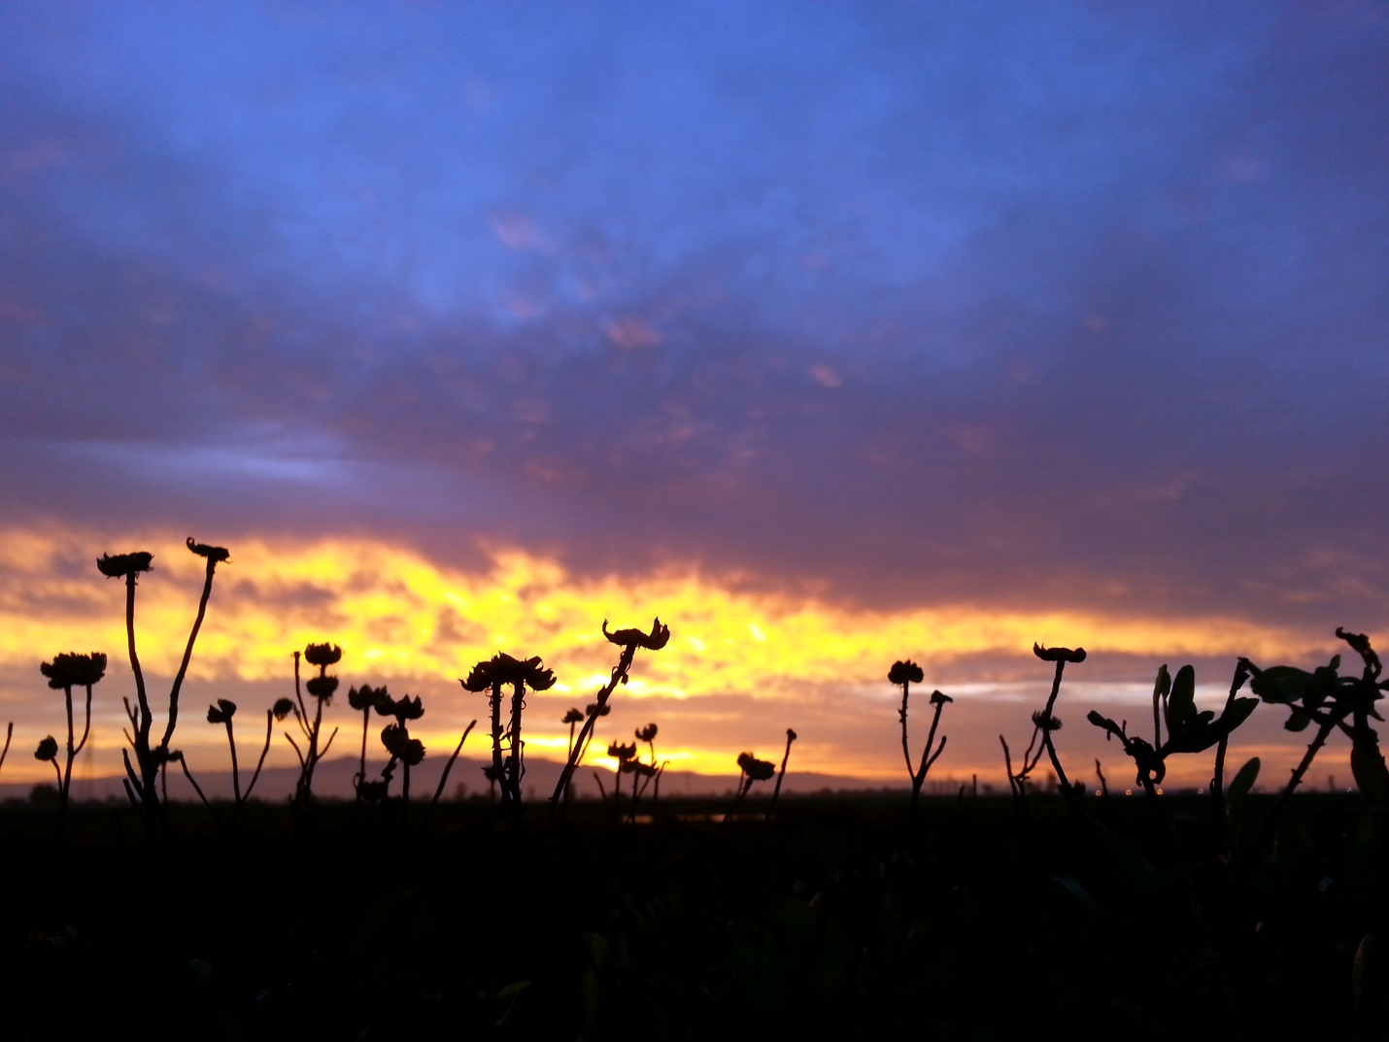

Version 1.0 January 2017

ON THE COVER
Sunrise at La Riviere Marsh, Fremont, California.
Photograph by: Orien Richmond.
NWRS Survey Protocol Signature Page

Protocol Title: Site-specific Protocol for Monitoring Marsh Birds: Don Edwards San Francisco Bay and San Pablo Bay National Wildlife Refuges
Version¹ : 1.0
Station Name:  Don Edwards San Francisco Bay NWR  San Pablo Bay NWR |  |  |  |  | Authors and Affiliations  Julian Wood, Point Blue Conservation Science  Nadav Nur, Point Blue Conservation Science  Leo Salas, Point Blue Conservation Science  Orien M. W. Richmond, U.S. Fish and Wildlife Service
Approvals
Action |  | Signature/Name |  |  |  |  | Date
Survey Coordinator²  Submitted by: |  | Joy Albertson, San Francisco Bay Complex Supervisory Biologist
Zone I&M³ or equivalent Approval: |  | Orien Richmond, I&M Wildlife Biologist
Regional I&M⁴ Approval: |  | Kaylene Keller, Region 8 I&M Coordinator
Version¹ | Date |  | Author | Change Made |  | Reason for Change

¹ Version is a decimal number with the number left of decimal place indicating the number of times this protocol has been approved (e.g., first approved version is 1.0.; prior to first approval all versions are 0.x; after first approval, all minor changes are indicated as version 1. x until the second approval and signature, which establishes version 2.0, and so on).
² Signature of station representative designated lead in development of a site-specific survey protocol.
³ Signature signifies approval of a site-specific survey protocol.
⁴ Signature by Regional I&M Coordinator signifies approval of a site-specific protocol.

Survey Protocol Summary

This site-specific survey protocol provides standardized methods for monitoring marsh birds and was designed for use by the U.S. Fish and Wildlife Service (USFWS) on two national wildlife refuges (NWRs) in the San Francisco Bay Estuary (Estuary): Don Edwards San Francisco Bay NWR (DESFB) and San Pablo Bay NWR (SPB). Use of standardized, statistically-based protocols provides increased confidence in data integrity, facilitates data sharing at local, regional and national levels and improves our ability to detect true population trends over time. The two refuges and other partners in the Estuary have previously used different methods to monitor marsh birds, thus this protocol provides an opportunity for increased standardization of the bay-wide monitoring program and, more importantly, improved accuracy and precision of marsh bird trends. This site-specific protocol is compatible with the National Protocol Framework for the Inventory and Monitoring of Secretive Marsh Birds (Conway 2016). The survey method consists of 10-minute point count surveys that are repeated three times during the survey season at each survey point. The survey methods incorporate a five minute passive listening period followed by call playback for two subspecies of conservation concern, the federally listed California Ridgway’s rail (Rallus obsoletus obsoletus; formerly California clapper rail, Rallus longirostris obsoletus) and state-listed California black rail (Laterallus jamaicensis coturniculus). The protocol facilitates the estimation of detection probability, which is a critical component for monitoring secretive marsh birds with low detection probability. Compatibility of different, standardized approaches is discussed. The protocol includes a probabilistic sampling design, a data management procedure and data analysis techniques. The sampling design incorporates stratification with respect to marsh characteristics and is intended to support both refuge-specific objectives and regional-scale objectives, including monitoring progress towards recovery objectives for California Ridgway’s rail from the USFWS Tidal Marsh Recovery Plan (U.S. Fish & Wildlife Service 2013).

Suggested citation:
Wood, J.K., Nur, N., Salas, L. and O.M.W. Richmond. 2017. Site-specific Protocol for Monitoring Marsh Birds: Don Edwards San Francisco Bay and San Pablo Bay National Wildlife Refuges. Prepared for the U.S. Fish and Wildlife Service, Pacific Southwest Region Refuge Inventory and Monitoring Initiative. Point Blue Conservation Science. Petaluma, CA.

This protocol is available from ServCat: https://ecos.fws.gov/ServCat/Reference/Profile/68062
Acknowledgments
The authors thank the staff of the San Francisco Bay National Wildlife Refuge Complex, including Anne Morkill, Joy Albertson, Meg Marriott, Rachel Tertes, Chris Barr, and Don Brubaker, and Point Blue staff Megan Elrod and Michael Fitzgibbon for valuable insights, review and contributions to this protocol document. Thanks to all of our conservation partners who contributed feedback, ideas and critical review (Jen McBroom and Toby Rohmer, Invasive Spartina Project; Steve Bobzien and Doug Bell, East Bay Regional Park District; Courtney Conway, University of Idaho; Colin Grant, Katherine Sun, Kim Turner and Kim Squires, U.S. Fish and Wildlife Service Ecological Services Branch; Giselle Block and Michael Cunanan, U.S. Fish and Wildlife Service Region 8 Refuge Inventory and Monitoring Initiative; Karen Taylor and Sarah Estrella, California Department of Fish and Wildlife; Cory Overton and Michael Casazza, U.S. Geological Survey). Thanks to Sharon Dulava, USFWS, and Megan Elrod, Point Blue, for enduring many hours in cold muddy environments and collecting the data that informed this protocol.

Contents
NWRS Survey Protocol Signature Page i
Survey Protocol Summary 2
Acknowledgments 3
Contents 3
List of Tables 4
List of Figures 5
Abbreviations 6
Narrative 7
Element 1: Introduction 7
Background 7
Objectives 11
Element 2: Sampling Design 15
Objectives: Overview 15
Sampling objectives 16
Rationale for sampling objectives 17
Sampling units and sample frame 18
Sample selection and size 19
Statistical power analysis 20
Sample selection 29
Survey timing and schedule 37
Sources of error 39
Element 3: Field Methods and Processing of Collected Materials 39
Element 4: Data Management and Analysis 39
Analysis methods 39
Element 5: Reporting 44
Annual reports 45
Synthesis reports 46
Reporting schedule 47
Report distribution 47
Element 6: Personnel Requirements and Training 47
Roles and responsibilities 47
Qualifications 47
Training 47
Element 7: Operational Requirements 48
Staff Time and Budget 48
Schedule 48
Coordination 49
Element 8: References 50
SOP 1: Field Methods – Version 1.0 – Dec 2016 53
Pre-survey Requirements 53
Equipment 53
Environmental Restrictions 54
Survey Timing 54
Data collection procedures 54
Mapping detections and determining unique counts 57
SOP 2 Data Management – Version 1.0 – April 2016 58
Database description 58
Data entry, verification, and editing 62
Metadata 78
Appendix A. Historic Survey Methods 80
Appendix B. Walking in the Marsh 81
Appendix C. San Francisco Bay Marsh Bird Survey Datasheet 84

List of Tables
Table 1. USFWS delisting criteria for California Ridgway’s rail. Numbers are based on estimates of true abundance and represent the best available population estimates. 8
Table 2. Management objectives and rationales for marsh birds that apply to Don Edwards San Francisco Bay and San Pablo Bay National Wildlife Refuges from available conservation plans. 12
Table 3. San Pablo Bay National Wildlife Refuge tier 1 survey study areas selected for surveys 31
Table 4. Don Edwards San Francisco Bay National Wildlife Refuge tier 1 survey study areas selected for surveys 32
Table 5. The number of transects in each strata for San Pablo Bay NWR (SPB) and Don Edwards San Francisco Bay NWR (DESFB). High quality habitat is the top quartile CA Ridgway’s Rail density, Low quality is the bottom three quartiles, young marsh is <50 years old and old marsh is ≥50 years old. 33
Table 6. Annual budget estimate for completing marsh bird surveys at Don Edwards San Francisco Bay National Wildlife Refuge (DESFB) assuming 10 transects and San Pablo Bay National Wildlife Refuge (SPB) assuming 8 transects. 48

List of Figures
Figure 1A. Power to detect increasing trends of 1.9% and 4.3% per year given current sampling effort at DESFB (10 transects) and SPB (8 transects), over a span of 5, 10, 15, and 20 years, for Type 1 error rate of 0.05 and 0.10. 23
Figure 1B. Power to detect decreasing trends of 3.4% and 5.0% per year given current sampling effort at DESFB (10 transects) and SPB (8 transects), over a span of 5, 10, 15, and 20 years, for Type 1 error rate of 0.05 24
Figure 2A. Power to detect increasing trends of 1.9% and 4.3% per year in relation to number of transects, from 8 to 30 transects, over a span of 10, 15, and 20 years, for Type 1 error rate of 0.05 and 0.10 25
Figure 2B. Power to detect decreasing trends of 3.4% and 5.0% per year in relation to number of transects, from 8 to 30 transects, over a span of 10, 15, and 20 years, for Type 1 error rate of 0.05 and 0.10. 26
Figure 3A. Power to detect increasing trends ranging from 1.9% to 8.0% per year given current sampling effort at DESFB (10 transects) and SPB (8 transects), over a span of 5, 10, 15, and 20 years, for Type 1 error rate of 0.05 and 0.10 27
Figure 3B. Power to detect decreasing trends ranging from 2.0% to 7.0% per year given current sampling effort at DESFB (10 transects) and SPB (8 transects), over a span of 5, 10, 15, and 20 years, for Type 1 error rate of 0.05 and 0.10 28
Figure 4. Selected survey study areas in Tidal Marsh Recovery Plan segments Q and R showing marsh suitability, age and quality 34
Figure 5. Selected survey study areas in Tidal Marsh Recovery Plan segments O and P showing marsh suitability, age and quality 35
Figure 6. Selected survey study areas in Tidal Marsh Recovery Plan segments M and N showing marsh suitability, age and quality 36
Figure 7. San Pablo Bay National Wildlife Refuge selected survey study areas and marsh suitability, age and quality 37
Figure 8. Detection probability for CA Ridgway’s rail in relation to Day of the Year (1= 1 Jan, 90 = 1 April, etc.). Best estimate (dark line) and confidence interval (gray band) are shown, setting all other covariates to their mean level. Results from Type A Survey Protocol (Liu et al. 2012). 38
Figure 9. Detection probability in relation to time relative to sunrise/sunset for CA Ridgway’s rail under the Type A (A) and North American (N. American) field methods with 95% confidence interval (colored bands) around the estimate. Negative values refer to “darker” minutes before sunrise or after sunset; positive values refer to “lighter” minutes after sunrise or before sunset. Results from Nur et al. (2016). 38

Abbreviations
CA | California
CCP | Comprehensive Conservation Plan, National Wildlife Refuge
CDFW | California Department of Fish and Wildlife
DESFB | Don Edwards San Francisco Bay National Wildlife Refuge
EBRPD | East Bay Regional Park District
ISP | Invasive Spartina Project
NWRS | National Wildlife Refuge System
SOP | Standard Operating Procedure
SPB | San Pablo Bay National Wildlife Refuge
TMRP | Recovery Plan for Tidal Marsh Ecosystems of Northern and Central California
USFWS | U. S. Fish and Wildlife Service

Narrative

Element 1: Introduction

Background
Don Edwards San Francisco Bay National Wildlife Refuge (hereafter ‘DESFB’) and San Pablo Bay National Wildlife Refuge (hereafter ‘SPB’) are part of the San Francisco Bay National Wildlife Refuge Complex and are located within the larger San Francisco Bay Estuary (hereafter ‘Estuary’), which is the second largest in the nation and the largest on the West Coast. The Estuary provides essential migrating and wintering habitat for hundreds of thousands of waterbirds and shorebirds and breeding habitat for a variety of waterbirds and marsh birds, including secretive marsh birds, such as the federally endangered California Ridgway’s rail (Rallus obsoletus obsoletus, formerly California clapper rail, hereafter CA Ridgway’s Rail) and state threatened California black rail (Laterallus jamaicensis coturniculus) (U.S. Fish and Wildlife Service 2011, 2012).

Human activities have negatively altered and dramatically reduced the tidal marsh ecosystem throughout the Estuary. Tidal marshes are estimated to have covered approximately 190,000 acres in the 19th century before substantial impacts from European settlers began around the Gold Rush (Goals Project 1999, 2015). Approximately 80% of the Estuary’s tidal marsh was subsequently converted to agricultural fields, pasture, salt production ponds, duck clubs and urban and commercial development (U.S. Fish & Wildlife Service 2013). Habitat loss, habitat degradation (from fragmentation, sedimentation, contaminants, subsidence, invasive species, human disturbance and other factors), predation, and overharvesting have been recognized as significant threats to marsh bird populations in the Estuary (Schwarzbach et al. 2006, Takekawa et al. 2006, 2012, Ackerman et al. 2012, U.S. Fish & Wildlife Service 2013). Potential future losses of tidal marsh due to sea level rise are an additional long-term threat (Stralberg et al. 2011, Thorne et al. 2012, Overton et al. 2015).

In response to the Estuary’s loss and degradation of tidal marshes and declines in associated wildlife of conservation concern, state, federal and private organizations are currently engaged in the largest tidal marsh restoration effort on the west coast (Stallings 2003, Trulio et al. 2007, U.S. Fish and Wildlife Service 2011, 2012). In 2009, the Estuary was estimated to have about 45,000 acres of tidal marsh. Since 2009, an additional 6,300 acres have been reconnected to the tides. With the help of Measure AA, passed in 2016, an additional 24,000 acres of tidal marsh will likely be added over the next 20-30 years as part of already funded or permitted restoration projects (Goals Project 2015, San Francisco Estuary Partnership 2015). Based on refuge estimates, DESFB will increase its extent of tidal marsh by approximately 4,560 acres and SPB will increase its extent of tidal marsh by approximately 740 acres by 2030.

Marsh bird populations are expected to increase as more tidal marsh habitat becomes available, thus monitoring changes in marsh bird populations can provide evidence for restoration success or failure and, ultimately, inform how we can improve our restoration and other management efforts. The recently completed Recovery Plan for Tidal Marsh Ecosystems of Northern and Central California (U.S. Fish & Wildlife Service 2013, hereafter “TMRP”) established delisting criteria that included population objectives for CA Ridgway’s rail by Recovery Unit (Table 1). This protocol addresses the two Recovery Units that contain SPB and DESFB refuges, Central/South San Francisco Bay and San Pablo Bay, respectively. The remaining Recovery Units (Suisun Bay, Central Coast, and Morro Bay) are not covered in this site-specific protocol, but the survey methods described here could be used in those areas.

Table 1. USFWS delisting criteria for California Ridgway’s rail. Numbers are based on estimates of true abundance and represent the best available population estimates.
Recovery Unit | Most Recent Population Estimate (adjusted from Liu et al. 2012) | Delisting Criteria (U.S. Fish & Wildlife Service 2013) | Average Annual Growth Rate Needed to Reach Delisting Criteria by 2063
Central/South San Francisco  Bay | 369 (range 305-456) | 3,180 | 4.3%
San Pablo Bay | 794 (range 649-970) | 2,080 | 1.9%

DESFB is in the Central/South Bay Recovery Unit, and SPB is in the San Pablo Bay Recovery Unit. The goal is to reach the delisting criteria by the year 2063. The TMRP recommends annual monitoring to assess progress toward recovery. However, neither the specifics of the survey methodology nor the monitoring design were described or outlined in the TMRP.

Marsh birds have been monitored on DESFB and SPB for decades using two main survey methods, airboat surveys and point count surveys. Point count surveys can either be passive or incorporate broadcast of marsh bird calls (referred to as “call-broadcast surveys,” “playback surveys,” or “call-count surveys”). High-tide winter airboat surveys have been conducted at selected marshes on DESFB by USFWS, California Department of Fish and Wildlife (CDFW) and East Bay Regional Park District (EBRPD) since 1982. Airboat surveys are conditional on weather and tide conditions, thus in some years they cannot be conducted. Airboat surveys are typically conducted only once in a given location each year, thus estimates of detection probability are difficult to derive.

Passive and call-broadcast point count surveys for marsh birds have been conducted by USFWS at DESFB since 1989. Originally, the survey method consisted of multiple observers remaining stationary at a survey point for 2 hours in a marsh, at sunrise or sunset, and spaced between 150 and 200 meters apart. Rail calls, time, direction and distance were noted on a map, and a summary map was prepared to derive a raw count of total rails per marsh. Playback was sometimes used. This survey methodology, known as the “Type B” stationary survey, is still used at LaRiviere Marsh at DESFB. In the early 2000’s, a new survey method was introduced at DESFB whereby observers conducted 10-minute point count surveys at multiple points (usually 6-8 per transect) spaced 200 m apart along transects. Three visits were typically conducted at each point in each year, and all surveys were conducted near sunrise or sunset. The first two visits were passive, and the third visit incorporated a 5-minute passive segment followed by a conditional 1-minute broadcast of CA Ridgway’s rail calls. The broadcast was conditional on no CA Ridgway’s rails having been previously detected at that point on the first two visits. One-minute broadcasts were followed by a 4-minute passive segment (10 minutes total). This survey methodology, known as the “Type A” survey method, has been widely used at numerous marsh study areas/sites throughout the Estuary, starting in 2005 (Liu et al. 2012), though it had been used at a smaller number of study areas before 2005. Starting in 2004, DESFB incorporated CA Ridgway’s rail call broadcast on all three visits during minute 6. This modified survey method is known as “Type C”.

Point count surveys for marsh birds were conducted on portions of SPB in 1998 and 2001-2002. In 2004, a point count survey method very similar to “Type A” was initiated and has been in use since that time. The SPB survey method consists of 10-minute point count surveys at multiple points (usually 6-8) spaced 200 m apart along transects. Three visits are typically conducted at each point each year, and surveys are conducted near sunrise or sunset. The first two visits are passive, and the third visit incorporates an initial 5-minute passive segment followed by an unconditional 1-minute broadcast of CA Ridgway’s rail calls followed by a 4-minute passive segment (10 minutes total). The call broadcast is employed regardless of detections that may have occurred on the previous two rounds. This is in contrast to the “Type A” survey method, in which the 3rd round call broadcast is conditional on not detecting CA Ridgway’s rails at that point on the first two visits.

Multiple survey methods were employed by USFWS and other agency and NGO partners involved in monitoring CA Ridgway’s rails due in part to differences in various organization’s monitoring goals, site access, CA Ridgway’s rail densities, operating budgets (see Historic survey methods, Appendix A). Because different survey methods were used, biologists were not able to compile and integrate data among partners as often as needed and were not able to easily extract information on recovery status, population trends, or response to restoration and management. In addition, the results may not have been reliable given the variation in methods. This arrangement did not meet the needs of managers seeking to identify and reduce threats to the CA Ridgway’s rail. As a result, the idea of identifying and promoting an efficient field method for surveying secretive marsh birds throughout the Estuary was pursued.

Broadcasting marsh bird vocalizations has been shown to generally increase detection probability for most marsh bird species (Gibbs and Melvin 1993, Hinojosa-Huerta et al. 2002, Lor and Malecki 2002, Allen et al. 2004, Conway et al. 2005, Conway and Gibbs 2011). Surveys where call broadcast is used on every visit are recommended for multi-species marsh bird monitoring under the Standardized North American Marsh Bird Monitoring Protocol (Conway and Seamans 2016). This protocol framework has been adopted by many federal, state and local organizations across the U.S. and provides the basis for this site-specific protocol for DESFB and SPB. One concern about adopting the North American Protocol among refuge staff and others conducting marsh bird monitoring is that call broadcast may cause disturbance to marsh birds and could potentially increase mortality risk (e.g., call broadcast might cause a rail to leave protective vegetation cover putting them at greater risk of predation). Available data are mixed about the effects of call broadcast on marsh bird movements. Legare et al. (1999) found evidence of small scale movements in response to call broadcast for Black Rails (males moved an average of 9.5 m in 63% of trials; females moved an average of 4.9 m in 47% of trials). In contrast, Bui et al. (2015) found that CA Ridgway’s Rail movements were not consistently influenced by call broadcast in San Francisco Bay. This concern has been addressed by adding specific provisions to the survey method to minimize the risk of predation (see Element 3).

The TMRP does not provide a specific monitoring design for surveying tidal marsh birds. Through a series of workshops, USFWS staff met with the authors to outline the needs and objectives that should inform a monitoring design focused primarily on CA Ridgway’s rails. The desired monitoring program should be sensitive enough to: (1) quantify increasing and decreasing population trends at the refuge, regional, and Estuary scales; (2) document responses in marsh bird populations with reference to tidal marsh restoration efforts at refuge, regional, and Estuary scales; (3) measure progress toward CA Ridgway’s rail recovery objectives at refuge and regional scales; and (4) detect substantial short-term declines and increases (>40%) over short time spans (3-5 years) in CA Ridgway’s rails at refuge and regional scales as an early warning system to refuge managers of imminent threats (e.g., introduction of a new predator or disease) or to indicate any other substantial changes of high concern. Given limited resources at both refuges, the desired monitoring program should also be maximally efficient so that it can be sustained through both bountiful and lean budget years. The Refuges and their partners have used different methods to monitor CA Ridgway’s rails and other marsh birds, which has made it more difficult to accurately estimate population sizes and trends across different spatial and temporal scales. Thus, this protocol provides an opportunity for increased standardization for effective and efficient Estuary-wide marsh bird monitoring.

In addition to informing managers about the large-scale effects of tidal marsh restoration on marsh bird populations and tracking progress toward delisting objectives for CA Ridgway’s rail, the monitoring data from this protocol can be used in conjunction with additional monitoring efforts to assess the effectiveness of ongoing or proposed management actions such as predator control, invasive plant removal, and marsh revegetation and enhancement. Marsh bird species can often serve as indicators for assessing the general health of wetland ecosystems, and their presence and abundance can be used as measures of the success of wetland restoration efforts (Lewis and Casagrande 1997). For example, marsh birds may be affected by accumulation of environmental contaminants in wetland substrates because they consume a wide variety of aquatic invertebrates (Klaas et al. 1980, Eddleman et al. 1988, Conway 1995, Schwarzbach et al. 2001, Takekawa et al. 2006, Tsao et al. 2008). Marsh birds are also affected by changes in wetland plant composition and invasion of wetlands by invasive plant species (Guntenspergen and Nordby 2006, Spautz et al. 2006, Overton et al. 2014).

The USFWS has a vested interest in marsh bird populations and their habitats because marsh birds are trust species protected by USFWS (trust resources include migratory birds, interjurisdictional fish, federal T&E species, and certain marine mammals). The USFWS National Wildlife Refuge System (NWRS) has been a key partner in developing and promoting a standardized marsh bird protocol (Conway and Seamans 2016) because refuges contain a disproportionate amount of tidal and non-tidal wetlands within their boundaries, and marsh birds can be influenced by refuge management actions. The Service has an additional interest in recovering federally listed threatened and endangered species (i.e., CA Ridgway’s rail) and contributing to the recovery of other species of conservation concern, including the state threatened California black rail. Only CA Ridgway’s rail and CA black rail vocalizations will be broadcast under this protocol. The highest-priority species for this protocol is the federally endangered CA Ridgway’s rail, and the protocol was designed specifically for maximizing detection of this species.

In addition to CA Ridgway’s rail and California black rail, five other secretive marsh bird species are considered focal species under this protocol including Virginia rail (Rallus limicola), sora (Porzana carolina), yellow rail (Coturnicops noveboracensis), American bittern (Botaurus lentiginosus), and least bittern (Ixobrychus exilis). All detections for these species will be recorded. The USFWS has identified black rails, yellow rails, and American bitterns as Birds of Conservation Concern because they are relatively rare and basic information on status and trends is lacking in most areas (U.S. Fish and Wildlife Service 2008). The State of California identifies yellow rail and least bittern as Bird Species of Special Concern; in addition to identification of California black rail as state threatened. Any detections of these seven focal species will be recorded and entered into the database.

Objectives

This protocol includes two types of objectives: management objectives and sampling objectives. Management objectives are statements detailing the resource outcomes a refuge plans to achieve (desired future conditions of a natural resource). Management objectives should be “SMART” (Specific, Measureable, Achievable, Relevant and Time bound). Sampling objectives provide the specifics for measuring the resource or related indicator targeted in the management objectives and include what will be surveyed (resource or ecological indicator), the attribute actually measured or estimated (e.g., body size, cover, density), the desired accuracy of estimates, the magnitude of change one wants to detect, the chance of error you are willing to accept, and the power to detect a change of a specified magnitude (Nur et al. 1999). This information is necessary for guiding decisions about the sampling design. Guidance on how to develop management and sampling objectives is described in more detail in Elzinga et al. (2001, pages 247-270).

Management Objectives
The TMRP (U.S. Fish & Wildlife Service 2013) sets forth specific abundance objectives for CA Ridgway’s rail (Table 2). The South Bay Salt Pond Adaptive Management Plan (Trulio et al. 2007) also contains specific abundance or density objectives for CA Ridgway’s rail based on objectives in the TMRP (Table 2). Likewise, the Refuges based their management objectives on the TMRP.

Table 2. Management objectives and rationales for marsh birds that apply to Don Edwards San Francisco Bay and San Pablo Bay National Wildlife Refuges from available conservation plans.
Conservation Plan | Management Objective | Rationale
DESFB CCP (U.S. Fish and Wildlife Service 2012) | Goal 1: Protect and contribute to the recovery of endangered, threatened, and other special status species on the Refuge by conservation and management of the habitats on which these species depend.  Objective 1.1. Conduct standardized monitoring efforts and research projects in coordination with other regional efforts for salt marsh harvest mouse and California clapper rail within five years. Improve high tide refugia for these species. | The California clapper rail and the salt marsh harvest mouse are two of the endangered species for which the Refuge was established. The Draft Tidal Marsh Recovery Plan (TMRP) identifies several actions needed to achieve recovery of the California clapper rail and salt marsh harvest mouse. Actions include evaluating and monitoring existing populations, protecting, managing, and restoring habitat, and conducting research necessary to promote recovery. Refuge management strategies will directly support the actions identified in the TMRP.
SPB CCP (U.S. Fish and Wildlife Service 2011) | Goal 1: Support and contribute to the recovery and protection of threatened and endangered species and related ecosystems of the San Francisco Estuary.  Objective 1.1. Within five years of the Plan, develop and begin to implement an inventory and monitoring (I&M) program that addresses native and non-native species, habitats, and ecosystems of San Pablo Bay. | Federally listed threatened, endangered, and candidate species are trust responsibilities under the jurisdiction of the Service. Threatened and endangered species, as well as those proposed for Federal listing, are likely to become extinct due to environmental factors. Listed species known to occur on the Refuge, the California clapper rail and the salt marsh harvest mouse, are dependent on tidal wetlands. As much as 90 percent of wetlands around the San Francisco Bay have been lost to development (Goals Project 1999). The Draft Recovery Plan for Tidal Marsh Ecosystems of Northern and Central California (Draft Tidal Marsh Recovery Plan) (USFWS 2009) identifies the need for monitoring to assess status, trends, habitat use, and threats to develop appropriate recovery actions. Refuge management strategies will support these objectives. Furthermore, understanding how listed species interact with their environment and other wildlife will support their recovery.
SPB CCP (U.S. Fish and Wildlife Service 2011) | Goal 1: (see above)  Objective 1.2 Within life of the Plan, evaluate population health, develop population goals, and identify and implement management actions that will preserve or enhance existing populations of priority species identified in the I&M program (see Objective 1.1). | The Draft Tidal Marsh Recovery Plan identifies several actions needed to achieve recovery of the California clapper rail and salt marsh harvest mouse. San Pablo Bay NWR Final Comprehensive Conservation Plan Actions include evaluating and monitoring existing populations, protecting, managing, and restoring habitat, and conducting research necessary to promote recovery. Refuge management strategies will directly support the actions identified in the Plan.

Conservation Plan | Management Objective | Rationale
South Bay Salt Pond Adaptive Management Plan (Trulio et al. 2007) | Clapper Rails: Project Objective 1A Restoration Target: Meet recovery plan criteria for clapper rail numbers (0.25 birds/ac over 10-year period) within the SBSP Restoration Project Area | Future actions are expected to open significant acreages of pond to tidal action in order to initiate development of significant areas of tidal habitat for California clapper rail and salt marsh harvest mouse and to allow large-scale testing of sediment dynamics and supply questions. One primary Project Objective is to provide adequate habitat to support pre-Interim Study Period numbers and diversity of waterbirds using the South Bay while increasing numbers of tidal marsh birds such as California clapper rails that have historically used the Bay.
Tidal Marsh Recovery Plan (U.S. Fish & Wildlife Service 2013) | Factor E/1. Downlist Criterion. To provide sufficient resilience to stochastic events, criteria under Factors A-C have been met and have resulted in at least the following average number of rails over a 10 year period, spread over a large geographic area:  Central/South SF Bay Recovery Unit: 1,060  San Pablo Bay Recovery Unit: 936  Note: Factors A-C relate to habitat, overutilization and predation/disease. | The average number of rails required for downlisting was calculated from the minimum required acreage (criteria A/1. A/2, and A/3), derived itself from a population viability analysis conducted for California clapper rail. For further information on this analysis, see Appendix F of the TMRP. The minimum acreage was multiplied by the rail density corresponding to the 60th percentile of observed winter populations for that particular region and are 0.15 bird/ac for Central/So SF Bay and 0.09 bird/ac for San Pablo Bay. Rather than specify a minimum number of rails that must be supported per marsh complex, it is assumed that a natural distribution over the entire recovery unit would result if the other minimum acreage protection and management criteria are met.  Surveys. Annual clapper rail monitoring should continue on Don Edwards San Francisco Bay National Wildlife Refuge, and expand to other Federal and State owned lands. Monitoring provides data that are useful both in the short-term for adaptive management of existing tidal marsh, and in the long-term to determine success of recovery efforts. Monitoring protocol should approximately follow current monitoring design used by PRBO Conservation Science in their estuary-wide surveys for long-term analysis purposes and should help to capture normal population fluctuations and to asses rail response to invasive Spartina control. As recovery efforts proceed, California clapper rail population distribution will expand. Intensive monitoring will be necessary to document the resulting range expansion.
Tidal Marsh Recovery Plan (U.S. Fish & Wildlife Service 2013) | Factor E/1. Delist Criterion. To provide sufficient resilience to stochastic events, criteria under Factors A-C have been met and have resulted in at least the following average number of rails over a 10 year period, spread over a large geographic area:  Central/South SF Bay Recovery Unit: 3,180  San Pablo Bay Recovery Unit: 2,080  Note: Factors A-C relate to habitat, overutilization and predation/disease. | The average number of rails required for delisting was calculated from the minimum required acreage above, derived itself from a population viability analysis conducted for California clapper rail. For further information on this analysis, see Appendix F. The minimum acreage was multiplied by the rail density corresponding to the 90th percentile of observed winter populations for that particular region. Those are 0.45 bird/ac and 0.20 bird/ac for Central/So SF Bay and San Pablo Bay, respectively. Rather than specify a minimum number of rails that must be supported per marsh complex, it is assumed that a natural distribution over the entire recovery unit would result if the other minimum acreage protection and management criteria are met. See information on Surveys above.

The TMRP established population objectives for delisting for each recovery unit (Table 1) but did not step down these population objectives to smaller scales (e.g., to the Refuge scale). The Refuge Comprehensive Conservation Plans (15-year management plans that set forth conservation goals and objectives for the Refuge; hereafter “CCPs”) similarly did not describe specific population objectives but did call for such goals to be developed (CCP Objective 1.2). In addition, there are no specific management objectives for the other marsh bird species in existing conservation plans.

The following management objectives were developed by Refuge staff for the purpose of this protocol and help meet the CCP objectives:

- During the period 2017-2063, achieve an average annual rate of increase in the CA Ridgway’s rail population at DESFB of at least 4.3% (2.3% during 2017-2032 and 5.5% during 2032-2063).
- During the period 2017-2063, achieve an average annual rate of increase in the CA Ridgway’s rail population at SPB of at least 1.9%.
- Maintain current levels of occupancy (proportion of occupied marshes) for Virginia rails and CA black rails on DESFB and SPB until 2032.

These objectives meet recovery objectives of the TMRP while recognizing the management constraints and opportunities described below.

Rationale for the CA Ridgway’s rail management objectives
CA Ridgway’s rail population size can be increased in two primary ways: (1) by increasing rail densities at existing marshes or (2) by establishing rail populations at newly restored marshes. Refuge management actions that can potentially increase rail densities at existing marshes include improvements to hydrology, restoration of upland-marsh transition zones, construction of marsh mounds, revegetation and predator control (Harding et al. 2001). Both refuges are restoring tidal marsh habitat by breaching levees surrounding salt production ponds, managed ponds and agricultural lands. Some breached ponds with starting elevations near mean higher high water are expected to provide new CA Ridgway’s rail habitat within a relatively short time span through natural sediment deposition and growth of emergent plants, while others will require years or even decades of sediment deposition before they can support suitable emergent vegetation; artificial deposition of sediment can accelerate the process of marsh accretion (Williams and Orr 2002, Brand et al. 2012). Establishment of rail populations at newly restored marshes is assumed to occur via unassisted (natural) colonization. The timing of CA Ridgway’s rail recolonization depends in large part on how quickly the study area reaches marsh plain elevations. Liu et al. (2012) found that recolonization has occurred on average about 20 years after levee breaching in the Estuary.

For DESFB, we assumed that CA Ridgway’s rail population growth over the next 15 years would primarily come from new habitat created through past tidal marsh restorations because resources for enhancements of existing marshes are expected to be minimal over this time frame, whereas tidal marsh acreage is projected to increase substantially from past restoration actions. For setting the population target, we made the simplifying assumption that the population growth rate for rails would equal the projected rate of growth in habitat acreage—this assumes constant densities between existing and restored marshes. Based on refuge estimates, DESFB is projected to increase its suitable rail habitat acreage from 10,348 acres to 14,914 acres by 2032, representing a 2.3% annual growth rate in tidal marsh acreage. Note that a 4.3% average annual growth rate for the entire Central/South Bay Recovery Unit will be required to reach the TMRP delisting criteria by 2063 (U.S. Fish & Wildlife Service 2013). To make up for the lower growth rate over the next 15 years, we set a higher target (5.5% annual growth rate) for DESFB from 2032-2063 that will be achieved through management of existing habitat including predator control and vegetation enhancement. It is important to note that this protocol was not designed to assess the effectiveness of specific management activities, which would require more intensive and targeted survey efforts. Also important to note, if other properties (not managed by USFWS) do not meet the target of 4.3% annual increase, then the recovery unit as a whole may not meet its goal, even though the Refuge may have met its stated goal.

For SPB, we assumed that population growth over the next 15 years would come from both enhancements to existing marshes and from tidal marsh restoration. SPB is currently incorporating habitat enhancements by improving hydrology and function to existing marshes. This includes creating high tide refuge habitat (marsh mounds) and gradually sloping and revegetating transition zones at Sonoma Creek West, Dickson Ranch, Cullinan East and Cullinan West. SPB plans to enhance Strip Marsh West and Strip Marsh East within the next 15 years. The 440-acre Skaggs Island will be restored via levee breaching. Beneficial reuse of sediment and densely planted rhizomatous vegetation will help raise subsided areas to marsh plain elevation. Skaggs Island is not expected to provide CA Ridgway’s rail habitat by 2032. East Cullinan (approximately 300 acres) will be brought up to marsh plain and then breached within the next 5 years. The enhancements are expected to increase habitat quality for CA Ridgway’s rail. SPB is projected to increase its tidal marsh acreage from 4,993 acres to 5,730 acres by 2032, representing a 0.9% annual growth rate in tidal marsh acreage. The SPB objective of 1.9% average annual growth rate includes growth from existing marsh enhancements and tidal marsh restoration. Note that if a 1.9% average annual growth rate is maintained on the refuge and throughout the San Pablo Bay Recovery Unit, this rate of change will result in reaching the TMRP delisting criteria for the recovery unit by 2063 (U.S. Fish & Wildlife Service 2013).

Element 2: Sampling Design

Objectives: Overview
The protocol and associated monitoring framework are designed to: (1) provide information on changes and variation in abundance of CA Ridgway’s rail over time and (2) provide a robust sampling framework for assessing CA Ridgway’s rail response to large-scale conservation and management actions that can be expanded to include other partners operating on non-Refuge lands throughout the Estuary. The survey method and design addresses multiple objectives. The first is to achieve sufficient precision to monitor changes in CA Ridgway’s rail abundance such that progress towards the 50-year TMRP recovery criteria (USFWS 2013) can be assessed. However, the protocol is not limited to a pre-determined change in abundance or density. Rather, the sampling design allows a range of changes in density to be detected; target values will be subject to revision over time, and trends are expected to change over the approximately 50-year TMRP time frame. Secondly, the protocol provides the ability to assess broad-scale response to tidal marsh restoration; local-scale management actions will likely require additional sampling that can build upon the effort described herein. Finally, the protocol provides the ability to detect short- and long-terms trends and one-year step changes in density that are of concern to the Refuge and other natural resource managers.

Whereas the absolute number of CA Ridgway’s rails in a marsh, the Refuge Complex, or the entire Estuary is of interest, it is important to acknowledge substantial limitations to estimating absolute abundance. Reliance on raw counts of individuals uncorrected for imperfect detection is inadequate because detection probability is much less than 100% and varies among surveys, thus confounding our ability to quantify differences in abundance among study areas or changes in abundance over time. Instead, the approach implemented here is to quantify variation in absolute density (abundance relative to area), in a statistically justified and robust manner that can easily be replicated and can be conducted on an annual basis.

The approach detailed here centers on the quantitative estimation and statistical analysis of variation in absolute density, that is, the number of individuals inferred to be actually present per unit of area. The key underlying relationship is the following:

density (birds per ha) x area (number of ha) = abundance (number of birds).

We focus on density in this protocol because this parameter explicitly takes into account the area being considered, both with regard to area sampled and with regard to area of inference. Another important strength to density estimation is that historic data are available that can be incorporated into an analysis. Thus, data collected and analyzed with respect to variation in density (either over time, or with regard to spatial variation) can provide a strong, quantitative basis for assessing progress in meeting conservation and management objectives. Density can readily be converted to abundance using data on habitat acreage to assess progress toward meeting abundance objectives, such as those laid out in the TMRP (USFWS 2013).

Sampling objectives
The sampling objectives for this protocol are:
- For each Refuge, achieve 80% statistical power to detect average increases in CA Ridgway’s rail density of 1.9% to 4.3% per year over 20 years with a Type I error rate of 0.05.
- For each Refuge, achieve 80% statistical power to detect average declines of 3.4% and 5.0% per year in CA Ridgway’s rail density per year over 20 years (representing total declines of 50% and 64%, respectively) with a Type I error rate of 0.05.
- For each Refuge, achieve 80% statistical power to detect a 40% or more one-year increase or decrease in CA Ridgway’s rail density compared to a suitable baseline period (e.g., 3+ years) with a Type I error rate of 0.05.
- Achieve sufficient precision to estimate trends in CA Ridgway’s rail density differentiated with respect to age of marsh (< 50 years vs. ≥50 years) as well as with respect to habitat quality as it pertains to CA Ridgway’s rail (high vs. low quality; see definition under “sample selection and size”). Trends are to be estimated at the refuge level; in addition, the sampling design can be scaled up to the regional level (corresponding with the recovery units in the TMRP), using this survey protocol as a framework.

Rationale for sampling objectives
Estimation and detection of increasing trend in density
The magnitude of a trend, whether increasing or decreasing, is one of the key variables determining the ability to statistically detect a trend, and thus represents an important input value in our design (Nur et al. 1999). With regard to the detection of increasing trends, we considered trend values that correspond to the long-term annual population growth rates that would be required to reach CA Ridgway’s rail delisting criteria by 2063 for each TMRP Recovery Unit (USFWS 2013). For the San Pablo recovery unit, the last population estimate was 794 birds in 2012 (Liu et al. 2012). To reach the TMRP delisting criterion of 2,080 birds by 2063, a constant annual growth rate of 1.9% would be required over the full time period. The corresponding trend to go from 369 birds in 2012 (Liu et al. 2012) to the delisting TMRP criterion of 3,180 birds for the Central and South Bay recovery unit is 4.3% per year. These rates represent initial “baseline” target values. This survey protocol addresses other target values that may be of equal or greater relevance with regard to management of CA Ridgway’s rails. It is important that this protocol addresses a variety of trend values; one single value is not sufficient, since: a) target values are expected to change over time and b) the monitoring framework needs to address multiple objectives, including monitoring at local and regional scales. Therefore, we assessed the ability of each Refuge to detect both trends (1.9% and 4.3% per year).

Note, in particular, that the “baseline” target calculations cited above, assume a 50-year time frame for achieving implied increases in density, and furthermore assume that all parcels in a recovery unit, regardless of land ownership, will achieve the stated increases in density in order to meet the recovery unit delisting criteria. If increasing density over a shorter time period is desired (see below) or if Refuge-managed parcels desire to contribute a larger share to the goals for a Recovery Unit than is implied by the area of tidal marsh that they manage, then other target trends would be relevant. Hence, we have considered the ability to detect and quantify a range of trend values.

The interval of time over which refuge-specific trends will be assessed, both increasing and decreasing, is between 5 and 20 years. It is expected that the monitoring program, once implemented, would be in place for longer than 20 years, but the design has used 20 years as the maximum value to consider.

Estimation and detection of decreasing trends
While the detection and quantification of decreasing trends is recognized as a priority, no specific values of trend magnitude were a priori identified. Here we consider two magnitudes: (1) a moderate decline of 3.4% per year which, if maintained, would result in a 30% decline after 10 years, a 40% decline after 15 years, and a 50% decline after 20 years, and (2) a more severe decline of 5.0% per year, which if maintained, would result in a 40% decline after 10 years, a 54% decline after 15 years, and, after 20 years, would result in a cumulative 64% decline.
Detection of short-term change in density over time.
We recognized that detection and estimation of short-term changes in density, as short as one year, are also of interest. Here we consider the ability to estimate and to detect a significant change after 1 year. More specifically, a step-change, either up or down. For example, Point Blue has reported a step change in the CA Ridgway’s rail density in the South Bay commencing in 2008, which has extended for several years (Liu et al. 2012). Furthermore, the 1-year change is evaluated relative to a baseline period: in this case, we have assumed a 3-year baseline period prior to the short-term increase or decrease.

Assessment of spatial variation in density and trend.
Detecting and estimating variation in density among study areas or regions of the Estuary and comparisons with regard to habitat quality and age of a marsh represents another objective of the monitoring framework, which is critical in assessing the need for, and success in, implementing conservation actions. Thus, the collection and analysis of data must be highly comparable among different study areas to allow for such assessment.

However, we note that assessment of spatial variation will be limited by the breadth and number of the study areas being analyzed. Thus, some comparisons may not be possible unless one considers a large number of study areas in addition to the Refuge. The monitoring framework has been developed to facilitate just such a comparison both with regard to comparing study areas with respect to overall density and in relation to changes in density over time.

Sampling units and sample frame
Two tier-approach
The sampling design consists of two tiers, which differ with respect to spatial extent. Tier 1 consists of refuge-managed properties, including all those that are owned by the two refuges and/or where they have management responsibility for CA Ridgway’s rail. The objectives for this tier focus on detecting trends over time for each Refuge (Sampling Objectives 1 and 2, described above) and detecting short-term changes (Sampling Objective 3, above). Tier 2 is the Recovery Unit level (San Pablo Bay Recovery Unit and Central/South San Francisco Bay Recovery Unit). Tier 2 includes additional areas not owned or managed by the Service. An important objective of the proposed monitoring protocol/framework is to provide the ability to estimate trends separately for high quality marsh study areas, which will also tend to be high density marsh study areas (though not necessarily so), compared to low quality marsh study areas. Here we refer to differences in habitat quality, which has been extensively analyzed by Point Blue (Liu et al. 2012). Estimation of habitat-specific trends fall under Sampling Objective 4. In addition, the sampling design provides the ability to track changes in density for young restored marshes (defined here as younger than 50 years; Liu et al. 2012) compared to older marshes (≥50 years old). Because restoration of tidal marsh is a high management priority in the Estuary, for USFWS and others (agencies, NGOs, etc.), this is also a component of Sampling Objective 4. Thus, the ability to track changes separately for these two categories of marsh study areas (high vs. low quality and old vs. young), applies both at the Tier 1 level, as well as at the broader Tier 2 level.

Note that we make no assumption of whether trends in density would necessarily differ when comparing marshes with respect to habitat quality or age, nor do we make assumptions regarding the direction of any difference. Rather, the design allows separate estimates of trend for these two categories. To accomplish Sampling Objective 4, the design includes stratification with respect to habitat quality and marsh age, as described below.

There are undoubtedly additional comparisons among extant marshes that will be of interest to the refuges and others. Tier 2 includes a large number of marsh study areas in addition to the Refuge study areas that historically and/or currently are being monitored by partners. Application of this monitoring framework to the larger sample of study areas will allow one to address a number of important questions regarding habitat features, significance of adjacent land use, tidal range, etc., as well as evaluate potential responses to management strategies or considerations.

Sample selection and size
The design is a stratified, hierarchical design; hierarchical in that survey locations are nested within marsh study areas. To the extent possible, we use random choice of marsh study areas, taking into account the stratification of study areas, which is described below. An additional consideration is the availability of legacy (a.k.a. historical) data. Statistical analysis of change over time (whether or not in response to management actions or other known environmental drivers) will be much stronger when the same survey points are monitored over time (as in longitudinal or “panel” studies). Optimizing the use of legacy marsh study areas is thus an important consideration, and places a constraint on randomization. That said, new study areas will be included as part of the sampling design described below.

Stratification
The design is stratified according to four criteria:
- First, by “bay region”: identified here as North Bay vs. Central/South Bay. The two regional populations have been shown to behave differently and are faced with different threats and stressors (Liu et al. 2012). Each region as identified can also be aligned with a TMRP recovery unit (San Pablo Bay and Central/South San Francisco Bay). In addition, SPB is in the North Bay region and San Pablo Bay recovery unit; DESFB is in the Central/South Bay region and Central/South San Francisco Bay recovery unit.

- Second, for DESFB only, by “segment group,” as identified in the TMRP (2013), for the Central/South San Francisco Bay recovery unit. DESFB spans the eastern, southern and western portions of the South San Francisco Bay. To ensure adequate representation across all areas of the South Bay, the sampling design includes representation from the following three segment groups: segments m and n, o and p, and q and r (see Figures 4-6). The design for SPB is not stratified by segment group.

- Third, by CA Ridgway’s rail habitat quality, which has been modeled across the Estuary by Liu et al. (2012) using several physical explanatory variables such as channel density, tidal range, etc. Habitat quality is correlated with density of CA Ridgway’s rail, but is defined independently of density (see Liu et al. 2012). One advantage of using quality rather than density for stratification is that study areas lacking previous surveys can still be classified with respect to “expected density” on the basis of habitat characteristics. We define the “high quality” category as the one corresponding to marshes in the top quartile of the quality measure. We define “low quality” as the marshes below the top quartile. To maximize the ability to detect change over time for these two categories, the sampling design consists of a 1:1 ratio of high:low quality marshes. Thus, marshes in the top quartile, as determined by habitat quality, will be over-sampled to a large extent. Refuge staff changed the habitat quality classification based on local site knowledge for LaRiviere Marsh, from “low” to “high.”

- Fourth, by marsh age class: marshes <50 years old vs. marshes ≥50 years old. On the basis of earlier analysis (Point Blue, unpublished), and given the distribution of marsh ages, we used 50 years as the cut-off in the classification. More specifically, 34.5% of marsh study areas in the Tier 2 sampling frame are “young”. For the sampling design, the ratio of young:older marshes is 2 young marshes for every 3 “older” marshes. That is, we are slightly over-representing young marshes in the design, compared to their frequency in the data set. The “older” category is diverse, including centennial marshes, ancient marshes, and older restored marshes (though the latter category is not common), hence we have included more marsh study areas in this category than “young”. Because of the limited number of study areas that can logistically be included in Tier 1 monitoring, we restrict the stratification to only two levels. Preliminary analyses by Point Blue indicated that young marshes differed from mid-aged marshes more so than mid-aged marshes did from older marshes, with respect to presence and abundance of tidal marsh bird species (unpublished).

An important feature of the sampling design is that it is flexible. This protocol identifies the minimum set of marsh study areas where monitoring will be conducted in Tier 1 in 2017. However, additional study areas are highly desired to improve statistical power, increase precision and address objectives in addition to Objectives 1 and 2. Such study areas can be added, consistent with this protocol, whether in 2017 or in future years. Furthermore, the protocol and study area selection is designed to be revisited every 5 years. The objective of the “revisit and revision” is to reconsider the allocation of marsh study areas due to changes in habitat quality and age of marsh study areas already included, as well as inclusion of any marsh study areas added since 2017. For example, a marsh that was previously low quality may transition to higher quality. Additionally, there may be marsh study areas that are no longer suitable due to logistical considerations (such as changes in access, permitting or safety). Also, marshes that were less than 50 years old, will at some point be more than 50 years old. Another impetus for the revisit is to include marshes that at one point in time (e.g., in 2017) were not considered to consist of suitable habitat for Ridgway’s rails, but after 5, 10, or 15 years are considered to be suitable. The transition from unsuitable to suitable may reflect a change in tidal action (e.g., from muted to fully tidal) and/or a change in vegetation. For example, one such criterion established by the South Bay Salt Pond Restoration Project is attaining at least 40% vegetation cover (Trulio et al. 2007).

Statistical power analysis
Given that the sampling objectives of this protocol are to be able to statistically detect and quantify declining and increasing trends (Sampling Objectives 1 and 2) as well as detect major short-term change (Sampling Objective 3), it was necessary to conduct a statistical power analysis. Nur et al. (1999) describe statistical power analysis for trends and other analyses with regard to the design of monitoring programs.

Statistical power to detect a trend depends on six parameters: (1) the sample size, or more generally the sampling effort in each unit of time (in this case, one year), (2) the number of years over which the trend is being assessed, (3) the magnitude of the trend for which power is being calculated, (4) the variability of the data to be used in the analysis, (5) the specific statistical test to be used, and (6) the alpha level (i.e., the Type I error rate) used in the statistical test (Nur et al. 1999). The first two components may be thought of as reflecting sampling effort, but there will be a difference in statistical power between conducting 10 surveys per year over 5 years, assuming a trend of t% per year, and conducting 5 surveys per year over 10 years, assuming the same trend.

To provide a robust foundation for the sampling design provided here, we conducted a multi-faceted power analysis, using simulations based on the extensive data collected by Point Blue, USFWS, and partners (Liu et al. 2012). The focus was on the Tier 1 monitoring, but we also provided some consideration of a spatial frame greater than just the Refuges, (such as Tier 2).

The following summarizes the power analysis conducted by L. Salas, N. Nur, J. Wood, and M. Elrod to support this protocol (unpublished; available from the authors). The statistical power analysis conducted comprised four components:
- Component 1. We evaluated the statistical power to detect specified trends (both positive and negative) given the current survey effort. The current effort was set at 10 marsh transects at DESFB and 8 marsh transects at SPB, where a transect consists of 4 to 8 survey points surveyed by one observer in a single visit. Each marsh can be sampled with one or more transects. The positive trends in component 1 were the “baseline” trends cited above in Sampling Objective 1: 1.9% and 4.3%. These increases do not necessarily represent management objectives for the Refuge; rather they are long-term, broad-scale recovery-unit baseline values. For SPB, we considered both 1.9% and 4.3% increases as target values; the same held for DESFB. In this component, we considered both increases and decreases. Detection of decreasing trends was also an important sampling objective; here we considered 3.4% and 5.0% decreases per year (see Element 2: Sampling Objectives).
- Component 2. We made the same assumptions of sampling effort for the two refuges as above, but we evaluated the statistical power to detect a one-time, one-year 40% change (up or down) with reference to a prior three years of “baseline” data.
- Component 3. We determined how statistical power changed as the sample size increased from the current effort of 8 and 10 transects, up to 30 transects. The latter value corresponded in terms of sample size to a regional or sub-regional monitoring program, rather than to monitoring at a single refuge.
- Component 4. We determined how statistical power changed in relation to the magnitude of the simulated trend (both positive and negative), given the current effort. Thus, this component addressed the question, “Given current level of effort, what trend magnitude can be detected with 80% power (as well as other levels of power)?”

To determine statistical power and other components associated with power (e.g., magnitude of trend that can be detected with adequate power), we conducted an extensive set of simulations. The procedure consisted of generating simulated samples of data for transects, each with a set number of points per transect, in this case, 6 points. To determine the appropriate magnitude of variance, we drew on our analysis from a large CA Ridgway’s rail dataset, spanning the years 2010-2014, a total of 110 transects (see Liu et al. 2012).

The simulations varied with respect to the number of transects, the time span (from 5 to 20 years), the magnitude and direction of the trend being simulated, and the significance level (i.e., alpha = 0.10 or alpha = 0.05). These parameters were set according to the four components listed above. The simulated data were analyzed using standard statistical methods, resulting in a trend being detected, or not detected at the specified alpha level for each simulated dataset. This exercise, repeated a sufficient number of times, gives an estimate of the probability of detecting a significant trend under the set of conditions which apply, and with the specific statistical test (detection of trend vs one-time change in mean).

Each simulated dataset thus consisted of generating a sample of rail abundance estimates at each point in each transect each year, with respect to the trend specified and year span. Error in determining the density of rails is significantly influenced by the probability of detection, so it is important that the variance estimate at each point used in the simulation already incorporates this source of error. The rail density estimate at each point was sampled from a probability distribution, and its variance was the variance estimate obtained from our analyses of the 2010-2014 data set, applying imperfect detection models. The simulated data also needed to capture variation among transects. The variance components around the transect density was also estimated from the imperfect detection model. We stratified the imperfect detection model, to include independent estimates of the variance for a stratum of marsh quality (high/low), and these were incorporated in the simulated data too. Mean and variance values were obtained from analyses of high quality (defined as top quartile) and “lower” quality marshes (the lower 75 percentile).

Component 3 above requires varying the number of transects. We assumed a 1:1 ratio of high to low quality marshes, and simply increased the number of transects in increments of 5. For simulations with an odd number of transects, the extra transect was assigned to the high quality stratum and thus assigned the variance for that stratum.

Lastly, some of the above components required estimation of power to detect negative trends. As rail density decreases, so does the variance at points, transects and strata. This effect was corrected in the simulation through a simple linear trend in the variance estimate, with a 1% decrease in variance/year.

Results for Components 1-4 are summarized here by Component:

Component 1:
- 10+ years needed for detecting selected trends (Applies also to Components 3 and 4): For detection of trends, whether increasing or decreasing, whether 1.9% to 4.3%, statistical power is inadequate after 5 years; this result is not surprising (Nur et al. 1999). At least 10 years are required (and often more) for detection of specified trends with sufficient power, given the nature of the variability in the data and errors associated with estimating detection probability.
- Assuming a 4.3% increase: 10 transects (current sample size at DESFB) is sufficient to achieve 80% power after 10 years, assuming alpha = 0.10 (Figure 1A). With alpha = 0.05, power is almost 75% for the same parameter values (10 years, 10 transects). With 8 transects (current sample size at SPB), power is substantially lower after 10 years, i.e., 62% and 54% respectively for alpha = 0.10 and 0.05, respectively, assuming a 4.3% increase per year. However, after 15 years, assuming 4.3% increase, power is very high (95% or greater), whether sample size is 8 or 10, and irrespective of whether alpha = 0.05 or 0.10.

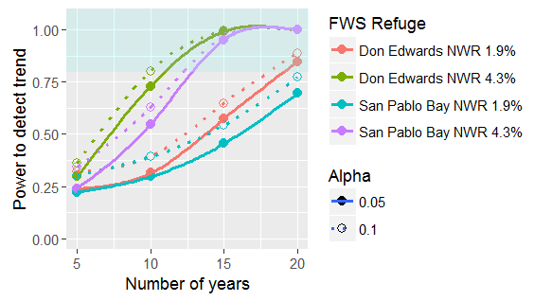

Figure 1A. Power to detect increasing trends of 1.9% and 4.3% per year given current sampling effort at DESFB (10 transects) and SPB (8 transects), over a span of 5, 10, 15, and 20 years, for Type 1 error rate of 0.05 and 0.10.

- Assuming a 1.9% increase: power is very low after 10 years, under all conditions (Figure 1A). Even after 15 years, power is relatively low, ranging from 45% to 64%. It will require 20 years to achieve at least 80% power, and that is assuming sample size = 10 transects. For a sample size of 8 transects, power after 20 years is only 69% to 77%, depending on alpha level.

- Neither a 3.4% nor a 5.0% decline per year can be detected with sufficient power after 10 years (Figure 1B). However, after 15 years, a 3.4% decline per year can be detected with more than 80% power assuming a sample size of 10 transects. With eight transects, statistical power approaches 80% (i.e., is 79%). We conclude that detecting a 3.4% decline over 15 years is a valid, attainable sampling objective.

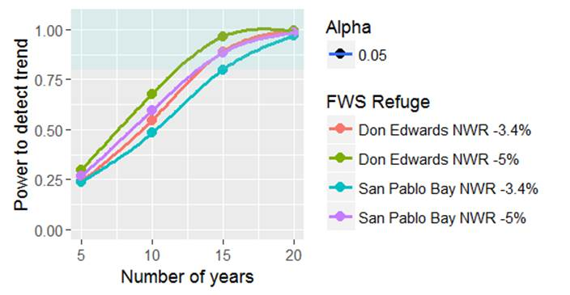

Figure 1B. Power to detect decreasing trends of 3.4% and 5.0% per year given current sampling effort at DESFB (10 transects) and SPB (8 transects), over a span of 5, 10, 15, and 20 years, for Type 1 error rate of 0.05.

- Conclusion from component 1: The ability to detect a 4.3% increase with 80% power after 10 to 15 years is a valid sampling objective, given current sample size. We assert that this sampling objective is applicable to both SPB and DESFB. Detection of 1.9% increase after 10 to 15 years is not a valid sampling objective with the current level of effort. Detection of a 1.9% increase per year can reasonably be accomplished with a 20-year time frame. Alternatively, detecting 1.9% increase after 15 years will require a substantially larger sample size.

The reason that 1.9% increase cannot be detected after 10 years is that such an increase is equal to a cumulative increase of only 20.7%. Such a “signal” is too subtle to detect given the intrinsic variability in the analysis of CA Ridgway’s rail surveys. Even after 15 years, a 1.9% increase per year only yields a cumulative increase of 32.6%, hence requiring greater than current effort of 8 or 10 transects to ensure high statistical power.

Component 2:
- A one-year “step change” of 40%, either increasing or decreasing, can be detected with 80% power (assuming alpha = 0.05), provided that the sample size is 10 transects. With alpha = 0.10, power is at least 85%. With only 8 transects, power is 75% or less, whether alpha = 0.05 or 0.10, and for both increases and decreases. Note that these calculations assume that abundance varies around a single baseline value for three years before either increasing or decreasing by 40%

- We conclude that the sampling objective of detecting a one-year, 40% change is supported, given current sampling effort. This objective is feasible to attain.

Component 3:
- Detecting a 4.3% increase after 10 years can be achieved with 80% power, if the sample size is at least 15 transects (Figure 2A).
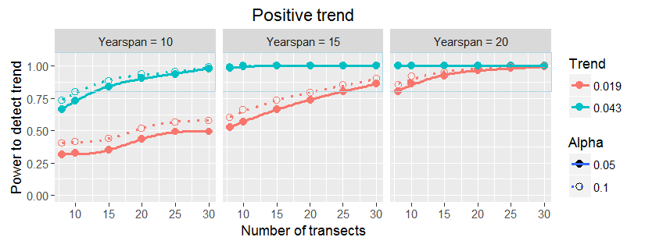
Figure 2A. Power to detect increasing trends of 1.9% and 4.3% per year in relation to number of transects, from 8 to 30 transects, over a span of 10, 15, and 20 years, for Type 1 error rate of 0.05 and 0.10.

- Detecting a 1.9% per year increase cannot feasibly be achieved after 10 years even if 30 transects are monitored (Figure 2A).

- Detecting a 1.9% per year increase with at least 80% power requires 20 years, assuming 10 transects (Figure 2A). With 8 transects, even after 20 years, the power is under 80%, assuming alpha = 0.05, though if alpha = 0.10, the power to detect is approximately 80%.

- A declining trend of 5% per year can be detected with 80% power after 10 years provided that the sample size is 15 transects (Figure 2B). If the trend is a decrease of 3.4% per year, then 20 transects will be required after 10 years to achieve 80% power (Figure 2B).

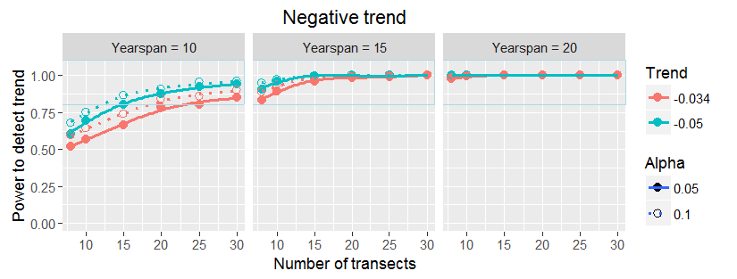

Figure 2B. Power to detect decreasing trends of 3.4% and 5.0% per year in relation to number of transects, from 8 to 30 transects, over a span of 10, 15, and 20 years, for Type 1 error rate of 0.05 and 0.10.

- Conclusion from component 3: A sample size of 15 transects over 10 years is required to detect changes of 4.3% increase or 5.0% decrease. A sample size of 10 transects over 20 years can detect an increase of 1.9% with 80% power. Note that a 1.9% increase per year translates into a cumulative change of 46% after 20 years.

Component 4:
- A trend of 6.0% per year increase can be detected with approximately 80% power after 10 years with a sample size of 8 transects (Figure 3A). With 10 transects, the trend that can be detected after 10 years is a little smaller, about 5.5% per year increase (Figure 3A).

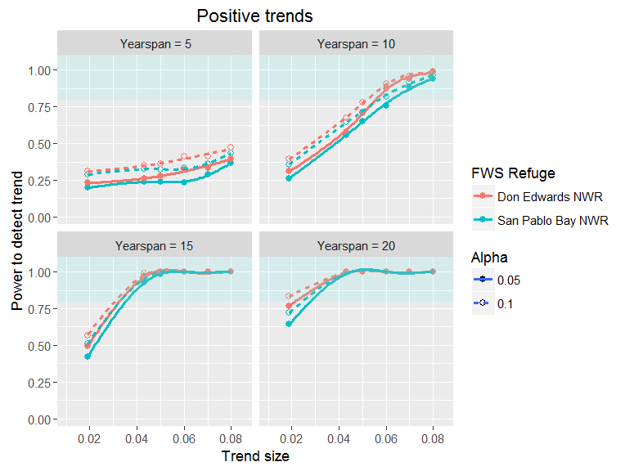
Figure 3A. Power to detect increasing trends ranging from 1.9% to 8.0% per year given current sampling effort at DESFB (10 transects) and SPB (8 transects), over a span of 5, 10, 15, and 20 years, for Type 1 error rate of 0.05 and 0.10.

- After 15 years, the magnitude of the trend that can be detected with 80% power is between 3.0 and 3.5% per year, depending on the sample size (10 and 8 transects, respectively; Figure 3A).

- After 20 years, trends as little as 2.0% increase per year can be detected, assuming 10 transects per year (Figure 3A).

- Declining trends will generally require at least 15 years to detect with at least 80% power. The exception is that a magnitude decline of 7% per year can be detected after 10 years, assuming 10 transects, with 75% to 80% power (for alpha = 0.05 and 0.10, respectively). Declines exceeding 7% per year were not analyzed. Note that a 7% decline after 10 years equals a 52% decline. In contrast, after 15 years, a 3.4% decline per year can be detected with 80% power; here, the cumulative decline only amounts to 40.5%. The increased sample size (16 years analyzed vs. 11 years), resulting in a tighter confidence interval around the regression slope, thus allows a smaller cumulative decline to be detected.

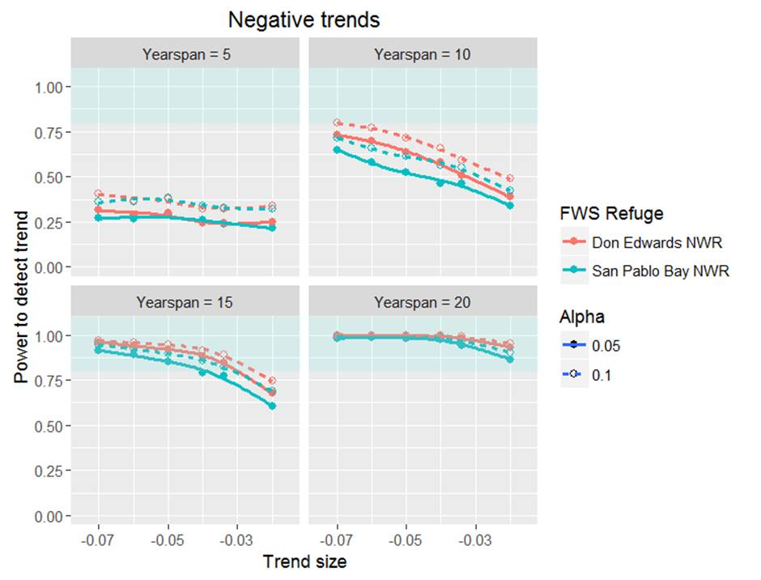

Figure 3B. Power to detect decreasing trends ranging from 2.0% to 7.0% per year given current sampling effort at DESFB (10 transects) and SPB (8 transects), over a span of 5, 10, 15, and 20 years, for Type 1 error rate of 0.05 and 0.10.

The above analyses make clear that “moderate” increasing and decreasing trends can be detected with adequate power, given the current level of effort, within 15 years. Here “moderate” is in the vicinity of 3.4% to 4.3% increase. However, slight trends (c. 2%) will require 20 years to meet the 80% criterion. That is not to say that a 2.0% trend cannot be detected after 10 to 15 years, but the probability is not high. In addition, the protocol described here has adequate power to detect a one-year increase or decrease of 40%

The protocol as described here can detect increasing or decreasing trends within 10 years with at least 80% power, but only if the sample size is increased substantially, or if the effect size (i.e., the magnitude of the trend to be detected) were larger than 4.3%.

An additional consideration is that statistical power will increase with reduction in error (or in statistical terms, reduction in residual variance); one way this can come about is by improving detection probability. Detection probability can be increased by increasing the number of visits per point, e.g., from three visits to five. Liu et al. (2009) evaluated the advantage of using five visits. However, the current protocol uses three visits, because field effort is limited; it is of greater value to monitor five study areas with three visits per point than to monitor only three study areas but with five visits to each point. In particular, stratification may not even be possible if the number of study areas is reduced from the current number, as a consequences of adding additional survey visits per point.

A second means to increase detection probability is to use playback on every visit. The power analysis presented here relied on historic data, collected with the standard Type A survey method, which is mostly passive (no playback), except that mid-way through the third visit, a playback is used if no rails were detected on the previous two visits. However, Nur et al. (2016) have completed an extensive experimental comparison of two survey methods: Type A (described above) and the Standardized North American Marsh Bird Monitoring Protocol (Conway 2016, hereafter “North American Protocol”), which uses playback on every visit. Nur et al. (2016) found that the North American Protocol increased detection probability and also decreased standard errors in estimating abundance, and thus statistical power increased up to 10% relative to the Type A survey method.

Sample selection
The goal of the sample selection process was to select a subset of core marsh study areas that would receive long-term, dedicated annual monitoring through 2063. The selection of sampling units for this protocol considered the site-specific sampling strata outlined above, current logistical constraints, and legacy (historical) monitoring efforts. These three criteria were used to determine the specific study areas to be monitored (Table 3).

The study area selection process began with a list of study areas provided by the Refuge that were Refuge-owned or managed. These included study areas with CA Ridgway’s rail habitat and study areas projected to have habitat by at least 2030. Refuge staff delineated study area boundaries, and USFWS Inventory and Monitoring Initiative (I&M) staff produced a shapefile of study areas. The study area list included study areas surveyed by USFWS as well as other organizations. Based on the desired effort level of 8 transects in SPB and 10 in DESFB, the study areas were selected to achieve a balance with respect to the four strata combinations (old marsh and high quality; old marsh and low quality; young marsh and high quality; young marsh and low quality). The California State Coastal Conservancy’s Invasive Spartina Project (ISP) and Point Blue currently survey selected study areas at DESFB. However, long-term funding of rail surveys by ISP and Point Blue is uncertain. Rail surveys at SPB are currently conducted by the refuge, and this is not expected to change in the future.

The study area selection process involved the following steps:
- Identify and map all study areas with suitable or projected future habitat owned or managed by the Refuge.
- Remove study areas not projected to have suitable rail habitat in 2017, the first year of protocol implementation.
- Remove study areas with difficult access (e.g., boat required, long walk to reach transect).
- For SPB, randomly select 8 study areas distributed evenly among the four strata combinations.
- For DESFB, for each segment group, randomly select 4 study areas distributed evenly among the four strata combinations (12 study areas total). For DESFB, remove two study areas based on logistical considerations and/or based on marsh age (the sampling design slightly favored young study areas) to reach 10 study areas.

After completing these steps, 7 study areas at SPB and 10 study areas at DESFB were identified for long-term monitoring with 1-2 transects per study area (Tables 3, 4 and 5; Figures 4-7). For DESFB, 3 of the 10 selected long-term monitoring study areas are currently being monitored by ISP and/or Point Blue; we assumed that these study areas would continue to be monitored by ISP/Point Blue for the foreseeable future using this protocol and that data would be shared with the refuge. DESFB staff will survey the remaining 7 study areas. Ideal Marsh North was one of the selected study areas that will be monitored by the refuge; in addition, the refuge will survey Ideal Marsh South (a non-selected study area) because surveys have been conducted there for a number of years and the refuge wanted to maintain continuity of the data set. DESFB will survey two additional non-selected study areas that are located off of the Refuge to assist ISP, Alameda Flood Control Channel and AFCC-Pond 3 (formerly Ecology Marsh). If ISP/Point Blue stop surveying one or more of their selected study areas in the future, the refuge could stop surveys at Ideal Marsh South, Alameda Flood Control Channel or AFCC-Pond 3 and shift that effort to cover the ISP/Point Blue selected study areas on the Refuge.

In some cases, more than one study area may be surveyed by a single transect (e.g., the Dumbarton transect also surveys Audubon West). Identifying those additional focal study areas that are associated with a transect is important in maintaining a consistent data collection effort. Additional focal study areas will be identified on the data form and detections in those areas will be recorded as “Outside Site = N”. A density estimate will be produced for each additional study area using data from the associated transect. Rail detections in study areas that are farther away from the transect or that are better surveyed by another transect are recorded as “Outside Site = Y”, are not included in the analysis, and densities for those study areas will not be estimated. It is advised to maintain the same additional focal study areas for a given transect, identified in Tables 3 and 4, among years.

The following guidelines can be used to determine whether an adjacent study area should be considered an additional focal study area:
- The study area should be within 100m of at least 3 points.
- The portion of the study area covered by the survey radius (200 m radius from the points) should be representative of the study area as a whole.
- The study area should not be surveyed more effectively by another transect.

Table 3. San Pablo Bay National Wildlife Refuge tier 1 survey study areas selected for surveys during the 2017-2021 period. High quality study areas represent the top quartile in CA Ridgway’s rail density with remaining study areas categorized as low quality. Young marshes are <50 years and old marshes are ≥50 years. Study areas selected for surveys during the 2017-21 period are indicated.

Study Area Name | Marsh Quality | Marsh Age | Transects | Points | Additional Focal Study Areas
Lower Tubbs Island | high | young | LTI-T1  LTI-T2 | 09, 10, 11, 12, 13  07, 08, 14, 15, 23, 24 | n/a
Sonoma Baylands Restoration | low | young | SBR-T1 | 01, 02, 03, 04, 05, 06 | n/a
Sonoma Creek West | low | old | SC-T1  SC-T2 | 01, 02, 03, 04, 05, 06  07, 08, 09 10, 11, 12 | n/a
Strip Marsh West | low | old | SMW-T1  SMW-T2 | 01, 02, 03, 04, 05, 06  07, 08 09 10, 11, 12, 13 | n/a
Tolay Creek | low | old | TC-T1 | 01, 02, 03, 04, 05, 06 | n/a
Tubbs Island Setback | low | young | TS-T1 | 01, 02, 03, 04, 05 | n/a
Tubbs Setback East | low | old | TS-T1 | 01, 02, 03, 04, 05 | n/a

Table 4. Don Edwards San Francisco Bay National Wildlife Refuge tier 1 survey study areas selected for surveys during the 2017-2021 period. High quality study areas represent the top quartile in CA Ridgway’s rail density with remaining study areas categorized as low quality. Young marshes are <50 years and old marshes are ≥50 years. Study areas selected for surveys during the 2017-21 period are indicated. Detections in Additional Focal Study Areas are recorded as “Outside Site = N.”

Study Area Name | Marsh Quality | Marsh Age | Transects | Points | Additional Focal Study Areas
Alameda Flood Control Channel*** | n/a | n/a | AFCC-T3  AFCC-T4 | 11, 12, 13, 14, 15, 16, 17, 18  19, 21, 23, 25, 27, 29, 31 | n/a
B2 North Quadrant* | high | young | OBEN-T1 | 06, 09, 11, 12, 14, 16, 19 | n/a
Coyote Creek Lagoon | low | young | CCL-T1 | 01, 02, 03, 04, 05, 06, 07 | Coyote Creek
Coyote Creek SE | low | old | COYE-T1 | 5A, 5C, 5E, 6B, 6C, 6D, 6E, 6F | n/a
Dumbarton Marsh | high | old | DUMA-T2 | 02, 04, 06, 08, 10, 12, 14 | Audubon West
Faber Marsh* | high | young | FABE-T1 | 03, 04, 06, 07, 12, 14, 16 | San Francisquito Creek
Ideal Marsh - North | low | old | IMAN-T1 | 01, 02, 04, 05, 07, 08, 09 | n/a
Ideal Marsh – South** | low | old | IMAS-T1 | 12, 14, 16, 18, 20, 22, 24, 26 | n/a
LaRiviere Marsh | high | young | LARV-T1 | 01, 02, 03, 04, 05 | n/a
Laumeister Marsh* | high | old | LAUM-T1 | 06, 07, 08, 09, 10, 11 | n/a
Mayhew's Landing | low | young | MALA-T1 | 01, 02, 03, 04, 05 | n/a
Redwood Shores | low | old | RESH-T1 | 01, 02, 03, 04, 05, 06, 07, 08 | Bird Island
AFCC-Pond 3***  (previously Ecology Marsh) | n/a | n/a | AFCP-T1  AFCP-T2 | 01, 02, 03, 04, 05, 06, 07  08, 09, 10, 11, 12, 13, 14 | Alameda Flood Control Channel
*Selected study area to be surveyed by ISP or Point Blue
**Non-selected Refuge study area that will be surveyed by the refuge to maintain a historical dataset and guide management actions
***Non-selected off-Refuge study area that will be surveyed by the refuge to assist ISP

Table 5. The number of transects in each strata for San Pablo Bay NWR (SPB) and Don Edwards San Francisco Bay NWR (DESFB). High quality habitat is the top quartile CA Ridgway’s Rail density, Low quality is the bottom three quartiles, young marsh is <50 years old and old marsh is ≥50 years old.

Refuge | Strata | Number of Transects
SPB | Low quality, young | 2
SPB | Low quality, old | 5
SPB | High quality, young | 2
SPB | High quality, old | 0*
DSFB | Low quality, young | 2
DSFB | Low quality, old | 4**
DSFB | High quality, young | 3
DSFB | High quality, old | 2
*No transects were identified for this category
**One of these transects are at a non-selected Refuge study area (Ideal Marsh South) that will be surveyed by the refuge to maintain a historical dataset

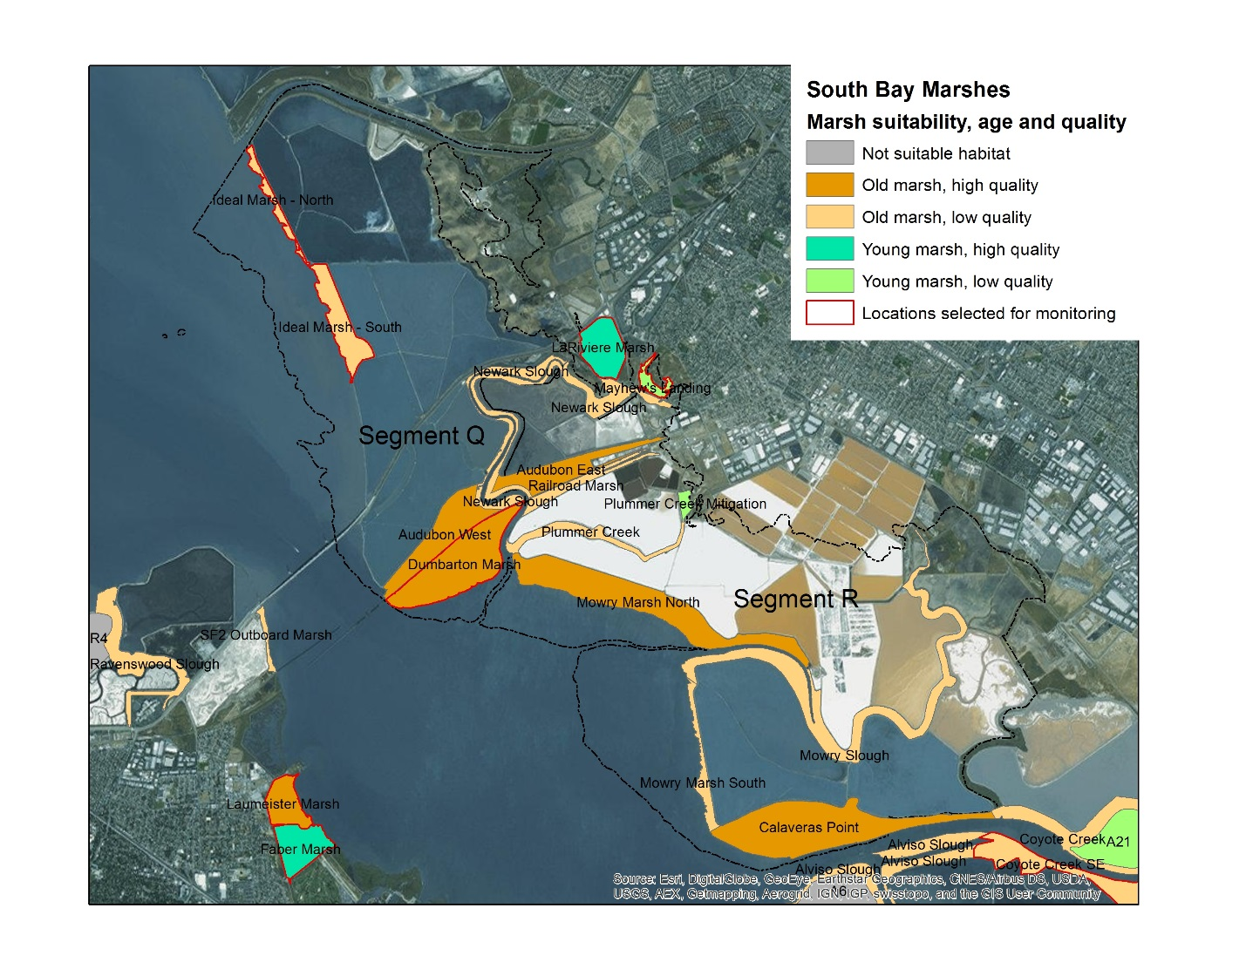
Figure 4. Selected survey study areas in Tidal Marsh Recovery Plan segments Q and R showing marsh suitability, age and quality.
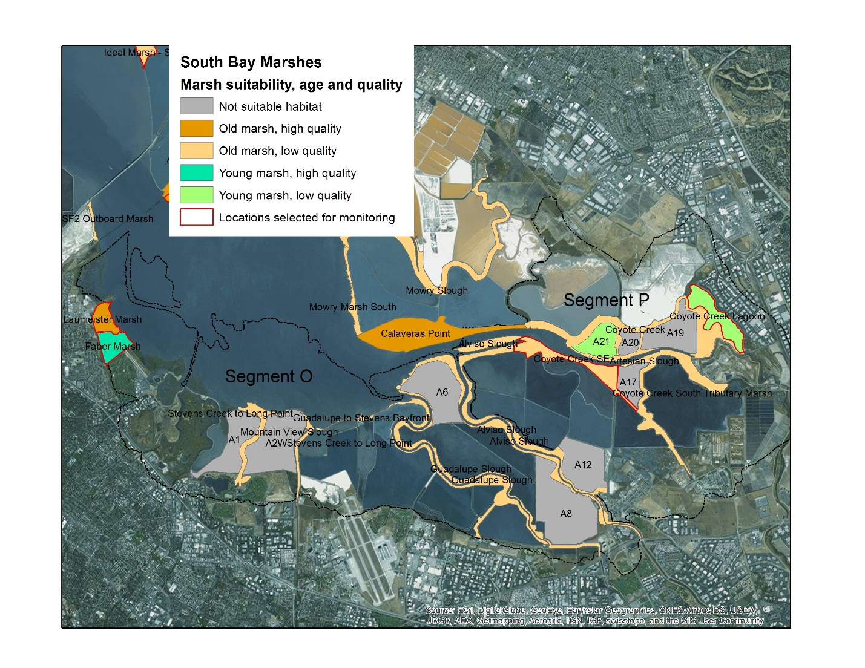
Figure 5. Selected survey study areas in Tidal Marsh Recovery Plan segments O and P showing marsh suitability, age and quality.

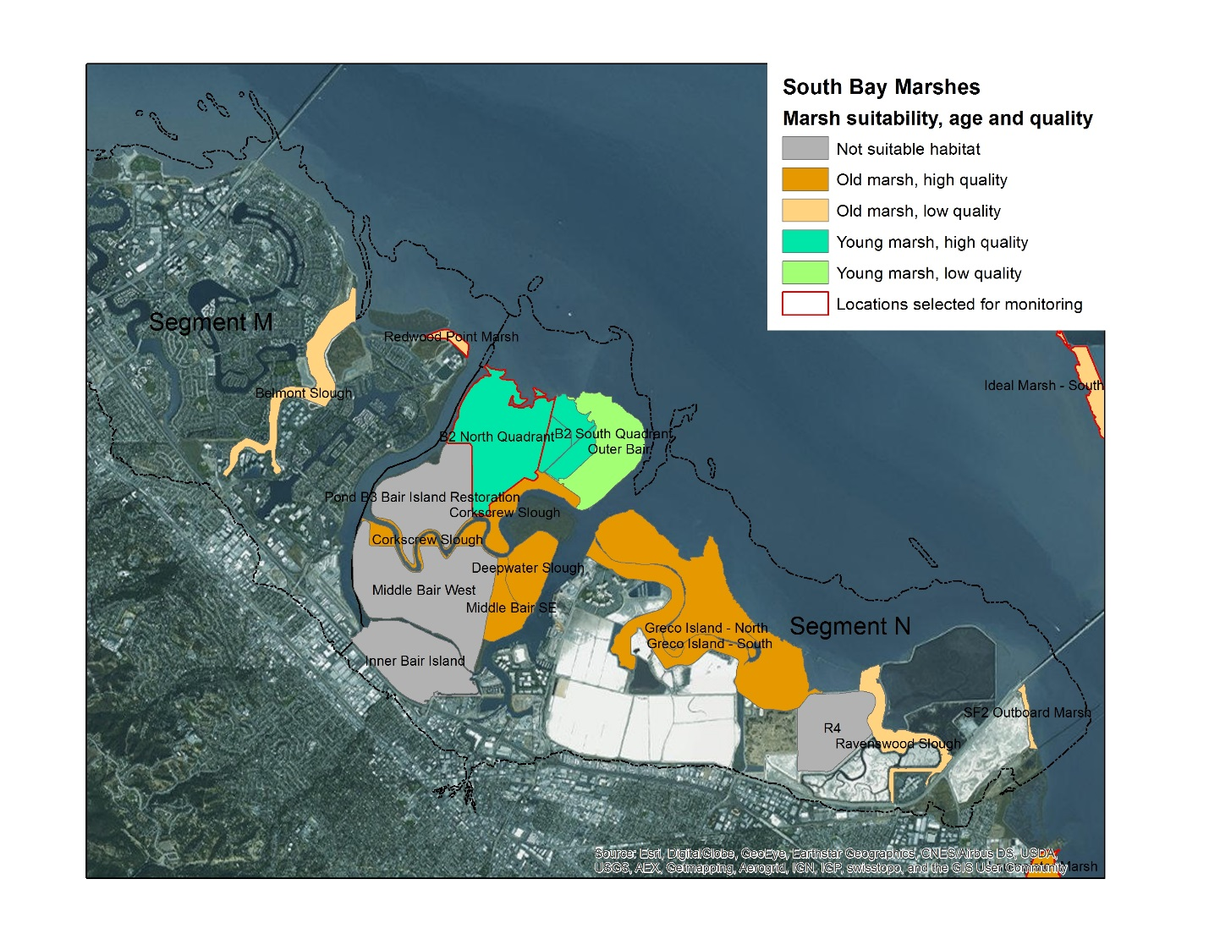
Figure 6. Selected survey study areas in Tidal Marsh Recovery Plan segments M and N showing marsh suitability, age and quality.

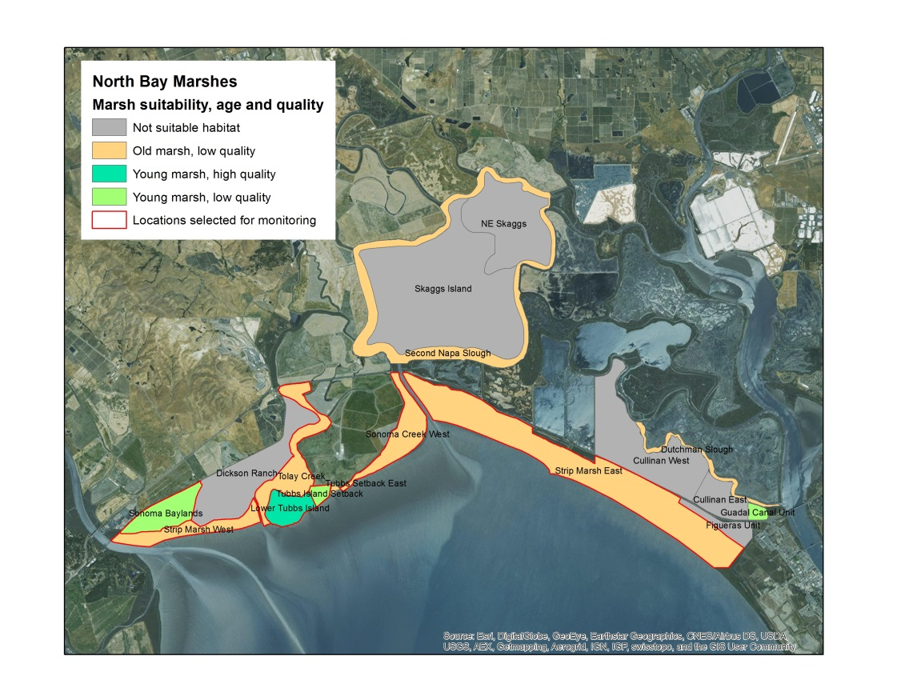
Figure 7. San Pablo Bay National Wildlife Refuge selected survey study areas and marsh suitability, age and quality.

We recommend that one representative transect per study area should be used for monitoring, if possible. Most of the selected study areas have existing transects. For new marsh study areas that are added, the protocol is to establish a single transect that spans a representative portion of the marsh based on habitat suitability. Each transect should have 6-8 points (8 preferred) with a spacing of at least 200 m between adjacent points. Spacing points farther apart (up to 400 m, is desirable but only if 6-8 points can be established and visited within the survey window. Random placement of points is not recommended because space is usually limited in Estuary’s marshes. Second, maintaining consistent spacing between points is desirable from a logistical standpoint (completing a transect within the desired time frame). Third, many marshes are not accessible throughout their extent. However, the order in which points can be surveyed is flexible (see below).

Survey timing and schedule
Surveys will take place during the late winter and early spring period (15 January – 15 April) when CA Ridgway’s rails have established their breeding territories and vocalizations are at their peak. Extensive analysis (Liu et al. 2012) has revealed that the peak in detection probability is about 20 February (Figure 8). Thus, the period of peak detections is approximately 15 January to 25 March. As in the prior field methods, or each survey point, there will be three “rounds” of surveys spread out over the survey season, which can maximally extend from 15 January to 15 April. However, because detection probability drops precipitously later in the season (Figure 8), surveys should be completed by 31 March if possible. If that is not possible, then surveys will be complete as soon as possible after that date. This attempt to end the surveys earlier in the season represents a change from previous field methods. Ideally, round 1 should be completed from 15 January to 6 February, round 2 from 7 February to 28 February, and round 3 from 1 March to 25 March. The period between 25 March and 15 April can be used to finish any remaining surveys if previous visits were cancelled due to weather or other logistics.

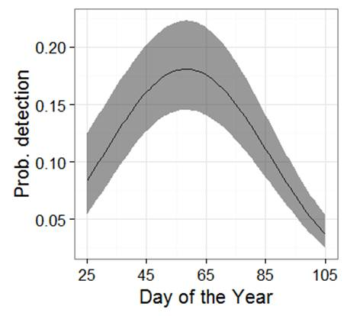
Figure 8. Detection probability for CA Ridgway’s rail in relation to Day of the Year (1= 1 Jan, 90 = 1 April, etc.). Best estimate (dark line) and confidence interval (gray band) are shown, setting all other covariates to their mean level. Results from Type A Survey Protocol (Liu et al. 2012).

Surveys will be conducted during the periods before and after sunset and sunrise, which are peak calling hours for CA Ridgway’s rail (Figure 9). All surveys must be conducted within a two hour (120-minute) period surrounding sunrise/sunset, starting no more than 60 minutes before sunrise or sunset and must terminate within 60 minutes of sunrise and sunset. Ideally, surveys should be conducted in a shorter period surrounding sunrise/sunset (e.g., within 40-45 min of sunrise/sunset). However, use of a shorter survey period will not be possible where a large number of points are being surveyed in a marsh, during one survey period. Furthermore, the decline in detection probability as surveys approach 60 minutes before or after sunrise/sunset will be less evident when the North American Protocol is used, with playback at every visit. Regardless, the time of the survey is included as a covariate in estimating detection probability (see Element 4).

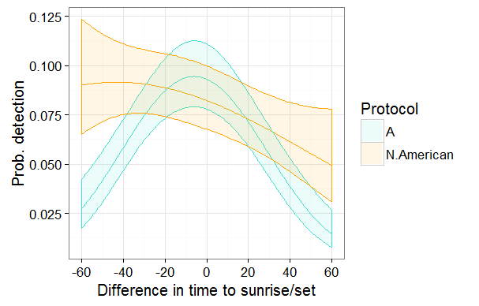
Figure 9. Detection probability in relation to time relative to sunrise/sunset for CA Ridgway’s rail under the Type A (A) and North American (N. American) field methods with 95% confidence interval (colored bands) around the estimate. Negative values refer to “darker” minutes before sunrise or after sunset; positive values refer to “lighter” minutes after sunrise or before sunset. Results from Nur et al. (2016).

Sources of error
Detection probability is much less than 100%, even if playback is conducted on every visit (Nur et al. 2016) (Figures 8 and 9). It is imperative to conduct repeated visits at each point in order to estimate detection probability (three visits per point per survey season as stipulated in this protocol).

We recommend the same observer for all points within a site-visit, that is, within one 2-hr session. However, it is preferable to use different observers for different visits within the same year. Across years, to the extent possible, it is desirable to retain a similar mixture of observers at an individual study area, at least at a subset of study areas. What we seek to avoid is having observer and year confounded. Thus, if observer 1 surveys a study area in Year 1 (all three visits) and observer 2 surveys the same study area in Year 2 (again, all three visits), it will be hard (but not impossible) to tease apart “year effects” from “observer effects.”

Environmental conditions at the study areas can lead to increased error. During higher tides, birds may move out of their core territories to seek refuge thereby introducing a source of error into the counts at a point. Therefore, surveys should be conducted when tides are < 4.5 ft (< 137 cm) relative to mean lower low water (MLLW) as measured at the nearest tide station or are not higher than the marsh plain (i.e., not higher than bank full) at the study area. Surveys during the day of a full moon that is visible during the survey should be avoided as birds may possibly be distracted by the broadcast vocalizations and become more vulnerable to predators that are taking advantage of the increase in ambient light. Ambient noise including winds > 10 mph is another source of error. The protocol addresses ways to minimize ambient noise (see Element 3).

Element 3: Field Methods and Processing of Collected Materials

Detailed field and data collection methods are described in SOP 1.

Element 4: Data Management and Analysis

For complete details on data management, see SOP 2 Data Management.

Analysis methods
The main purpose of analyzing data collected with the protocol is to determine if the refuges are meeting the management objectives outlined in Element 1: Introduction. Those management objectives are repeated below:

- During the period 2017-2063, achieve an average annual rate of increase in the CA Ridgway’s rail population at DESFB of at least 4.3% (2.3% during 2017-2032 and 5.5% during 2032-2063).
- During the period 2017-2063, achieve an average annual rate of increase in the CA Ridgway’s rail population at SPB of at least 1.9%.
- Maintain current levels of occupancy (proportion of occupied marshes) for Virginia rails and CA black rails on DESFB and SPB until 2032.

The most rigorous way to examine rates of population change and occupancy is through the use of hierarchical models, which involve the estimation of population size or occupancy along with detection probability. However, hierarchical modeling requires specialized expertise that is not currently available at the two Refuges, therefore we have devised simpler summary metrics that can be derived for annual reporting. The refuges will require outside assistance with analysis of rates of change using hierarchical modeling on a periodic basis (at least once every five years, but more often as needed). Six approaches for data summary and analysis are described in this protocol: (1) highest minimum count; (2) index of relative density; (3) indices of rates of change; (4) index of occupancy; (5) analysis of density indices; and (6) hierarchical modeling with analysis of detection probability. To assess progress toward the management goals stated above, the first two approaches are described for CA Ridgway’s rail and the third approach is described for Virginia rail and black rail. However, each approach can be applied to any secretive marsh bird. The summaries of individuals detected and density indices can be used to identify sudden changes in a population that would warrant additional analysis. This would ideally involve analysis of a larger dataset that includes non-Refuge study areas surveyed by partner organizations (as in Liu et al. 2012). Some of the limitations of count and density indices are discussed by Johnson (2008). Furthermore, detecting the rates of change stated above with sufficient power as described in the power analysis in Element 2 will require density indices that account for probability of detection (the fourth approach). Without this, a larger sample size (more years and/or more study areas) will be needed to detect the minimum trends needed to reach Refuge goals.

Highest minimum count
On an annual basis, the highest number of unique CA Ridgway’s rails detected in a study area for that year (termed the “highest minimum count”) is compiled and can be used to construct annual summaries (see SOP 1 for details regarding data collection and processing and see Element 5 for details regarding annual reporting). For example, if at least 4, 8 and 7 unique birds are detected during three visits at a given marsh study area, the “highest minimum count” for that study area would be 8 birds. This index is a minimum count because we know that detection probability is <1, which means the true abundance could be >8 birds. Detections at all distances from survey points are included, but each unique bird is only counted once (e.g., the same bird heard from two different survey points would only be counted once). Unique birds detected while moving to or from transects in a study area or between points (outside of the official survey time), but within the study area, are also included. The “highest minimum count” metric provides an index of abundance at a marsh study area or site.

Index of relative density
On an annual basis, the relative density of unique CA Ridgway’s rails detected per unit area (termed the “index of relative density”) is compiled and can be used to construct annual summaries (see SOP 1 for details regarding data collection and processing and see Element 5 for details regarding annual reporting). The index of relative density is calculated as follows. For each visit, the total number of unique birds detected within 200 m of each survey point and within the 10-minute point count is calculated. That total number is then divided by the number of points and the area of rail habitat surveyed on each visit (number of survey points x area of a 200-m radius circle, which is approximately 12.57 ha, if all of that area is rail habitat). The resulting numbers for each visit are averaged over the three visits. For example, assume that during three visits to a study area 3, 6 and 5 unique birds are detected within 200 m of 7 survey points (and assume that each point is surrounded by 100% rail habitat within 200 m). The “index of relative density” for the study area would be 14 rails/(7 points*12.57 ha*3 visits) = 0.053 rails/ha. This is considered a minimum density index (per point, per visit) because we know that detection probability is <1, which means the true abundance for the study area could be >6 birds. Each unique bird is only counted once (e.g., the same bird heard from two different survey points would only be counted once). Unique birds detected while moving to or from transects in a study area or between points (outside of the 10-minute point count) would not be included. The area surveyed at each point is adjusted accordingly if there is less than 100% rail habitat within the 200 m radius.

Index of one-year rate of change
An index for the rate of change in one year for the total highest minimum count (summed across all transects) or the average index of relative density (averaged across all transects) can be calculated using the following equation:

$m= \frac{\left(p_{2}-p_{1}\right)}{p_{1}}×100$%

where p₁ is the total highest minimum count (or average index of relative density) for the previous year and p₂ is the total highest minimum count (or average index of relative density) in the current year. For example, if the total highest minimum count for CA Ridgway’s rails at DESFB was 33 birds for 2014 and 35 birds for 2015, the index of the annual rate of population change would be: ((35 – 33)/33*100%) = 6.06%.

Index of average annual rate of change
For a longer time series, a simple index of the average annual rate of change between two time points, $\overline{m},$ calculated using either the total highest minimum count (summed across one or more study areas) or using the average index of relative density (averaged over one or more study areas) can be obtained using the following equation:

[(p2/p1)^(1/[t2-t1])-1] x 100%

where p₁ is the total highest minimum count (or average index of relative density) for the first year, p₂ is the total highest minimum count (or average index of relative density) for the last year, t₁ is the start year, t₂ is the end year, and A^B indicates raising A to the exponent B.

For example, if the total highest minimum count of CA Ridgway’s rails at DESFB was 28 birds for 2010 and 36 birds for 2015, the index of the average annual rate of change would be: [(36/28)^(1/[2015 – 2010])-1]*100% = 5.15% increase per year.

However, if counts were obtained or density indices calculated in the intervening years, these values should be included in a linear regression of the natural log-transform of these count or index values. The average rate of change can then be obtained from these results by exponentiating the coefficient, subtracting that value from 1 and multiplying by 100%; see Nur et al. (1999, page 13) for details.

Index of occupancy
On an annual basis, an index of occupancy for Virginia rails and CA black rails can be compiled and can be used to construct annual summaries (see SOP 1 for details regarding data collection and processing and see Element 5 for details regarding annual reporting). An index of occupancy can be can estimated for other species of interest such as sora and American bittern, although no objectives were described for these species in this protocol. The index of occupancy is the maximum proportion of occupied survey points in a study area. For each visit to a study area, the total number of points occupied by each species is calculated; to be considered occupied, at least one bird of the species of interest must be detected from the survey point. The maximum number of occupied points across all visits is divided by the total number of points that were surveyed in the study area to arrive at the index of occupancy. For example, assume 3, 0 and 2 points were occupied by Virginia rails at a study area with 14 points across three visits in a given year. The “index of occupancy” for the study area would be 3/14 = 0.21. This is considered a minimum occupancy index (known as “naïve” occupancy) because we know that detection probability is <1, which means the true occupancy could be >3 points. Only unique birds are considered for occupancy (the same bird detected at two points would result in only one point being occupied).

It is important to point out that the preceding metrics of highest minimum count, relative density, population change and occupancy do not take into account factors such as detection probability, habitat covariates, etc.; thus, they should be interpreted with caution. More reliable estimates of population change will be obtained using hierarchical models on an interval of approximately every 5 years. However, the simpler metrics provided above are easy to calculate and may allow refuges to detect large changes in true abundance (assuming count indices are correlated with true abundance) over short time periods, which could be important for management interventions. The formulas for the above metrics (except for the formulas involving the index of relative density) assume that the exact same study areas are being surveyed every year. If the number of study areas or transects within study areas changes over time, e.g., the number of survey points changes, then adjustments to the analyses will be required.

Analysis of density indices
Nur et al. (1999) provides guidance on how to conduct statistical analyses of density indices based on data collected as part of avian monitoring programs. That reference provides examples both with regard to trend estimation as well as analysis of habitat associations or other variables relevant to management. One primary concern when conducting such analyses is to ensure that the probability distribution of residuals is appropriate to the analysis. Either log-transformation of index values (Nur et al. 1999) or use of a log-link with count data is recommended; the latter can be carried out using a Generalized Linear Model (GLM; Dobson and Barnett 2008).

We note that use of a log-transformation or a log-link, while necessary, may not be sufficient. Whereas Poisson regression is commonly available, and many statistical procedures allow for Poisson-distributed residuals, count data in real life almost always display “over-dispersion” relative to the Poisson distribution (Nur et al. 1999). Analysts must evaluate the distribution of residuals and implement the appropriate procedure. For count data (as exemplified by the analyses described in this section), negative binomial regression (Hilbe 2011) is generally the most appropriate, and thus recommended, approach. For example, tidal marsh survey data from three marsh bird species were analyzed by Stralberg et al. (2010); two species were best modeled by negative binomial regression (black rail and salt marsh yellowthroat Geothlypis trichas sinuosa), analyzing counts of individuals for each survey-visit-point, while the third species (tidal marsh song sparrows, Melospiza melodia samuelis and M. m. maxillaris) was best analyzed with a linear model (i.e., normally-distributed residuals with an identity link). Negative binomial regression models and other GLMs can be fit with many statistical packages such as R, STATA, and SAS. Analyses using negative binomial regression should be carried out on the counts of individuals detected at each survey point in each visit, rather than on the summary statistics obtained by summing over survey points or over visits; or calculating mean values.

Even though “density index analysis” as described here does not explicitly estimate detection probability, it is recommended that, where possible, such analyses include covariates associated with variation in detection probability (as determined by other studies). For example, time of day relative to sunrise/sunset is an important determinant of detection probability (Wood et al. 2014, Wood et al. 2016). The exact time and date of each survey visit at each survey point will be known, and these variables can be entered in a multi-variable model (e.g., a GLM, such as negative binomial regression). Negative binomial regression and similar methods can account for the area being surveyed as an offset term (Hilbe 2011).

Hierarchical modeling with analysis of detection probability
Hierarchical modeling is more complex and requires estimation of detection probability for individual marsh birds. Detection probability for CA Ridgway’s rails is substantially less than 100% (Liu et al. 2012, Wood et al. 2014, and Conway 2015). Furthermore, detection probability for the species demonstrates strong temporal variation (Liu et al. 2012, Wood et al. 2014, 2016). Thus, statistically controlling for detection probability improves the estimation of abundance by: a) reducing statistical error, and thus improving statistical power, and b) controlling for variation due to factors that influence detection probability independent of variation in abundance. Notably, detection probability has been shown to vary with time of day relative to sunrise/sunset, day of year, and among years (Liu et al. 2012, Wood et al. 2014, and Wood et al. 2016). The dependence of detection probability for CA Ridgway’s rail on time of day and day of year is illustrated in Element 2 (see Fig 2 and 3, above). It is also possible that detection probability varies with habitat characteristics. Wood et al. (2016) investigated whether detection probability differed with respect to density of CA Ridgway’s rail, where marshes were categorized as either “low” or “high” density, relative to median density. Wood et al. (2016) found no statistically significant difference, but this should not be taken as demonstration of no difference, especially since the sample size was small. The analysis method outlined here is able to accommodate the possibility of spatial or temporal variation in detection probability, whether or not such variation has been previously demonstrated or not. Where there may be concern about possible variation in detection probability, the appropriate covariates can be modeled as illustrated below.

The analysis of detection probability is complex. A hierarchical model is required, as described by Royle and Dorazio (2008). In such a model, one simultaneously analyzes two components, which together determine the number of individuals actually detected during a survey: (1) the number of individuals actually present (whether detected or not) in the surveyed area, during the time of the survey, symbolized D, and (2) the probability of detection of an individual, provided that it is present in the area being surveyed during the time of the survey.

More formally this can be presented as an equation, with each term calculated with respect to the appropriate area:

N = pDet x D,

Where N is the number of individuals detected per area surveyed, pDet is the probability of detection (defined above), and D is the true number of individuals present in the area being surveyed during the time of the survey and calculated per area surveyed. Hierarchical models applicable to this protocol are described by Royle and Dorazio (2008) and Dail and Madsen (2011).

The direct analysis of detection probability through a hierarchical model is both complex and challenging, but provides a statistically-based means to partition differences in the number of detections due differences in detection probability from differences due to the true difference in abundance. In addition, to estimate the actual absolute density (or abundance) requires knowledge of detection probability.

The protocol outlined here uses repeated surveys as a means to estimate detection probability as part of a hierarchical, so-called “mixture” model (Royle and Dorazio 2008). The package used to conduct the analysis is unmarked part of the R statistical language; unmarked is documented in Fiske and Chandler (2011). Thus, a key provision of implementing the protocol is that the same points are surveyed three times per breeding season. Fewer visits per point per breeding season will compromise the ability to estimate detection probability. More than three visits per point per breeding season is not recommended in order to optimize the number of points and number of marshes being surveyed. That is, there will be a trade-off between the number of visits per point and the number of points; three visits represents the optimum.

Unmarked provides the means to analyze variation in abundance and in detection probability, as a function of variables of management interest as well as “nuisance” variables, for which we seek to statistically control and thus reduce error. Variables that can be modeled include temporal variation (e.g., abundance as a function of year) as well as spatial variation. The analysis is conducted at the level of the individual survey “event” (one point surveyed at one visit); thus, abundance is estimated for each survey point in each breeding season. The assumption we make is that true abundance at a survey point does not vary from one visit to another within the same breeding season, which defines the “closure”. Thus, variation in the number of detections (including zero detections at a visit) for one survey point during one breeding season allows us to make inferences regarding detection probability. Examples of such analyses are presented in Liu et al. (2012), Wood et al. (2014) and Wood et al. (2016). Liu et al. (2012) specifically highlight and illustrate three distinct applications of these types of models: (1) analysis of models to provide study area-specific estimates of abundance, (2) analysis of models to provide year-specific estimates of abundance, while correcting for variation in study area-specific abundance, and (3) analysis of ecological variables (within a study area and at the landscape-level) that may influence abundance of CA Ridgway’s rail. For example, analyses in Liu et al. (2012) indicated a highly significant drop in abundance in the Estuary from 2007 to 2008, both in the North Bay and South Bay regions. Liu et al.’s (2012) analysis also identified marsh size and marsh shape as significant predictors of CA Ridgway’s rail abundance: density (birds per ha) is greatest at large, compact marshes (rounder vs. linear), but the effect of marsh size exhibited diminishing returns.

The site-specific protocol outlined here can be used for analysis of other species, but a limiting factor is the number of detections. For example, black rails may be detected in sufficient numbers at SPB to permit this type of analysis, but it is not clear whether that is the case for other secretive marsh bird species, besides black rails and CA Ridgway’s rail. That said, other tidal marsh species such as tidal marsh song sparrows and common yellowthroats can be analyzed with these methods. Similar limitations apply at DESFB.

Another means to analyze detection probability is through distance sampling, specifically using the program DISTANCE (Buckland et al. 2001). We do not describe this approach in any detail since the use of repeated-visits in a mixture model is preferable. However, were repeated visits not available for a refuge for some reason, this would be a viable option. Note that distance sampling requires a number of restrictive assumptions, such as absence of movement during the survey period at a point.

Element 5: Reporting

Reporting the results of marsh bird surveys is critical to the success of the monitoring program and involves presenting accurate, timely information in a format that can be used by those who can act on that information. This section describes two types of reports, annual reports and synthesis reports, and provides recommendations on the format and content of these reports, their distribution schedules and their recipients.

Annual reports are designed to briefly describe the survey effort for that season, present summaries of birds detected, relate summaries of birds detected to management objectives and alert resource managers of sudden changes that could trigger more investigation or management actions. Annual reports also serve the purpose of fulfilling permit requirements. Synthesis reports involve analysis of multiple years of data to estimate population trends, relate population trends to management objectives, assess response to conservation actions, and provides specific recommendations for improving habitat and species management.

Annual reports
After the completion of each survey season for each refuge, an annual report will be submitted to the Recovery Permit Coordinator at the appropriate FWO by January 31, per 10(a)(1)(A) permit requirements. In addition to the permit requirements for the annual reports, the following information is recommended for inclusion within the final report. Each refuge will prepare an annual report to document the survey effort describing the study areas and survey points that were visited, any adjacent study areas that were included as Focal Study Areas (e.g., other Study Areas within 100 m that are not surveyed on their own), survey dates, and observers. The annual report will provide a summary of indices for CA Ridgway’s rails (highest minimum count, index of relative density), an index of the annual rate of change and an index of occupancy for Virginia rails and CA black rails Element 4 Summary of individuals detected). The annual report should reference the methods described herein and document in detail any changes, interpretations or assumptions regarding the field methods or sampling design. Any problems or difficulties encountered and corrective measures taken as well as recommendations for improving the protocol should also be described.

The annual report should include an introduction, methods, results, and a brief discussion assessing how the indices of annual rates of change for CA Ridgway’s rails compare to management objectives and describing conditions at the refuge or regionally that may affect the population (e.g., management activities, restoration events, changes in hydrology, etc.). However, relating changes in raw counts or density indices derived from naïve counts to site conditions should be done with caution because count data are highly variable and the probability of detection, which is very low for this species, is not accounted for. Counts and density indices may be useful in identifying sudden changes in the population that should prompt more in-depth analyses. The type of analysis described above under “Analysis of density indices” would not be especially time-consuming or onerous to carry out in such a case.

The marsh bird Access database has a built-in query to facilitate annual reporting, named “All Species Visits and Detections.” This query is accessed from the database Main Menu via a button on the right (“Export All Species Visits and Detections”). RMarkdown scripts have been developed to generate annual reports for DESFB and SPB. These scripts take in data from the Access “All Species Visits and Detections” query output file and calculate the desired metrics for annual reporting.

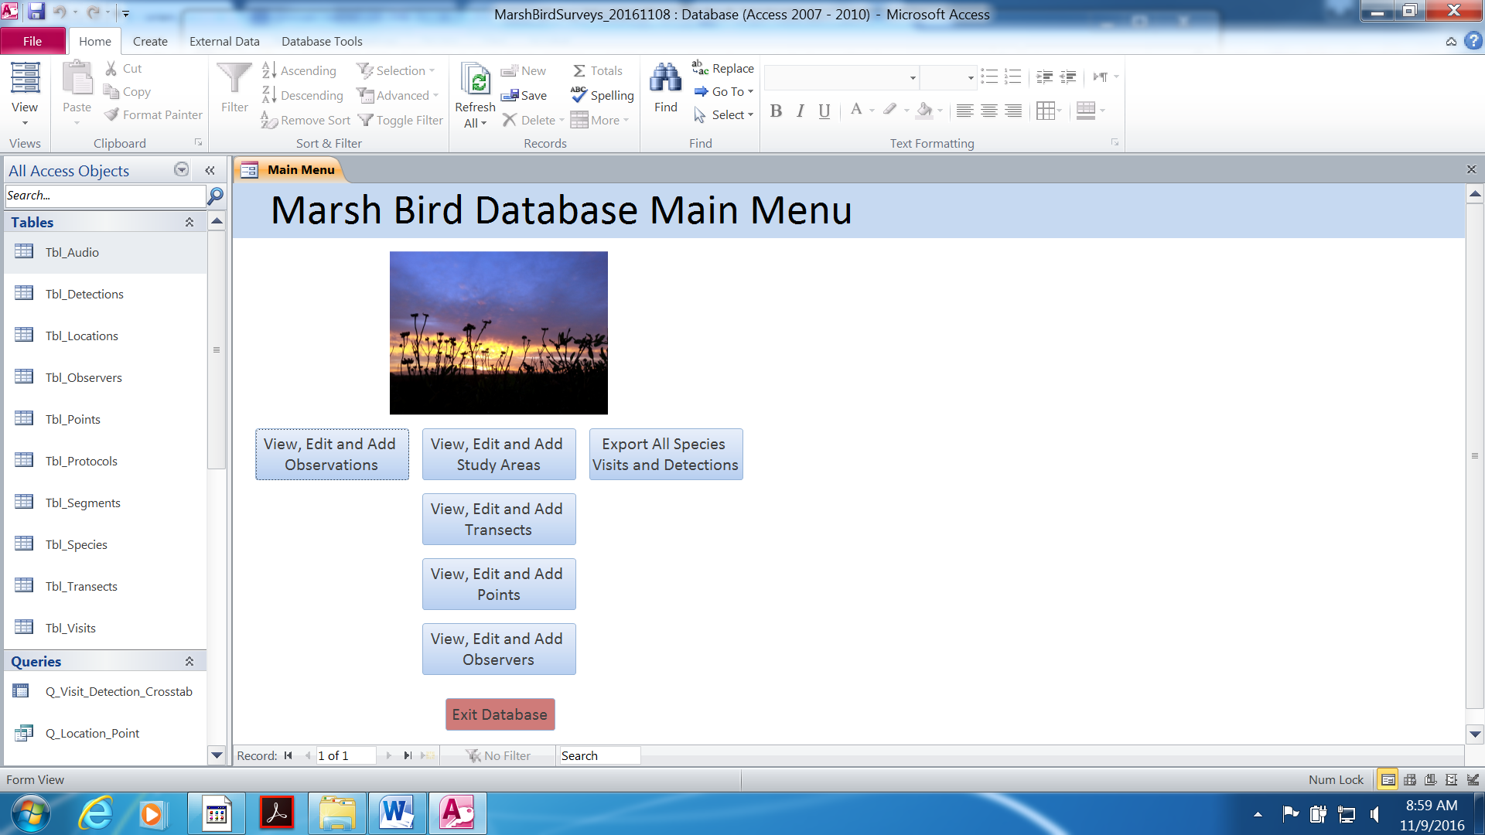

The “Export All Species Visits and Detections” button exports core visit and detection information for all years and locations for DEFSB and SPB as a Microsoft Excel file; the file can be sorted by project, year, study area, species, etc. for generating the annual count and density indices and performing other specific analyses. This query includes records at all distances from survey points and birds that were detected Outside Site, Outside Time, and Duplicate Birds.

Synthesis reports
The format for synthesis reports, produced every 5 years or more often, should follow the recommended format for the annual report but will contain more details for the analysis methods, results, discussion and recommendations. Survey data from multiple partners operating throughout the Estuary should be solicited and compiled prior to the analysis. Solicited data would be in a format defined in the California Avian Data Center using the National Secretive Marshbird protocol standards (see here for descriptions: http://data.pointblue.org/science/biologists/php/protocolsearch.php). Current and historic data collected using different but compatible field methods (e.g., various “Type A” surveys with a 10-minute repeated visit structure) should also be included but the analysis will need to consider that the probability of detection may vary with survey method. Synthesis reports should be carried out by scientists with expertise in modeling zero-inflated data and/or hierarchical modeling in conjunction with biologists familiar with the field methods and knowledgeable in the focal species’ natural history. Synthesis reports will likely require from two to four or more weeks of time for a statistician to complete in addition to the biologists’ time. The analysis should follow the recommendations described in Element 4 Hierarchical modeling: Analysis of detection probability.
Analysis and synthesis reports should include:
  - Estimates of detection probability
  - Average density by study area
  - Trends in density by bay region and by refuge
  - Assessment of short-term trends and changes
  - Comparison of population trends with management objectives for CA Ridgway’s rail at each refuge
  - Comparison of occupancy with management objectives for Virginia Rail and CA black rail at each refuge
  - Response to restoration and management
  - Associations with habitat and landscape characteristics

Reporting schedule
Annual reports should be distributed as soon as possible after the surveys are completed and no later than January of the following year. Synthesis reports should be completed every 3-5 years or as needed and as funding allows.

Report distribution
Reports will be distributed to all Estuary partners involved in CA Ridgway’s rail and CA black rail surveys, Bay-Delta U.S. Fish and Wildlife Office, and any other interested partners such as tidal marsh landowners, and managers.

Copies of reports will be printed and stored at DESFB and SPB headquarters and on ServCat.

Element 6: Personnel Requirements and Training

Roles and responsibilities
Each refuge will have one coordinator (typically the refuge biologist) who will plan, schedule and coordinate marsh bird surveys in each year. The coordinator is responsible for ensuring that all marsh bird surveyors are covered by a USFWS 10(a)(1)(A) permit (see Qualifications, below), all marsh bird surveyors have received adequate training (see Training, below) and all equipment is in working order (Element 3). The coordinator is responsible for planning and coordinating each season’s surveys (see Schedule below), ensuring that new data sheets and maps are available for surveyors (Element 3 above) and analyzing and reporting on survey results (see Element 5). Marsh bird surveyors are responsible for completing the required training (see Training, below), conducting surveys (see Element 3) and entering data into the database following surveys (see Element 4). Occasionally other refuge staff (e.g., biological technicians or volunteers) will assist with data entry.

Qualifications
Marsh bird surveyors, those collecting data using this protocol, must be listed on the USFWS 10(a)(1)(A) (issued by the USFWS Ecological Services Program). This requirement stems from the presence of the federally listed CA Ridgway’s rail in the tidal marshes on the refuges. All marsh bird surveyors must have average to above average hearing and vision and must be in good physical condition (e.g., able to walk long distances in cold and hot temperatures).

Training
The following steps should be taken to train individuals in conducting marsh bird surveys:
- Read the “Walking in the Marsh” document (Appendix B) which provides information on increasing safety and reducing wildlife/plant impacts while conducting surveys.
- Review SOP 1, including instructions for conducting surveys and recording data using the data sheet (Appendix C).
- Learn to recognize calls of secretive marsh bird species using recorded vocalizations. Common rail species in the Estuary are Virginia rail, sora, CA black rail, and CA Ridgway’s rail. Virginia rail and Ridgway’s rail calls can sometimes be confused. Learn to recognize the calls of other marsh bird species (e.g., marsh wren, mallard, and ring-necked pheasant) as they can be confused with focal species calls when heard under less than optimal conditions.
- After reviewing rail recordings, visit study areas (at dawn and dusk) that are known to have rails or assist with surveys where rails are likely to be detected. Suggested study areas include:
  - CA Ridgway’s rails: Gallinas Creek (San Pablo Bay), Arrowhead Marsh (Central San Francisco Bay) and Faber Marsh (South San Francisco Bay).
  - CA black rails: Gallinas Creek, Lower Tubbs Island/Tolay Creek (San Pablo Bay NWR), Rush Ranch, Peytonia Slough Ecological Reserve, and Hill Slough.
  - Sora and Virginia rails: Hill Slough diked marshes (right off Grizzly Island Road), Rush Ranch at Suisun Slough, Peytonia Slough Ecological Reserve and levee north of the Benicia-Martinez Bridge.
- During study area visits, someone experienced at identifying the variety of vocalizations that each rail species can make should accompany the person being trained.
- All trainees should attend the annual survey training hosted by ISP and Point Blue.
- All observers are required to receive training from a biologist carrying a 10(a)(1)(A) permit and to accompany her/him on at least ten surveys where Ridgway's Rails are detected. More training may be required and is up to the discretion of the permitted biologist.
- Following the above steps, a person should demonstrate an ability to recognize and distinguish calls of different rail species and other similar sounding marsh birds. The person in training should also be able to demonstrate knowledge of how to avoid impacts to the marsh environment and the species it supports.

Element 7: Operational Requirements

Staff Time and Budget

Table 6. Annual budget estimate for completing marsh bird surveys at Don Edwards San Francisco Bay National Wildlife Refuge (DESFB) assuming 10 transects and San Pablo Bay National Wildlife Refuge (SPB) assuming 8 transects.
Refuge | FWS Staff Training and Preparation Time (hours) | FWS Staff Survey Time (hours) | Volunteer Time (hours) | Equipment Costs (e.g., batteries, fuel, etc.)
DESFB | 41 | 120 | 48 | $600
SPB | 8 | 126 | 65 | $400

Schedule
Nov or Dec: Prior to the beginning of the rail breeding season, marsh bird surveyors attend the annual CA Ridgway’s rail coordination meeting with ISP, Point Blue, CDFW, EBRPD, and others that may be conducting rail surveys that year. U.S. Fish and Wildlife Service Ecological Services staff are invited to attend as well. Research, studies and management are discussed, as well as planning and coordination of the upcoming field season.
Dec: The survey coordinator inventories equipment, purchases additional equipment if needed and tests/purchases batteries.
Jan: Marsh bird surveyors and trainees attend the annual field training (usually coordinated by ISP), which includes bird call id, compass skills, estimating distances and a mock survey.
Jan: The survey coordinator for each refuge determines the marsh transects that will be surveyed in that year, and the number of surveyors needed for each location. If time permits, one to two staff go out prior to the start of surveys to place numbered pinflags at survey points, using a GPS unit and map.
Jan-Apr: The survey coordinator develops a schedule for when surveys will be completed on a weekly basis during the survey period (Jan 15-Apr 15). Factors to consider in the scheduling include weather, tide, date of the previous survey, moon cycles (See SOP 1), accessibility, and number of transects per marsh. Accessibility depends predominantly on levee conditions in wet weather. Levees require 3 days minimum and up to two weeks to dry after a rain before they are safe to drive; this also limits damage to levees.
Jan-Apr: Permitted marsh bird surveyors conduct surveys.
Jan-Jun: Mapping (immediately following a survey), data entry and proofing
Jun-Aug: Data preparation, summarizing, report writing

Coordination
January surveys may coincide with waterfowl hunt days, and therefore we recommend scheduling surveys near hunt areas on non-hunt days, if applicable, or surveyors should wear orange safety vests.

DESFB staff often assist SPB staff with marsh bird surveys.

Communicating the survey schedule to other surveyors to avoid being in the same areas at the same time is critical to reduce the chances of an observer recording the broadcasts of another observer as a unique detection. (e.g., Point Blue will need to coordinate study area visits with Avocet Research Associates at Sonoma Baylands because some of the survey points are < 200 m apart.)

Element 8: References

Ackerman, J., M. L. Casazza, J. Takekawa, and M. P. Herzog. 2012. Does mercury contamination reduce body condition of endangered California clapper rails? Environmental Pollution 162:439–448.
Allen, T., S. L. Finkbeiner, and D. H. Johnson. 2004. Comparison of detection rates of breeding marsh birds in passive and playback surveys at Lacreek National Wildlife Refuge, South Dakota. Waterbirds 27:277–281. <<Go to ISI>://000224562700004>.
Brand, L. A., L. M. Smith, J. Y. Takekawa, N. D. Athearn, K. Taylor, G. G. Shellenbarger, D. H. Schoellhamer, and R. Spenst. 2012. Trajectory of early tidal marsh restoration: Elevation, sedimentation and colonization of breached salt ponds in the northern San Francisco Bay. Ecological Engineering 42:19–29.
Buckland, S. T., D. R. Anderson, K. P. Burnham, J. L. Laake, D. L. Borchers, and Thomas, L. 2001. Introduction to distance sampling: estimating abundance of biological populations. Oxford University Press, Oxford, UK.
Bui, T. D., J. Y. Takekawa, C. T. Overton, E. R. Schultz, J. M. Hull, M. L. Casazza, T. D. Bui, and E. R. Schultz. 2015. Movements of Radio-Marked California Ridgway’s Rails During Monitoring Surveys: Implications for Population Monitoring. Journal of Fish and Wildlife Management 6:227–237.
Conway, C. J., J. P. Gibbs, and D. Haukos. 2005. Effectiveness of call-broadcast surveys for monitoring marsh birds. Auk 122:26–35. <<Go to ISI>://000229711300003>. Accessed 11 Jun 2013.
Conway, C. J., and J. P. Gibbs. 2011. Summary of intrinsic and extrinsic factors affecting detection probability of marsh birds. Wetlands 31:403–411. <http://link.springer.com/10.1007/s13157-011-0155-x>. Accessed 11 Jun 2013.
Conway, C. J. 1995. Virginia Rail (Rallus limicola). A. Poole and F. Gill, editors. The Birds of North America, No. 173. The Academy of Natural Sciences, Philadenphia, and The American Ornithologists’ Union, Washington D.C.
Conway, C. J. 2011. Standardized North American Marsh Bird Monitoring Protocol. Waterbirds 34:319–346. <http://www.bioone.org/doi/abs/10.1675/063.034.0307>.
Conway, C. J. and M. E. Seamans. 2016. National Wildlife Refuge System Protocol Framework for Inventory and Monitoring of Secretive Marsh Birds. Inventory and Monitoring, National Wildlife Refuge System, U.S. Fish and Wildlife Service, Fort Collins, CO.
Dail, D., and L. Madsen. 2011. Models for estimating abundance from repeated counts of an open metapopulation. Biometrics 67.2: 577-587.
Dobson, A. J., and A. G. Barnett. 2008. An Introduction to Generalized Linear Models, 3rd ed. Chapman & Hall/CRC: Boca Raton.
Eddleman, W. R., F. L. Knopf, B. Meanley, F. A. Reid, and R. Zembal. 1988. Conservation of North American rallids. Wilson Bulletin 100:458–475. <<Go to ISI>://A1988Q195400009>.
Elzinga, C. L., D. W. Salzer, J. W. Willoughby, and J. P. Gibbs. 2001. Monitoring plant and animal populations. Blackwell Science, Inc., Malden, MA.
Gibbs, J. P., and S. M. Melvin. 1993. Call-Response Surveys For Monitoring Breeding Waterbirds. Journal of Wildlife Management 57:27–34. <<Go to ISI>://A1993KH00600004>.
Goals Project. 1999. Baylands Ecosystem Habitat Goals. A report of habitat recommendations prepared by the San Francisco Bay Area Wetlands Ecosystem Goals Project. San Francisco, CA.
Goals Project. 2015. The Baylands and Climate Change: What We Can Do. Baylands Ecosystem Habitat Goals Science Update 2015 prepared by the San Francisco Bay Area Wetlands Ecosystem Goals Project. California State Coastal Conservancy. Oakland, CA.
Guntenspergen, G. R., and J. C. Nordby. 2006. The impact of invasive plants on tidal-marsh vertebrate species: common reed (Phragmites australis) and smooth cordgrass (Spartina alterniflora) as case studies. Pages 229–237 in R. Greenberg, J. Maldonado, S. Droege, and M. McDonald, editors. Studies in Avian Biology No. 32. Volume 32. The Cooper Ornithological Society, Camarillo, CA.
Harding, E. K., D. Doak, and J. D. Albertson. 2001. Evaluating the effectiveness of predator control: the non-native red fox as a case study. Conservation Biology 15:1114–1122.
Hardin, J. and J. Hilbe. 2007. Generalized linear models and extensions, 2nd ed. Stata Press, College Station, Texas.
Hilbe, J. 2011. Negative binomial regression, 2nd edition. Cambridge Univ. Press,
Hinojosa-Huerta, O., S. DeStefano, and W. W. Shaw. 2002. Evaluation of call-response surveys for monitoring breeding Yuma Clapper Rails (Rallus longirostris yumanensis). Journal of Field Ornithology 73:151–155. <<Go to ISI>://000175362000005>.
Johnson, D. 2008. In defense of indices: the case of bird surveys. Journal of Wildlife Management 72:857-868.
Klaas, E., H. Ohlendorf, and E. Cromartie. 1980. Organochlorine residues and shell thicknesses in eggs of the Clapper Rail, Common Gallinule, Purple Gallinule, and Limpkin (Class Aves), eastern and southern United States, 1972-74. Pesticides Monitoring Journal 14:90–94.
Legare, M. L., W. R. Eddleman, P. A. Buckley, and C. Kelly. 1999. The effectiveness of tape playback in estimating Black Rail density. Journal of Wildlife Management 63:116–125. <<Go to ISI>://000078199400011>.
Lewis, C., and D. G. Casagrande. 1997. Using avian communities to evaluate salt marsh restoration. Yale School of Forestry and Environmental Studies Bulletin Series. Pages 204–236 in D. G. Casagrande, editor. Restoration of an Urban Salt Marsh. New Haven, CT.
Liu, L., J. Wood, N. Nur, D. Stralberg, and M. Herzog. 2009. California clapper rail (Rallus longirostris obsoletus) population monitoring: 2005–2008. Technical report to CDFG. PRBO Conservation Science, Petaluma, CA.
Liu, L., J. Wood, N. Nur, L. Salas, and D. Jongsomjit. 2012. California Clapper Rail (Rallus longirostris obsoletus) Population monitoring: 2005-2011. PRBO Technical Report to the California Department of Fish and Game.
Lor, S., and R. A. Malecki. 2002. Call-response surveys to monitor marsh bird population trends. Wildlife Society Bulletin 30:1195–1201. <<Go to ISI>://000180540900025>.
Nur, N., S. L. Jones, and G. R. Geupel. 1999. A statistical guide to data analysis of avian monitoring programs. U.S. Fish & Wildlife Service Biological Technical Publication BTP-R6001-1999, Washington, D.C. 61.
Nur, N, L. Salas, J. Wood, and M. Elrod. 2016. An Evaluation of Two Secretive Marsh Bird Survey Protocols in San Francisco Bay. Point Blue Conservation Science Final Report to USFWS Inventory and Monitoring Program, Sacramento, CA.
Overton, C. T., M. L. Casazza, J. Y. Takekawa, D. R. Strong, and M. Holyoak. 2014. Tidal and seasonal effects on survival rates of the endangered California clapper rail: does invasive Spartina facilitate greater survival in a dynamic environment? Biological Invasions 16:1897–1914. <http://link.springer.com/10.1007/s10530-013-0634-5>. Accessed 7 Jan 2016.
Overton, C. T., J. Y. Takekawa, M. L. Casazza, T. D. Bui, M. Holyoak, and D. R. Strong. 2015. Sea-level rise and refuge habitats for tidal marsh species: Can artificial islands save the California Ridgway’s rail? Ecological Engineering 74:337–344.
Royle, J. A., and R. M. Dorazio. 2008. Hierarchical modeling and inference in ecology: The analysis of data from populations, metapopulations, and communities. Academic Press, New York.
San Francisco Bay Joint Venture. 2015. Tidal Marsh Ecosystem Conservation Needs, Targets, and Implementation. Fairfax, CA.
San Francisco Estuary Partnership. 2015. The State of the Estuary 2015. Oakland, CA.
Schwarzbach, S. E., J. D. Albertson, and C. M. Thomas. 2006. Effects of predation, flooding and contamination on reproductive success of California Clapper Rails (Rallus longirostris obsoletus) in San Francisco Bay. The Auk 123:45–60.
Schwarzbach, S. E., J. D. Henderson, C. M. Thomas, and J. D. Albertson. 2001. Organochlorine concentrations and eggshell thickness in failed eggs of the California clapper rail from South San Francisco Bay. The Condor 103:620. <http://aoucospubs.org/doi/full/10.1650/0010-5422(2001)103%5B0620%3AOCAETI%5D2.0.CO%3B2>. Accessed 7 Jan 2016.
Spautz, H., N. Nur, D. Stralberg, and Y. Chan. 2006. Multiple-scale habitat relationships of tidal-marsh breeding birds in the San Francisco Bay Estuary. Studies in Avian Biology No. 32 32:247–269.
Stallings, L. 2003. South Bay Salt Ponds Initial Stewardship Plan. Woodland, CA.
Stralberg, D., M. Brennan, J. C. Callaway, J. K. Wood, L. M. Schile, D. Jongsomjit, M. Kelly, V. T. Parker, and S. Crooks. 2011. Evaluating Tidal Marsh Sustainability in the Face of Sea-Level Rise: A Hybrid Modeling Approach Applied to San Francisco Bay. PLoS ONE 6.
Takekawa, J., I. Woo, K. Thorne, K. Buffington, N. Nur, M. Casazza, and J. Ackerman. 2012. Bird communities: Effects of fragmentation, disturbance, and sea level rise on population viability. Pages 175–194 in A. Palaima, editor. Ecology, Conservation, and Restoration of Tidal Marshes: The San Francisco Estuary. University of California Press, Berkeley, CA.
Takekawa, J. Y., I. Woo, H. Spautz, N. Nur, L. Grenier, K. Malamud-Roam, J. C. Nordby, A. Cohen, F. Malamud-Roam, and S. E. Wainwright-De La Cruz. 2006. Environmental threats to tidal-marsh vertebrates of the San Francisco Bay Estuary. Studies in Avian Biology No. 32 32:176–197.
Thorne, K. M., J. Y. Takekawa, and D. L. Elliott-fisk. 2012. Ecological Effects of Climate Change on Salt Marsh Wildlife: A Case Study from a Highly Urbanized Estuary. Journal of Coastal Research 28:1477–1487.
Trulio, L., D. Clark, S. Ritchie, and A. Hutzel. 2007. South Bay Salt Pond Restoration Project Adaptive Management Plan.
Tsao, D. C., A. K. Miles, J. Y. Takekawa, and I. Woo. 2008. Potential Effects of Mercury on Threatened California Black Rails. Archives of Environmental Contamination and Toxicology 56:292–301. <http://link.springer.com/10.1007/s00244-008-9188-4>. Accessed 7 Jan 2016.
U.S. Fish & Wildlife Service. 2013. Recovery Plan for Tidal Marsh Ecosystems of Northern and Central California. Sacramento, CA.
U.S. Fish and Wildlife Service. 2008. Birds of Conservation Concern 2008. United States Department of Interior, Fish and Wildlife Service, Division of Migratory Bird Management, Arlington, VA.
U.S. Fish and Wildlife Service. 2011. San Pablo Bay National Wildlife Refuge Final Comprehensive Conservation Plan. Newark, CA.
U.S. Fish and Wildlife Service. 2012. Don Edwards San Francisco Bay National Wildlife Refuge Final Comprehensive Conservation Plan. Fremont, CA.
Williams, P. B., and M. K. Orr. 2002. Physical evolution of restored breached levee salt marshes in the San Francisco Bay estuary. Restoration Ecology 10:527–542.

SOP 1: Field Methods – Version 1.0 – Dec 2016

San Francisco Bay Secretive Marsh Bird Survey Field Methods

The following list of instructions describe the necessary steps to prepare for and conduct a secretive marsh bird survey. Refer to the numbered Elements in the San Francisco Bay Secretive Marsh Bird Survey Protocol for details.

Pre-survey Requirements
- Obtain required survey permits (See Element 6)
  - USFWS Endangered Species Permit, ESA Section 10(a)(1)(A) including a List of Authorized Individuals containing the observer’s name.
  - California DFW Memorandum of Understanding (if applicable)
  - Site-specific permissions (e.g. Special Use Permit from a National Wildlife Refuge)
- Training (See Element 6)
  - All observers conducting surveys under this protocol are required to receive training from a biologist carrying a 10(a)(1)(A) permit and to accompany her/him on at least ten surveys where Ridgway’s Rails are detected (see Element 6). More training may be required and is up to the discretion of the permitted biologist
  - Attend annual secretive marsh bird field training and calibration sessions to identify secretive marsh bird calls, estimate distance to calling birds, record accurate bearing and review other aspects of data collection.
  - Read and understand the “Walking in the Marsh” document (Appendix B).

Equipment
- Vehicle (truck, boat, or bike)
- GPS Unit
- binoculars
- rangefinder
- thermometer (optional)
- anemometer (wind meter)
- compass with adjustable declination
- clipboard (optional: rope sling for carrying)
- rubber bands or clips (for holding forms on clipboard)
- sufficient blank data forms (Appendix C)
- map of the study area and surrounding area with survey points
- portable speaker
  - Speaker volume should be between 80-90 dB at 1-m in front of the speaker without distortion
- audio player
  - USFWS-approved audio file with California Ridgway’s rail and California black rail vocalizations and minute call-outs <insert link or contact for file>
- cell phone or radio (for safety and communication)
- water and snacks
- headlamp
- spare supplies (e.g., batteries, pens)
- hat (large brimmed hats such as lifeguard hats that interfere with one’s ability to hear clearly in all directions should be avoided. Hats that muffle one’s ears should be folded or lifted fashionably above the ears during the 10-minute survey period.)
- sunscreen

Environmental Restrictions
- Conduct surveys at tides when tidal sloughs are no more than bank full, approximately <4.5-ft MLLW at the nearest tide station. Tide height at bank full will vary by study area. Avoid high (flood) tides when possible.
- Surveys during the day of a full moon that is visible during the survey period should be avoided because birds may be more visible to predators if they respond to broadcasts.
- Surveys should not be conducted in winds averaging >10 mph or with gusts reaching 15 mph which alters, distorts, or muffles rail vocalizations. An anemometer should be used to accurately measure wind speed.
- Surveys should not be conducted during steady rain. Conducting surveys during precipitating fog and light, short duration showers is acceptable provided that observer’s ability to accurately estimate distance and to record data onto the paper datasheets is not adversely affected.
- Avoid surveying study areas during particularly noisy periods such as commute hours or during construction. In some cases this will not be possible highlighting the importance of modeling the probability of detection.

Survey Timing
- Conduct surveys between 15 January and 15 April. Because detection probability decreases later in the season, efforts should be made to complete most surveys by 25 March.
- Surveys at a particular location should be spaced at least 1 week apart.
- Surveys will be conducted within a 2-hour window and ideally, 80-90 minutes, centered on local sunrise or sunset (e.g., surveys may begin no earlier than 1 hour before sunrise or sunset and may extend no longer than 1 hour after sunrise or sunset).
- Alter the direction or time of day (am vs. pm) of your surveys such that the same points are not surveyed during very dark or very light hours on each round. Ideally, each point should be visited close to peak calling time (sunrise/sunset) in at least one round which may involve arriving at the study area earlier to start at the far end of the transect.
- Ideally, round 1 should be completed from 15 January to 6 February, round 2 from 7 February to 28 February, and round 3 from 1 March to 25 March. The period from 25 March to 15 April can be used to finish any remaining surveys if previous visits were cancelled due to weather or other logistics.

Data collection procedures
Pre-survey procedures and considerations
- We recommend that the same observer be used for all survey points within a site-visit, that is, within one 2-hr session. However, it is preferable to use different observers for different visits within the same year (see Sources of error, pg. 38).
- Approach the survey point with as little disturbance to the birds as possible, and begin your survey as soon as you are oriented and are confident you can estimate distances accurately and all necessary gear is ready (ideally, less than 1 minute).
- Any bird flushed by an approaching observer prior to the start of a survey or after a survey has concluded should be recorded on a separate line as a bird detected “outside time” unless the same bird was also detected during the survey.
- If something substantially interferes with your ability to detect birds during the 10-minute count (e.g., a loud airplane or vehicle), stop the count until the disturbance has passed and start over. Cross out the interrupted data and note what happened on your form.
- Call-broadcast should be halted in the presence of a potential rail predator within 200 m of the survey point and not resumed until the predator leaves the area. If the predator does not leave the area within 10 minutes, resume the count without employing the broadcast.

Visit Information
- Before you begin the first point on the transect, fill out the top of the data sheet. First, record the observer(s) conducting the survey.
- Record the study area(s) that are the target of the survey; i.e., those study areas that will be within range of the points on the transect that are of interest for the project (see Sample selection, pg. 31). Study Area 1 is considered the primary study area; we assume that all birds are detected in Study Area 1 unless a different Study Area is specified in the “Study Area Detected” column in the detection section below.
- Record the transect code, visit number for that year and date (mm-dd-yyyy).
- Check a box to indicate the protocol. All surveys should use the 2-species North American Marsh Bird Protocol unless a passive survey is conducted due to equipment failure or the presence of predators.

Study area Conditions
- Record weather conditions at the beginning of the transect and, if desired, from any survey point along the transect as conditions change. Additional weather data can be recorded in the Notes section or on the back of the form.
- Record wind speed using an anemometer (mph or kph) or use the Beaufort wind scale: 0 smoke rises vertically, 1 wind direction shown by smoke drift; 2 wind felt on face, leaves rustle; 3 leaves & small twigs in constant motion, light flag extended; 4 raises dust and loose paper, small branches are moved, 5 small trees with leaves sway, crested wavelets on inland.
- Record the temperature (in Fahrenheit or Celsius) using a thermometer.
- Record sky conditions/code: 0 clear or a few clouds, 1 partly cloudy or variable sky, 2 cloudy or overcast, 4 fog or smoke, 5 drizzle, 6 rain, 8 showers.
- Record noise levels at the study area either by estimating and using the noise code or using a decibel meter and recording an average over a 10-second period and marking whether in dbA or dbC.

Survey Procedure
- To begin the 10-minute survey, record the Point ID using the Study Area code representing the study area and the 2-digit point number (e.g., DUMW01), record the start time (24-hr clock) and press play on the audio device. The first bird detection will be entered on the next line below. The speaker should be placed on the ground or on the bow of the boat pointing toward the majority of the marsh and away from the observer. For your convenience, the sound track will announce the beginning of each 1-minute segment and the species call broadcasts will begin at minute 6. The call broadcasts should continue regardless of rail response. Check the Min 1, Min 2, etc. boxes to the right of the “study area detected” column on the same row where you recorded the point code and start time to track where you are in the call broadcast sequence. Rail vocalizations will be broadcast on each visit at every point, unless a potential rail predator is present (see above). If the broadcast is halted or not employed for any reason, enter a “Y” under “Playback halted (Y/N)?” and record in the notes a description of why.
- Record all vocalizations for focal marsh birds on the datasheet
  - Each individual bird is given its own line on the data sheet; detections for each bird are recorded by writing the call type within the minute it was detected (minute 1-10). For duetting pairs, each bird will be recorded on its own line using the clatter, “C,” detection code (i.e., there will be two lines of data for each duetting pair). Enter the same map code for each individual of a duetting pair to indicate they are paired. Only record the call type once per minute segment, even if a bird repeats the same vocalization multiple times within the same minute. Do not record detections from same individual on more than one line at a survey point. This may involve crossing out a line of data if the individual is discovered to have been already recorded from the same point. Individuals that were recorded from another point will be kept and marked as “duplicate bird.”
  - Record all detections using the following species-specific codes that correspond to the type of detection:
    - All species: V = visual sighting
    - Ridgway’s Rail: C = Clatter, K = kek, B = kek-burr, KH=kek-hurrah, SK = squawk, P = purr, CH = churr (Do not use a duet code. See above.)
    - Black Rail: KKD= ki-ki-doo, GR = grr, CHT = churt/krup, TCH = tch (laugh), PE = peep
    - Virgina Rail: G = grunt, T = tick-it/kiddick, KI = kicker, KIU = kiu/squawk, KK = kikik
    - Sora: WH = whinny, PW = per-weep, KEE = kee
    - American Bittern: PL = pump-er-lunk, CP = chu-peep, KO = kok
    - Least Bittern: COO = coo; KAK = kak, ERT = ert
    - Yellow Rail: CC = click, CA = cackle, WHZ = wheeze
    - Predators (e.g., feral cats, raptors and corvids) and any notable behavior (e.g. nest building) should be recorded in the notes along with the point number the predator is closest to.
    - Other bird species of interest can be recorded in the notes section.
  - Record the bearing to each individual rail detected relative to true north (i.e., compass declination should be set annually).
  - Record the distance to each individual marsh bird detected from the surveyor, standing at the center of the survey point. The distance should be to the location where an individual was first detected, regardless of its behavior. If the bird subsequently moves, do not change the original distance recorded.
  - If the bird was detected in Study Area 2 or 3, record the name or code of the study area in the “study area detected” column. If the bird was detected in the primary study area (Study Area 1), this field can be left blank. If the bird was detected in a non-target study area (not of concern for the project), the code can be entered or left black if the area is not named.
  - Mark any rails detected in outside study areas identified at the top of the form as “outside study area.” Whether a Study Area is considered a “target” study area (those identified at the top of the form) should be determined prior to the season and may depend on factors such as restoration, marsh type, and if a study area is surveyed by another observer or organization (see Sample selection pg. 31).
- Rails detected before or after the 10-minute point count period will be recorded as “outside time.”
- If no birds are detected at a point, keep the check marks you entered under each minute bin
- Skip a line to leave a blank row before entering information for the next point.

Mapping detections and determining unique counts
- All detections will be mapped onto a paper map of the study area AFTER the transect is complete to determine whether each detection is unique.
- Using a compass adjusted for local declination and a map of the study area showing true north, plot the location of each detection onto the paper map.
- To map the location, turn the compass dial until the desired bearing is aligned with the notch or arrow at the top of the compass. Place the compass on the map and rotate the compass until the north of the compass (marked “N” or 0 degrees) with the true north on the map. Most compasses with adjustable declination will have a series of red or black parallel orientation lines on the bottom of the dial that are aligned with true north.
- Place the edge of the compass on the survey point. The edge of the compass will now be pointing in the direction indicated on the dial.
- Create a scale bar by marking a small piece of paper that exactly matches the scale bar on the map. Alternatively, creating maps with concentric circles of known distance from each survey point will speed up the mapping process.
- Hold the scale bar to the compass edge with 0 m originating at survey point.
- Mark the map based on the estimated distance from the survey point to the individual.
- Each mapped individual or pair is marked with a number or letter on the map that corresponds to the “map ref. code” field on the datasheet.
- After mapping all individuals, assess which birds may be duplicates by looking for locations that fall within your distance estimation and bearing measurement error. Note that many factors can influence the estimated distance to calling birds such as wind, background noise, whether the bird is calling from within a channel, the direction of the bird’s head relative to the observer, etc.
- If there is reasonable doubt that two or more detections are duplicates, do not enter the suspected duplicates as unique individuals.
- If two or more birds are considered duplicates, assign the unique detection to the point that is closest to the calling center (duplicate bird = N). The other detection(s) will be entered as duplicate bird = Y.
- To calculate the “highest minimum count,” sum the number of unique detections (duplicate bird = N) for each species (separately) for each study area including unique birds detected outside of the survey time (i.e., not during a 10 min count). Detections at all distances from survey points are included. Sum the number of unique detections for each study area separately if more than one target study area is surveyed on the same datasheet.

SOP 2 Data Management – Version 1.0 – April 2016

This SOP describes the database for storing marsh bird monitoring data and provides instructions for data entry, data validation, and database administration. The marsh bird monitoring data will temporarily reside in an Access database. In the future, the data will be migrated to the online California Avian Data Center (CADC; http://data.prbo.org/cadc2/), which is a node of the Avian Knowledge Network (AKN). A project for the marsh bird monitoring data has already been established in CADC, but the database requires some additional work before it is ready to be used. The fields in the Access database were designed to be easily migrated over to the National Marsh Bird Monitoring database.

Database description
The marsh bird monitoring database is a relational database created in Microsoft Access that is a tool for storing and managing marsh bird survey data based on the Standardized North American Marsh Bird Monitoring Protocol (Conway 2016). The database consists of seven tables (Table 1). Note that some fields are a legacy of previous studies (e.g., the protocol comparison study: Nur et al. 2016), thus not all fields will be used for data entry and management in this SOP.

Table 1. Marsh bird Access database tables, fields and field definitions.
Table Name | Field Name | Field Definition
Tbl_Audio | AudioCall_ID | Unique identifier for an audio call record
Tbl_Audio | AudioCallSource | Source of the detection (Absent, Present, Visual or Species Code; e.g., “RIRA”)
Tbl_Audio | AudioCallCode | Code for the detection (0,1,V or code for bird vocalizations)
Tbl_Audio | AudioCall | Name for bird vocalizations
Tbl_Detections | Detection_ID | Unique identifier for a detection record
Tbl_Detections | Visits_ID | Unique identifier that links to Tbl_Visits
Tbl_Detections | LocationDetected | Study area/marsh site where the bird was detected (may be a location adjacent to the primary survey location)
Tbl_Detections | Point | Survey point identification code
Tbl_Detections | StartTime | Time the survey at the point was started, four digits in military time (e.g., 1625 for 4:25pm)
Tbl_Detections | MapRefCode | Map reference code
Tbl_Detections | SpeciesCode | 4-letter AOU bird species code
Tbl_Detections | NumDetected | Number of birds detected (historical data only; new data assumes one bird per detection record)
Tbl_Detections | Bearing | Direction to bird in degrees 0-360
Tbl_Detections | Distance | Estimated distance to bird (meters)
Tbl_Detections | DistanceAid | 0 none; 1 rangefinder; 2 distance bands on aerial photo; 3 surveyor flags tied to vegetation; 9 distance not recorded
Tbl_Detections | Min1 – Min10 | Select audio call code of bird during each time segment
Tbl_Detections | PlaybackHalted | Was call broadcast stopped during the visit to the point? (e.g., due to a predator) Y/N
Tbl_Detections | OutsideSite | Was this detection in the target study area(s)? Y/N
Tbl_Detections | OutsideTime | Was this detection during the 10-minute survey period for the survey point? Y/N
Tbl_Detections | DuplicateBird | Was this bird counted from another point? Y/N (Mark “Y” only if the individual was entered as “N” from another point.)
Tbl_Detections | Obs_X | Enter X-coordinates of observer location if detection was not at an official survey point. UTM Zone 10 NAD83
Tbl_Detections | Obs_Y | Enter Y-coordinates of observer location if detection was not at an official survey point. UTM Zone 10 NAD83
Tbl_Detections | OtherCallType | Enter any non-standard detection types
Tbl_Detections | Notes | Additional details
Tbl_Locations | Location_ID | Unique identifier for a study area record
Tbl_Locations | Project | Project associated with the location; e.g., Don Edwards SF Bay NWR or San Pablo Bay NWR
Tbl_Locations | Location | Study area (marsh site) name
Tbl_Locations | LocationCode | Study area (marsh site) code
Tbl_Locations | TMRPSegment | Tidal Marsh Recovery Plan Segment
Tbl_Locations | ISPName | Invasive Spartina Project study area/location name
Tbl_Locations | ISPCode | Invasive Spartina Project study area/location code
Tbl_Locations | AreaAcres | Area of the study area (marsh site) in acres
Tbl_Locations | Ownership | Study area/location ownership
Tbl_Locations | Management | Entity that owns the study area/location
Tbl_Locations | ProtectedAreaName | Entity that manages the study area/location
Tbl_Locations | MarshQuality | Marsh quality for RIRA derived from Point Blue marsh quality model (high/low)
Tbl_Locations | MarshAge | Marsh age in 2016 (> or < 50 years)
Tbl_Locations | MarshAgeCode | Marsh age code (old or young)
Tbl_Locations | StrataCode | Strata code (old_high; old_low; young_high; young_low)
Tbl_Locations | AccessDifficulty | Access difficulty (low=drive or short walk; med=drive on levees, long walk; high=boat)
Tbl_Locations | Notes | Notes
Tbl_Observers | Observer_ID | Unique identifier for an observer record
Tbl_Observers | ObserverName | Observer last name, first name
Tbl_Points | Point_ID | Unique identifier for a point record
Tbl_Points | Point | Survey point identification code
Tbl_Points | Location | Study area (marsh site) name associated with the point
Tbl_Points | Transect | Transect identifier; transects are groups of 4-8 points that are surveyed together
Tbl_Points | Easting | X coordinate; UTM Zone 10
Tbl_Points | Northing | Y coordinate; UTM Zone 10
Tbl_Points | BAY | Bay code
Tbl_Points | BAY2 | Bay code 2
Tbl_Points | PercHab50 | Percent of habitat within 50 meters of the point
Tbl_Points | PercHab100 | Percent of habitat within 10 meters of the point
Tbl_Points | FocalSite | Focal study area (marsh site) associated with the point
Tbl_Points | FocalSite2 | Second focal study area (marsh site) associated with point (e.g., Additional Focal Study Area)
Tbl_Points | FocalSite3 | Third focal study area (marsh site) associated with point (e.g., Additional Focal Study Area)
Tbl_Points | StationID | Secondary point identification code
Tbl_Points | Subsite | Subsite associated with the point
Tbl_Points | Area | Area of rail habitat within 200 m of the point (hectares)
Tbl_Points | PerimeterAreaRatio | Perimeter to area ratio of the study area (marsh site) associated with the point
Tbl_Points | Perimeter | Perimeter of the study area (marsh site) associated with the point
Tbl_Points | COMPLEX | Marsh complex
Tbl_Points | MarshType | Marsh type
Tbl_Points | YearRestored | Year marsh associated with the point was restored
Tbl_Points | BinRestored | Bin restored
Tbl_Protocols | Protocol_ID | Unique identifier for protocol record
Tbl_Protocols | ProtocolName | Marsh bird survey protocol name
Tbl_Protocols | ProtocolDescription | Marsh bird survey protocol description
Tbl_Segments | Segments_ID | Unique identifier for segment records
Tbl_Segments | Segment_Code | Tidal Marsh Recovery Plan Segment Code
Tbl_Segments | Segment_Name | Tidal Marsh Recovery Plan Segment Name
Tbl_Species | Species_ID | Unique identifier for species records
Tbl_Species | SpeciesCode | American Ornithologists' Union (AOU) 4-letter species code
Tbl_Species | CommonName | Species common name
Tbl_Species | SciName | Species scientific name
Tbl_Species | TSN | Integrated Taxonomic Information System (ITIS) Taxonomic Serial Number (TSN)
Tbl_Transects | Transects_ID | Unique identifier for transect records
Tbl_Transects | Location | Study area (marsh site) name
Tbl_Transects | Transect | Transect code (e.g., “LRIV-T1”)
Tbl_Visits | Visits_ID | Unique identifier for visit records
 | Project | Project associated with the visit; e.g., Don Edwards SF Bay or San Pablo Bay NWR
 | Organization | Name of lead observer's organization (e.g., USFWS, Point Blue, CADFW, EBRPD, ISP, USGS)
 | Location | Name of the primary (focal) study area (marsh site) for the survey
 | StudyArea2 | Name of the secondary study area (marsh site) for the survey (e.g., Additional Focal Study Area)
 | StudyArea3 | Name of the tertiary study area (marsh site) for the survey (e.g., Additional Focal Study Area)
 | ObservationProtocol | Marsh bird survey protocol used during the visit; see Tbl_Protocols for definitions
 | Transect | Transect code (e.g., "LRIV-T1") representing a group of points that are surveyed together
 | Visit | 1 = first survey of a given year, 2 = 2nd survey of a given year, etc.
 | SurveyDate | Survey date (MM/DD/YYYY)
 | SurveyYear | Survey year
 | DuplicateVisit | Is this a duplicate entry for the visit (e.g., a trainee's data entered in addition to main surveyor's data) Yes/No
 | DataSharing | Data sharing rating; default value is "RAW"
 | Observer | Primary observer (Last name, First name)
 | Observer2 | Other observer (Last name, First name)
 | Observer3 | Other observer (Last name, First name)
 | MultipleObservers | No: one official observer/counter used at this point; Yes: multiple official observers/counters used at this point (for double observer studies only)
 | Temperature | Temperature (degrees)
 | TemperatureUnits | Celsius or Fahrenheit
 | Wind | Wind speed in mph or kph OR wind speed Beaufort Code
 | WindUnits | "mph", "kph" or "Beaufort code"
 | WindDirection | 0-360 degrees
 | SkyCode | 0 clear/few clouds 1 partly cloudy/variable 2 cloudy/overcast 4 fog/smoke 5 drizzle 6 rain 8 showers
 | Noise | Numeric value of ambient noise level in dbA or dbC or noise code
 | NoiseUnits | "dbA", "dbC" or "noise code"
 | HighTideTime | Time of high tide, four digits in military time
 | TideCode | Tide code
 | BoatType | Boat type
 | CB_Min1_5 | Call broadcast for minutes 1 through 5, enter "PASSIVE"
 | CB_Min6 | Call broadcast for minute 6: enter PASSIVE or species code ending in "C" for complete or "I" for interrupted (e.g., "BLRAC" or "BLRAI")
 | CB_Min7 | Call broadcast for minute 7: enter PASSIVE or species code ending in "C" for complete or "I" for interrupted (e.g., "RIRAC" or "RIRAI")
 | CB_Min8 | Call broadcast for minute 8: enter PASSIVE or species code ending in "C" for complete or "I" for interrupted (e.g., "SORAC" or "SORAI")
 | CB_Min9 | Call broadcast for minute 9: enter PASSIVE or species code ending in "C" for complete or "I" for interrupted (e.g., "VIRAC" or "VIRAI")
 | CB_Min10 | Call broadcast for minute 10: enter PASSIVE or species code ending in "C" for complete or "I" for interrupted (e.g., "AMBIC" or "AMBII")
 | Notes | Additional details

Tbl_Visits stores information about visits to survey points such as observer, location name, date, weather codes and call broadcast protocol. Each visit has a unique identifier (Visits_ID) that is an autogenerated number. This ID field is linked to Tbl_Detections in a one-to-many relationship (one visit record can have multiple detection records, but not the other way around). Tbl_Detections stores information about the detections made of individual birds during each unique visit to a survey point, such as point code, start time, species, bearing, distance, and detection history (which call types were detected in 1-minute increments during the survey). The Tbl_Locations, Tbl_Transects and Tbl_Points tables store information about study areas (marsh sites), survey transects and survey points, respectively. A location is a study area or marsh site, a survey point is a fixed position within the study area where the observer stands to conduct the point count, and a transect is a collection of survey points, usually 4-8, that are surveyed together. Tbl_Audio, Tbl_Observers, Tbl_Segments, Tbl_Species and Tbl_Protocols are lookup tables that are used to standardize data entry (e.g., ensure that the spelling of observer names is consistent), provide additional data for queries (e.g., provide the scientific name for a given species code), or document metadata (e.g., provide protocol descriptions).

The survey coordinators for Don Edwards San Francisco Bay National Wildlife Refuge (DESFB) and San Pablo Bay National Wildlife Refuge (SPB) will each manage their own local copies of the marsh bird database or will use one copy of the database that is maintained at DESFB. In the future, the marsh bird monitoring database will be incorporated into the California Avian Data Center (CADC), which is managed by Point Blue Conservation Science (Point Blue).

Data entry, verification, and editing
Proofing Data Sheets
    - Upon returning from the field, surveyors should proofread their data sheets, making sure that they have been filled out completely. All data sheets should have been reviewed for completeness while in the field. However, some deficiencies in data recording may not be identified until all data sheets have been reviewed as a group and some errors are inevitable.
    - As part of the proofing process, surveyors must determine: (1) how many unique marsh birds were detected at each survey point; (2) the study areas (locations or marsh sites) where each bird was located when detected; (3) whether any of the marsh birds detected at a given point were detected previously at a different point; and (4) whether any of the detections were outside of the survey time (outside of the 10-minute survey window). Surveyors can use a variety of methods to confirm the information above, such as plotting locations of marsh bird detections on an aerial photo using the bearing and distance information recorded in the field. Surveyors have to individually determine whether two detections that are close together represent a single bird or two different birds (see SOP 1 for details). Multiple study areas (marsh sites) can be within range of a single survey point; e.g., a transect runs along a levee with two different study areas on either side that are both of interest for surveying). It is important to accurately identify the study area (marsh site or location) where each bird was located when detected. If a bird is detected outside of the study area(s) that are of interest for that survey (e.g., an adjacent marsh that is not a target of the survey), then the bird must be marked as “Outside Study Area” on the data sheet. Birds that were detected outside of target study areas can then be filtered out during analysis and reporting. Birds that were already detected at a previous point should be kept on the data sheet and entered into the database, but they must be marked as duplicate birds (“Duplicate Bird”) on the data sheet. Duplicate bird records are filtered out for analysis and reporting. Likewise, birds detected outside of the 10-min survey window are marked as “Outside Time” on the data sheet, and those records can be filtered out for reporting (unique birds detected outside of the 10-min survey window are included in some metrics, including the “highest minimum count” metric; see Element 4).
Scanning Data Sheets
    - After finalizing and proofing the original data sheets and as soon as possible upon returning from the field, surveyors should scan each original field data sheet and review each resulting pdf for clarity. The scanned data sheets are a back-up copy in the event that the original data sheet is lost, thus it is important that they are readable. All scans should be saved to the appropriate refuge server with filename “Marsh_Bird_Datasheet_<<Study_Area>>_YYYYMMDD.”
Entering Data into the Marsh Bird Database
    - Once the hardcopy datasheets are scanned, the data are entered into the Access database for the appropriate refuge, preferably by the marsh bird surveyor who collected the data (sometimes data entry will be completed by a refuge intern or volunteer). All information that is included on a data sheet should be included in the database.
    - When the surveyor opens the Access file, they will see the Marsh Bird Database Main Menu. The main menu shows one button for viewing, editing and adding observations (left column), four buttons for viewing, editing and adding study areas, transects, points and observers (middle column) and one button for data export (right column).
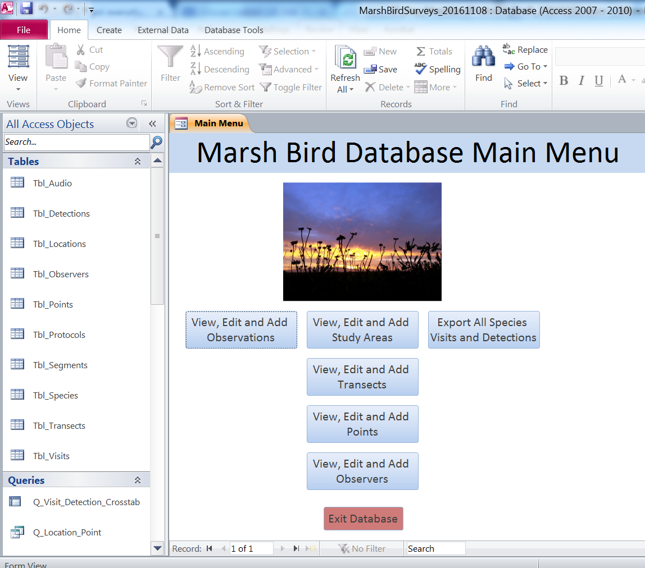
    - Study areas (marsh sites or locations), transects, points and observers are not manually keyed in during data entry for each visit; rather, the surveyor selects from a list of study areas, transects, points and observers that have been prepopulated in the corresponding tables: Tbl_Locations, Tbl_Transects, Tbl_Points and Tbl_Observers. This minimizes errors due to mistyping. Before adding observations for a given survey season, the survey coordinator should first ensure that all study areas, transects, points, and observers are in the database (buttons in middle column).
Viewing, Editing and Adding Study Areas
    - To find and view an existing study area, click the “View, Edit and Add Study Areas” button from the Main Menu. Use the “Find Existing Study Area” toggle list at the top of the Study Area Data Entry page. When you select the study area of interest, you will be able to view information for that record.
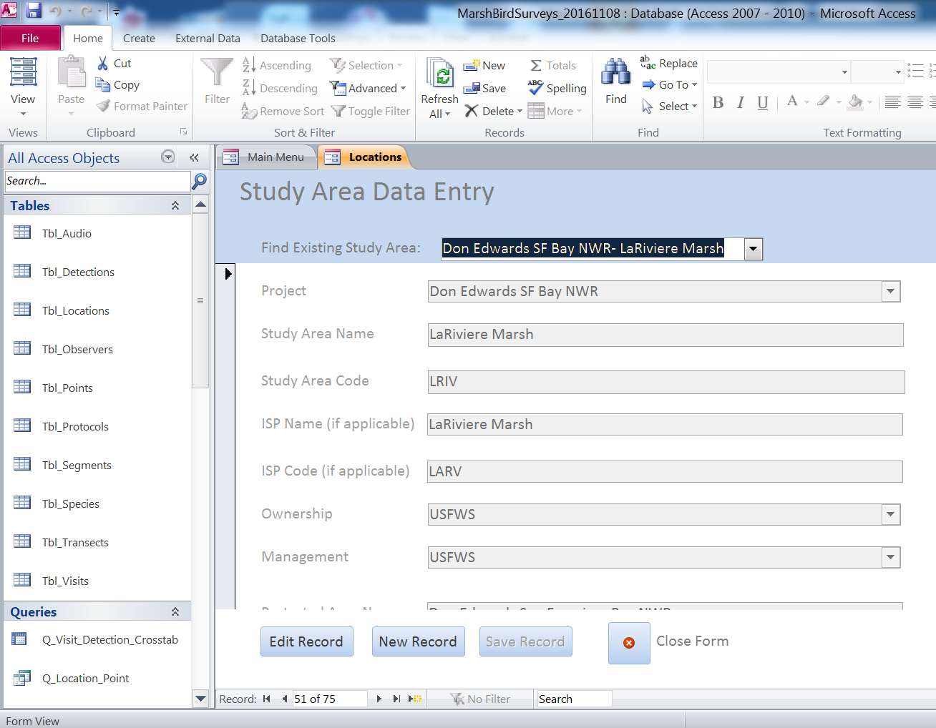
    - To find and edit an existing study area, click the “View, Edit and Add Study Areas” button from the Main Menu. Use the “Find Existing Study Area” toggle list at the top of the Study Area Data Entry page to select the study area you want to edit. When you have selected the study area of interest, click the “Edit Record” button at the bottom of the page. The fields for that record will now be editable. Make the edits, then click “Save Record” at the bottom of the page. Click “Close Form” to return to the Main Menu.

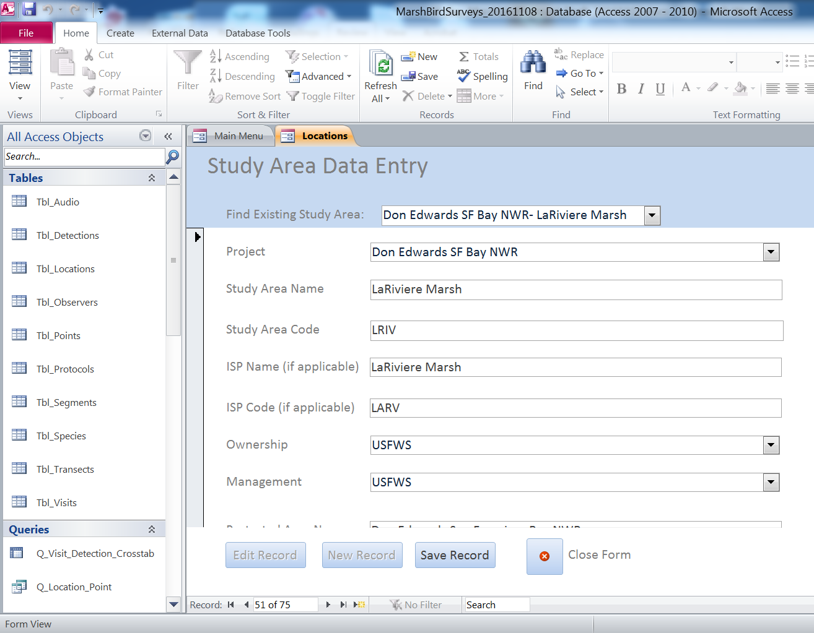
    - To add a new study area, click the “View, Edit and Add Study Areas” button from the Main Menu. Use the “Find Existing Study Area” toggle list at the top of the Study Area Data Entry page to make sure the study area isn’t already in the database. If it isn’t in the database, click the “New Record” button at the bottom of the page. This will open a new record with editable fields. Add the information for the new study area, then click “Save Record” at the bottom of the page. Click “Close Form” to return to the Main Menu.
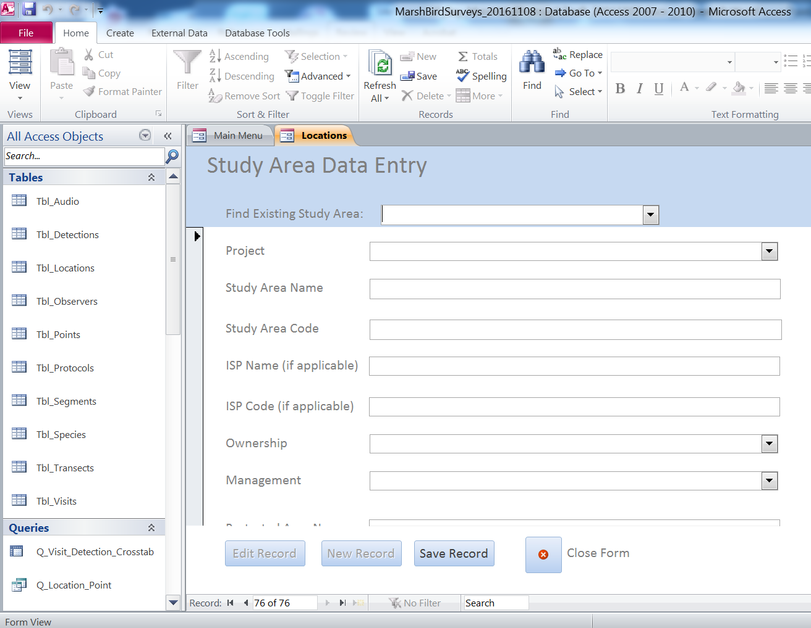
Viewing, Editing and Adding Transects
    - To find and view an existing transect, click the “View, Edit and Add Transects” button on the Main Menu. Use the “Find Existing Transect” toggle list at the top of the Transect Data Entry page. When you select the location of interest, you will be able to view information for that record.
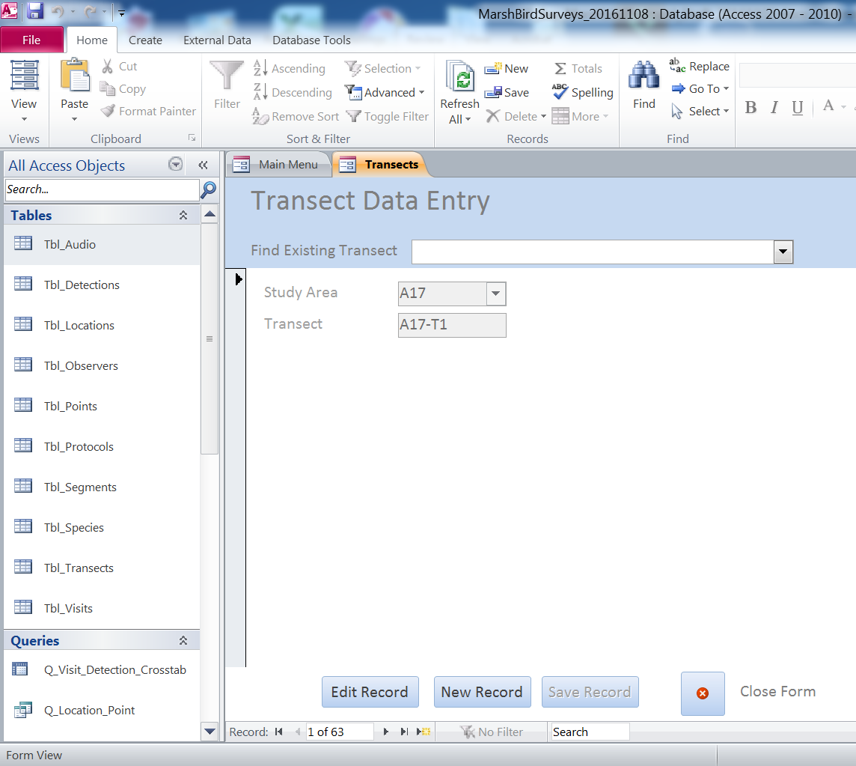
    - To find and edit an existing transect, click the “View, Edit and Add Transects” button on the Main Menu. Use the “Find Existing Transect” toggle list at the top of the Transect Data Entry page to select the transect you want to edit. When you have selected the transect of interest, click the “Edit Record” button at the bottom of the page. The fields for that record will now be editable. Make the edits, then click “Save Record” at the bottom of the page. Transects should be named using the code for the study area. In cases where multiple transects are conducted within a study area, the transect code should be followed by a dash “-“ and TX where X represents the number of the transect (for example, “LRIV-T1”) for the first transect at LaRiviere marsh. To assign survey points to the edited transect, use the “View, Edit and Add Points” button. Click “Close Form” to return to the Main Menu.

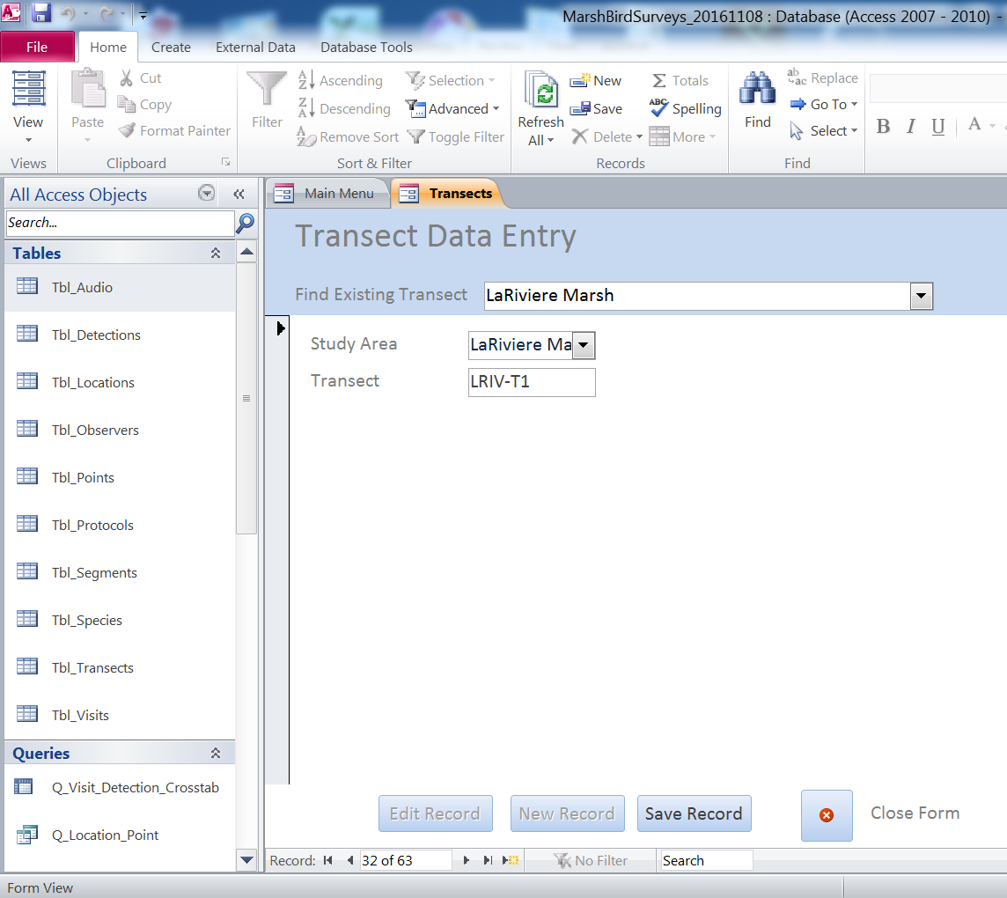

    - To add a new transect, click the “View, Edit and Add Transects” button on the Main Menu. Use the “Find Existing Transect” toggle list at the top of the Point Data Entry page to make sure the transect isn’t already in the database. If it isn’t in the database, click the “New Record” button at the bottom of the page. This will open a new record with editable fields. Add the information for the new transect, then click “Save Record” at the bottom of the page. Transects should be named using the code for the study area. In cases where multiple transects are conducted within a study area, the transect code should be followed by a dash “-“ and TX where X represents the number of the transect (for example, “LRIV-T1”) for the first transect at LaRiviere marsh. To assign survey points to the new transect, use the “View, Edit and Add Points” button. Click “Close Form” to return to the Main Menu. Note: if the new transect is at a new location, you will need to add the new location first before you add the new transect.

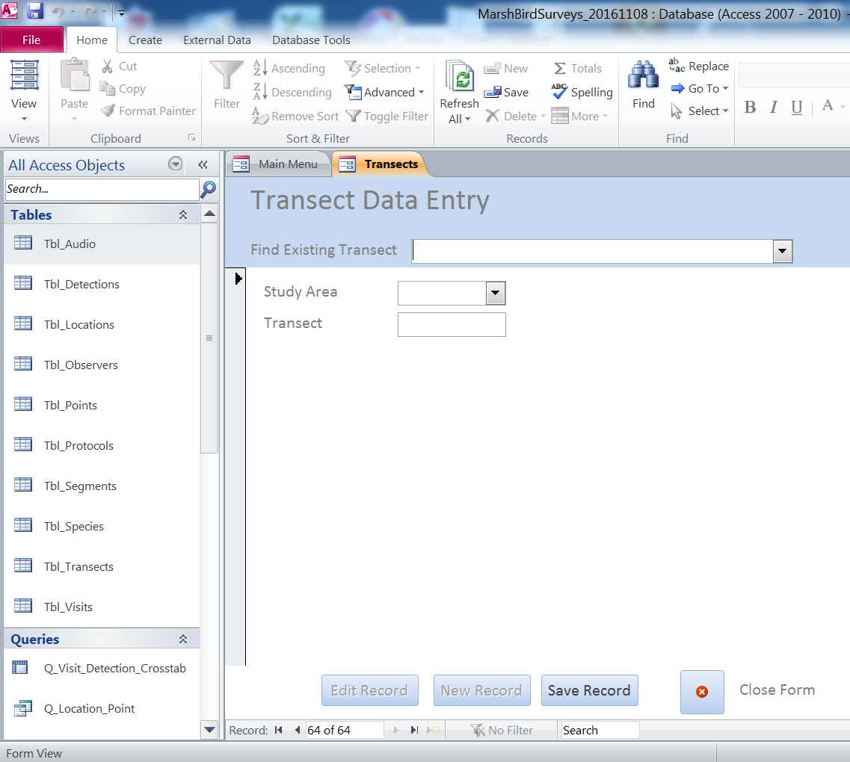
Viewing, Editing and Adding Points
    - To find and view an existing point, click the “View, Edit and Add Points” button on the Main Menu. Use the “Find Existing Point” toggle list at the top of the Point Data Entry page. When you select the location of interest, you will be able to view information for that record.
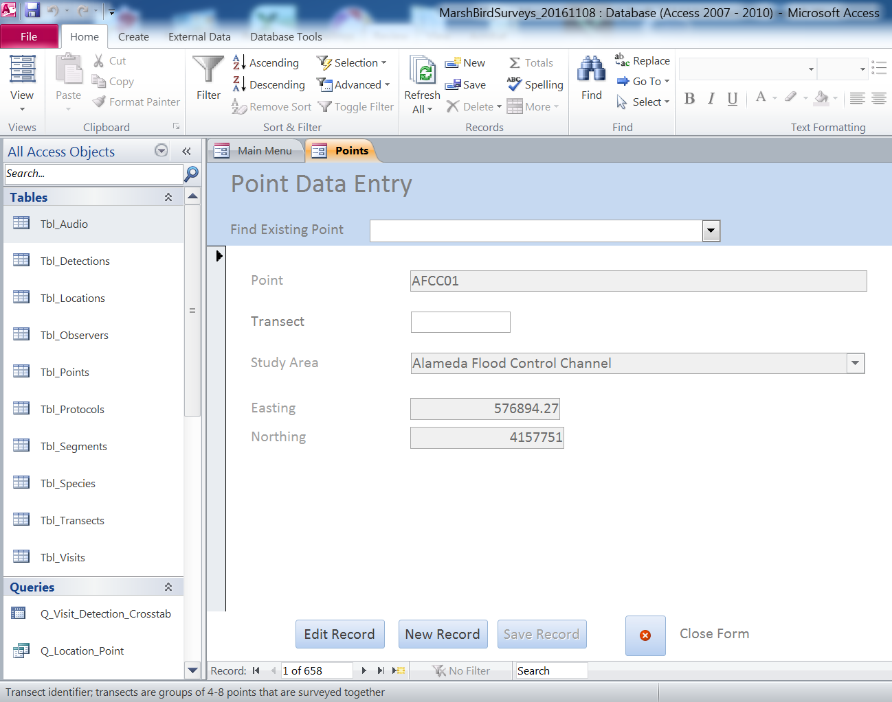
    - To find and edit an existing point, click the “View, Edit and Add Points” button on the Main Menu. Use the “Find Existing Point” toggle list at the top of the Point Data Entry page to select the point you want to edit. When you have selected the point of interest, click the “Edit Record” button at the bottom of the page. The fields for that record will now be editable. Make the edits, then click “Save Record” at the bottom of the page. Click “Close Form” to return to the Main Menu.
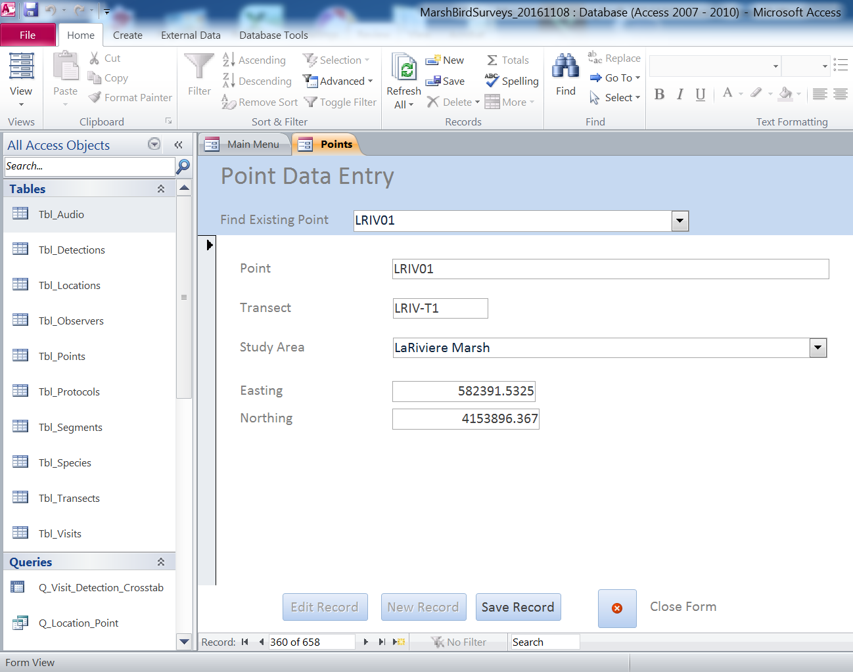
    - To add a new point, click the “View, Edit and Add Points” button on the Main Menu. Use the “Find Existing Point” toggle list at the top of the Point Data Entry page to make sure the point isn’t already in the database. If it isn’t in the database, click the “New Record” button at the bottom of the page. This will open a new record with editable fields. Add the information for the new point, then click “Save Record” at the bottom of the page. Click “Close Form” to return to the Main Menu. Note: if the new point is at a new location, you will need to add the new location first before you add the new point.
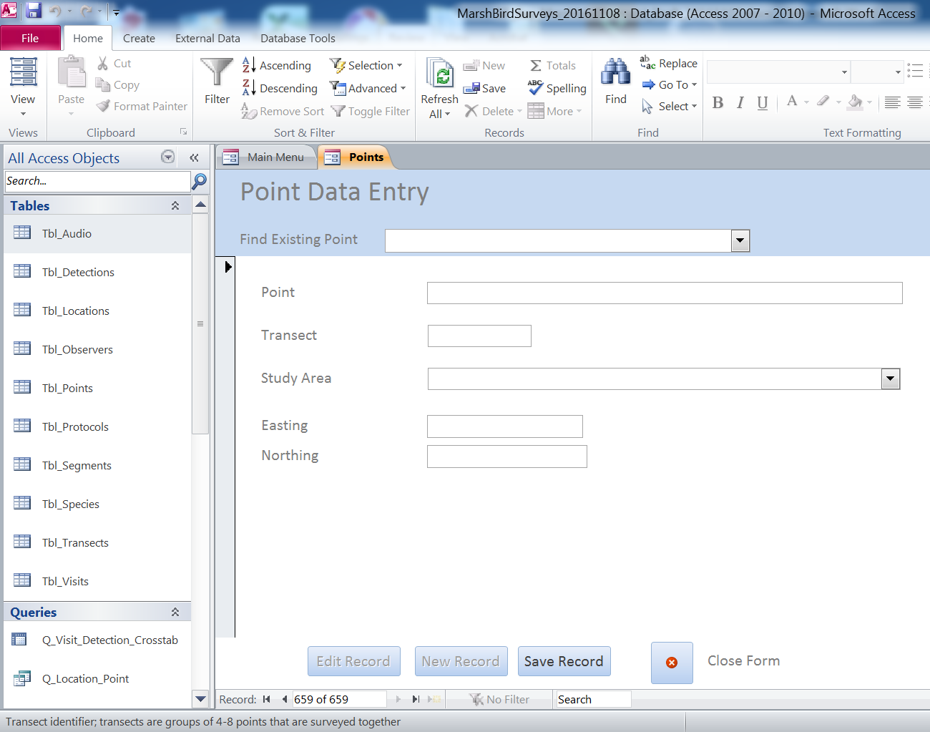
Viewing, Editing and Adding Observers
    - To find and view an existing observer, click the “View, Edit and Add Observers” button on the Main Menu. Use the “Find Observer” toggle list at the top of the Observer Data Entry page to view existing observers.
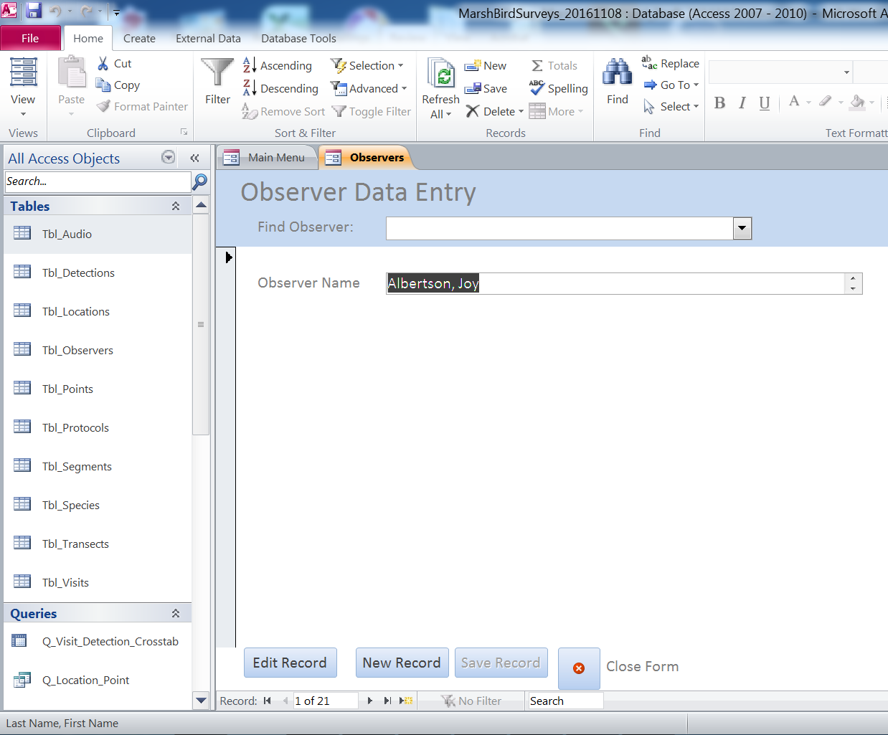
    - To find and edit an existing observer, click the “View, Edit and Add Observers” button on the Main Menu. Use the “Find Observer” toggle list at the top of the Observer Data Entry page to select the observer you want to edit. When you have selected the observer of interest, click the “Edit Record” button at the bottom of the page. The field for that record will now be editable. Make the edits, then click “Save Record” at the bottom of the page. Observer names should always be in this format: “last name, first name”. Click “Close Form” to return to the Main Menu.

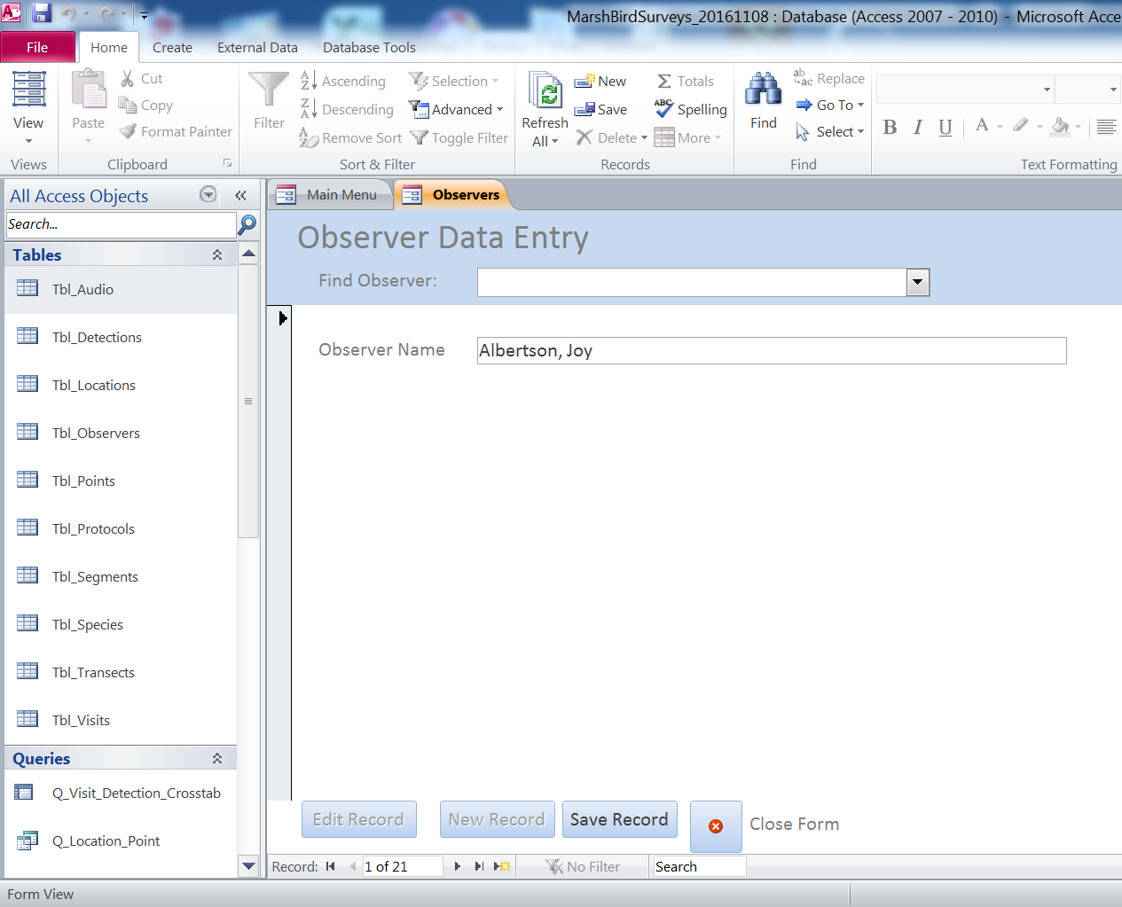

    - To add a new observer, click the “View, Edit and Add Observers” button on the Main Menu. Use the “Find Observer” toggle list at the top of the Observer Data Entry page to make sure the observer isn’t already in the database. If they aren’t in the database, click the “New Record” button at the bottom of the page. This will open a new record with editable fields. Add the name for the new observer, then click “Save Record” at the bottom of the page. Observer names should always be in this format: “last name, first name”. Click “Close Form” to return to the Main Menu.
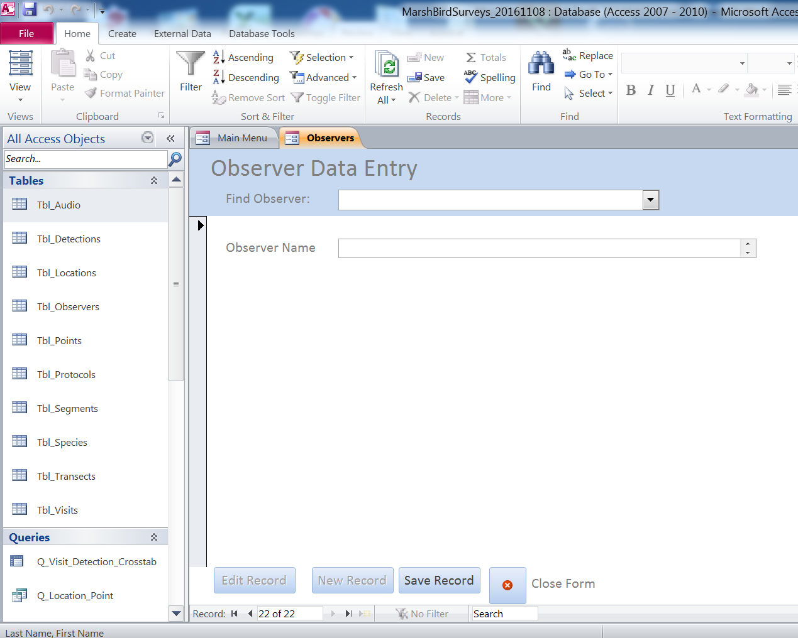
Viewing, Editing and Adding Observations
    - After all study area locations, points and observers have been entered into the appropriate forms, you can then work with viewing, editing and entering observations (visit and detection data).
    - To find and view observations, click the “View, Edit and Add Observations” button on the Main Menu. Use the “Find Existing Record” toggle list at the top of the Visit and Detection Data Entry page. Observations are selected using the point name, date, visit and project. When you select the observation of interest, you will be able to view information for that record.
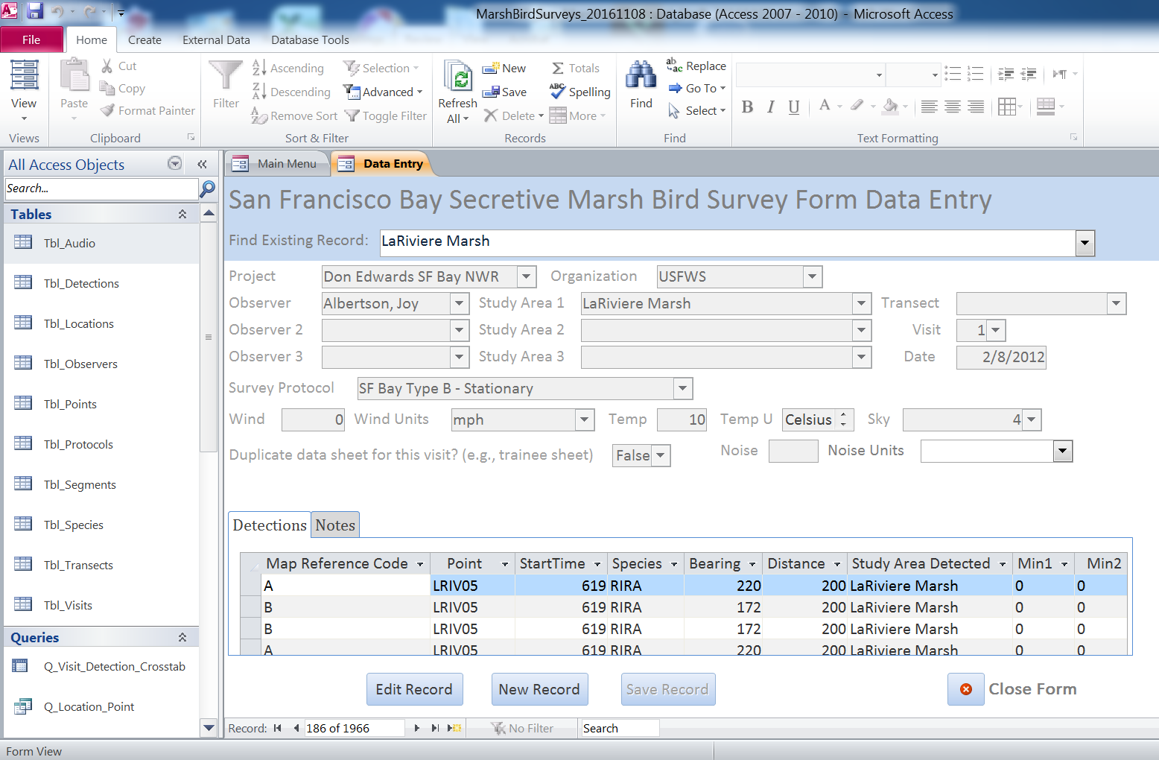
    - To find and edit an existing observation, click the “View, Edit and Add Observations” button on the Main Menu. Use the “Find Existing Record” toggle list at the top of the Visit and Detection Data Entry page to select the observation you want to edit. Observations are selected using the point name, date, visit and project. When you have selected the observation of interest, click the “Edit Record” button at the bottom of the page. A warning box will pop up saying “WARNING! You are in edit mode. Data can now be changed.” Click OK. The fields for that record will now be editable. Make the edits, then click “Save Record” at the bottom of the page. Click “Close Form” to return to the Main Menu.
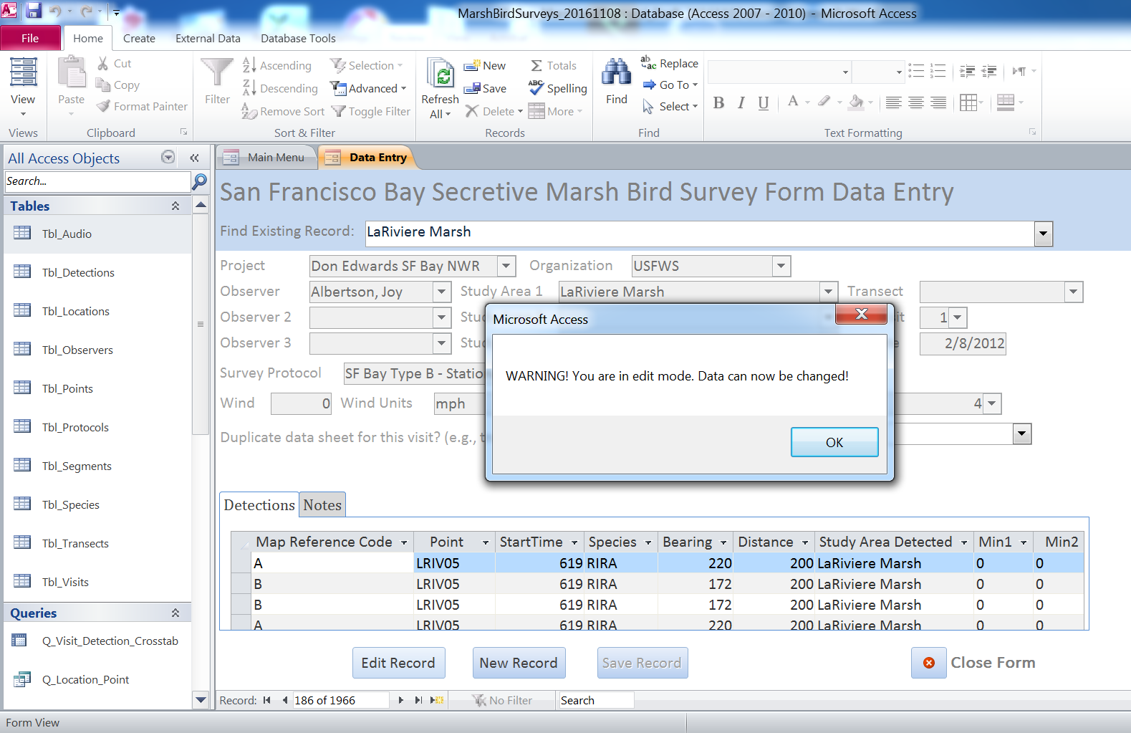
    - To add a new observation, click the “View, Edit and Add Observations” button on the Main Menu. You can use the “Find Existing Record” toggle list at the top of the Visit and Detection Data Entry page to make sure the observation isn’t already in the database. Observations are selected using the point name, date, visit and project. If the observation isn’t in the database, click the “New Record” button at the bottom of the page. This will open a new record with editable fields. Add the information for the new observation, then click “Save Record” at the bottom of the page. Click “Close Form” to return to the Main Menu. Note: if the new observation is at a new location or new survey point or conducted by a new observer, you will need to add the location, point or observer first (see above sections) before you add the observation (visit and detection data).
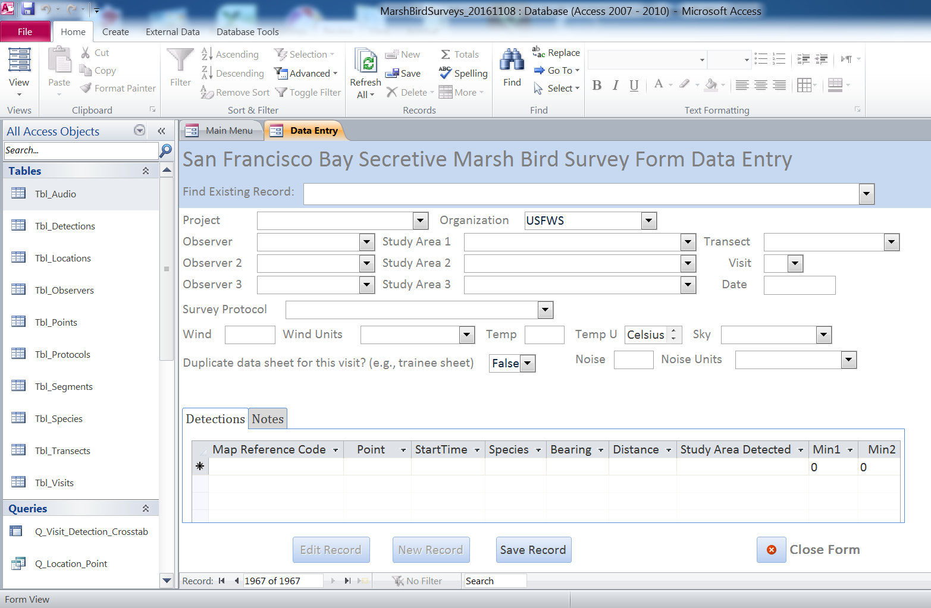
More Details on Adding Observations: Visit Form
    - More details on data entry for observations (visit and detection data) are provided below because this is the most critical part of the data entry process. The Visit and Detection Data Entry form is divided into two sections. The upper section contains the visit information (Visit Form), and the lower embedded subform contains the detection information (Detection Subform). Multiple detection records can be associated with a single visit. Each unique marsh bird detected during a visit at a point should have exactly one record (row) in the Detection Subform; e.g., RIRA duets should be entered as two unique birds, each with its own row of data in the Detections Subform, with “C” for clatter call in the minute segment(s) when the duet occurred. There are two exceptions to the “one bird, one record” rule; a bird detected from multiple points will have multiple records (rows) in the database, one record/row for each point where it was detected. The detection that we will use to summarize data at the study area/marsh site scale should be the detection closest to the point; the other detection should be marked as “Duplicate Bird,” see below. This is true even if the closer individual was detected after it was detected from another point but was farther away from that point. Duplicate birds are filtered out when we report count indices at the study area/marsh site scale.
    - Project: Select the project that the observation is associated with. Refuge staff should select “Don Edwards SF Bay NWR” or “San Pablo Bay NWR”.
    - Organization: Select the organization that conducted the survey (the default value is “USFWS”).
    - Observer: Select the primary observer from the drop-down list. If you don’t see the observer in the list, then add the observer to the Observer table (“View, Edit and Add Observers button on the Main Menu”, see above).
    - Observer 2: If there is a second observer, select their name from the drop-down list. If you don’t see the observer in the list, then add the observer to the Observer table (“View, Edit and Add Observers button on the Main Menu”, see above).
    - Observer 3: If there is a third observer, select their name from the drop-down list. If you don’t see the observer in the list, then add the observer to the Observer table (“View, Edit and Add Observers button on the Main Menu”, see above).
    - Study Area 1: Select the primary study area for the survey. You must select the project first before you select the study area (study areas are filtered by project). If you don’t see the appropriate study area in the pick list, then add the study area (“View, Edit and Add Study Areas button on the Main Menu”, see above). Before adding Study Areas, confirm with partner organizations that there is not already a name and code for that study area.
    - Study Area 2: Select a secondary study area, if applicable, where birds may be detected during the survey. If you don’t see the appropriate study area in the pick list, then add the study area (“View, Edit and Add Study Areas button on the Main Menu”, see above).
    - Study Area 3: Select a tertiary study area, if applicable, where birds may be detected during the survey. If you don’t see the appropriate study area in the pick list, then add the study area (“View, Edit and Add Study Areas button on the Main Menu”, see above).
    - Transect: Select the appropriate transect. If you don’t see the appropriate transect in the pick list, then add the transect to the study area (“View, Edit and Add Transects button on the Main Menu”, see above). You then need to add and link the corresponding points to the transect (“View, Edit and Add Points button on the Main Menu”, see above).
    - Visit: Select the survey visit (1, 2, 3, etc.), which corresponds to the visit number for that point in a given year; e.g., the first visit of the season would be “1”; the second visit of the season would be “2”, etc.
    - Date: Enter the survey date in MM/DD/YYYY format, or you can click on the calendar icon to select the date. Remember to double check the date to make sure it is correct.
    - Survey Protocol: Select the survey protocol that was used for the survey. The options are listed below. Starting in 2017, all surveys should be conducted with the 2-species North American Protocol (also see Appendix A):
      - 2-Species North American Protocol: 10 min point count; all visits have 5 min passive listening; 30 sec each of BLRA, RIRA call broadcast interspersed w/ 30 sec silence each; 3 min passive listening
      - 5-Species North American Protocol: 10 min point count; all visits have 5 min passive listening; 30 sec each of BLRA, RIRA, SORA, VIRA, AMBI call broadcast interspersed w/ 30 sec silence each
      - SF Bay Type A – Standard: 10 min point count; first 2 visits are passive listening; 3rd visit is passive if RIRA were detected previously at that point or during the first 5 minutes of the 3rd visit, otherwise, after 5 min passive listening; 1 min RIRA call broadcast; 4 min passive listening
      - SF Bay Type B – Stationary: 120 min point count; all passive, usually with one observer at each survey point but often with multiple observers at different points simultaneously recording detections.
      - SF Bay Type C – Modified: 10 min point count; all visits have 5 min passive listening; 1 min RIRA call broadcast; 4 min passive listening
      - Passive: 10 min point count; passive (no call broadcast).
    - Wind: Enter a number for wind speed in mph/kph or a number corresponding to the Beaufort code:
      - 0 – Calm: Calm, smoke rises vertically (<1 mph)
      - 1 – Light air: Smoke indicates direction (1-3 mph)
      - 2 – Light breeze: Wind felt on face (4-7 mph)
      - 3 – Gentle breeze: Leaves and twigs moving (8-12 mph)
      - 4 – Moderate breeze: Small branches moving (13-18 mph)
      - 5 – Fresh breeze: Small trees sway (19-24 mph)
      - 6 – Strong breeze: Large branches moving (25+ mph)
      - 8 – Other (does not fit a code)
      - 9 – Not recorded

    - Wind Units: Select the appropriate units for wind: mph, kph or Beaufort code.
    - Temperature: Select the temperature in degrees.
    - Temperature Units: Select Celsius or Fahrenheit.
    - Sky Code: Select the appropriate sky code:
      - 0 – Clear or few clouds
      - 1 – Partly cloudy (scattered)
      - 2 – Cloudy (broken) or overcast
      - 4 – Fog or smoke
      - 5 – Drizzle
      - 7 – Snow
      - 8 – Showers
      - 9 – Not recorded
    - Noise: Enter a number for the ambient noise level in dbA/dbC or enter a noise code:
      - 0 – No background noise during most of the survey
      - 1 – Faint background noise for >half of the survey
      - 2 – Moderate background noise; hard to hear birds >100 m
      - 3 – Loud background noise; hard to hear birds >50 m
      - 4 – Intense background noise; hard to hear birds >25 m
      - 9 – Not recorded
    - Noise Units: Select the appropriate units for noise: dbA, dbC or noise code.
    - Duplicate Data Sheet for this Visit?: The default value for this field is False/No. Select “Yes” if the visit being entered is a duplicate; e.g., a trainer and trainee complete a survey. The trainer enters their data (the official data) but wants the trainee to get practice entering their data sheet. The trainee’s data is a duplicate visit. Records marked “Yes” will be filtered out when reporting abundance indices by location.

More Details on Adding Observations: Detection Subform
​If no birds were detected, you ​still​ need to enter the point and start time​ in the Detection Subform​ (see below). The rest of the Detection Subform is left blank. If one or more birds were detected, enter the rest of the data ​into the Detection Subform ​as shown below.​

    - Map Reference Code: Enter the map reference code for the bird. For duetting birds, use the same Map Reference Code to indicate the pair vocalized in unison.
    - Point: Select the point where the survey was conducted. If you don’t see the appropriate point in the pick list, then search existing points and add a new point if necessary (“View, Edit and Add Points” button on the Main Menu, see above).
    - Start Time: Enter the time the survey at the point was started, four digits in military time (e.g., 1625 for 4:25pm).
    - Species Code: Select the species code for the bird that was detected:
      - RIRA – California Ridgway’s Rail
      - BLRA – California Black Rail
      - VIRA – Virginia Rail
      - SORA – Sora
      - YERA – Yellow Rail
      - AMBI – American Bittern
      - LEBI – Least Bittern
    - Bearing: Enter the compass bearing to the bird (0-360)
    - Distance: Enter the estimated distance to the bird in meters
    - Study Area Detected: Select the Study Area where the bird was detected. The default value is Study Area 1 from the Visit portion of the form. If the bird was detected in Study Area 2 or 3 or another study area, select the appropriate study area from the drop down list.
    - Min1 – Min10: For each minute of the 10-minute survey, the default value is 0 or absent, meaning there were no detections of the bird in each 1-minute segment. For each 1-minute segment in which the bird was detected, select the method by which the bird was detected (visual or auditory by call type). Only one detection type can be entered in each minute bin. If the bird gave multiple types of vocalizations, the one associated with breeding should be prioritized. For each species, the detection cue to be prioritized appears at the top of the list below:
      - Visual – V (applies to all species)
      - RIRA: C – clatter
      - RIRA: B – kek burr
      - RIRA: K – kek
      - RIRA: KH – kek-hurrah
      - RIRA: SK – squawk
      - RIRA: P – purr
      - RIRA: CH – churr
      - BLRA: KKD – ki-ki-doo
      - BLRA: GR – grrr
      - BLRA: CHT – churt/krup
      - BLRA: TCH – tch/laugh
      - VIRA: G – grunt
      - VIRA: KI – kicker
      - VIRA: KIU – kiu
      - VIRA: KK – kikik
      - VIRA: T – tick-it
      - SORA: WH – whinny
      - SORA: PW – per-weep
      - SORA: KEE – kee
      - YERA: CC – click-click
      - YERA: CA – cackle
      - YERA: WHZ – wheeze
      - AMBI: PL – pump-er-lunk
      - AMBI: CP – chu-peep
      - AMBI: KO – kok
      - LEBI: COO – coo
      - LEBI: KAK – kak
      - LEBI: ERT – ert

    - Playback halted?: Select “Yes” if call broadcast was interrupted or never used during the survey. This may be due to a nearby predator (enter sightings in Notes) or equipment problems. Otherwise, the default value is set to “No.” If “Yes,” explain why in the Notes.
    - Outside Study Area: The default value for this field is False/No. Select “Yes” if the bird was detected outside of the Study Area including all Additional Focal Study Areas for the survey (e.g., not in Study Areas 1, 2 or 3; see Tables 3 and 4). Records marked “Yes” will be filtered out when reporting abundance indices by location.
    - Outside Time: The default value for this field is False/No. Select “Yes” if the bird was detected outside of a 10-minute survey period (e.g., while walking between survey points) and not during a 10-minute survey period.
    - Duplicate Bird: The default value for this field is False/No. Select “Yes” if the bird was detected at from another point (and not entered as a Duplicate Bird) during the same survey. Records marked “Yes” will be filtered out when reporting abundance indices by location.
    - Notes: Add any notes about the detection that are relevant. For example, if a clatter vocalization was part of a duet, you can enter “duet”. Predator sightings should be recorded along with the point nearest the predator and any interactions with secretive marsh birds.

More Details on Adding Observations: Notes Subform
    - Notes: Enter any notes about the visit that are relevant (e.g., sources of noise that could affect the survey, presence of predators, additional weather information, etc.).
Proofing Entered Data
    - After all data from each data sheet have been entered, the data entry person will initial and date the “Data Entered” line in the box on the bottom of that data sheet.

    - After initial data entry, each record in the database will be individually proofed for errors against the original data sheets. The same person that entered the data will proof the data in the database, reviewing the data and summaries (from queries) to check for typos, errors, and blank fields. As each datasheet is proofed, date and initial the “Data Proofed” line on the bottom of that data sheet. It is the responsibility of the survey coordinator at each refuge to ensure that data entry and data proofing are completed promptly following a survey (within one week).

Metadata
The Access databases that will be maintained by DESFB and SPB contain important metadata (e.g., field definitions in the design views of tables). This protocol document should be attached to each version of the Access database.

Data security and archiving
Original hardcopies of datasheets will be stored in 13-8.10 of the WLD Files at DESFB. Scanned copies of data sheets will be maintained on refuge servers, which are protected by the USFWS firewall M:\REFUGES & PROGRAMS\BIOLOGY\MARSH_BIRDS\Data. The Access databases for each refuge that store all marsh bird survey data will be backed up to refuge servers. The USFWS is responsible for performing periodic backups of all data residing on refuge servers. Each year, after all data for the survey year has been entered and proofed for each refuge, the survey coordinator for each refuge will export all of their data residing in the database and store as an archived copy (.csv or .txt). This archived flat file must be stored on each refuge’s server. Annual reports with data tables (raw counts per marsh study area) will be archived on ServCat.

In the future, marsh bird data for both refuges will be managed online in the California Avian Data Center (CADC).

Appendix A. Historic Survey Methods

Appendix A. Description of historic field methods for surveying California Ridgway’s rail.
Organization |  | Protocol Name | Description | Multiple visits | Duration (minutes) | Playback | Visits
 | Multiple (ISP, Point Blue, DFW) | Type A Standard | Point count with 1-min RIRA Broadcasts on 3rd visit conditional on no RIRA heard during previous visits. | Yes | 10 | Conditional | 3
 | SPBNWR | Type A SPBNWR Modified | As above but with 1-min RIRA broadcasts on 3rd visit regardless of detections during previous visits. Broadcast not used if RIRA detected on previous point during the 3rd visit. | Yes | 10 | Conditional | 3
 | DENWR | Type B Stationary (90 min) | Passive detections recorded on maps with multiple observers at different locations pooling data to generate a site-level estimate. | Yes | 90 | No | 3
 | OEI | Type B Stationary (120 min) | As above with 1-min broadcasts during 3rd visit if no RIRA detected. | Yes | 120 | Conditional | 3
 | DENWR, OEI | Type C | Point count with 1-min RIRA broadcast on each visit. Broadcast terminated if RIRA is detected. | Yes | 10 | Unconditional | 3
 | Multiple (DENWR, EBP) | Type E Airboat | Visual search of entire marsh by airboat during extreme high tide when the majority of marsh plain veg is inundated. | No | N/A | No | 1
ISP |  | Type F Preliminary Habitat Suitability Assessment | Visual habitat assessment to determine if suitable RIRA habitat is present; if habitat is suitable, a protocol C survey is typically conducted. | No | N/A | No | 1
Multiple |  | Type G 120 min Consultant Protocol | As above but survey terminated if RIRA detected. | Yes | 120 | Conditional | 4
Multiple |  | 5 Species Pilot National Protocol | Point count survey with unconditional 30-sec broadcast of 5 species (BLRA, RIRA, SORA, VIRA, AMBI) on each visit. Aka. Conway or Pilot Protocol. Paired with Type A Standard surveys as part of pilot protocol study. | Yes | 10 | Unconditional | 3

Appendix B. Walking in the Marsh

Walking In the Marsh:

Methods to Increase Safety and Reduce Impacts to Wildlife/Plants

I. Safety

- Before heading out into the marsh check the tides: tides can affect your ability to move through the marsh. Be aware of how long you plan to be in the marsh, what channels you may have to cross, and how the tides will change while you are in the field.

- Plan your route through the marsh: use existing aerial imagery and maps to identify channels and sloughs that may impede access. When available, use high points such as boardwalks or levees to scope out a route. Scoping a route can be especially important in scenarios where visibility across the marsh is low (e.g., South Bay, Suisun). It may be necessary to flag stations and/or access corridors through the marsh prior to surveys. If more than one person is accessing the marsh, travel together along major access routes to avoid the development of multiple paths. At the end of the sampling period, persons furthest out should walk out first, meeting up with others along the major access route to minimize the potential of people getting lost and ensuring that anyone who is injured will be found in a timely manner (before everyone else has left the marsh). The goal should be to plan a safe route into and out of the marsh while minimizing travel and pathways.

- Channels and sloughs: Avoid jumping channels in locations where you cannot see through vegetation on the opposite bank. Thick vegetation (e.g., pickleweed, gumplant) can obscure the edge of the bank. Considerations before jumping: depth of water/channel, steepness of the channel edges, tide levels. If you are not confident that you can make the jump and the edges have high dense vegetation that you cannot see through…..DO NOT JUMP.

- Getting stuck in the mud: If you are sinking into mud, try to keep moving to avoid getting stuck further. If a leg gets stuck, try to twist your leg to break the suction while leaning your weight on your other leg or knee. Use whatever material you have available (e.g., clipboard, backpack) for leverage (e.g., lean on those items).

- Other: Besides general items such as water and food, it’s a good idea to bring a flashlight and a phone (+GPS) in cases of an emergency. Let someone know what marsh area you will be in and when you plan to complete work for the day. Designate an end time and final meeting place when more than one person is out in the marsh at the same time.

II. Avoiding Impacts to Wildlife and Plants

- Movement through the Marsh. While walking through the marsh, keep noise to a minimum. Avoid using multiple pathways through the marsh. Use trails if they exist. Plan and map your route to minimize environmental impacts and decrease running into hazards/barriers such as large channels. When looking for a suitable place to jump a channel, do not walk along the edge of the channel/slough because these areas provide nesting habitat for many species including the endangered CA Ridgway’s rail. To find an alternate jump site, walk parallel to the channel at a distance where vegetation is lower in height and where visibility of the ground surface is greater. At all times, observe the environment you are walking through to avoid disturbance. Choose channel jump sites where vegetation is lower or you can clearly discern what you are jumping onto. In general, avoid walking adjacent and parallel to channels/sloughs.

- Avoiding nests and nest substrates. Tidal marsh species have nests that are well concealed and therefore easy to disturb when walking through the marsh. To avoid stepping on a nest, do not walk through thick vegetation or areas where you cannot see through to the ground. Avoid walking on vegetation whenever possible since plants serve as nesting substrate for many species in the marsh. In general, be aware of the area you are walking through. See Table 1 for nest characteristics of common tidal marsh birds.

- Bird Behavior. If a bird vocalizes or flushes within close range of where you are standing or walking (e.g., < 10-m), it is possible that a nest or young are nearby. When these circumstances arise, stop whatever you are doing and leave the immediate area (be sure to watch where and what you are walking on). Choose an alternate route through the marsh, identify the new route and location of the sighting/occurrence on a map, and record coordinates of the location if possible. Be sure to pass this information on to others that may use the same route or are conducting surveys in the same area. Be very observant of where you walk as you leave the area. There exists the possibility that you could step on a nest or young, both of which can be concealed by vegetation and are cryptic. When alarmed, individuals may freeze in place (especially juveniles).

- Tidal lagoons/ponds. Avoid walking along tidal lagoons and ponds in marsh interiors that support foraging, roosting, or nesting shorebirds and waterfowl. Be observant of the distance at which birds flush or become alarmed.

- Tides. Avoid conducting surveys during high tides as much as possible. These are periods when
wildlife species are at greatest risk (e.g., predation). If your surveys require a high tide, be aware of the increased risk you may cause for wildlife and take all precautions to reduce that risk (e.g., avoiding areas where sensitive species are known to occur).

Table 1. Nest characteristics and breeding season of common tidal marsh birds.
Nest characteristics |  | Ridgway’s Rail | Black Rail | Song Sparrow | Common Yellowthroat | Marsh Wren
Size and shape (approximate) |  | Platform, ~8 in  (20 cm) | Small cup w/ canopy ~4 in  (10 cm) | Small cup  ~4 in  (10 cm) | Small cup  ~3 in (8 cm) | Spherical or  Football shape
Concealment |  | High | High | High | High | Low
Height above ground |  | Ground or slight rise | < 30 cm | < 30 cm | Commonly < 30 cm | > 30 cm
 | Breeding season | Mar-Jul | Apr-Jul | Mar-Jun | Mar-Jul | Mar-Jul
Nest substrate
Salicornia (pickleweed) |  | X* | X* | X* | X | X
Grindelia (gumplant) |  | X* | X | X* | X* | X
Distichlis spicata (saltgrass) |  | X
Bolboschoenus maritimus  (alkali bulrush) |  |  | X* | X* | X* | X*
Schoenoplectus americanus  (chairmaker’s bulrush) |  |  | X* | X* | X* | X*
Schoenoplectus acutus/californicus  (hardstem bulrush) |  |  | X | X | X | X*
Bolboschoenus robustus  (big bulrush) |  | X
Spartina foliosa  (California cordgrass) |  | X | X | X | X | X*
Typha (cattails) |  |  | X | X* | X* | X*
Wrack |  | X
*common nest substrate
Sources: Point Blue (IRWM training document, 2004), Goals Project (2000), The Birds of North America (No.’s 340, 448, 704).

Like birds, the endangered salt marsh harvest mouse (SMHM) also constructs a nest. The nest is commonly a ball of vegetation that is on the ground or up in pickleweed (Fisler 1965). The reproductive season for SMHM peaks during summer and fall (Fisler 1965, Bias 1993).

Appendix C. San Francisco Bay Marsh Bird Survey Datasheet (Attached)

U.S. Fish and Wildlife Service  U.S. Department of the Interior  National Wildlife Refuge System |   

