Minidoka National Wildlife Refuge

  - Vegetation Classification Report

January 2018

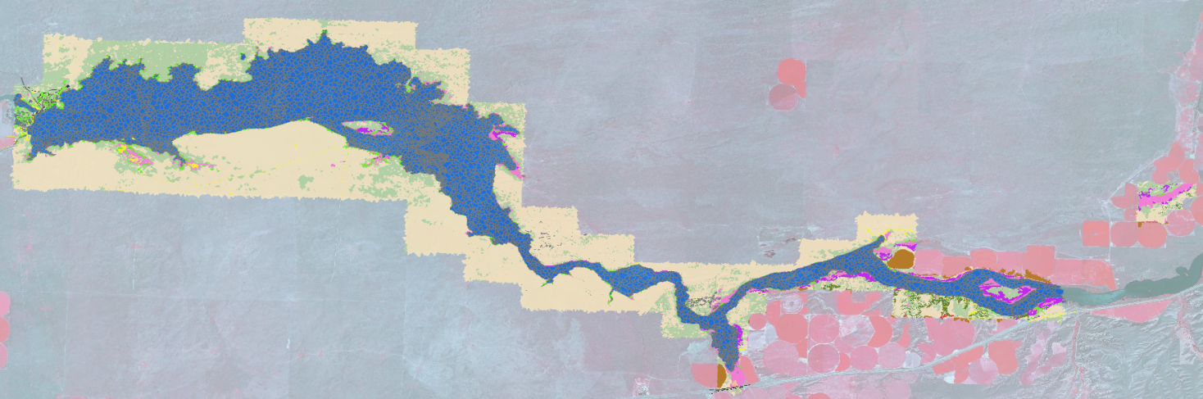

Figure. Example of vegetation map for Minidoka National Wildlife Refuge.

Contents

Contents 1
Introduction 2
Background 2
Overview of Minidoka NWR 2
Refuge Needs 3
Vegetation Classification Methods & Results 4
Remote Sensing Methods 4
Map Validation 5
Map Finalization 5
Results 5
VEGETATION/LAND COVER CLASSIFICATION (MND_SEGS2) 5
[ALLIANCE2] 5
LANDSCAPE COMPONENTS 8
MND_VegHt_cls 8
MND_VegHt_CNT 9
ISO_CNT 9
ACCURACY ASSESSMENT 12
Conclusions 12

Acknowledgements: Ty Matthews, Erin Stockenberg, and Chris Moller (under contract https://www.swca.com/portland, mod originated under NWI contract)

Introduction
This report accompanies the Minidoka National Wildlife Refuge (NWR) spatial vegetation/habitat database. The purpose of this report is to provide enough information so that the spatial vegetation database can be used with full knowledge of the potential uses of the data and to provide enough relevant information so that the methods could be followed with similar results.
This project occurred over the period from Fall 2015 through 2017. It was funded through the USFWS Region 1 Inventory and Monitoring Initiative. The goals of the project were to; a) provide a vegetation map in Region 1 based on expert knowledge, remote sensing and mapping methods, and field verified data and b) provide Minidoka NWR with a geospatial vegetation database that can be used for planning and refuge management with specific attributes for habitat condition assessments.
This report provides background for the project, including information about past habitat mapping projects, and an articulation of the refuge needs that drove the project. Also, field methods and subsequent vegetation classification and legend development will be discussed. Next, remote sensing methodology is discussed, followed by discussion of the accuracy assessment field campaign.
Finally, results will be evaluated, with an emphasis on understanding confusion between mapping classes. The appendix provides important information to accompany the use of the map, and a dichotomous key to the mapping classes of Minidoka NWR.

Background

Overview of Minidoka NWR

The Minidoka NWR is an overlay refuge on lands withdrawn by the Bureau of Reclamation located on the Snake River Plain in south-central Idaho, 12 miles northeast of the town of Rupert, Idaho. The primary feature is Lake Walcott, the reservoir formed by the construction of the Minidoka Dam in 1906. The dam, power plant, irrigation canals, and lake water levels are all managed by the Bureau of Reclamation (BOR). Adjacent to the dam and refuge headquarters is Lake Walcott State Park which is administered by the Idaho Department of Parks and Recreation (IDP&R). Prior to 1996 it was administered by the BOR. The park provides the public with picnic, camping and boat launch facilities. The project land and water areas are managed as a refuge for wildlife by the US FWS.
Minidoka Refuge extends upstream approximately 25 miles from the Minidoka Dam along both shores of the Snake River, encompassing approximately 24,500 acres, of which 10,500 acres are the open water of Lake Walcott, the Snake River, and some small marsh areas. Vegetative types are predominantly sagebrush-grass and short bunchgrass complexes. The overstory is composed primarily of sagebrush and rabbitbrush with the understory mainly cheatgrass, crested wheatgrass, and native grasses and forbs. Native grasses commonly found include western wheatgrass, Indian ricegrass, Sandberg’s bluegrass, bottlebrush squirreltail, needle-and-thread, and green needlegrass.
The large expanse of open water with its dry surrounding uplands attracts numerous avian species including waterfowl, shorebirds, and wading birds. The refuge bird list currently shows 243 species, of which 85 species are known to nest on the refuge. Other wildlife includes pronghorn, mule deer, porcupine, beaver, otter, rabbits, small rodents, bats, coyotes, and mustelids.
The topography of the refuge is generally rolling, open terrain with numerous basalt outcrops. Soils are shallow and vary from sandy loam to coarse gravel and are sensitive to wind erosion. At an elevation of 4200 feet, the climate is semi-arid. Temperatures range from an average minimum of -5oF in January to an average maximum of 97oF in July, with extremes of -35oF and 100+oF being recorded. Rainfall averages less than 11 inches per year and is normally light during the summer months. Combined with temperatures in the 90's, this can produce highly volatile range conditions.
Historically, refuge and surrounding land use was restricted to livestock grazing. However, following the construction of Minidoka Dam and its associated irrigation canals, some of the surrounding lands are now farmed. Potatoes, sugar beets, beans, alfalfa, and wheat are the primary crops. Grazing is still a vital part of the local economy. No farming is presently being done on the refuge and grazing was eliminated in 1995, except where there is no boundary fencing.
The refuge is immediately surrounded primarily by a sagebrush landscape of Bureau of Land Management (BLM) Lands. Management of refuge uplands must be considered within this larger landscape, as most sage dependent species have large home ranges that transcend the refuge boundaries.

Refuge Needs

Like many refuges, there is a need for better vegetation and habitat maps. For Minidoka NWR, the needs were a better estimate of habitat types, and percentages of component structural classes (herb/forb, shrubs, and tree) of the refuge. There is a need for baseline information for habitat objective and management planning and additional information for sampling, monitoring and restoration activities on the refuge. There are several recent, ongoing, and planned monitoring and restoration activities on the refuge. Baseline spatial data on habitat types will provide a reference point for vegetation and wildlife rehabilitation and monitoring as well as assessing change on refuge management units.

Vegetation Classification Methods & Results

Remote Sensing Methods

Imagery and LiDAR Sources

The principal imagery source was 1-meter aerial photography from the National Agricultural Imagery Program (NAIP). The most recent imagery was from 2015. However, there is some variability in vegetation from year‐to‐year. Other imagery dates and online images were referenced as part of the classification process. These images and other ancillary data inform the decision making for the vegetation mapping. These included other forms of satellite imagery to target peak growing season of cheatgrass (maximum greenness) to map distribution. This green-up period does not align with the NAIP available so DigitalGlobe scenes were accessed.
Light Detection and Ranging (LiDAR) data, captured in 2016, was also used to create the map. The LiDAR provided another key piece of information with vegetation height and topography to assist in the mapping. The vegetation height and elevation data were provided by the US Bureau of Reclamation and USFWS. The main topographic variable of interest for the mapping was finding areas of similar elevation to describe depressional wetlands, drainages and determine vegetation heights to distinguish among herbaceous, shrub and tree heights. Using a combination of bare‐earth, vegetation height (derived from subtracting bare‐earth from the first return), hillshaded vegetation heights and aerial imagery were useful in determining upland vs. wetland breaks, as well as structural differences within low‐lying (emergent and herbaceous), shrub and forested classes.

Image Processing and Classification
Image segmentation is the process of clumping raster pixels with similar values into relatively homogenous vector‐based polygons. Software called eCognition was used for image segmentation using NAIP imagery as the primary input. Several scales of segmentation were used to determine the final polygons for use. The scale varied size shape of the polygon outputs to reach an acceptable level of detail. The average size of the polygons was 0.61 acres with a standard deviation of 0.864 acres. The polygon sizes range from a few square meters (9) to 11.1 acres. Larger areas represented homogenous areas mostly within the grassland, sagebrush and open water classes. Smaller polygons captured highly variable areas or areas with vastly different image values than surrounding pixels (e.g. rocks within water or small wetland inclusions within uplands). This segmentation process produced 43,973 individual polygons within the project area.
The final segments were exported from eCognition, along with attribute fields for minimum, maximum, mean, and standard deviation for vegetation height and elevation. These resulting segments were output to an ESRI Geodatabase for hybrid classification using supervised and unsupervised classification, and photo interpretation.
Photo interpretation methods involved overlaying the eCognition‐based polygons on top of multiple dates of imagery and LiDAR. LiDAR and vegetation height data were particularly useful in visually distinguishing shrub vs. grassland classes.
Supervised and unsupervised classifications created with ArcMap based on the NAIP imagery were also created. These outputs form the basis for information on the landscape components within each polygon. The classes were used to determine an estimate of the type of vegetation within each area on a pixel-by-pixel basis. The classes were particularly well suited for pulling out dense vegetation, trees, and highly contrasting features on the landscape (e.g. bare ground, wetland vegetation and open water). Other classes exhibited mixed components. Pixels with proportions of grasses, shrubs and bare ground that were not composed of one landscape component (pure grass) were classified with field data and expert knowledge. Many of these mixed areas were then estimated percentages of grass cover such as cheatgrass and crested wheat. Cheatgrass and other invasive/introduced species tended to create monotypic vegetation cover and were more distinct than other more sparse native cover types.

Map Validation
A validation field trip was conducted in late September 2013. The mapping analysts spent several days reviewing a draft map in the field. The purpose was to field‐test the map and see how well the draft represented ground characteristics. There were no formal protocols involved, other than to focus on areas that the mapping analyst had questions about.
Image segments, classified and labeled using methods described above were visited and assessed for accuracy. If the map call was correct, a note was taken on the polygon using ArcPad. If not, then the correct call was given for review in the office. This data served as an expert review of the users accuracy, while not a formal statistical process provided confidence that the map accuracy was meeting the manager’s needs.

Map Finalization
The map was finalized in the office using ArcMap throughout 2017. Beyond the land cover classification, each polygon has numerous attributes that describe landscape components (percentages of grass, cheatgrass, crested wheat, shrub, tree and bare ground). Additionally, vegetation height measurements are included in a height class table. These measures are based on the processed LiDAR data. These calculations were completed using the zonal statistics commands in ArcGIS.
The amount of each vegetation cover type was computed for the classification.

Results

VEGETATION/LAND COVER CLASSIFICATION (MND_SEGS2)

[ALLIANCE2]
The land cover/vegetation classification field [ALLIANCE2] contains the classification code for each polygon. There are 16 individual class descriptions below.
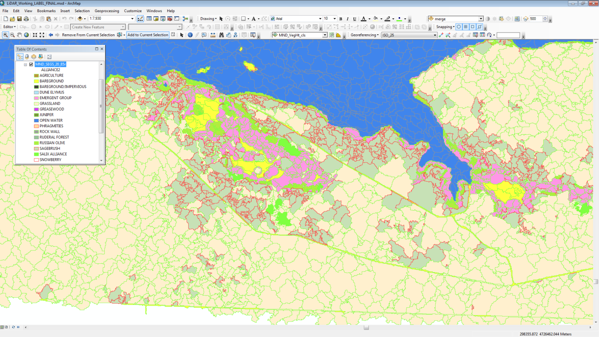
Figure 1 Example of final classification for Minidoka National Wildlife Refuge.

AGRICULTURE
Agriculture class contains agricultural fields. These areas are typically dominated by row crops and are irrigated. There are several fields adjacent to the refuge which appeared to have grain (barley/wheat), alfalfa and other crops. There are 340 polygons and around 212 acres in the dataset.

BARE GROUND
This class represents areas dominated by bare soil and gravel. Gravel and bare soil roads and dried mud flats fall into this class. While many of the vegetated classes have high percentage of bare soils, these areas fall into their respective vegetative classes. Bare ground makes up a little more than 25 acres.

BARE GROUND/IMPERVIOUS
Similar to bare ground, this class is dominated by non-vegetated areas. Typically these areas are paved (concrete or asphalt) areas. These areas include roads and buildings and make up less than 23 acres.

DUNE ELYMUS
These areas are present north of the reservoir. The class is dominated by sandy soils and sparse vegetation. These areas make up approximately 25 acres.

EMERGENT GROUP
This class contains most wetlands dominated by emergent herbaceous vegetation. Cattails, rushes, low-lying willow and other typical hydrophytic plants dominate this class. There may be wetland or riparian tree (willow or Russian olive) or shrub trees present. The refuge has more than 650 acres (2.4% total mapped area) of wetlands in this class.

GRASSLAND
The grassland class is dominant class across the landscape. 41% of the total mapped area and more than 70% of non-wetland vegetated classes. As previously mentioned, the dominant grasses are cheatgrass, crested wheatgrass, and native grasses and forbs. Native grasses commonly found include western wheatgrass, Indian ricegrass, Sandberg’s bluegrass, bottlebrush squirreltail, needle-and-thread, and green needlegrass.

GREASEWOOD
Greasewood dominated shrub areas make up around 300 acres of the refuge. It is found along the northern portion of the river and on islands within the river and side channels.

JUNIPER
Juniper is found in a few localized areas on the refuge. These trees straddle the shrub and tree height class. The understory may dominate the classification in some areas and shift the class to either grassland or sagebrush class.

OPEN WATER
Open water represents around 10,457 acres of the mapped surface area of the refuge. These habitats are flooded during the year.

PHRAGMITES
The phragmites class is localized in the Raft River drainage. This class makes up around 5 acres and can be considered wetlands.

ROCKWALL
This class is not well represented but apparent on the landscape. Basal rock outcroppings exist in the uplands throughout the refuge. These make up less than 1% of the mapped extent.

RUDERAL FOREST
Much of the built-up area around Minidoka dam, the visitor areas and refuge buildings have native and ruderal trees. For purposes of this classification all landscaped trees in these areas are combined in this class. This class makes up almost 17 acres.

RUSSIAN OLIVE
Russian olive trees rim the reservoir and make up about 236 acres. This class may be over represented as much of the emergent vegetation associated with the non-native trees is classified along with these invasive trees.

SAGEBRUSH
Much of the mapped landscape appears as though it belongs to this class. However, using a 15% threshold for shrub cover pushed much of this into the grassland category. This class includes several sagebrush species as well as rabbitbrush and may include small proportions of other shrubs like greasewood. Overall, this class represents almost 14% of the landscape (almost 3660 acres).

SALIX

SNOWBERRY

LANDSCAPE COMPONENTS
As part of the classification we attempted to quantify the relative quantities of land cover components. These components are represented in the database by percentages of grass ([PCT_GRASS]), cheatgrass ([PCT_CHEAT]), crested wheat ([PCT_CW]), shrub ([PCT_SHRUB)], tree ([PCT_TREE)] and bare ground ([PCT_BARE)]. All landscape components range from 0-100.

MND_VegHt_cls
The vegetation height class table relates to LiDAR-derived vegetation heights. Rather than calculating a continuous surface, it was more computationally efficient to divide these into classes that correspond to structural classes. Classes range from 0-8.
Value 0 encompasses the lowest vegetation heights. Lower lying herbaceous material such as grasses and forbs fall into this class. Some lower woody vegetation is also present but usually represents sagebrush and other materials not high enough by themselves to be classified as a shrub class.
Values 1-3 indicate classic shrubs present on the refuge. Sagebrush, willow spp., greasewood, some Juniper and rabbitbrush spp., all fall into this class. Additionally, there are several herbaceous species such as cattail, bulrush and others with sufficient height and vegetation density to fall into this height class.
Values 4-8 capture the tree species and potentially taller shrubs in the transition from shrub-height to tree-heights. Much of the riparian vegetation (taller willows and Russian olive) as well as Juniper are in this class. The taller native and non-native trees are also represented in these. There are some other features such as powerlines and towers in this class. These may push some of the classes into a higher structural class (i.e. shrubtree) but those should be localized and easy to detect.
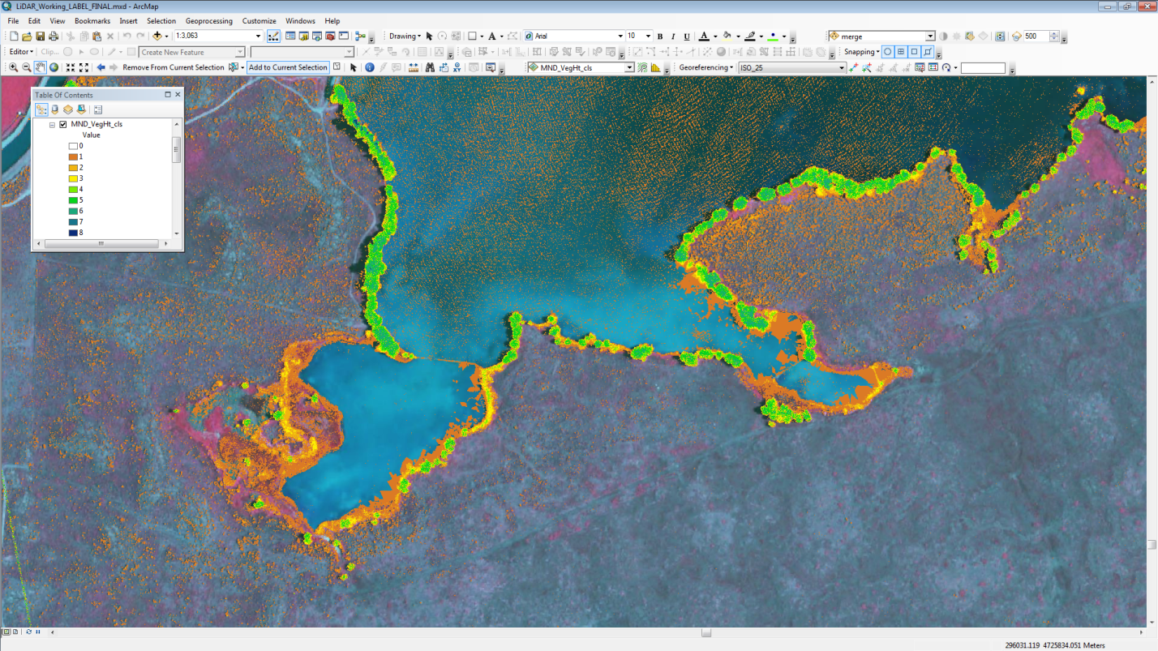
Figure 2 Example of vegetation height classification for Minidoka National Wildlife Refuge.

MND_VegHt_CNT
The vegetation class count table shows the counts and percentages of each of the eight classes of MND_VegHt_cls within each segment polygon. Each class has an area (count) and a percent of total area. [VALUE_0], [VALUE_1]… [VALUE_8] represent the area of each class (0-8) respectively. The sum of these areas should equal the area of the polygon. [PCT_VAL1], [PCT_VAL2]... [PCT_VAL8] represent the percent of each value respectively and should sum to 100. These fields can query the class values or the percent total coverage to determine vegetation heights or overall height class percentages per polygon or across the landscape.

ISO_CNT
The classification table, ISO_CNT, contains the imagery classification area counts and percentages for each polygon. The classification was derived from supervised and unsupervised methods to attempt to correlate the different spectral signatures from aerial imagery and landscape observations. The individual classes were classified by photo-interpretation, professional experience and field site visits. The area and percentages of the classes were used in conjunction with the vegetation heights and field information to quantify overall percent cover of cover components. These components are represented in the database by percentages of grass ([PCT_GRASS]), cheatgrass ([PCT_CHEAT]), crested wheat ([PCT_CW]), shrub ([PCT_SHRUB)], tree ([PCT_TREE)] and bare ground ([PCT_BARE)].
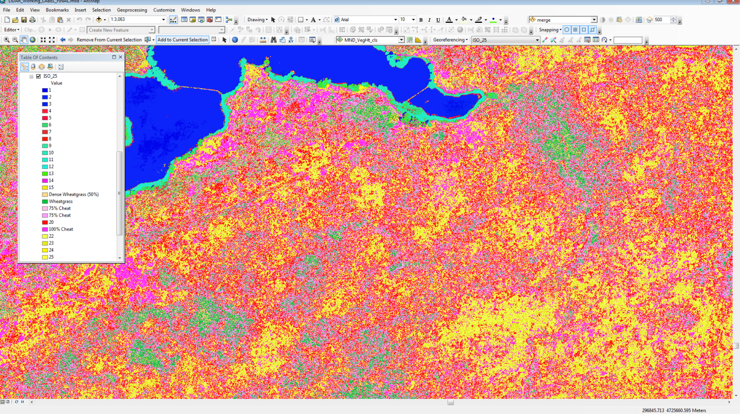
Figure 3 Example of ISO Classification of Minidoka National Wildlife Refuge for various cover types.
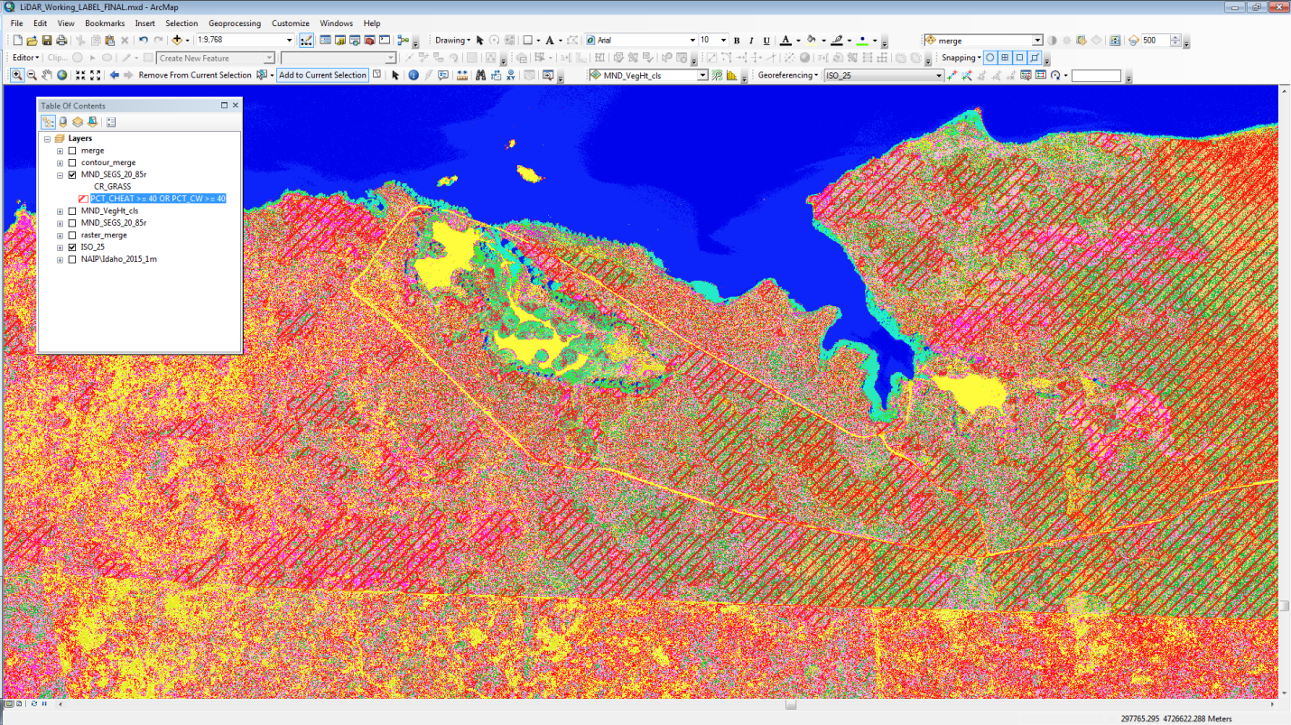
Figure 4 Example of SQL query for cheatgrass or crested wheat grass greater than 40% estimated cover.
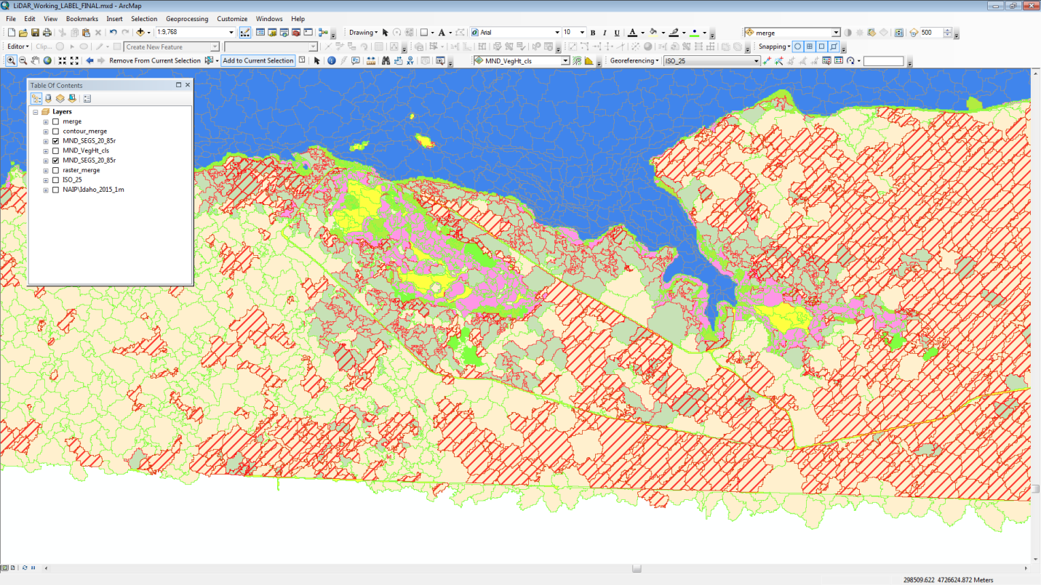
Figure 5 Example of SQL query for cheatgrass or crested wheat grass greater than 40% estimated cover

ACCURACY ASSESSMENT
A field‐based accuracy assessment was completed in December of 2017.
The Surveying team, over the course of the two years of field assessment, visited a series of polygons to characterize which would comprise the training and accuracy data for the mapping. The surveyor navigated to the field polygon using GPS units. When the surveyor was within the field polygon, they used the Minidoka NWR vegetation key (Appendix 1) to label a point with a map class. 5 photos were taken of the point, one in each cardinal direction, and 1 towards the ground.
If there was some confusion regarding which mapping class the vegetation should go into, secondary, and if necessary, tertiary calls were made. For example, if it was not clear that a particular vegetation patch was Baltic Rush, or Ruderal Wet Meadow, then both were recorded. In the final accuracy assessment, both would be considered “acceptable” calls.
All points were collected into a database and intersected with the final vegetation polygons. This gave us an AA data set of 216 points. Not all map classes had reported map accuracy.

Conclusions
The vegetation of Minidoka National Wildlife Refuge was mapped following a hybrid remote sensing and classification scheme. The methodology consisted of field‐based vegetation classification, remote sensing methods including image segmentation, supervised and unsupervised classification, photo interpretation, and field validation. A field‐based accuracy assessment was conducted.
Overall, the accuracy was within excepted error limits. This is quite good for a map to this level of detail. The reported accuracy is for the finest level of class distinction. If the map and points were rolled up (generalized) into the coarser classes (structure), or CCP classes higher accuracies would be expected.
This level of accuracy and detail should provide managers and planners with a new level of information to visualize and develop alternatives over the entire refuge. Over time, this map should be updated to reflect changing conditions. The map should be of high enough quality and detail to allow refuge or I&M staff to update the map without recreating it.

