Minidoka Vegetation Sampling Geodatabase User Guide
Table of Contents
Introduction 2
Data Model Description 4
Procedures for Checking Out and Checking in ArcPad Layers for Field Data Collection 6
Prepare files for check out to mobile device 8
Prepare Reference Layers 13
Definition Queries 14
Load the data to the GPS Unit 16
ArcPad Instructions 19
Setting up the GPS Maps for Field Work 19
Background Layers 20
Editing Features 21
All Form Properties 23
Sample ID - Group Form* 24
Alliance_Assoc_EIA Form* 25
Alliance Data Entry Form 26
Map Class Data Entry Form 27
Association Data Entry Form 27
EIA1 Data Entry Form 28
EIA2 Data Entry Form 28
Site Info Data Entry Form 29
Comments Data Entry Form 29
Species Form 32
Species Data Entry Form 32
Comments Entry Form 33
ArcPad Navigation Aids 33
Full Segmentation Layer 33
Labelling Features within ArcPad 33
Go To Navigation 36
GPS Unit Performance 38
Check-in Data from GPS to Geodatabase (ArcMap) 40
Data Definition Tables 45
Table 1. Alliance Codes 46
Table 2. Alliance Scientific Names 47
Table 3. Alliance Common Names 49
Table 4. Association Code 51
Table 5. Association Name 53
Table 6. Association Shortened Scientific Name 55
Table 7. Group Code 61
Table 8. Group Name 62
Table 9. MacroGroup Code 63
Table 10. MacroGroup Name 63
Table 11. Species Common Name 64
Table 12. Species Scientific Name 73
Table 13. EIA Scores 81
Table 14. Cover Classes 81
Table 15. Height Classes 82
Table 16. Alliance Map Labels 82
Table 17. Alliance Aggregate Classes 83
Versioning 84

Introduction
The Minidoka Vegetation Sampling Geodatabase was developed in 2015 to support a field data collection effort to expand baseline knowledge of the vegetation communities and their condition (with comparison to high quality reference sites in the region [EIA]). Refuge staffs supported by a team of botanical experts on contract through NatureServe and the State of Idaho will collect vegetation community information along with a set of other habitat variables and measures. This information will inform a vegetation mapping/modeling process to generate a current cover map.
The field teams will be equipped with Trimble Juno3B GPS units running ArcPad.
The Minidoka Vegetation Sampling Geodatabase is a relational geodatabase consisting of one vector (point) feature class. Linked to the feature class (to be referred to as the Veg_Points for the remaining document), are two relational tables; Alliance_Assoc_EIA and Species
By developing this as a relational model it is possible to repeat monitoring for a point feature over a long period of time in a tidy data model that will be readily available for analysis.
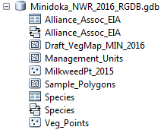
Veg_Point (vector) Feature Class Primary Key: Sample_ID
Alliance_Assoc_EIA
Species

This document will describe the data model and provide a process for using this data model along with a custom designed ArcPad form (.apl) for field data collection.

Data Model Description
This geodatabase and procedure works best when running ArcGIS 10.3.1 and ArcPad 10.2. R3.
Computer must have ArcPad 10 or higher and Microsoft Mobile Device Center installed.
Vegetation survey data will be stored in a point feature class. Two related tables store the specific information related to the vegetation class and Environmental Integrity Assessment (EIA).
- Veg_Points
- Alliance_Assoc_EIA (Table 1)- Alliance, Map Class, Association, EIA metrics and comments.
- Species (Table 2)- Species

A segmented layer was generated using eCognition, this segmentation delineates similar habitat into vegetation community polygons. The vegetation survey data will be used to train a classifier and label the polygons into NVCS classes.
- Sample_Polygons

Sample sites were randomly selected using the segmentation layer. Samples were spatially balanced across the refuge and stratified by landcover types (NLCD). Segments are classed if they are selected for sampling.
- Sample_Polygons (Definition Query Selected_Sample = 1)

Management Units were creatd and are included in the geodatabase for planning and navigation purposes. The outer boundaries of the management units also represent the boundaries of the refuge.
- Management_Units

In 2016, a draft map was created using 2015 field data as training points. This map utilizes the 2015 segmentation layer and has labelled the polygons with Alliance Map Labels (these are aggregated Alliances for the most part), Ruderal estimates, other structure attributes.
- Draft_VegMap_MIN_2016

Minidoka collects and manage their data in their local UTM projection, so to facilitate the use of this system with their already existing data (such as roads, management units, aerial imagery, etc.) the preferred projection is local UTM zone.
Minidoka_Veg_2016_RGDB_v1.gdb

Minidoka_Veg_2016_RGDB_v1.mxd
Layer files- symbology (ArcMap and ArcPad) are available for the feature classes included in the geodatabase.
- Draft_VegMap_MIN_2016.lyr
- Sample_Polygons.lyr (Definition Query set on)
- Sample_Points.lyr (Derived center points for the sample Polygons, may be less intense on the units processing to navigate using the point layer, then on approach turn on the segmentation)
- Full_Segments.lyr (Sample_Polygons)
- Veg_Points.lyr
- Management_Units.lyr

A custom layer file for the Veg_Points feature class to be used on the GPS unit, which will generate a custom field form is provided.
Minidoka_Veg_2016_RGDB_v1.apl

Procedures for Checking Out and Checking in ArcPad Layers for Field Data Collection
A preloaded MXD is provided. Fix broken links as needed.
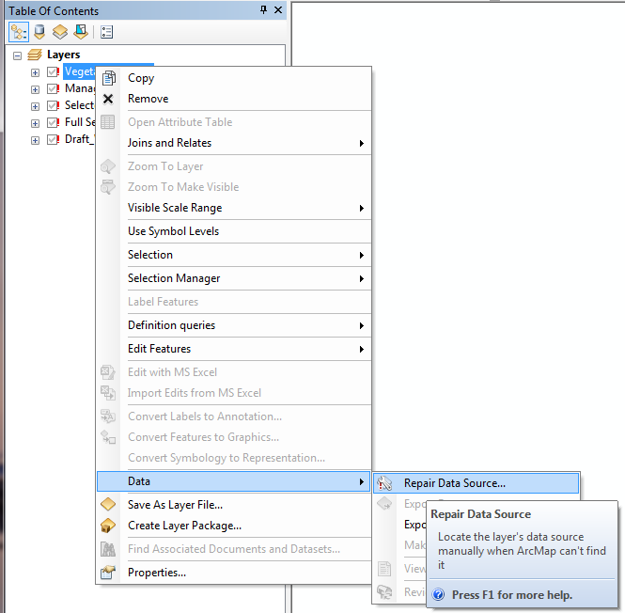
If no MXD is available, Start ArcGIS, add the data layer from MMG_GCS_v1.gdb* > Grid_50m_GCS
Zoom to your refuge, Save Map Document.
If needed, Use the Layer Properties>Symbology to set the layer properties. Layers are provided for the following feature classes.
- Draft_VegMap_MIN_2016.lyr
- Sample_Polygons.lyr (Definition Query set on)
- Sample_Points.lyr (Derived center points for the sample Polygons, may be less intense on the units processing to navigate using the point layer, then on approach turn on the segmentation)
- Full_Segments.lyr (Sample_Polygons)
- Veg_Points.lyr
- Management_Units.lyr

Ensure ArcPad tools are properly setup in ArcGIS.
Go to Customize and turn on ArcPad Data Manager.
Next, go to Toolbars and turn on ArcPad Data Manager.
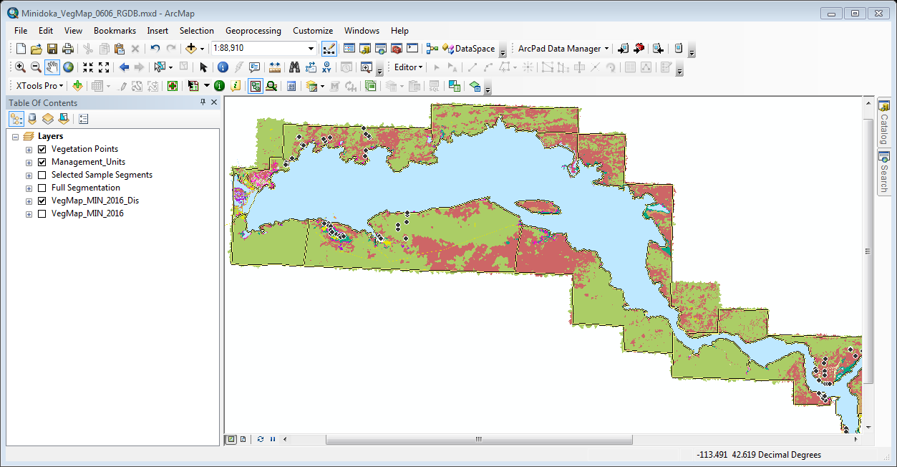

Prepare files for check out to mobile device
First set the viewer to the extent of the data you want to check-out. Smaller extent checkouts can be preferable if you intend to package up imagery to check out in your project or if you have a large refuge or survey area. It is recommended if you have a large survey area to break your checkout into smaller ‘units’. Large extents will take longer to process and can slow down the GPS unit response times.
The recommended method is to perform a checkout based on the Management Unit extent if you at a large refuge.
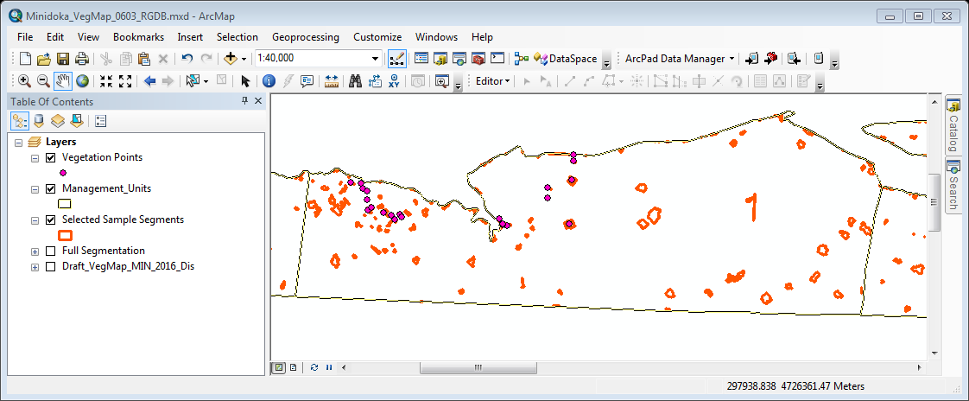
Preprocessing Unit checkouts for field work can be a time saver, by doing this in advance you can be at the ready to visit any part of the refuge on short notice.
Go to the ArcPad Data Manager Toolbar
Click Get Data for ArcPad. Next to Welcome Screen (you can select the box to Not Show Again).
The Select Data screen will open. Update the Action column (right click) for each of the layers. Many Some layers can be checked out as background layers for navigation or other orientation purposes, but they all must have the same projection as the Veg_Points grid feature class. ArcPad cannot project on the fly.
ArcPad provides very simple Go To functionality for editable layers. Recommend to Checkout Data for editing for navigation as well as data collection where it makes sense Veg_Points, Selected Sample Segments.
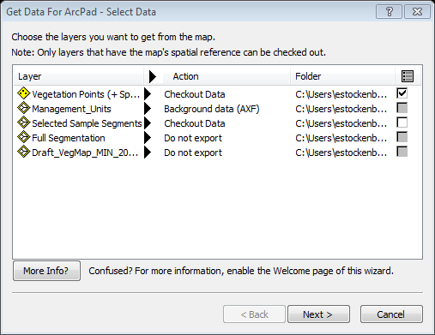
But we will be updating the Vegetation Points (Veg_Points) file. Update the Action for the point layer, Check Out for disconnected editing in ArcPad > Data based on defined extent. The defined extent is that extent shown in the map viewer/data frame window.
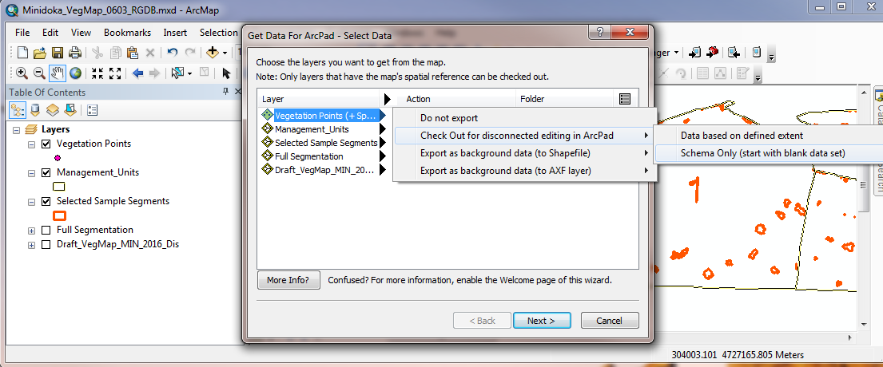
Next, check the check box at the end of the row to use the custom form called Minidoka_Veg_2016_RGDB_v1.apl

Checking the box will display the Open Layer ‘explorer’.
Navigate to the location of the Minidoka_Veg_2016_RGDB_v1.apl and click Open.
Click Next to Select the Picture Options. Update the folder path when the Photo field is being used in the data model, Click Next.
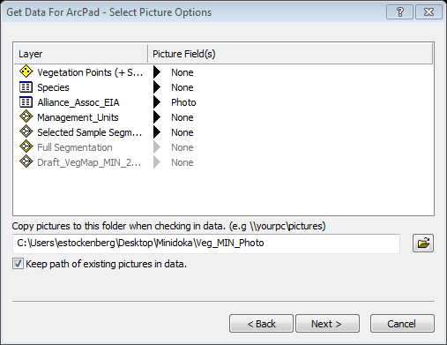
Click Next to Select the Output Options.
Use the current display extent to focus your data collection on the area to be surveyed using this checkout. It is recommended to only check out as large an extent as needed. Use of predefined bookmarks and survey target extents is recommended.
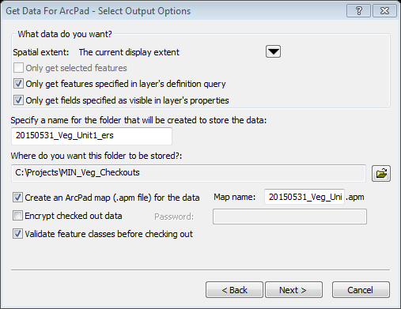
Create a folder to store the data. Set where you want to store the data. It is best to set-up a directory for this specifically. For example, ‘Veg_Checkouts’.
When the data from ArcMap is checked out a folder will be created to hold the checkout.
Tip: Name this folder will descriptive elements such as When_What_Where_Who. An example might be ‘20150531_Veg_Unit1_ers’.
Tip: Notice the date format, it is the best format for organizing your files according to date.
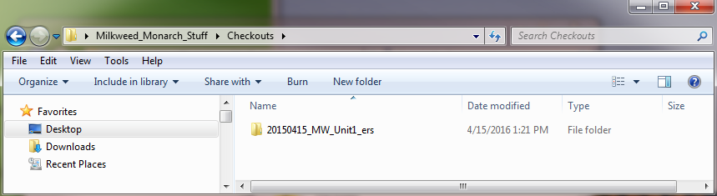
Lastly, give the map that will be opened in ArcMap a name. An easy way to keep it all straight is to use the folder name, you can just copy and paste. Click Next.
Leave all the other settings with the defaults on the Deployment Options screen.
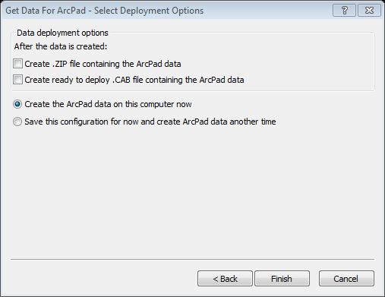
Click Finish.
This could take some time depending on the extent of the checkout. Be patient!
You ought to receive a message. Review to make sure the number of feature layers matches what you would expect.
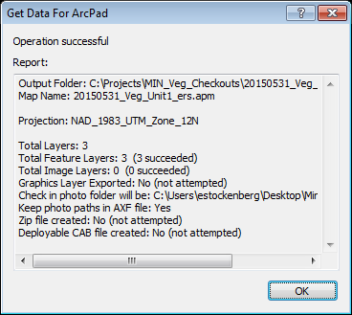
Click OK to close dialog box.
Tip: The symbology that is set in the current ArcMap document will be used in ArcPad.

Prepare Reference Layers
A good strategy for reference layers is to check them out and put them in a general file folder on the GPS unit, they can be added to a project at any time but do not need to be checked out every time. This reduces the checkout time and ensures the necessary files are always available on the GPS unit when in the field.
Preprocessed Checkouts are available with layer symbology. See ArcPad Instructions for more information on how to add these layers to your check-out.
- VegMap_Background
- Full_ Segmentation
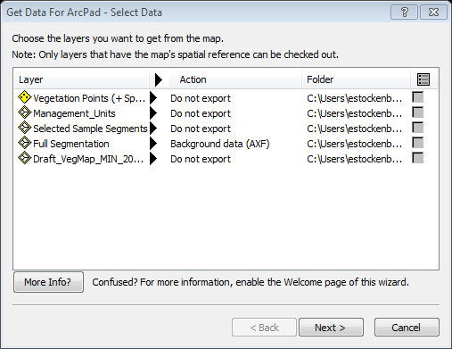
The VegMap layer is simply too big for the Juno to handle. It is essential to narrow down the extent of the checkout for field use.

Definition Queries
Definition queries are a nice way to limit the data you take into the field. For example, the sample frame (Selected Sample Segments) is coded with Management Units, each of these units have survey sites. You can limit the checkout procedure to only checkout a specific management unit.
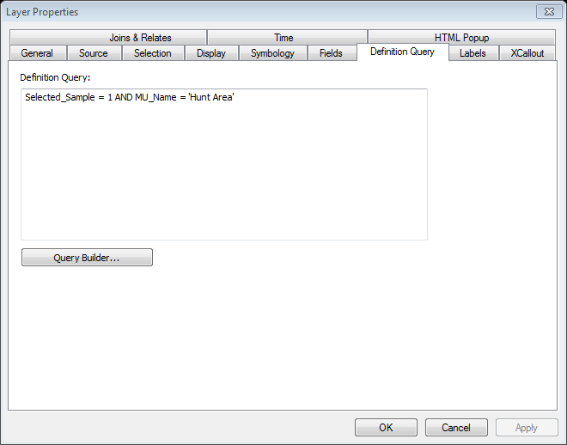
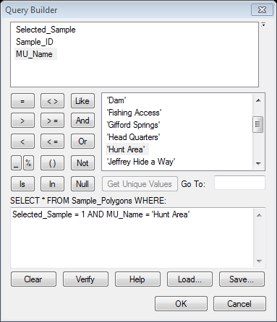
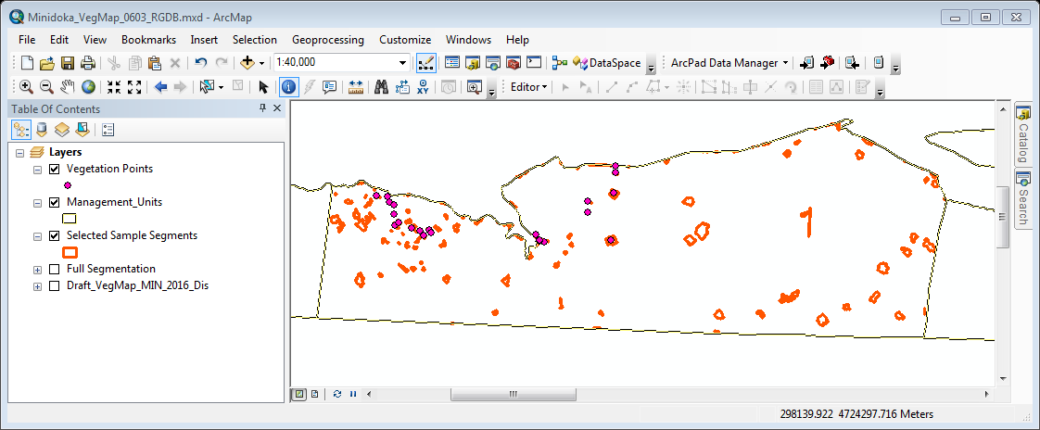

Load the data to the GPS Unit
Open Microsoft Mobile Device Manager
Plug your Trimble into the computer using the USB cord.
You will see a couple messages on the GPS indicating it is communicating and Microsoft Mobile Device Center should eventually indicate Connected. Connect without setting up your device.

Go to Connect without setting up your device, click.
Go to File Management. Browse the contents of your mobile device.

That will bring up an explorer window with your device showing. Double click on the drive.


Go to My Documents and create a folder for the project on the Trimble unit. In the example below the folder is named ‘Veg_Checkouts’. This folder will be used to store all your checkouts.
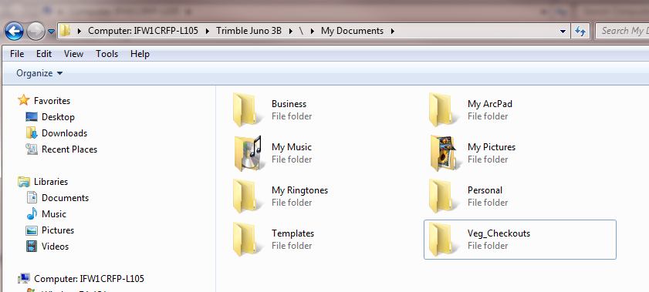
Now, go back to the location where you saved your ArcPad data and Copy the entire folder of prepared files. And any Background layer checkout you need to have.
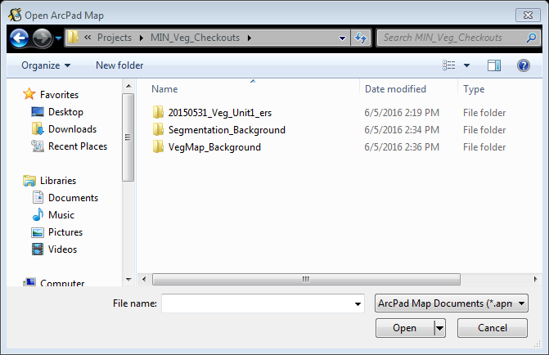
Return to the Trimble folder (set up in the previous step). And paste into the working directory folder. By copying this folder over, you have moved a copy to the GPS which will be used in the field (edits and new data collection).
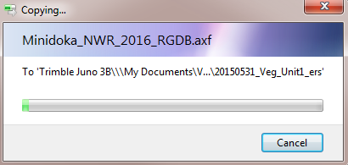
It is always good practice to open the map on the unit and take a test point before heading out to the field. You want to make sure everything loaded properly before you are out in the middle of nowhere!
If more than one field crew or field tech is going to collect data, do a separate checkout for each and name the folders accordingly.

ArcPad Instructions

Setting up the GPS Maps for Field Work

These steps can be done in the office prior to going out in the field.
Go to the GPS unit, Click the ArcPad icon and Choose map to open.
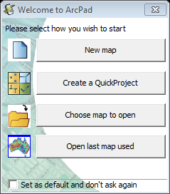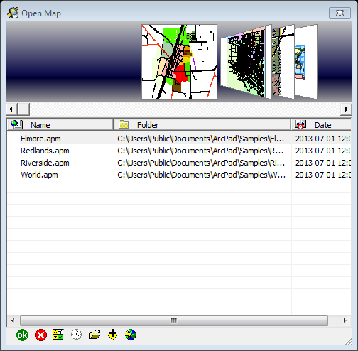
Navigate to the folder where the .apm (ArcPad map document) is stored. Open folder select the .apm file. Select the .apm and click Open.
Once the map opens zoom into a scale you can clearly see the sample points.
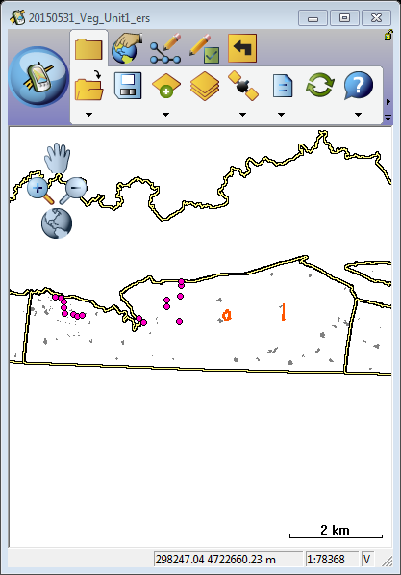
If you are connected to satellites you can alternatively set the GPS to Center on GPS. This will put the crosshairs in the middle of the screen and show you your position. When walking a red arrow like feature will point in the direction you are moving. This red arrow feature disappears when standing still.

Background Layers
If you are using pre-prepared background layers, add them into the project at this point.
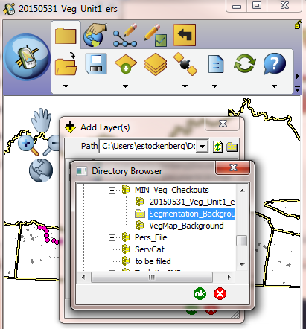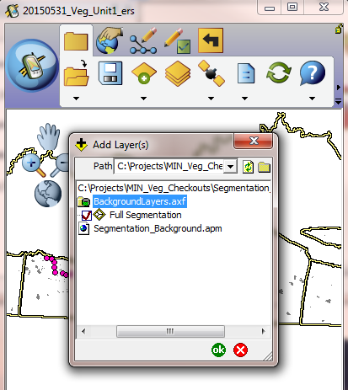
Since you do not want reference layers on at all times, go to the Layer properties and turn off the visibility.
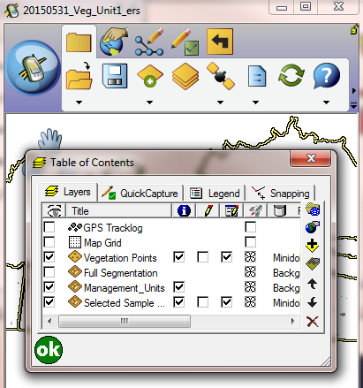
Save the .apm file.
Repeat the process for other background layers.
The VegMap layer is simply too big for the Juno to handle. It is essential to narrow down the extent of the checkout for field use.

Editing Features
When it is time to collect attributes, turn on editing for the point layer. Notice the red box around the icon, that red box indicates it is editable.
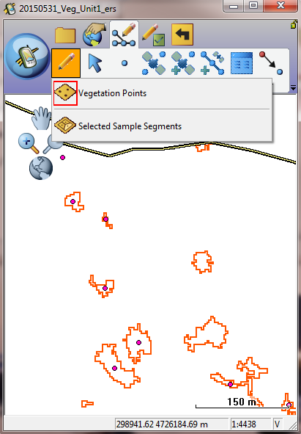
Practice taking a point using GPS capture and taking a point using the select tool.
To create a point, select the blue arrow and click on the map, OR use Select at GPS Position (if you are standing in the segment).
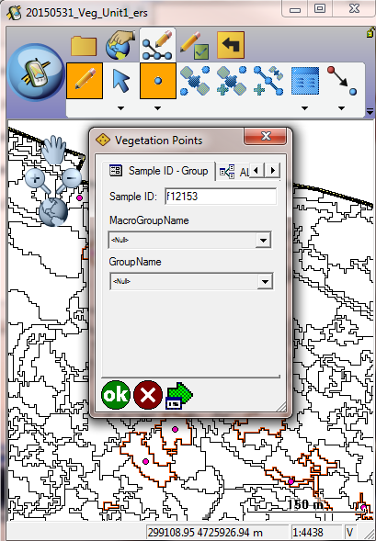
Once the feature is placed on the map the custom form should appear.
If you do not see the above form you did not check out the data using the custom form. Redo the process to ensure you have full functionality during your data collection.

All Form Properties
The following sections describe the requested data fields in each geodatabase form. The highlighted fields are required, the rest are optional but please fill them out if you have the opportunity.
Not all of these forms need to be filled out while in the field. The underlined form names with an asterisks need to be filled out in the field, the rest can be done in the office.
This geodatabase is relational. The Sample ID – Group is the primary feature class, it represents a layer made up of Veg_Points. Each point is related to two tables. The relationship between the feature class and the related tables is one:many. Meaning, for each point there can be many records associated in each of the tables. Multiple records (or attributes) are captured by filling out the respective form, selecting the blue arrow to get back to the main form page, and then selecting the add data button again (blue circle with white plus sign). Repeat this work flow as many times as you need to enter all appropriate attributes. This process will be described in more detail below.

Sample ID - Group Form*
This form is directly tied to the Veg_Point Feature Class.
Use the arrows to move between the tabs in order to enter data in the various relational tables. Each table has its own tab.
The graphic below is expanded to show all the tabs, each tab corresponds to the feature class and the relational tables .
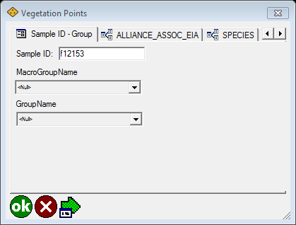

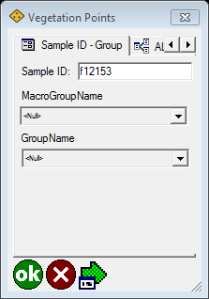
Work through as many of the tabs as necessary, and then click the green OK button.
The green OK button completes the record (a feature class record and related table records), and closes the forms.
Do not click the green OK button until you have completed the Grid Properties and the Related Table tabs, as needed.
Sample ID: Refer to the Sample Segments or Full Segmentation layer for the Sample ID. Only one point should be placed within any given segment.
MacroGroup Name:
Group Name:

Alliance_Assoc_EIA Form*
This form is used to report Alliance, Association community classification and EIA scores at the observation site.
Alliance, Association and EIA scores are stored in a relational table. To add to the table select the blue circle with plus sign.
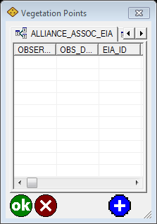
There are a series of forms that you will work through to add all the attributes for the site.
See Table X for list of choices and definitions. (Relational table, multiple records may be entered for a single cell)
When the tab is selected the attribute table is displayed showing all records for the selected feature (grid cell).

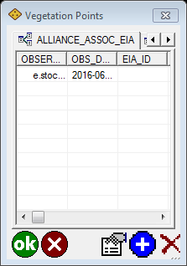

Clicking on a record in the attribute table will select it and a record marker will show to the far left of the record and it may be highlighted 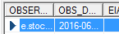
The show attributes button  can be used to review the record in form view, or a scrollbar can be used to scroll across and review the attributes.
Click the blue plus sign button  to open the form and enter data.
The red X  will delete the selected record in the attribute table

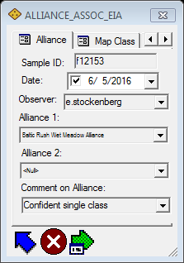

Alliance Data Entry Form
Click the blue arrow button  after updating the data fields to close the form and return to the attribute table.
The green arrow is useful if you will be repeating an attribute, such as Observer or Alliance. This will save the value for the next record, and use it as a temporary default.
To turn this on, fill in the attributes you will want repeated and click the green arrow. It will then become highlighted . The default setting can be deactivated on any subsequent new record by re-clicking the green arrow, this will remove the highlighting.

Map Class Data Entry Form
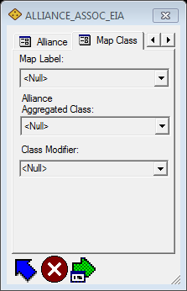

Association Data Entry Form
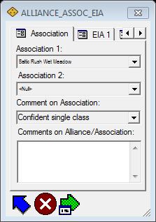

EIA1 Data Entry Form
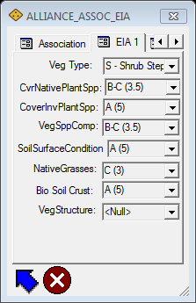

EIA2 Data Entry Form
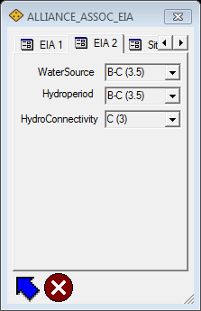

Site Info Data Entry Form
This form is used to report other site information for refuge analysis and mapping at the observation site. Values for percent of biologic crust, bare soil, rock, litter and ruderal must be recorded as an integer (no decimals, no special characters, no letter. Values should be within the range of 0-100.
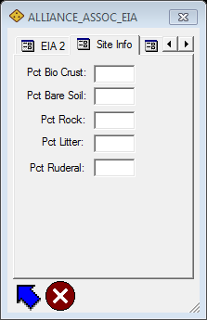

Comments Data Entry Form
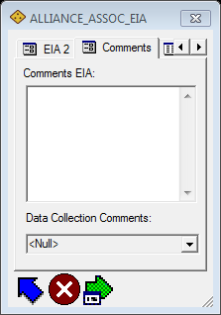

TIP: Alternate Workflow for Alliance_Assoc_EIA Tab
An alternate workflow for collecting the attributes is to scroll over to the Attributes tab. The Attributes tab lists every field in the forms described above and can be used for data entry. The example below has been expanded to show the entire attribute table. In general only a small portion can be viewed on handheld devices so more scrolling may be required.

Expanded Desktop View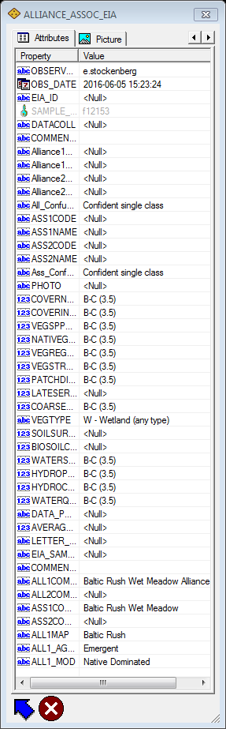
Typical handheld view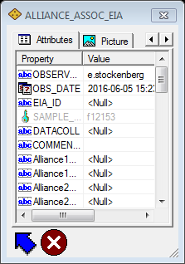

Species Form
This form is used to report known species that occur on the site.
See Table X for list of choices and definitions. Species are stored in a relational table, multiple records may be entered for a single point. When the tab is selected the attribute table is displayed showing all records for the selected feature. If new feature the table will appear blank.
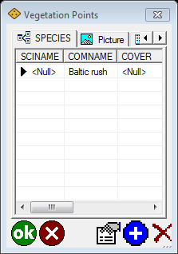

Attribute Table view
Clicking on a record in the attribute table will select it and a record marker will show to the far left of the record and it may be highlighted .
The show attributes button can be used to review the record in form view, or a scrollbar can be used to scroll across and review the attributes.
Click the blue plus sign button to open the form and enter data.
The red X will delete the selected record in the attribute table.
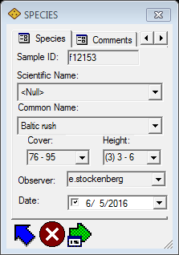

Species Data Entry Form
Click the blue arrow button after updating the data fields to close the form and return to the attribute table.
The green arrow is useful if you will be repeating an attribute, such as Observer and Date. This will save the value for the next record, and use it as a temporary default.
To turn this on, fill in the attributes you will want repeated and click the green arrow. It will then become highlighted . The default setting can be deactivated on any subsequent new record by re-clicking the green arrow, this will remove the highlighting.

Comments Entry Form
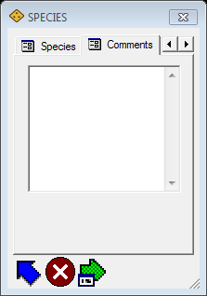

ArcPad Navigation Aids

Full Segmentation Layer
These features can be selected from the map viewer and used for assisted navigation. They can also be labelled, on the fly, on the field unit.

Labelling Features within ArcPad
Layers checked out from ArcMap can be labelled on the fly using ArcPad. This is very useful for reviewing and selecting sample sites for surveying.
Go to the main screen. Select the layers icon. A window will open that can be used to control the functionality of each layer. There are many options here such as limiting which layers can utilize the identify window. Also limiting which layers are editable.
To access the symbology and labelling options, select the layer you want to set labels, then click the little hand over feature button.
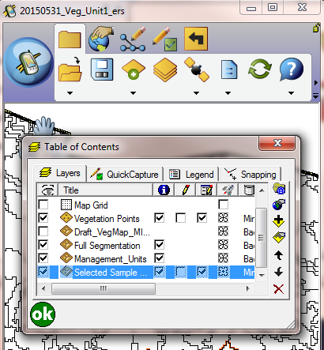
A new window will open, select the Labels tab. Change the radial button to Labels using field: and set the dropdown to SAMPLE_ID. Click OK. Adjust the font size by clicking the red A.
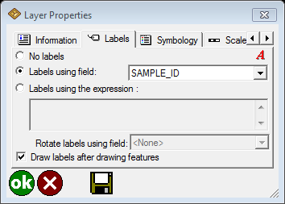

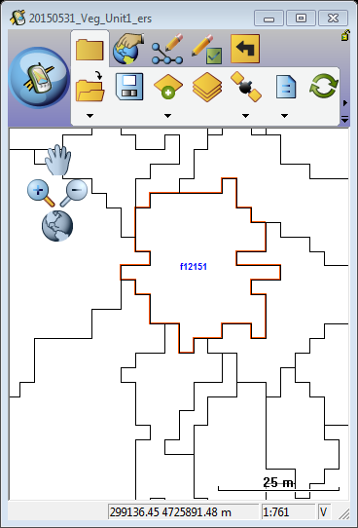

Go To Navigation
Go To Selected Features is a handy way to use the ArcPad map as a way to identifying and navigating to your survey sites. Once you have the labels turned on you can clearly see the plot order of all the available survey sites.
To use this functionality go to the edit menu and turn on the editing for the survey sites layer. To use navigation this way the layer that you want to target must be an editable layer!
Then Select the next site using the select tool. And then click Go to Selected Feature.
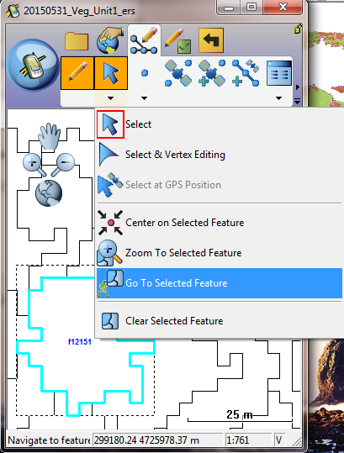
The destination is displayed with a Mark label.
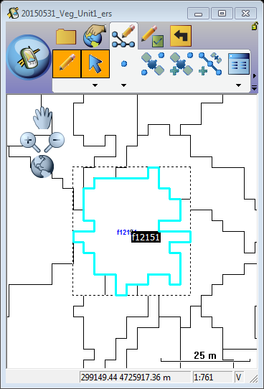
Use the GPS Position Window to view the distance (DST) and bearing (BRG) from your current GPS position to your selected destination
Tip
Activating the GPS: It is not necessary to activate the GPS before selecting a navigation destination. However, the GPS does need to be activated in order to open the GPS Position Window and view the distance and bearing to the destination.
Tip
Clearing the selected destination: To clear the selected destination and remove the destination Mark label, tap the Clear Selected Feature located on the drop-down list below the Select menu on the toolbar. The Mark label is displayed when a destination has been selected.

GPS Unit Performance
GPS unit performance can be improved by reducing the number of visible layers while navigating. It can take a lot of processing power to redraw very detailed layers such as the segmentation or draft veg map. It is best to keep these turned off until they are needed (you are within range of the target).
It is always best practice to stop editing after data collection is finished and before exiting the map, and save and close your map on the GPS unit before downloading the data back to your computer.

*************************************************************************************

Scroll through each of the tabs and fill in the attributes that are appropriate.
Be sure to click the green OK to save.
It is always best practice to stop editing after data collection is finished and before exiting the map, and save and close your map on the GPS unit before downloading the data back to your computer.

Check-in Data from GPS to Geodatabase (ArcMap)
Connect your GPS to the computer and let Mobile device center connect.
Now the data will be copied from the device to your checkout folder, and you will be replacing the checkout with your edited version. But first, make a backup! Make a copy and stick it into your check-in backup folder before you replace the actual checked out folder.
When you attempt to overwrite the checked out (not edited) folder with your edited version you will receive a warning, click Yes and proceed.
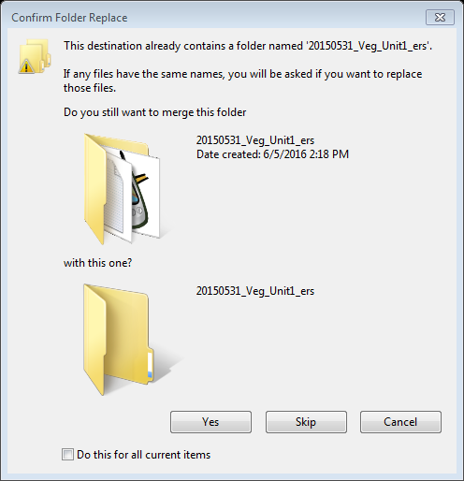
Return to ArcPad Data Manager.

Use the Green plus to navigate to your edited checkout data. Select the axf file. You will then see a summary of how many features and relational table records were added and/or modified. Select the Feature Classes with new or modified data. Click Check in.
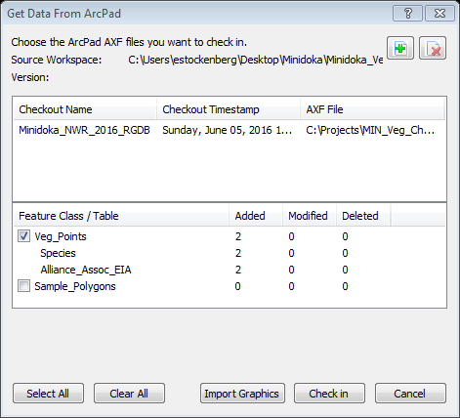
If you do this process outside an edit session you will receive a warning that you cannot undo. If you are worried; Cancel, go into an edit session and return to this point that way you can undo if need be.
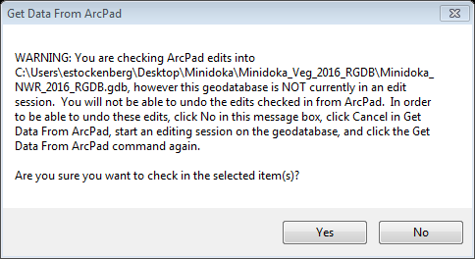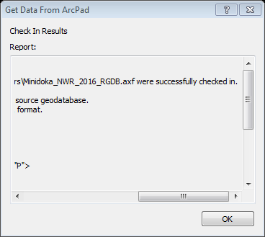
The check-in process may take some time depending on the number of features collected and the size of the extent. Please be patient!
A Results dialog will appear and look to see that your layers were successfully checked in.
Scroll across and look for the successfully checked in message. Click OK. Then Cancel out of the Get Data from ArcPad window.

Go look at your data!
Remember the data is now normalized across one feature class and two relational tables. The link between the tables is the Sample_ID.
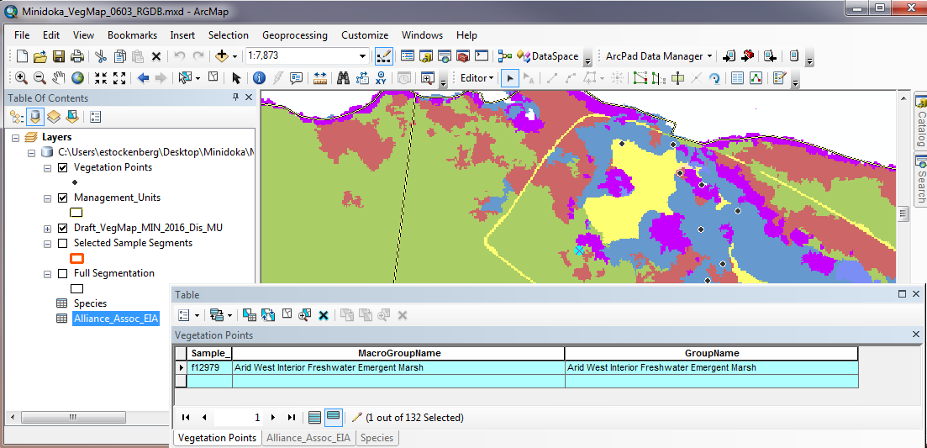
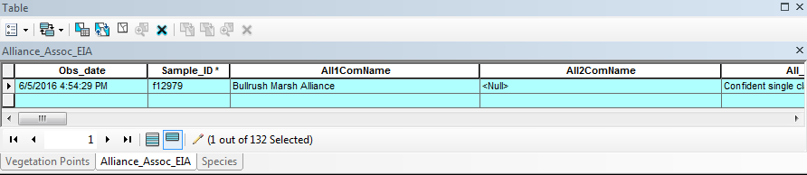
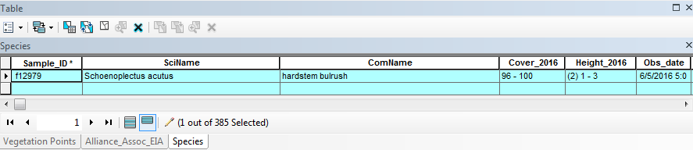
The Identify tool is also useful for looking at records in relational tables.
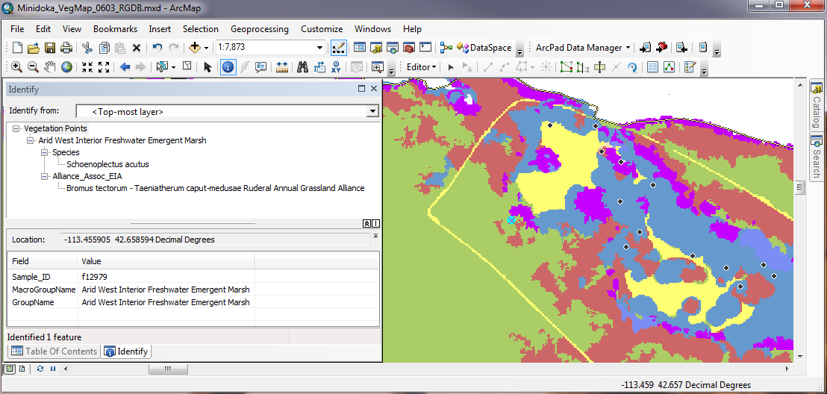

Data Definition Tables

Table 1. Alliance Codes
AllCode
Code | Description
A1046 | A1046
A1262 | A1262
A1270 | A1270
A1329 | A1329
A1332 | A1332
A1374 | A1374
A1814 | A1814
A3183 | A3183
A3194 | A3194
A3195 | A3195
A3196 | A3196
A3202 | A3202
A3257 | A3257
A3496 | A3496
A3497 | A3497
A3566 | A3566
A3759 | A3759
A3798 | A3798
A3799 | A3799
A3800 | A3800
A3806 | A3806
A3807 | A3807
A3847 | A3847
A3848 | A3848
A3849 | A3849
A3895 | A3895
A3896 | A3896
A3927 | A3927
A3975 | A3975
A3985 | A3985
A3988 | A3988
A4011 | A4011
A4148 | A4148
A4149 | A4149
A4165 | A4165
A4192 | A4192
A4213 | A4213
A4217 | A4217
Anew01 | Anew01
Anew02 | Anew02
Anew03 | Anew03
Anew04 | Anew04
nd | No Data
sc | See Comments
zb | Bare Ground
zc | Cultivated Crops
zd | Developed
zw | Open Water

Table 2. Alliance Scientific Names
AllSciName
Code | Description
Achnatherum hymenoides - Pseudoroegneria spicata - Muhlenbergia pungens Grassland Alliance | Achnatherum hymenoides - Pseudoroegneria spicata - Muhlenbergia pungens Grassland Alliance
Agropyron cristatum Western Ruderal Perennial Grassland Alliance | Agropyron cristatum Western Ruderal Perennial Grassland Alliance
Amaranthus (californica, powellii) Sparce Mud Flat Alliance | Amaranthus (californica, powellii) Sparce Mud Flat Alliance
Artemisia spp. - Mixed Shrub Ruderal Understory Shrubland Alliance | Artemisia spp. - Mixed Shrub Ruderal Understory Shrubland Alliance
Artemisia tridentata ssp. tridentata - Artemisia tridentata ssp. xericensis Dry Shrubland Alliance | Artemisia tridentata ssp. tridentata - Artemisia tridentata ssp. xericensis Dry Shrubland Alliance
Artemisia tridentata ssp. tridentata - Artemisia tridentata ssp. xericensis Mesic Shrubland & Steppe Alliance | Artemisia tridentata ssp. tridentata - Artemisia tridentata ssp. xericensis Mesic Shrubland & Steppe Alliance
Bare Ground | Bare Ground
Bromus tectorum - Taeniatherum caput-medusae Ruderal Annual Grassland Alliance | Bromus tectorum - Taeniatherum caput-medusae Ruderal Annual Grassland Alliance
Carex praegracilis - Carex scopulorum - Eleocharis quinqueflora Herbaceous Alliance | Carex praegracilis - Carex scopulorum - Eleocharis quinqueflora Herbaceous Alliance
Centaurea solstitialis - Isatis tinctoria - Salsola tragus Ruderal Annual Forb Alliance | Centaurea solstitialis - Isatis tinctoria - Salsola tragus Ruderal Annual Forb Alliance
Chrysothamnus viscidiflorus Shrubland & Shrub Herbaceous Alliance | Chrysothamnus viscidiflorus Shrubland & Shrub Herbaceous Alliance
Conyza canadensis - Cirsium arvense - Lactuca serriola Ruderal Herbaceous Alliance | Conyza canadensis - Cirsium arvense - Lactuca serriola Ruderal Herbaceous Alliance
Cultural Vegetation | Cultural Vegetation
Developed | Developed
Distichlis spicata Alkaline Wet Meadow Alliance | Distichlis spicata Alkaline Wet Meadow Alliance
Elaeagnus angustifolia Ruderal Woodland Alliance | Elaeagnus angustifolia Ruderal Woodland Alliance
Eleocharis palustris - Eleocharis acicularis Marsh Alliance | Eleocharis palustris - Eleocharis acicularis Marsh Alliance
Elymus lanceolatus - Hesperostipa comata - Phacelia hastata Central Rocky Mountain Sand Deposit Grassland Alliance | Elymus lanceolatus - Hesperostipa comata - Phacelia hastata Central Rocky Mountain Sand Deposit Grassland Alliance
Ericameria nauseosa - Eriogonum leptocladon - Tetradymia tetrameres Sparse Scrub Alliance | Ericameria nauseosa - Eriogonum leptocladon - Tetradymia tetrameres Sparse Scrub Alliance
Ericameria nauseosa Shrubland & Shrub Herbaceous Alliance | Ericameria nauseosa Shrubland & Shrub Herbaceous Alliance
Festuca idahoensis - Pseudoroegneria spicata - Pascopyrum smithii Mesic Grassland Alliance | Festuca idahoensis - Pseudoroegneria spicata - Pascopyrum smithii Mesic Grassland Alliance
Great Basin & Intermountain Ruderal Shrubland | Great Basin & Intermountain Ruderal Shrubland
Hesperostipa comata Bunch Herbaceous Alliance | Hesperostipa comata Bunch Herbaceous Alliance
Juncus balticus - Juncus mexicanus Herbaceous Alliance | Juncus balticus - Juncus mexicanus Herbaceous Alliance
Juniperus osteosperma / Herbaceous Understory Woodland & Savanna Alliance | Juniperus osteosperma / Herbaceous Understory Woodland & Savanna Alliance
Juniperus osteosperma / Shrub Understory Woodland Alliance | Juniperus osteosperma / Shrub Understory Woodland Alliance
Krascheninnikovia lanata Dwarf-shrubland & Dwarf-shrub Herbaceous Alliance | Krascheninnikovia lanata Dwarf-shrubland & Dwarf-shrub Herbaceous Alliance
Leymus cinereus - Leymus triticoides Herbaceous Alliance | Leymus cinereus - Leymus triticoides Herbaceous Alliance
No Data | No Data
Open Water | Open Water
Phragmites australis - Arundo donax - Alopecurus pratensis Ruderal Marsh Alliance | Phragmites australis - Arundo donax - Alopecurus pratensis Ruderal Marsh Alliance
Physocarpus malvaceus - Symphoricarpos albus Mesic Shrubland Alliance | Physocarpus malvaceus - Symphoricarpos albus Mesic Shrubland Alliance
Poa pratensis - Agrostis gigantea - Agrostis stolonifera Ruderal Marsh Alliance | Poa pratensis - Agrostis gigantea - Agrostis stolonifera Ruderal Marsh Alliance
Poa secunda - Muhlenbergia richardsonis - Carex douglasii Moist Meadow Alliance | Poa secunda - Muhlenbergia richardsonis - Carex douglasii Moist Meadow Alliance
Populus angustifolia Riparian Woodland & Forest Alliance | Populus angustifolia Riparian Woodland & Forest Alliance
Populus deltoides - Populus alba- Robina pseudoacacia Planted/Escaped Woodland | Populus deltoides - Populus alba- Robina pseudoacacia Planted/Escaped Woodland
Populus deltoides ssp. wislizeni - Populus deltoides ssp. monilifera - Salix amygdaloides Riparian Woodland Alliance | Populus deltoides ssp. wislizeni - Populus deltoides ssp. monilifera - Salix amygdaloides Riparian Woodland Alliance
Potamogeton natans - Polygonum amphibium Aquatic Vegetation Alliance | Potamogeton natans - Polygonum amphibium Aquatic Vegetation Alliance
Redfieldia flexuosa - Leymus flavescens - Achnatherum hymenoides Grassland Alliance | Redfieldia flexuosa - Leymus flavescens - Achnatherum hymenoides Grassland Alliance
Rhus trilobata - Crataegus rivularis - Forestiera pubescens Shrubland Alliance | Rhus trilobata - Crataegus rivularis - Forestiera pubescens Shrubland Alliance
Salix alba - Salix fragilis Ruderal Riparian Forest Alliance | Salix alba - Salix fragilis Ruderal Riparian Forest Alliance
Salix exigua - Salix irrorata Shrubland Alliance | Salix exigua - Salix irrorata Shrubland Alliance
Salix spp. - Artemisia cana Ruderal Understory Wet Shrubland Alliance | Salix spp. - Artemisia cana Ruderal Understory Wet Shrubland Alliance
Sarcobatus vermiculatus Intermountain Shrub Alliance | Sarcobatus vermiculatus Intermountain Shrub Alliance
Schoenoplectus americanus - Schoenoplectus acutus - Scirpus microcarpus Herbaceous Emergent Alliance | Schoenoplectus americanus - Schoenoplectus acutus - Scirpus microcarpus Herbaceous Emergent Alliance
See Comments | See Comments
Suaeda occidentalis - (& other Alkaline annual forbs) Sparse Semi-Alkaline Wet Meadow | Suaeda occidentalis - (& other Alkaline annual forbs) Sparse Semi-Alkaline Wet Meadow
Typha domingensis - Typha latifolia - Typha angustifolia Western Herbaceous Emergent Alliance | Typha domingensis - Typha latifolia - Typha angustifolia Western Herbaceous Emergent Alliance

Table 3. Alliance Common Names
AllComName
Code | Description
Amaranthus (californica, powellii) Sparce Mud Flat Alliance | Amaranthus (californica, powellii) Sparce Mud Flat Alliance
Baltic Rush Wet Meadow Alliance | Baltic Rush Wet Meadow Alliance
Bare Ground | Bare Ground
Basin Big Sagebrush Dry Shrubland Alliance | Basin Big Sagebrush Dry Shrubland Alliance
Basin Big Sagebrush Mesic Steppe & Shrubland Alliance | Basin Big Sagebrush Mesic Steppe & Shrubland Alliance
Basin Wildrye - Beardless Wildrye Alkaline Wet Meadow Alliance | Basin Wildrye - Beardless Wildrye Alkaline Wet Meadow Alliance
Blowout Grass - Yellow Wildrye - Indian Ricegrass Grassland Alliance | Blowout Grass - Yellow Wildrye - Indian Ricegrass Grassland Alliance
Bullrush Marsh Alliance | Bullrush Marsh Alliance
Cattail Marsh Alliance | Cattail Marsh Alliance
Cheatgrass - Medusa head Ruderal Annual Grassland Alliance | Cheatgrass - Medusa head Ruderal Annual Grassland Alliance
Clustered Sedge - Mt Sedge - Fewflower Spikerush Wet Meadow Alliance | Clustered Sedge - Mt Sedge - Fewflower Spikerush Wet Meadow Alliance
Common Reed - Giant Reed - Meadow Foxtail Ruderal Marsh Alliance | Common Reed - Giant Reed - Meadow Foxtail Ruderal Marsh Alliance
Common Spikerush - Needle Spikerush Marsh Alliance | Common Spikerush - Needle Spikerush Marsh Alliance
Coyote Willow - Bluestem Willow Shrubland Alliance | Coyote Willow - Bluestem Willow Shrubland Alliance
Crack Willow - White Willow Ruderal Riparian Forest Alliance | Crack Willow - White Willow Ruderal Riparian Forest Alliance
Crested Wheatgrass Western Ruderal Perennial Grassland Alliance | Crested Wheatgrass Western Ruderal Perennial Grassland Alliance
Cultural Vegetation | Cultural Vegetation
Developed | Developed
Eastern Cottonwood - White Poplar - Black Locust Planted/Escaped Woodland Alliance | Eastern Cottonwood - White Poplar - Black Locust Planted/Escaped Woodland Alliance
Greasewood Intermountian Wet Shrubland Alliance | Greasewood Intermountian Wet Shrubland Alliance
Great Basin & Intermountain Ruderal Shrubland | Great Basin & Intermountain Ruderal Shrubland
Green Rabbitbrush Shrubland Alliance | Green Rabbitbrush Shrubland Alliance
Horseweed - Canada Thistle - Prickly lettuce Ruderal Herbaceous Alliance | Horseweed - Canada Thistle - Prickly lettuce Ruderal Herbaceous Alliance
Idaho Fescue - Bluebunch Wheatgrass - Mesic Grassland Alliance | Idaho Fescue - Bluebunch Wheatgrass - Mesic Grassland Alliance
Indian Ricegrass - Bluebunch wheatgrass - Sandhill Muhly Grassland Alliance | Indian Ricegrass - Bluebunch wheatgrass - Sandhill Muhly Grassland Alliance
Kentucky Bluegrass - Redtop - Creeping Bentgrass Ruderal Marsh Alliance | Kentucky Bluegrass - Redtop - Creeping Bentgrass Ruderal Marsh Alliance
Narrowleaf Cottonwood Riparian Woodland Alliance | Narrowleaf Cottonwood Riparian Woodland Alliance
Needle and Thread Grassland Alliance | Needle and Thread Grassland Alliance
Ninebark - Snowberry Mesic Shrubland Alliance | Ninebark - Snowberry Mesic Shrubland Alliance
No Data | No Data
Open Water | Open Water
Peach Leaf Willow (Rio Grande - Plains Cottonwood) Woodland Alliance | Peach Leaf Willow (Rio Grande - Plains Cottonwood) Woodland Alliance
Pondweed Aquatic Vegetation Alliance | Pondweed Aquatic Vegetation Alliance
Rubber Rabbitbrush - Sand Buckwheat - Fourpart Horsebrush Sparse Scrub Alliance | Rubber Rabbitbrush - Sand Buckwheat - Fourpart Horsebrush Sparse Scrub Alliance
Rubber Rabbitbrush Shrubland Alliance | Rubber Rabbitbrush Shrubland Alliance
Russian Olive Ruderal Riparian Scrub Alliance | Russian Olive Ruderal Riparian Scrub Alliance
Sagebrush (native) - Mixed shrub (native) Ruderal understory Shrubland Alliance | Sagebrush (native) - Mixed shrub (native) Ruderal understory Shrubland Alliance
Saltgrass Alkaline Wet Meadow Alliance | Saltgrass Alkaline Wet Meadow Alliance
Sandberg Bluegrass - Mat Muhly - Douglas' Sedge Moist Meadow Alliance | Sandberg Bluegrass - Mat Muhly - Douglas' Sedge Moist Meadow Alliance
See Comments | See Comments
Suaeda occidentalis - (& other Alkaline annual forbs) Sparse Semi-Alkaline Wet Meadow | Suaeda occidentalis - (& other Alkaline annual forbs) Sparse Semi-Alkaline Wet Meadow
Sumac - Hawthorn - Stretchberry Shrubland Alliance | Sumac - Hawthorn - Stretchberry Shrubland Alliance
Thickspike wheatgrass - Needle and Thread Grass - Silver Phacelia Grassland Alliance | Thickspike wheatgrass - Needle and Thread Grass - Silver Phacelia Grassland Alliance
Utah Juniper / Grass understory Woodland Alliance | Utah Juniper / Grass understory Woodland Alliance
Utah Juniper / Shrub understory Woodland Alliance | Utah Juniper / Shrub understory Woodland Alliance
Willow (native) - Silver sagebrush Ruderal Understory Wet Shrubland Alliance | Willow (native) - Silver sagebrush Ruderal Understory Wet Shrubland Alliance
Winterfat Steppe & Dwarf-shrubland Alliance | Winterfat Steppe & Dwarf-shrubland Alliance
Yellow Star-thistle - Dyer's woad - Prickly Russian thistle Ruderal Annual Forb Alliance | Yellow Star-thistle - Dyer's woad - Prickly Russian thistle Ruderal Annual Forb Alliance

Table 4. Association Code
AssCode
Code | Description
CEGL000738 | CEGL000738
CEGL000947 | CEGL000947
CEGL001008 | CEGL001008
CEGL001016 | CEGL001016
CEGL001018 | CEGL001018
CEGL001121 | CEGL001121
CEGL001202 | CEGL001202
CEGL001323 | CEGL001323
CEGL001329 | CEGL001329
CEGL001359 | CEGL001359
CEGL001362 | CEGL001362
CEGL001363 | CEGL001363
CEGL001366 | CEGL001366
CEGL001373 | CEGL001373
CEGL001475 | CEGL001475
CEGL001479 | CEGL001479
CEGL001563 | CEGL001563
CEGL001577 | CEGL001577
CEGL001650 | CEGL001650
CEGL001657 | CEGL001657
CEGL001703 | CEGL001703
CEGL001770 | CEGL001770
CEGL001833 | CEGL001833
CEGL001838 | CEGL001838
CEGL001840 | CEGL001840
CEGL001843 | CEGL001843
CEGL002010 | CEGL002010
CEGL002360 | CEGL002360
CEGL002660 | CEGL002660
CEGL002699 | CEGL002699
CEGL002713 | CEGL002713
CEGL002799 | CEGL002799
CEGL002815 | CEGL002815
CEGL002919 | CEGL002919
CEGL002925 | CEGL002925
CEGL002933 | CEGL002933
CEGL002966 | CEGL002966
CEGL003019 | CEGL003019
CEGL004004 | CEGL004004
CEGL005269 | CEGL005269
CEGL005417 | CEGL005417
CEGL005470 | CEGL005470
CEGL005590 | CEGL005590
CEGL005591 | CEGL005591
CEGL005592 | CEGL005592
CEGL005593 | CEGL005593
CEGL005594 | CEGL005594
CEGL005595 | CEGL005595
CEGL005602 | CEGL005602
CEGL005604 | CEGL005604
CEGL005605 | CEGL005605
CEGL005606 | CEGL005606
CEGL005614 | CEGL005614
CEGL005615 | CEGL005615
CEGL005616 | CEGL005616
CEGL005619 | CEGL005619
CEGL005622 | CEGL005622
CEGL005623 | CEGL005623
No Data | No Data
Provisional1 | Provisional1
Provisional2 | Provisional2
Provisional3 | Provisional3
Provisional4 | Provisional4

Table 5. Association Name
AssComName
Code | Descriptio
Baltic Rush Wet Meadow | Baltic Rush Wet Meadow
Barnyardgrass Ruderal Wet Meadow | Barnyardgrass Ruderal Wet Meadow
Basin Big Sagebrush / Basin Wildrye Shrubland | Basin Big Sagebrush / Basin Wildrye Shrubland
Basin Big Sagebrush / Bluebunch Wheatgrass Shrub Grassland | Basin Big Sagebrush / Bluebunch Wheatgrass Shrub Grassland
Basin Big Sagebrush / Needle and Thread Shrubland | Basin Big Sagebrush / Needle and Thread Shrubland
Basin Big Sagebrush / Sandberg Bluegrass Shrubland | Basin Big Sagebrush / Sandberg Bluegrass Shrubland
Basin Wildrye Wet Meadow | Basin Wildrye Wet Meadow
Big sagebrush - Rubber Rabbitbrush / Cheatgrass Ruderal Shrubland | Big sagebrush - Rubber Rabbitbrush / Cheatgrass Ruderal Shrubland
Black Locust Ruderal Woodland | Black Locust Ruderal Woodland
Cheatgrass Ruderal Annual Grassland | Cheatgrass Ruderal Annual Grassland
Chokecherry / Big Basin Wildrye Shrubland | Chokecherry / Big Basin Wildrye Shrubland
Clustered Field Sedge Wet Meadow | Clustered Field Sedge Wet Meadow
Common Reed Western Ruderal Wet Meadow | Common Reed Western Ruderal Wet Meadow
Common Spikerush Marsh | Common Spikerush Marsh
Cosmopolitan Bulrush Herbaceous | Cosmopolitan Bulrush Herbaceous
Coyote Willow / Common Reed Ruderal Wet Shrubland | Coyote Willow / Common Reed Ruderal Wet Shrubland
Coyote Willow / Mesic Forbs Shrubland | Coyote Willow / Mesic Forbs Shrubland
Crack Willow - White Willow Ruderal Woodland | Crack Willow - White Willow Ruderal Woodland
Eastern Cottonwood Western Ruderal Woodland | Eastern Cottonwood Western Ruderal Woodland
Floating Pondweed Aquatic Vegetation | Floating Pondweed Aquatic Vegetation
Golden Current Shrubland | Golden Current Shrubland
Greasewood / Baltic Rush Wet Shrubland | Greasewood / Baltic Rush Wet Shrubland
Greasewood / Basin Wildrye Wet Shrubland | Greasewood / Basin Wildrye Wet Shrubland
Greasewood / Big sagebrush Wet Shrubland | Greasewood / Big sagebrush Wet Shrubland
Greasewood / Indian Ricegrass Wet Shrubland | Greasewood / Indian Ricegrass Wet Shrubland
Greasewood / Rubber Rabbitbrush Wet Shrubland | Greasewood / Rubber Rabbitbrush Wet Shrubland
Greasewood / Saltgrass Shrubland | Greasewood / Saltgrass Shrubland
Green Rabbitbrush / Bluebunch Wheatgrass Shrubland | Green Rabbitbrush / Bluebunch Wheatgrass Shrubland
Green Rabbitbrush / Cheatgrass Ruderal Shrubland | Green Rabbitbrush / Cheatgrass Ruderal Shrubland
Green Rabbitbrush / Crested Wheatgrass Ruderal Shrubland | Green Rabbitbrush / Crested Wheatgrass Ruderal Shrubland
Green Rabbitbrush / Kentucky Bluegrass Ruderal Shrubland | Green Rabbitbrush / Kentucky Bluegrass Ruderal Shrubland
Green Rabbitbrush / Needle and Thread Shrubland | Green Rabbitbrush / Needle and Thread Shrubland
Green Rabbitbrush / Sandburg bluegrass - Cheatgrass Ruderal Shrubland | Green Rabbitbrush / Sandburg bluegrass - Cheatgrass Ruderal Shrubland
Green Rabbitbrush / Western Wheatgrass Shrubland | Green Rabbitbrush / Western Wheatgrass Shrubland
Hardstem Bulrush Marsh | Hardstem Bulrush Marsh
Indian Ricegrass - Lemon Scurfpea Grassland | Indian Ricegrass - Lemon Scurfpea Grassland
Lewis Mock Orange / Scabland Penstemon Shrubland | Lewis Mock Orange / Scabland Penstemon Shrubland
Narrowleaf Cottonwood / Basin Big Sagebrush - Sumac Riparian Woodland | Narrowleaf Cottonwood / Basin Big Sagebrush - Sumac Riparian Woodland
Narrowleaf or Broadleaf Cattail Marsh | Narrowleaf or Broadleaf Cattail Marsh
Needle and Thread - Indian Ricegrass Grassland | Needle and Thread - Indian Ricegrass Grassland
No Data | No Data
Peachleaf Willow Woodland | Peachleaf Willow Woodland
Rubber Rabbitbrush / Yellow Wildrye / Lemon Scurfpea Shrubland | Rubber Rabbitbrush / Yellow Wildrye / Lemon Scurfpea Shrubland
Rubber Rabbitbrush Shrubland | Rubber Rabbitbrush Shrubland
Russian Olive Ruderal Woodland | Russian Olive Ruderal Woodland
Russian Thistle Ruderal Grassland | Russian Thistle Ruderal Grassland
Saltgrass Wet Meadow | Saltgrass Wet Meadow
Sandburg bluegrass - Cheatgrass Ruderal Grassland | Sandburg bluegrass - Cheatgrass Ruderal Grassland
Sandburg Bluegrass - Granite Prickly Phlox Moist Meadow | Sandburg Bluegrass - Granite Prickly Phlox Moist Meadow
Sandburg Bluegrass Moist Meadow | Sandburg Bluegrass Moist Meadow
Seepweed Herbaceous Vegetation | Seepweed Herbaceous Vegetation
Skunkbush Sumac Moist-Wet Shrubland | Skunkbush Sumac Moist-Wet Shrubland
Tansy Mustard - Cheatgrass Ruderal Grassland | Tansy Mustard - Cheatgrass Ruderal Grassland
Thickspike Wheatgrass / Lupine Grassland | Thickspike Wheatgrass / Lupine Grassland
Thurber's Needlegrass - Cheatgrass Ruderal Grassland | Thurber's Needlegrass - Cheatgrass Ruderal Grassland
Utah Juniper / Basin Big Sagebrush / Bluebunch wheatgrass Woodland | Utah Juniper / Basin Big Sagebrush / Bluebunch wheatgrass Woodland
Utah Juniper / Basin Big sagebrush Woodland | Utah Juniper / Basin Big sagebrush Woodland
Utah Juniper / Bluebunch wheatgrass Woodland | Utah Juniper / Bluebunch wheatgrass Woodland
Utah Juniper / buckbrush / Sandburg bluegrass | Utah Juniper / buckbrush / Sandburg bluegrass
Utah Juniper / Indian Ricegrass Woodland | Utah Juniper / Indian Ricegrass Woodland
Western Wheatgrass Herbaceous | Western Wheatgrass Herbaceous
Winter fat / Indian Ricegrass dwarf-shrubland | Winter fat / Indian Ricegrass dwarf-shrubland
Yellow Wildrye Grassland | Yellow Wildrye Grassland

Table 6. Association Shortened Scientific Name
AssShortSciName
Code | Description
Achnatherum nelsonii / Lupinus argenteus Herbaceous Vegetation | Achn nelsonii / Lupinus argenteus Herbaceous Vegetation
Achnatherum thurberianum - Bromus tectorum ruderal Herbaceous Vegetation | Achn thurberianum - Bromus tectorum ruderal Herbaceous Vegetation
Agropyron cristatum - Bromus tectorum ruderal Herbaceous Vegetation | Agro cris - Bromus tectorum ruderal Herbaceous Vegetation
Agropyron cristatum Western Ruderal Perennial Grassland Alliance | Agro cris Western Ruderal Perennial Grassland Alliance
Alnus incana / Mesic Forbs Shrubland | Alnus incana / Mesic Forbs Shrubland
Amaranthus californica Mudflat Herbaceous Vegetation | Amaranthus californica Mudflat Herbaceous Vegetation
Art trid - (Ericameria nauseosa) / Bromus tectorum Ruderal Shrubland | Art trid - (Ericameria nauseosa) / Bromus tectorum Ruderal Shrubland
Art trid (ssp. trid, ssp. xericensis) / Pse spi Shrub Herbaceous Vegetation | Art trid (ssp. trid, ssp. xericensis) / Pse spi Shrub Herbaceous Vegetation
Art trid ssp. trid / Fes ida Shrubland | Art trid ssp. trid / Fes ida Shrubland
Art trid ssp. trid / Hesperostipa comata Shrubland | Art trid ssp. trid / Hesperostipa comata Shrubland
Art trid ssp. trid / Leymus cinereus Shrubland | Art trid ssp. trid / Leymus cinereus Shrubland
Art trid ssp. trid / Poa secunda Shrubland | Art trid ssp. trid / Poa secunda Shrubland
Art trid ssp. vas - Chamaebatiaria millefolium / Penstemon deustus Shrubland | Art trid ssp. vas - Chamaebatiaria millefolium / Penstemon deustus Shrubland
Art trid ssp. vas - Purshia trid / Poa secunda Shrubland | Art trid ssp. vas - Purshia trid / Poa secunda Shrubland
Art trid ssp. vas - Purshia trid / Pse spi Shrubland | Art trid ssp. vas - Purshia trid / Pse spi Shrubland
Art trid ssp. vas - Symphoricarpos oreophilus / Pse spi Shrubland | Art trid ssp. vas - Symphoricarpos oreophilus / Pse spi Shrubland
Art trid ssp. vas / Bromus tectorum ruderal Shrubland | Art trid ssp. vas / Bromus tectorum ruderal Shrubland
Art trid ssp. vas / Fes ida Shrub Herbaceous Vegetation | Art trid ssp. vas / Fes ida Shrub Herbaceous Vegetation
Art trid ssp. vas / Hesperostipa comata Shrubland | Art trid ssp. vas / Hesperostipa comata Shrubland
Art trid ssp. vas / Leymus cinereus Shrubland | Art trid ssp. vas / Leymus cinereus Shrubland
Art trid ssp. vas / Pse spi Shrubland | Art trid ssp. vas / Pse spi Shrubland
Art trid ssp. wyo/ Achnatherum hymenoides Shrubland | Art trid ssp. wyo/ Achnatherum hymenoides Shrubland
Art trid ssp. wyo/ Achnatherum thurberianum - Bromus tectorum ruderal Shrubland | Art trid ssp. wyo/ Achnatherum thurberianum - Bromus tectorum ruderal Shrubland
Art trid ssp. wyo/ Agropyron cristatum ruderal Shrubland | Art trid ssp. wyo/ Agropyron cristatum ruderal Shrubland
Art trid ssp. wyo/ Bromus tectorum ruderal Shrubland | Art trid ssp. wyo/ Bromus tectorum ruderal Shrubland
Art trid ssp. wyo/ Fes ida Shrubland | Art trid ssp. wyo/ Fes ida Shrubland
Art trid ssp. wyo/ Hesperostipa comata Shrubland | Art trid ssp. wyo/ Hesperostipa comata Shrubland
Art trid ssp. wyo/ Pascopyrum smithii Shrub Herbaceous Vegetation | Art trid ssp. wyo/ Pascopyrum smithii Shrub Herbaceous Vegetation
Art trid ssp. wyo/ Poa secunda - Bromus tectorum ruderal Shrubland | Art trid ssp. wyo/ Poa secunda - Bromus tectorum ruderal Shrubland
Art trid ssp. wyo/ Pse spi Shrubland | Art trid ssp. wyo/ Pse spi Shrubland
Art trip ssp. trip/ Achnatherum thurberianum Shrubland | Art trip ssp. trip/ Achnatherum thurberianum Shrubland
Art trip ssp. trip/ Bromus tectorum ruderal Shrubland | Art trip ssp. trip/ Bromus tectorum ruderal Shrubland
Art trip ssp. trip/ Fes ida Shrub Herbaceous Vegetation | Art trip ssp. trip/ Fes ida Shrub Herbaceous Vegetation
Art trip ssp. trip/ Hesperostipa comata Shrub Herbaceous Vegetation | Art trip ssp. trip/ Hesperostipa comata Shrub Herbaceous Vegetation
Art trip ssp. trip/ Koeleria macrantha Shrubland | Art trip ssp. trip/ Koeleria macrantha Shrubland
Art trip ssp. trip/ Leymus cinereus Shrub Herbaceous Vegetation | Art trip ssp. trip/ Leymus cinereus Shrub Herbaceous Vegetation
Art trip ssp. trip/ Pascopyrum smithii - Bromus tectorum ruderal Shrubland | Art trip ssp. trip/ Pascopyrum smithii - Bromus tectorum ruderal Shrubland
Art trip ssp. trip/ Poa secunda - Bromus tectorum ruderal Shrubland | Art trip ssp. trip/ Poa secunda - Bromus tectorum ruderal Shrubland
Art trip ssp. trip/ Pse spi Shrub Herbaceous Vegetation | Art trip ssp. trip/ Pse spi Shrub Herbaceous Vegetation
Artemisia arbuscula ssp. arbuscula / Bromus tectorum ruderal Shrubland | Art arb ssp. arb / Bromus tectorum ruderal Shrubland
Artemisia arbuscula ssp. arbuscula / Hesperostipa comata Shrubland | Art arb ssp. arb / Hesperostipa comata Shrubland
Artemisia arbuscula ssp. arbuscula / Poa secunda Shrub Herbaceous Vegetation | Art arb ssp. arb / Poa secunda Shrub Herbaceous Vegetation
Artemisia arbuscula ssp. arbuscula / Pse spi Shrub Herbaceous Vegetation | Art arb ssp. arb / Pse spi Shrub Herbaceous Vegetation
Artemisia arbuscula ssp. longiloba / Fes ida Shrub Herbaceous Vegetation | Art arb ssp. longiloba / Fes ida Shrub Herbaceous Vegetation
Atriplex canescens - Krascheninnikovia lanata Shrubland | Atriplex canescens - Krascheninnikovia lanata Shrubland
Atriplex canescens / Achnatherum hymenoides Shrubland | Atriplex canescens / Achnatherum hymenoides Shrubland
Bromus tectorum - Taeniatherum caput-medusae Ruderal Annual Grassland Alliance | Bromus tectorum - Taeniatherum caput-medusae Ruderal Annual Grassland Alliance
Bromus tectorum Ruderal Herbaceous Vegetation | Bromus tectorum Ruderal Herbaceous Vegetation
Carex atherodes Herbaceous Vegetation | Carex atherodes Herbaceous Vegetation
Carex nebrascensis Herbaceous Vegetation | Carex nebrascensis Herbaceous Vegetation
Carex pellita Herbaceous Vegetation | Carex pellita Herbaceous Vegetation
Carex praegracilis Herbaceous Vegetation | Carex praegracilis Herbaceous Vegetation
Carex utriculata Herbaceous Vegetation | Carex utriculata Herbaceous Vegetation
Cercocarpus ledifolius - Purshia trid / Poa secunda Shrubland | Cercocarpus ledifolius - Purshia trid / Poa secunda Shrubland
Chamaebatiaria millefolium / Penstemon deustus Sparse Vegetation | Chamaebatiaria millefolium / Penstemon deustus Sparse Vegetation
Chry vis / Agropyron cristatum Shrubland | Chry vis / Agropyron cristatum Shrubland
Chry vis / Bromus tectorum ruderal Shrubland | Chry vis / Bromus tectorum ruderal Shrubland
Chry vis / Hesperostipa comata Shrubland | Chry vis / Hesperostipa comata Shrubland
Chry vis / Pascopyrum smithii Shrubland | Chry vis / Pascopyrum smithii Shrubland
Chry vis / Poa pratensis Ruderal Shrub Herbaceous Vegetation | Chry vis / Poa pratensis Ruderal Shrub Herbaceous Vegetation
Chry vis / Poa secunda - Bromus tectorum ruderal Shrubland | Chry vis / Poa secunda - Bromus tectorum ruderal Shrubland
Chry vis / Pse spi Shrubland | Chry vis / Pse spi Shrubland
Conyza canadensis - Cirsium arvense - Lactuca serriola Ruderal Herbaceous Alliance | Conyza canadensis - Cirsium arvense - Lactuca serriola Ruderal Herbaceous Alliance
Distichlis spicata Herbaceous Vegetation | Distichlis spicata Herbaceous Vegetation
Echinochloa crus-galli Ruderal Herbaceous Vegetation | Echinochloa crus-galli Ruderal Herbaceous Vegetation
Elaeagnus angustifolia Ruderal Woodland | Elaeagnus angustifolia Ruderal Woodland
Eleocharis palustris Herbaceous Vegetation | Eleocharis palustris Herbaceous Vegetation
Elymus lanceolatus / Lupinus argenteus Herbaceous Vegetation | Elymus lanceolatus / Lupinus argenteus Herbaceous Vegetation
Elymus repens Ruderal Herbaceous Vegetation | Elymus repens Ruderal Herbaceous Vegetation
Ericameria nana - Holodiscus dumosus / Penstemon deustus Shrubland | Eric nana - Holodiscus dumosus / Penstemon deustus Shrubland
Ericameria nana / Poa secunda / Penstemon deustus Sparse Vegetation | Eric nana / Poa secunda / Penstemon deustus Sparse Vegetation
Ericameria nauseosa / Leymus flavescens / Psoralidium lanceolatum Shrubland | Ericameria nauseosa / Leymus flavescens / Psoralidium lanceolatum Shrubland
Ericameria nauseosa Shrubland | Ericameria nauseosa Shrubland
Eriogonum ovalifolium var. depressum Dwarf-shrubland | Eriogonum ovalifolium var. depressum Dwarf-shrubland
Escaped or Planeted Robinia psuedoacacia | Escaped or Planeted Robinia psuedoacacia
Fes ida - Pse spi Herbaceous Vegetation | Fes ida - Pse spi Herbaceous Vegetation
Hesperostipa comata - Achnatherum hymenoides Herbaceous Vegetation | Hesp comata - Achnatherum hymenoides Herbaceous Vegetation
Hesperostipa comata - Poa secunda Herbaceous Vegetation | Hesp comata - Poa secunda Herbaceous Vegetation
Jun ost / Art trid ssp. trid / Pseudoroegnaria spicata Woodland | Jun ost / Art trid ssp. trid / Pseudoroegnaria spicata Woodland
Jun ost / Art trid ssp. trid Woodland | Jun ost / Art trid ssp. trid Woodland
Jun ost / Art trid ssp. wyo/ Hesperostipa comata Wooded Shrubland | Jun ost / Art trid ssp. Wyo / Hesperostipa comata Wooded Shrubland
Jun ost / Art trid ssp. wyoWoodland | Jun ost / Art trid ssp. Wyo Woodland
Jun ost / Fes ida Woodland | Jun ost / Fes ida Woodland
Jun ost / Hesperostipa comata Woodland | Jun ost / Hesperostipa comata Woodland
Jun ost / Pse spi Woodland | Jun ost / Pse spi Woodland
Jun ost / Purshia trid / Poa secunda Woodland | Jun ost / Purshia trid / Poa secunda Woodland
Jun sco / Art trid ssp. wyoWoodland | Jun sco / Art trid ssp. Wyo Woodland
Jun sco / Poa secunda / Penstemon deustus Woodland | Jun sco / Poa secunda / Penstemon deustus Woodland
Juncus balticus Herbaceous Vegetation | Juncus balticus Herbaceous Vegetation
Juniperus (ost, sco) / Art trid ssp. wyo- Chamaebatiaria millefolium Woodland | Jun (ost, sco) / Art trid ssp. Wyo - Chamaebatiaria millefolium Woodland
Juniperus (sco, ost) / Ericameria nana Wooded Herbaceous Vegetation | Jun (sco, ost) / Ericameria nana Wooded Herbaceous Vegetation
Krascheninnikovia lanata / Achnatherum hymenoides Dwarf-shrubland | Krascheninnikovia lanata / Achnatherum hymenoides Dwarf-shrubland
Leymus cinereus Herbaceous Vegetation | Leymus cinereus Herbaceous Vegetation
No Data | No Data
Pascopyrum smithii Herbaceous Vegetation | Pascopyrum smithii Herbaceous Vegetation
Philadelphus lewisii / Penstemon deustus Sparse Vegetation | Philadelphus lewisii / Penstemon deustus Sparse Vegetation
Phragmites australis Western North America Temperate Ruderal Herbaceous Vegetation | Phragmites australis Western North America Temperate Ruderal Herbaceous Vegetation
Pinus flexilis / Chamaebatiaria millefolium / Poa secunda Sparse Vegetation | Pin flex / Chamaebatiaria millefolium / Poa secunda Sparse Vegetation
Pinus flexilis / Purshia trid Woodland | Pin flex / Purshia trid Woodland
Planted Populus deltoides - Populus alba | Planted Populus deltoides - Populus alba
Poa secunda - Bromus tectorum ruderal Herbaceous Vegetation | Poa sec - Bromus tectorum ruderal Herbaceous Vegetation
Poa secunda / Leptodactylon pungens Sparse Vegetation | Poa sec / Leptodactylon pungens Sparse Vegetation
Poa secunda Herbaceous Vegetation | Poa sec Herbaceous Vegetation
Populus angustifolia / Artemisia tridentata spp. tridentata - Rhus trilobata | Pop angust / Art trid spp. tridentata - Rhus trilobata
Populus balsamifera ssp. trichocarpa Northern Rocky Mountain Riparian Forest & Woodland Alliance | Pop bal ssp. tri Northern Rocky Mountain Riparian Forest & Woodland Alliance
Potamogeton natans Herbaceous Vegetation | Potamogeton natans Herbaceous Vegetation
Prunus virginiana / Leymus cinereus Shrubland | Prunus virginiana / Leymus cinereus Shrubland
Pse spi - Balsamorhiza sagittata - Poa secunda Herbaceous Vegetation | Pse spi - Balsamorhiza sagittata - Poa secunda Herbaceous Vegetation
Pse spi - Melica bulbosa Herbaceous Vegetation | Pse spi - Melica bulbosa Herbaceous Vegetation
Pse spi - Poa secunda / Balsamorhiza sagittata Herbaceous Vegetation | Pse spi - Poa secunda / Balsamorhiza sagittata Herbaceous Vegetation
Pse spi - Poa secunda Herbaceous Vegetation | Pse spi - Poa secunda Herbaceous Vegetation
Pse spi / Crepis acuminata Herbaceous Vegetation | Pse spi / Crepis acuminata Herbaceous Vegetation
Purshia trid - Ericameria nana / Penstemon deustus Shrubland | Pur trid - Ericameria nana / Penstemon deustus Shrubland
Purshia trid - Philadelphus lewisii / Poa secunda Shrubland | Pur trid - Philadelphus lewisii / Poa secunda Shrubland
Purshia trid / Achnatherum thurberianum Shrubland | Pur trid / Achnatherum thurberianum Shrubland
Purshia trid / Leymus cinereus Shrub Herbaceous Vegetation | Pur trid / Leymus cinereus Shrub Herbaceous Vegetation
Purshia trid / Pse spi - Leymus cinereus Shrub Herbaceous Vegetation | Pur trid / Pse spi - Leymus cinereus Shrub Herbaceous Vegetation
Purshia trid / Pse spi Shrub Herbaceous Vegetation | Pur trid / Pse spi Shrub Herbaceous Vegetation
Rhus trilobata Intermittently Flooded Shrubland | Rhus trilobata Intermittently Flooded Shrubland
Ribes aureum Shrubland | Ribes aureum Shrubland
Rumex crispus Ruderal Herbaceous Vegetation | Rumex crispus Ruderal Herbaceous Vegetation
Salix (fragilis, alba) Ruderal Woodland | Salix (fragilis, alba) Ruderal Woodland
Salix amygdaloides Woodland | Salix amygdaloides Woodland
Salix exigua / Mesic Forbs Shrubland | Salix exigua / Mesic Forbs Shrubland
Salix exigua / Phalaris arundinacea Ruderal Shrubland | Salix exigua / Phalaris arundinacea Ruderal Shrubland
Salsola spp. Ruderal Herbaceous Vegetation | Salsola spp. Ruderal Herbaceous Vegetation
Sarcobatus vermiculatus / Achnatherum hymenoides Shrubland | Sarco vermi / Achnatherum hymenoides Shrubland
Sarcobatus vermiculatus / Artemisia tridentata Shrubland | Sarco vermi / Artemisia tridentata Shrubland
Sarcobatus vermiculatus / Ericameria nauseosa Shrubland | Sarco vermi / Ericameria nauseosa Shrubland
Sarcobatus vermiculatus / Leymus cinereus Shrubland | Sarco vermi / Leymus cinereus Shrubland
Sarcobatus vermiculatus Shrubland | Sarcobatus vermiculatus Shrubland
Schoenoplectus acutus Herbaceous Vegetation | Scho acutus Herbaceous Vegetation
Schoenoplectus americanus Western Herbaceous Vegetation | Scho americanus Western Herbaceous Vegetation
Schoenoplectus maritimus Herbaceous Vegetation | Scho maritimus Herbaceous Vegetation
Sisymbrium altissimum / Bromus tectorum ruderal Herbaceous Vegetation | Sisymbrium altissimum / Bromus tectorum ruderal Herbaceous Vegetation
Sporobolus airoides - Muhlenbergia asperifolia Herbaceous Vegetation | Spor air - Muhlenbergia asperifolia Herbaceous Vegetation
Suaeda calceoliformis Herbaceous Vegetation | Suaeda calceoliformis Herbaceous Vegetation
Typha (latifolia, angustifolia) Western Herbaceous Vegetation | Typha (latifolia, angustifolia) Western Herbaceous Vegetation

Table 7. Group Code
GCode
Code | Descriptio
G246 | G246
G271 | G271
G272 | G272
G273 | G273
G302 | G302
G303 | G303
G310 | G310
G311 | G311
G506 | G506
G510 | G510
G521 | G521
G524 | G524
G525 | G525
G526 | G526
G531 | G531
G537 | G537
G538 | G538
G544 | G544
G600 | G600
G775 | G775
G797 | G797
nd | nd
sc | sc
zb | zb
zc | zc
zd | zd
zw | zw

Table 8. Group Name
GName
Code | Descriptio
Arid West Interior Freshwater Emergent Marsh | Arid West Interior Freshwater Emergent Marsh
Bare Ground | Bare Ground
Central Rocky Mountain Lower Montane, Foothill & Valley Grassland | Central Rocky Mountain Lower Montane, Foothill & Valley Grassland
Central Rocky Mountain Montane-Foothill Deciduous Shrubland | Central Rocky Mountain Montane-Foothill Deciduous Shrubland
Colorado Plateau - Great Basin Juniper Woodland & Savanna | Colorado Plateau - Great Basin Juniper Woodland & Savanna
Cultural Vegetation | Cultural Vegetation
Developed | Developed
Great Basin & Intermountain Ruderal Dry Shrubland & Grassland | Great Basin & Intermountain Ruderal Dry Shrubland & Grassland
Interior West Ruderal Riparian Forest & Scrub | Interior West Ruderal Riparian Forest & Scrub
Intermountain Dry Tall Sagebrush Shrubland & Steppe | Intermountain Dry Tall Sagebrush Shrubland & Steppe
Intermountain Mesic Tall Sagebrush Shrubland & Steppe | Intermountain Mesic Tall Sagebrush Shrubland & Steppe
Intermountain Semi-Desert Grassland | Intermountain Semi-Desert Grassland
Intermountain Semi-Desert Shrubland & Steppe | Intermountain Semi-Desert Shrubland & Steppe
Intermountain Sparsely Vegetated Dune Scrub & Grassland | Intermountain Sparsely Vegetated Dune Scrub & Grassland
No Data | No Data
North American Desert Alkaline-Saline Herbaceous Wetland & Playa | North American Desert Alkaline-Saline Herbaceous Wetland & Playa
North American Desert Alkaline-Saline Shrub Wetland | North American Desert Alkaline-Saline Shrub Wetland
Open Water | Open Water
Rocky Mountain & Great Basin Lowland & Foothill Riparian Shrubland | Rocky Mountain & Great Basin Lowland & Foothill Riparian Shrubland
Rocky Mountain & Great Basin Montane Riparian Forest | Rocky Mountain & Great Basin Montane Riparian Forest
Rocky Mountain Subalpine-Montane Mesic Grassland & Meadow | Rocky Mountain Subalpine-Montane Mesic Grassland & Meadow
See Comments | See Comments
Temperate Pacific Freshwater Wet Mudflat Group | Temperate Pacific Freshwater Wet Mudflat Group
Vancouverian & Rocky Mountain Montane Wet Meadow & Marsh | Vancouverian & Rocky Mountain Montane Wet Meadow & Marsh
Western Interior Riparian Forest & Woodland | Western Interior Riparian Forest & Woodland
Western North American Ruderal Wet Shrubland, Meadow & Marsh | Western North American Ruderal Wet Shrubland, Meadow & Marsh
Western North American Temperate Freshwater Aquatic Vegetation | Western North American Temperate Freshwater Aquatic Vegetation

Table 9. MacroGroup Code
MGCode
Code | Descriptio
M026 | M026
M034 | M034
M036 | M036
M048 | M048
M073 | M073
M075 | M075
M082 | M082
M109 | M109
M168 | M168
M169 | M169
M171 | M171
M298 | M298
M301 | M301
M499 | M499
M888 | M888

Table 10. MacroGroup Name
MGName
Code | Descriptio
Arid West Interior Freshwater Emergent Marsh | Arid West Interior Freshwater Emergent Marsh
Central Rocky Mountain Montane-Foothill Grassland & Shrubland | Central Rocky Mountain Montane-Foothill Grassland & Shrubland
Great Basin & Intermountain Dry Shrubland & Grassland | Great Basin & Intermountain Dry Shrubland & Grassland
Great Basin & Intermountain Tall Sagebrush Shrubland & Steppe | Great Basin & Intermountain Tall Sagebrush Shrubland & Steppe
Interior Warm & Cool Desert Riparian Forest | Interior Warm & Cool Desert Riparian Forest
Interior West Ruderal Flooded & Swamp Forest | Interior West Ruderal Flooded & Swamp Forest
Intermountain Singleleaf Pinyon - Utah Juniper - Western Juniper Woodland | Intermountain Singleleaf Pinyon - Utah Juniper - Western Juniper Woodland
Rocky Mountain & Great Basin Montane Riparian Forest | Rocky Mountain & Great Basin Montane Riparian Forest
Rocky Mountain-Vancouverian Subalpine-High Montane Mesic Meadow | Rocky Mountain-Vancouverian Subalpine-High Montane Mesic Meadow
Vancouverian Lowland Wet Shrubland, Wet Meadow & Marsh | Vancouverian Lowland Wet Shrubland, Wet Meadow & Marsh
Warm & Cool Desert Alkali-Saline Wetland | Warm & Cool Desert Alkali-Saline Wetland
Western North American Cool Semi-Desert Ruderal Scrub & Grassland | Western North American Cool Semi-Desert Ruderal Scrub & Grassland
Western North American Freshwater Aquatic Vegetation | Western North American Freshwater Aquatic Vegetation
Western North American Montane-Subalpine Wet Shrubland & Wet Meadow | Western North American Montane-Subalpine Wet Shrubland & Wet Meadow
Western North American Ruderal Wet Shrubland, Meadow & Marsh | Western North American Ruderal Wet Shrubland, Meadow & Marsh

Table 11. Species Common Name
SpeciesCommonName
Code | Description
alfalfa | alfalfa
alkali buttercup | alkali buttercup
alkali muhly; scratchgrass | alkali muhly; scratchgrass
alkali sacaton | alkali sacaton
American elm | American elm
American licorice | American licorice
American sloughgrass | American sloughgrass
analogue sedge | analogue sedge
Anderson's larkspur | Anderson's larkspur
annual bur ragweed | annual bur ragweed
annual rabbitsfoot grass; rabbitsfoot | annual rabbitsfoot grass; rabbitsfoot
antelope bitterbrush | antelope bitterbrush
Antelope Island skeletonplant | Antelope Island skeletonplant
aquatic green algae | aquatic green algae
arrowleaf balsamroot | arrowleaf balsamroot
bald spikerush | bald spikerush
Baltic rush | Baltic rush
barnyardgrass | barnyardgrass
basalt milkvetch | basalt milkvetch
basin big sagebrush | basin big sagebrush
basin wildrye; Great Basin wildrye | basin wildrye; Great Basin wildrye
bay forget-me-not | bay forget-me-not
beaked sedge | beaked sedge
bearded sprangletop | bearded sprangletop
beardless wildrye | beardless wildrye
biennial cinquefoil | biennial cinquefoil
biennial wormwood | biennial wormwood
big devils beggartick | big devils beggartick
bigbract verbena | bigbract verbena
black cottonwood | black cottonwood
black medick | black medick
black sagebrush | black sagebrush
Blue Mountain buckwheat | Blue Mountain buckwheat
blue penstemon | blue penstemon
bluebunch wheatgrass | bluebunch wheatgrass
bog yellowcress | bog yellowcress
Booth's evening-primrose | Booth's evening-primrose
boxelder | boxelder
broadleaf arrowhead | broadleaf arrowhead
broadleaf cattail; common cattail | broadleaf cattail; common cattail
broadleaved pepperweed | broadleaved pepperweed
broom snakeweed | broom snakeweed
bulbous bluegrass | bulbous bluegrass
bull thistle | bull thistle
bushy bird's beak | bushy bird's beak
bushy knotweed | bushy knotweed
Canada goldenrod | Canada goldenrod
Canada thistle | Canada thistle
Canadian horseweed | Canadian horseweed
catnip | catnip
chairmaker's bulrush | chairmaker's bulrush
cheatgrass | cheatgrass
chokecherry | chokecherry
clasping pepperweed | clasping pepperweed
climbing nightshade | climbing nightshade
cloaked bulrush | cloaked bulrush
clustered broomrape | clustered broomrape
clustered field sedge | clustered field sedge
common dandelion | common dandelion
common duckweed | common duckweed
common evening-primrose; hairy evening-primrose | common evening-primrose; hairy evening-primrose
common kochia; summercypress; burning bush | common kochia; summercypress; burning bush
common mallow | common mallow
common mullein | common mullein
common reed | common reed
common sowthistle | common sowthistle
common spikerush | common spikerush
common sunflower | common sunflower
common threesquare | common threesquare
common/gray rabbitbrush | common/gray rabbitbrush
coon's tail; coontail | coon's tail; coontail
corn | corn
cosmopolitan bulrush | cosmopolitan bulrush
crack willow | crack willow
creeping bentgrass | creeping bentgrass
creeping meadow foxtail | creeping meadow foxtail
crested wheatgrass | crested wheatgrass
crossflower | crossflower
Cryptantha | Cryptantha
curly dock | curly dock
curlycup gumweed | curlycup gumweed
curlytop knotweed | curlytop knotweed
cushion buckwheat | cushion buckwheat
cushion cryptantha | cushion cryptantha
deathcamas | deathcamas
Douglas' dustymaiden | Douglas' dustymaiden
Douglas' sedge | Douglas' sedge
Dyer's woad | Dyer's woad
Eaton's aster | Eaton's aster
entireleaved thelypody | entireleaved thelypody
fernleaf biscuitroot | fernleaf biscuitroot
field bindweed | field bindweed
field pennycress | field pennycress
fireberry hawthorn | fireberry hawthorn
fivehorn smotherweed | fivehorn smotherweed
flatspine stickseed | flatspine stickseed
Fleabane | Fleabane
flixweed; tansymustard; herb sophia | flixweed; tansymustard; herb sophia
floating pondweed | floating pondweed
fourwing saltbush | fourwing saltbush
fowl bluegrass | fowl bluegrass
fowl mannagrass | fowl mannagrass
fox sedge | fox sedge
foxtail barley | foxtail barley
Franklin's sandwort | Franklin's sandwort
freckled milkvetch | freckled milkvetch
Fremont's goosefoot | Fremont's goosefoot
fringed willowherb | fringed willowherb
Geranium | Geranium
German-madwort | German-madwort
giant sumpweed | giant sumpweed
golden currant | golden currant
golden dock | golden dock
grand collomia | grand collomia
granite prickly phlox | granite prickly phlox
greasewood | greasewood
Great Plains cottonwood; eastern cottonwood | Great Plains cottonwood; eastern cottonwood
green ash | green ash
green bristlegrass | green bristlegrass
hardstem bulrush | hardstem bulrush
hoary tansyaster; hoary aster | hoary tansyaster; hoary aster
Holboell's rockcress | Holboell's rockcress
hooked bristlegrass | hooked bristlegrass
Hooker's balsamroot | Hooker's balsamroot
houndstongue | houndstongue
Idaho fescue | Idaho fescue
Indian ricegrass | Indian ricegrass
inland saltgrass; saltgrass | inland saltgrass; saltgrass
intermediate wheatgrass | intermediate wheatgrass
iodinebush | iodinebush
Japanese brome | Japanese brome
Kentucky bluegrass | Kentucky bluegrass
knotsheath sedge | knotsheath sedge
knotweed | knotweed
lambsquarters | lambsquarters
lanceleaf goldenweed | lanceleaf goldenweed
leafy pondweed | leafy pondweed
lemon scurfpea | lemon scurfpea
lemonade sumac; skunkbush sumac | lemonade sumac; skunkbush sumac
lesser burrdock | lesser burrdock
lesser Indian paintbrush | lesser Indian paintbrush
lesser rushy milkvetch | lesser rushy milkvetch
lettuce | lettuce
little hogweed | little hogweed
littleleaf pussytoes | littleleaf pussytoes
littlepod false flax | littlepod false flax
lobeleaf groundsel | lobeleaf groundsel
longleaf groundcherry; long-leaved groundcherry | longleaf groundcherry; long-leaved groundcherry
low pussytoes | low pussytoes
Lupine | Lupine
mariposa lily | mariposa lily
marsh skullcap | marsh skullcap
mat muhly | mat muhly
meadow barley | meadow barley
medusahead | medusahead
Menzies' fiddleneck | Menzies' fiddleneck
Minidoka beardtongue | Minidoka beardtongue
mountain tansymustard | mountain tansymustard
narrowleaf cattail | narrowleaf cattail
narrowleaf cottonwood | narrowleaf cottonwood
narrowleaf plantain | narrowleaf plantain
narrowleaf willow; coyote willow | narrowleaf willow; coyote willow
Nebraska sedge | Nebraska sedge
neckweed | neckweed
needle-and-thread | needle-and-thread
Nettle-leaved Goosefoot | Nettle-leaved Goosefoot
nineleaf biscuitroot | nineleaf biscuitroot
nodding beggartick | nodding beggartick
northern catalpa | northern catalpa
northwestern Indian paintbrush | northwestern Indian paintbrush
Nuttall's alkaligrass | Nuttall's alkaligrass
owlfruit sedge | owlfruit sedge
pale agoseris | pale agoseris
paleyellow iris | paleyellow iris
Paradox cinquefoil | Paradox cinquefoil
peachleaf willow | peachleaf willow
Penstomen | Penstomen
perennial sowthistle | perennial sowthistle
plains evening-primrose | plains evening-primrose
plains pricklypear; prickly-pear cactus | plains pricklypear; prickly-pear cactus
poison hemlock | poison hemlock
Potentilla sp | Potentilla sp
povertyweed | povertyweed
Powell's amaranth | Powell's amaranth
prairie fleabane | prairie fleabane
prairie wedgescale | prairie wedgescale
prickly lettuce | prickly lettuce
prickly sowthistle | prickly sowthistle
prostrate knotweed | prostrate knotweed
prostrate pigweed | prostrate pigweed
purple threeawn | purple threeawn
Pursh seepweed | Pursh seepweed
quackgrass | quackgrass
rayless alkali aster | rayless alkali aster
red clover | red clover
red saltwort; red glasswort; red swampfire | red saltwort; red glasswort; red swampfire
redwool plantain; alkali plantain | redwool plantain; alkali plantain
reed canarygrass | reed canarygrass
ribseed sandmat; corrugate-seeded spurge | ribseed sandmat; corrugate-seeded spurge
rice cutgrass | rice cutgrass
rockcress | rockcress
Rocky Mountain beeplant | Rocky Mountain beeplant
Rocky Mountain goosefoot | Rocky Mountain goosefoot
Rocky Mountain juniper | Rocky Mountain juniper
Rosa spp. | Rosa spp.
rough bugleweed | rough bugleweed
rough cockleburr; common cocklebur | rough cockleburr; common cocklebur
rubber rabbitbrush; gray rabbitbrush | rubber rabbitbrush; gray rabbitbrush
Russian olive | Russian olive
Russian thistle; tumbleweed | Russian thistle; tumbleweed
sago pondweed | sago pondweed
saline saltbush | saline saltbush
saltlover | saltlover
sand dropseed | sand dropseed
sand dune wallflower | sand dune wallflower
Sandberg bluegrass; Sandberg's bluegrass | Sandberg bluegrass; Sandberg's bluegrass
scabland penstemon | scabland penstemon
Scotch thistle; Scotch cottonthistle | Scotch thistle; Scotch cottonthistle
sea milkwort | sea milkwort
seaside arrowgrass | seaside arrowgrass
shortawn foxtail | shortawn foxtail
shortray fleabane | shortray fleabane
short-rayed alkalai aster | short-rayed alkalai aster
showy milkweed | showy milkweed
Siberian elm | Siberian elm
silver maple | silver maple
silverleaf phacelia | silverleaf phacelia
silverweed cinquefoil | silverweed cinquefoil
slender buckwheat | slender buckwheat
smooth bromegrass | smooth bromegrass
smooth horsetail | smooth horsetail
Snake River cryptantha | Snake River cryptantha
softstem bulrush | softstem bulrush
spear saltbush | spear saltbush
spiny hopsage | spiny hopsage
spiny phlox | spiny phlox
spotted fritillary | spotted fritillary
spotted ladysthumb | spotted ladysthumb
squirreltail | squirreltail
starry false lily of the valley; starry Solomon's-seal | starry false lily of the valley; starry Solomon's-seal
stickywilly | stickywilly
stinging nettle | stinging nettle
strawberry clover | strawberry clover
stream orchid | stream orchid
suncup | suncup
swamp milkweed | swamp milkweed
swamp smartweed | swamp smartweed
sweet sagewort | sweet sagewort
sweetclover | sweetclover
tailcup lupine | tailcup lupine
tall annual willowherb | tall annual willowherb
tall fescue | tall fescue
tall tumblemustard; tumble mustard | tall tumblemustard; tumble mustard
tall wheatgrass | tall wheatgrass
tapertip hawksbeard | tapertip hawksbeard
tapertip onion | tapertip onion
tarragon | tarragon
thorn skeleton weed | thorn skeleton weed
threepetal bedstraw | threepetal bedstraw
Thurber's needlegrass | Thurber's needlegrass
Torrey's rush | Torrey's rush
tufted lovegrass; purple lovegrass | tufted lovegrass; purple lovegrass
tumbling saltweed | tumbling saltweed
turpentine wavewing | turpentine wavewing
Utah juniper | Utah juniper
Utah serviceberry | Utah serviceberry
veiny dock | veiny dock
Virginia creeper | Virginia creeper
Virginia creeper; thicket creeper | Virginia creeper; thicket creeper
water hemlock | water hemlock
water knotweed | water knotweed
water speedwell | water speedwell
watercress | watercress
western aster | western aster
western goldentop; western goldenrod | western goldentop; western goldenrod
western marsh cudweed | western marsh cudweed
western poison ivy | western poison ivy
western snowberry | western snowberry
western stoneseed | western stoneseed
western tansymustard | western tansymustard
Western water hemlock | Western water hemlock
western wheatgrass | western wheatgrass
western white clematis | western white clematis
wheat sedge | wheat sedge
white bryony | white bryony
white poplar | white poplar
white sand verbena | white sand verbena
white willow | white willow
whitedaisy tidytips | whitedaisy tidytips
white-stemmed globemallow; Munro's globemallow | white-stemmed globemallow; Munro's globemallow
Wilcox's woollystar | Wilcox's woollystar
wild cucumber | wild cucumber
wild mint; field mint | wild mint; field mint
willow dock | willow dock
winterfat | winterfat
witchgrass | witchgrass
Wood's rose | Wood's rose
woolly plantain | woolly plantain
woolly sedge | woolly sedge
Wyoming big sagebrush | Wyoming big sagebrush
yellow bee plant; yellow spiderflower | yellow bee plant; yellow spiderflower
yellow fritillary | yellow fritillary
yellow rabbitbrush; green rabbitbrush | yellow rabbitbrush; green rabbitbrush
yellow salsify | yellow salsify
yellow wildrye | yellow wildrye
yellow willow | yellow willow

Table 12. Species Scientific Name
SpeciesSciName
Code | Description
Abronia mellifera | Abronia mellifera
Acer negundo var. violaceum | Acer negundo var. violaceum
Acer saccharinum | Acer saccharinum
Achnatherum hymenoides | Achnatherum hymenoides
Achnatherum thurberianum | Achnatherum thurberianum
Agoseris glauca | Agoseris glauca
Agropyron (=Pseudoroegneria) spicata | Agropyron (=Pseudoroegneria) spicata
Agropyron cristatum | Agropyron cristatum
Agropyron repens | Agropyron repens
Agrostis stolonifera | Agrostis stolonifera
Allenrolfea occidentalis | Allenrolfea occidentalis
Allium acuminatum | Allium acuminatum
Alopecurus aequalis | Alopecurus aequalis
Alopecurus arundinaceus | Alopecurus arundinaceus
Amaranthus albus | Amaranthus albus
Amaranthus powellii | Amaranthus powellii
Ambrosia acanthicarpa | Ambrosia acanthicarpa
Amelanchier utahensis | Amelanchier utahensis
Amsinckia menziesii | Amsinckia menziesii
Antennaria dimorpha | Antennaria dimorpha
Antennaria microphylla | Antennaria microphylla
Arabis holboellii | Arabis holboellii
Arabis sp. | Arabis sp.
Arctium minus | Arctium minus
Arenaria franklinii | Arenaria franklinii
Argentina anserina | Argentina anserina
Aristida purpurea | Aristida purpurea
Artemisia annua | Artemisia annua
Artemisia biennis | Artemisia biennis
Artemisia dracunculus | Artemisia dracunculus
Artemisia nova | Artemisia nova
Artemisia tridentata ssp. tridentata | Artemisia tridentata ssp. tridentata
Artemisia tridentata ssp. wyomingensis | Artemisia tridentata ssp. wyomingensis
Asclepias incarnata | Asclepias incarnata
Asclepias speciosa | Asclepias speciosa
Asperugo procumbens | Asperugo procumbens
Astragalus convallarius | Astragalus convallarius
Astragalus filipes | Astragalus filipes
Astragalus lentiginosus | Astragalus lentiginosus
Atriplex canescens | Atriplex canescens
Atriplex patula | Atriplex patula
Atriplex rosea | Atriplex rosea
Atriplex subspicata | Atriplex subspicata
Balsamorhiza hookeri | Balsamorhiza hookeri
Balsamorhiza sagittata | Balsamorhiza sagittata
Bassia hyssopifolia | Bassia hyssopifolia
Bassia scoparia | Bassia scoparia
Beckmannia syzigachne | Beckmannia syzigachne
Bidens cernua | Bidens cernua
Bidens vulgata | Bidens vulgata
Bolboschoenus maritimus | Bolboschoenus maritimus
Bromus inermis | Bromus inermis
Bromus japonicus | Bromus japonicus
Bromus tectorum | Bromus tectorum
Bryonia alba | Bryonia alba
Calochortus | Calochortus
Camelina microcarpa | Camelina microcarpa
Camissonia boothii | Camissonia boothii
Camissonia contorta | Camissonia contorta
Camissonia sp. | Camissonia sp.
Carex atherodes | Carex atherodes
Carex douglasii | Carex douglasii
Carex nebrascensis | Carex nebrascensis
Carex pellita | Carex pellita
Carex praegracilis | Carex praegracilis
Carex retrorsa | Carex retrorsa
Carex simulata | Carex simulata
Carex stipata | Carex stipata
Carex utriculata | Carex utriculata
Carex vulpinoidea | Carex vulpinoidea
Castilleja angustifolia | Castilleja angustifolia
Castilleja minor ssp. minor | Castilleja minor ssp. minor
Catalpa speciosa | Catalpa speciosa
Ceratophyllum demersum | Ceratophyllum demersum
Chaenactis douglasii | Chaenactis douglasii
Chamaesyce glyptosperma | Chamaesyce glyptosperma
Chara sp. | Chara sp.
Chenopodium album | Chenopodium album
Chenopodium fremontii | Chenopodium fremontii
Chenopodium murale | Chenopodium murale
Chenopodium salinum | Chenopodium salinum
Chorispora tenella | Chorispora tenella
Chrysothamnus nauseosus | Chrysothamnus nauseosus
Chrysothamnus viscidiflorus | Chrysothamnus viscidiflorus
Cicuta maculata (?) | Cicuta maculata (?)
Cicutata douglasii | Cicutata douglasii
Cirsium arvense | Cirsium arvense
Cirsium vulgare | Cirsium vulgare
Clematis ligusticifolia | Clematis ligusticifolia
Cleome lutea | Cleome lutea
Cleome serrulata | Cleome serrulata
Collomia grandiflora | Collomia grandiflora
Conium maculatum | Conium maculatum
Convolvulus arvensis | Convolvulus arvensis
Conyza canadensis | Conyza canadensis
Cordylanthus ramosus | Cordylanthus ramosus
Crataegus chrysocarpa | Crataegus chrysocarpa
Crepis acuminata | Crepis acuminata
Cryptantha circumscissa | Cryptantha circumscissa
Cryptantha sp. | Cryptantha sp.
Cryptantha spiculifera | Cryptantha spiculifera
Cynoglossum officinale | Cynoglossum officinale
Delphinium andersonii | Delphinium andersonii
Descurainia incana | Descurainia incana
Descurainia pinnata | Descurainia pinnata
Descurainia sophia | Descurainia sophia
Distichlis spicata | Distichlis spicata
Echinochloa crus-galli | Echinochloa crus-galli
Echinocystis lobata | Echinocystis lobata
Elaeagnus angustifolia | Elaeagnus angustifolia
Eleocharis erythropoda | Eleocharis erythropoda
Eleocharis palustris | Eleocharis palustris
Elymus elymoides | Elymus elymoides
Elymus repens | Elymus repens
Epilobium brachycarpum | Epilobium brachycarpum
Epilobium ciliatum | Epilobium ciliatum
Epilobium ciliatum ssp. watsonii | Epilobium ciliatum ssp. watsonii
Epipactis gigantea | Epipactis gigantea
Equisetum laevigatum | Equisetum laevigatum
Eragrostis pectinacea | Eragrostis pectinacea
Eriastrum wilcoxii | Eriastrum wilcoxii
Ericameria nauseosa | Ericameria nauseosa
Erigeron lonchophyllus | Erigeron lonchophyllus
Erigeron strigosus | Erigeron strigosus
Eriogonum microthecum | Eriogonum microthecum
Eriogonum ovalifolium | Eriogonum ovalifolium
Eriogonum sp. | Eriogonum sp.
Eriogonum strictum | Eriogonum strictum
Erysimum capitatum | Erysimum capitatum
Euthamia occidentalis | Euthamia occidentalis
Festuca idahoensis | Festuca idahoensis
Fraxinus pennsylvanica | Fraxinus pennsylvanica
Fritillaria atropurpurea | Fritillaria atropurpurea
Fritillaria pudica | Fritillaria pudica
Galium aparine | Galium aparine
Galium trifidum | Galium trifidum
Geranium | Geranium
Glaux maritima | Glaux maritima
Glyceria striata | Glyceria striata
Glycyrrhiza lepidota | Glycyrrhiza lepidota
Gnaphalium palustre | Gnaphalium palustre
Grayia spinosa | Grayia spinosa
Grindelia squarrosa | Grindelia squarrosa
Gutierrezia sarothrae | Gutierrezia sarothrae
Halogeton glomeratus | Halogeton glomeratus
Helianthus annuus | Helianthus annuus
Hesperostipa comata ssp. comata | Hesperostipa comata ssp. comata
Hordeum brachyantherum | Hordeum brachyantherum
Hordeum jubatum | Hordeum jubatum
Iris pseudacorus | Iris pseudacorus
Isatis tinctoria | Isatis tinctoria
Iva axillaris | Iva axillaris
Iva xanthifolia | Iva xanthifolia
Juncus balticus | Juncus balticus
Juncus torreyi | Juncus torreyi
Juniperus osteosperma | Juniperus osteosperma
Juniperus scopulorum | Juniperus scopulorum
Krascheninnikovia lanata | Krascheninnikovia lanata
Lactuca | Lactuca
Lactuca serriola | Lactuca serriola
Lappula occidentalis | Lappula occidentalis
Layia glandulosa | Layia glandulosa
Leersia oryzoides | Leersia oryzoides
Lemna minor | Lemna minor
Lepidium latifolium | Lepidium latifolium
Lepidium perfoliatum | Lepidium perfoliatum
Leptochloa fusca ssp. fascicularis | Leptochloa fusca ssp. fascicularis
Leymus cinereus | Leymus cinereus
Leymus flavescens | Leymus flavescens
Leymus triticoides | Leymus triticoides
Linanthus pungens | Linanthus pungens
Lithospermum ruderale | Lithospermum ruderale
Lolium arundinaceum | Lolium arundinaceum
Lomatium dissectum | Lomatium dissectum
Lomatium triternatum | Lomatium triternatum
Lupinus caudatus | Lupinus caudatus
Lupinus sp. | Lupinus sp.
Lycopus asper | Lycopus asper
Lygodesmia dianthopsis | Lygodesmia dianthopsis
Machaeranthera canescens | Machaeranthera canescens
Maianthemum stellatum | Maianthemum stellatum
Malva neglecta | Malva neglecta
Medicago lupulina | Medicago lupulina
Medicago sativa | Medicago sativa
Melilotus officinalis | Melilotus officinalis
Mentha arvensis | Mentha arvensis
Muhlenbergia asperifolia | Muhlenbergia asperifolia
Muhlenbergia richardsonis | Muhlenbergia richardsonis
Myosotis laxa | Myosotis laxa
Nepeta cataria | Nepeta cataria
Oenothera villosa | Oenothera villosa
Onopordum acanthium | Onopordum acanthium
Opuntia polyacantha | Opuntia polyacantha
Orobanche fasciculata | Orobanche fasciculata
Packera multilobata | Packera multilobata
Panicum capillare | Panicum capillare
Parthenocissus quinquefolia | Parthenocissus quinquefolia
Parthenocissus vitacea | Parthenocissus vitacea
Pascopyrum smithii | Pascopyrum smithii
Penstemon cyaneus | Penstemon cyaneus
Penstemon deustus | Penstemon deustus
Penstemon perpulcher | Penstemon perpulcher
Penstemon sp. | Penstemon sp.
Phacelia hastata | Phacelia hastata
Phalaris arundinacea | Phalaris arundinacea
Phlox hoodii | Phlox hoodii
Phragmites australis | Phragmites australis
Physalis longifolia | Physalis longifolia
Plantago eriopoda | Plantago eriopoda
Plantago lanceolata | Plantago lanceolata
Plantago patagonica | Plantago patagonica
Pleiacanthus spinosus | Pleiacanthus spinosus
Poa bulbosa | Poa bulbosa
Poa palustris | Poa palustris
Poa pratensis | Poa pratensis
Poa secunda | Poa secunda
Polygonum amphibium | Polygonum amphibium
Polygonum aviculare | Polygonum aviculare
Polygonum hydropiperoides | Polygonum hydropiperoides
Polygonum lapathifolium | Polygonum lapathifolium
Polygonum persicaria | Polygonum persicaria
Polygonum ramosissimum | Polygonum ramosissimum
Polygonum sp. | Polygonum sp.
Polypogon monspeliensis | Polypogon monspeliensis
Populus alba | Populus alba
Populus angustifolia | Populus angustifolia
Populus balsamifera ssp. trichocarpa | Populus balsamifera ssp. trichocarpa
Populus deltoides | Populus deltoides
Portulaca oleracea | Portulaca oleracea
Potamogeton foliosus | Potamogeton foliosus
Potamogeton natans | Potamogeton natans
Potentilla biennis | Potentilla biennis
Potentilla paradoxa | Potentilla paradoxa
Potentilla sp | Potentilla sp
Prunus virginiana | Prunus virginiana
Pseudoroegneria spicata | Pseudoroegneria spicata
Psoralidium lanceolatum | Psoralidium lanceolatum
Pteryxia terebinthina | Pteryxia terebinthina
Puccinellia nuttalliana | Puccinellia nuttalliana
Purshia tridentata | Purshia tridentata
Pyrrocoma lanceolata var. lanceolata | Pyrrocoma lanceolata var. lanceolata
Ranunculus cymbalaria | Ranunculus cymbalaria
Rhus trilobata | Rhus trilobata
Ribes aureum | Ribes aureum
Rorippa nasturtium-aquaticum | Rorippa nasturtium-aquaticum
Rorippa palustris | Rorippa palustris
Rosa spp. | Rosa spp.
Rosa woodsii | Rosa woodsii
Rumex crispus | Rumex crispus
Rumex maritimus | Rumex maritimus
Rumex salicifolius | Rumex salicifolius
Rumex venosus | Rumex venosus
Sagittaria latifolia | Sagittaria latifolia
Salicornia rubra | Salicornia rubra
Salix alba | Salix alba
Salix amygdaloides | Salix amygdaloides
Salix exigua | Salix exigua
Salix fragilis | Salix fragilis
Salix lutea | Salix lutea
Salsola kali | Salsola kali
Sarcobatus vermiculatus | Sarcobatus vermiculatus
Schoenoplectus acutus | Schoenoplectus acutus
Schoenoplectus americanus | Schoenoplectus americanus
Schoenoplectus maritimus | Schoenoplectus maritimus
Schoenoplectus pungens | Schoenoplectus pungens
Schoenoplectus tabernaemontani | Schoenoplectus tabernaemontani
Scirpus pallidus | Scirpus pallidus
Scutellaria galericulata | Scutellaria galericulata
Setaria verticillata | Setaria verticillata
Setaria viridis | Setaria viridis
Sisymbrium altissimum | Sisymbrium altissimum
Solanum dulcamara | Solanum dulcamara
Solidago canadensis | Solidago canadensis
Sonchus arvensis | Sonchus arvensis
Sonchus asper (?) | Sonchus asper (?)
Sonchus oleraceus | Sonchus oleraceus
Sphaeralcea munroana | Sphaeralcea munroana
Sphenopholis obtusata | Sphenopholis obtusata
Sporobolus airoides | Sporobolus airoides
Sporobolus cryptandrus | Sporobolus cryptandrus
Stuckenia pectinata | Stuckenia pectinata
Suaeda calceoliformis | Suaeda calceoliformis
Symphoricarpos occidentalis | Symphoricarpos occidentalis
Symphyotrichum ascendens | Symphyotrichum ascendens
Symphyotrichum ciliatum | Symphyotrichum ciliatum
Symphyotrichum eatonii | Symphyotrichum eatonii
Symphyotrichum frondosum | Symphyotrichum frondosum
Taeniatherum caput-medusae | Taeniatherum caput-medusae
Taraxacum officinale | Taraxacum officinale
Thelypodium integrifolium | Thelypodium integrifolium
Thinopyrum intermedium | Thinopyrum intermedium
Thinopyrum ponticum | Thinopyrum ponticum
Thlaspi arvense | Thlaspi arvense
Toxicodendron rydbergii | Toxicodendron rydbergii
Tragopogon dubius | Tragopogon dubius
Trifolium fragiferum | Trifolium fragiferum
Trifolium pratense | Trifolium pratense
Triglochin maritima | Triglochin maritima
Typha angustifolia | Typha angustifolia
Typha latifolia | Typha latifolia
Ulmus americana | Ulmus americana
Ulmus pumila | Ulmus pumila
Urtica dioica | Urtica dioica
Verbascum thapsus | Verbascum thapsus
Verbena bracteata | Verbena bracteata
Veronica anagallis-aquatica | Veronica anagallis-aquatica
Veronica peregrina | Veronica peregrina
Xanthium strumarium | Xanthium strumarium
Zea mays | Zea mays
Zigadenus sp. | Zigadenus sp.

Table 13. EIA Scores
EIA_Scores
Code | Descriptio
1 | D (1)
3 | C (3)
3.5 | B-C (3.5)
4 | B (4)
5 | A (5)

Table 14. Cover Classes
Cover_2016
Code | Description
0 | 0
1 - 3 | 1 - 3
4 - 10 | 4 - 10
16 - 25 | 16 - 25
26 - 50 | 26 - 50
51 - 75 | 51 - 75
76 - 95 | 76 - 95
96 - 100 | 96 - 100
No Data | No Data

Table 15. Height Classes
Height_2016
Code | Description
(1) 0 - 1 | (1) 0 - 1
(2) 1 - 3 | (2) 1 - 3
(3) 3 - 6 | (3) 3 - 6
(4) 6 - 15 | (4) 6 - 15
(5) 15 - 30 | (5) 15 - 30
(6) 30+ | (6) 30+

Table 16. Alliance Map Labels
AllMap
Code | Description
Baltic Rush | Baltic Rush
Big Sagebrush | Big Sagebrush
Bluegrass | Bluegrass
Bullrush | Bullrush
Cattail | Cattail
Cheatgrass | Cheatgrass
Cottonwood | Cottonwood
Crested Wheat | Crested Wheat
Dune Elymus | Dune Elymus
GB Wildrye | GB Wildrye
Greasewood | Greasewood
Green Rabbitbrush | Green Rabbitbrush
Horseweed | Horseweed
Juniper Grass | Juniper Grass
Juniper Shrub | Juniper Shrub
Native Grassland | Native Grassland
Native Will | Native Will
Pondweed | Pondweed
Reed | Reed
Ricegrass Bluebunch - Muhly Grassland | Ricegrass Bluebunch - Muhly Grassland
Rubber Rabbitbrush | Rubber Rabbitbrush
Ruderal Forest | Ruderal Forest
Ruderal Willow | Ruderal Willow
Russian Olive | Russian Olive
Saltgrass | Saltgrass
Sandberg Bluegrass | Sandberg Bluegrass
Sedge | Sedge
Snowberry | Snowberry
Spikerush | Spikerush
Sumac | Sumac
Thistle | Thistle
Willow | Willow
Winterfat Steppe | Winterfat Steppe

Table 17. Alliance Aggregate Classes
AllAgg
Code | Description
Cottonwood | Cottonwood
Dune Elymus | Dune Elymus
Emergent | Emergent
Grassland | Grassland
Grassland/Emergent | Grassland/Emergent
Greasewood | Greasewood
Juniper | Juniper
Ruderal Forest | Ruderal Forest
Russian Olive | Russian Olive
Shrub | Shrub
Snowberry | Snowberry
Water | Water
Willow | Willow

Versioning
Version 1: June 6, 2016

