Mobile Hydroacoustic Surveys to Monitor Invasive Carp Populations in Large Rivers:
Standard Operating Protocols and Considerations for Program Expansion
Prepared by:
Wes Bouska, USFWS La Crosse FWCO
Nathan Evans, USFWS Carterville FWCO Wilmington Substation
Michael Glubzinski, USFWS Carterville FWCO Wilmington Substation
Garrett Johnson, USFWS Carterville FWCO
Jahn Kallis, USFWS Columbia FWCO

Contents
Acknowledgements 4
Using This Document 4
Introduction 4
Hydroacoustics Sampling Equipment 6
Split-Beam Transducers 6
DT-X Scientific Echosounder 7
Calisphere 8
Mechanical Rotator 8
Field Computer 8
Battery Back-up 9
Research Vessel Requirements and Considerations 9
Equipment Set-up 9
Setting transducer angles 12
Checking transducer angles 13
Transducer Calibration Settings and Calibration Methods 16
Calibration Steps 18
Transducer Mobile Survey Data Collection Settings and Methods 20
Adjustments to Configuration Settings in the Field 21
Exclusion Zones 22
Nearfield Zone 22
Bottom Exclusion Zone 22
Sampling Tips Important For All Basins 22
Survey Methods by Sub-Basin 24
Upper Mississippi River 24
Upper Illinois Waterway 26
Chicago Sanitary Shipping Canal Electric Dispersal Barrier System 27
Ohio River 27
Sampling Large Backwater Lakes or Reservoirs During Removal Events 29
Physical Fish Sampling 30
Upper Mississippi River 31
Upper Illinois River 31
Ohio River 31
Hydroacoustic Data Management During Surveys 32
After the Survey: Data Post-Processing with Echoview 32
Calibration Instructions 34
Analysis of the Main Channel and Off-Channel Survey Data 41
Setup phase 41
Mobile survey analysis 42
Bring Data into Echoview 42
Check Transducer Orientation 43
Identify Bottom Line and Exclusion Lines 44
Edit the Bottom Line 47
Examine Echogram to Designate Regions of “Bad Data” 53
Setting Target Identification Parameters 56
Detecting Fish Tracks 61
Editing Fish Tracks 64
Fish Track Detection Algorithm 66
Algorithm Adjustment 67
Setting up the Sampling Interval Prior to Exporting your Data 67
Data Exporting 67
Understanding Exported Files From Echoview 68
Fish Tracks .csv file 68
Single Targets.csv file 68
Data Analysis and Reporting 69
Pairing Hydroacoustics with Physical Catch Data 69
R Analysis Instructions 69
Preparing Input Data files 70
Output 75
Troubleshooting 76
Long-Term Hydroacoustic Data Management 76
Considerations for Hydroacoustics Program Expansion 76
Budgeting for Hydroacoustic Surveys 77
Conclusion 79
Literature Cited and Important Texts for Review 79

Acknowledgements
Large river, mobile hydroacoustic surveys and the collection and interpretation of mobile hydroacoustic data using a side-looking approach, particularly for the assessment of invasive populations of Silver and Bighead Carp, was largely pioneered by Dr. David Glover, Dr. Ruairi MacNamara, and Dr. David Coulter, researchers at Southern Illinois University in the lab of Dr. James Garvey, for use on the Illinois River and in the Chicago Area Waterways system. Dr. Glover later went on to work for the US Fish and Wildlife Service (FWS) and helped develop an early hydroacoustic program in order to establish and improve monitoring capabilities for other major river basins. This document describes how to process hydroacoustic data collected using methodologies refined by Dr. Glover and Dr. MacNamara, using an Echoview analysis template developed by Dr. Glover, and interpreted using R code developed by Dr. Coulter and refined by Dr. Nathan Evans (USFWS Wilmington) and Garrett Johnson (USFWS Carterville). Other members of the Region 3 Hydroacoustics Working Group provided comments and editorial help.

Using This Document
This document provides an overview of hydroacoustics technology and how the FWS plan to use hydroacoustics in the stock assessment of invasive carp. This document contains step by step instructions to set up and deploy the equipment, collect, process, and analyze hydroacoustic data, and provides the specific protocols that have been developed for different river basins. This document is intended as a guide, a training tool, and a resource for developing new hydroacoustic programs in other FWS regions and basins. Questions may be directed to Wes Bouska (wesley_bouska@fws.gov) and the USFWS Region 3 Hydroacoustics Working Group. Assistance may also be available by contacting Echoview or BioSonics, and referring to the software help files.

Introduction
In support of the National Plan, and to meet expectations from our partners and Congress to serve a lead role in the control and evaluation of invasive carp, the FWS conducts mobile hydroacoustics surveys in the Greater Mississippi River Basin to obtain data on the relative abundance, size distribution, spatial distribution, and biomass of Bighead and Silver Carp. Hydroacoustics is not a stand-alone gear for stock assessment, however, and must be accompanied by physical sampling gears (traditional or non-traditional) as discussed below. As such, a coordinated hydroacoustics sampling program should be considered as one part of a comprehensive stock assessment of invasive carp that will allow us to 1) guide contracted harvest efforts (both from a large-scale pool-specific basis and a small-scale targeted effort basis) that are expected to increase in the near future, 2) inform potential selection of optimal location(s) for deterrents to upstream movement, and 3) more accurately evaluate the long-term and basin-wide efficacy of management strategies such as harvest and deterrents. The resulting capabilities afforded through implementation of a comprehensive basin-wide stock assessment of invasive carp populations is highlighted by the following list of supported National Plan goals.
- Goal 2: Contain and control the expansion of feral populations of bighead, black, grass, and silver carps in the United States.
- Goal 3: Extirpate, or reduce to levels of insignificant effect, feral populations of bighead, black, grass, and silver carps in the United States.
- Goal 4: Minimize potential adverse effects of feral bighead, black, grass, and silver carps.
- Goal 6: Conduct research to provide accurate and scientifically valid information necessary for the effective management and control of bighead, black, grass, and silver carps in the United States.
- Goal 7: Effectively plan, implement, and evaluate management and control efforts for bighead, black, grass, and silver carps in the United States.

Hydroacoustics is among the least size-biased sampling gears currently available to fisheries professionals, thereby providing more accurate relative abundance and size distribution information for stock assessment purposes. Furthermore, the large spatial coverage capabilities of hydroacoustics compared to traditional gears, can provide more precise and accurate relative abundance estimates, particularly for patchily distributed fish such as invasive carp. As mentioned, hydroacoustics is not a stand-alone gear and requires physical sampling techniques with traditional, or non-traditional, fisheries gears to separate the overall fish community size distribution into species-specific distributions.
The added benefit of obtaining information from physical sampling fisheries gears as part of a comprehensive stock assessment program is that it gives us the opportunity to evaluate changes in these populations expected from successful management implementation that are not possible with just hydroacoustics. For example, physical sampling allows us to evaluate changes in body condition, age, growth, and mortality. As such, hydroacoustics should be considered as one component of a larger comprehensive stock assessment program that is required for successful control and evaluation of invasive carp. Maintaining consistency in a comprehensive stock assessment program will be important moving forward with a national approach that expands into other sub-basins.
The standard operating procedures for quantifying relative abundance of invasive carp in large rivers using mobile hydroacoustics in combination with more traditional fisheries gears is currently defined in the literature by MacNamara et al. (2016) and Coulter et al. (2018). These methods were developed for the Illinois River, and modifications may be required based on the circumstances encountered across other river systems. This document details general hydroacoustic sampling requirements and considerations as well as specific protocols for sampling several different sub-basins. Pertinent literature as well as step-by-step protocols detailing echosounder settings, transducer calibration, survey design, data processing, and data management are also included. Because the FWS hydroacoustics program is still developing, consider this a living document that may be adapted as methods are refined through field testing.

Hydroacoustics Sampling Equipment
The FWS has adopted a hydroacoustics system manufactured by BioSonics Inc., for their large river hydroacoustics program. The basic system consists of two, 200 kHz split beam transducers, the DT-X echosounder, a mechanical rotator to direct the transducers, and a data collection computer. In addition to fisheries stock assessment applications, the BioSonics package can also be used for bathymetry mapping and benthic habitat classification. Other companies manufacture scientific grade echosounders and transducers (e.g. Simrad, HTI), but the Region 3 Hydroacoustics Working Group recommends BioSonics equipment in order to maintain program consistency, standardization, and across program compatibility of equipment. The purchase of these items can be accomplished through a sole source request if necessary.

Split-Beam Transducers
Transducers are available in a number of designs and different frequencies for different applications. For large river mobile fisheries surveys, the FWS uses 200 kHz split-beam transducers manufactured by BioSonics, which have a small near-field exclusion zone (~1 m). A low frequency transducer such as 38 kHz, will travel through the water farther before the sound waves are absorbed, but has a larger near-field exclusion zone (up to 4 m). High frequency transducers such as the 420 kHz can be used to assess zooplankton populations in lakes or oceans, but high turbulence from current, coupled with turbulence from the surface when collecting side-looking data, creates a lot of interference on the echogram and makes larger fish targets hard to identify.
The transducer sends sound waves into the water column. These sound waves bounce off any objects encountered (fish, plants, rocks, mud) and return back to the transducer. The size and density of the object(s) encountered will affect the strength of the returning signal (the target strength). The target strength can be used to calculate the length of a fish target. They are called split-beam transducers, not because the “beam” or package of sound waves being projected is split, but because the face of the transducer is split into several listening surfaces. This allows the echosounder to track a target across the beam, and triangulate its position, providing distance, depth, and direction of travel information (Figure 1).
Each transducer is precisely calibrated by BioSonics after manufacture, and the system calibration data sheet for each transducer is provided by BioSonics. The exact frequency and beam angle of different 200 kHz transducers will often vary slightly due to the manufacturing process, with slight differences in frequency also reducing interference between multiple transducers. We can look at two transducers owned by the La Crosse FWCO as an example. The true frequency and functional beam angle of these transducers are as follows:
S/N DT-200-0615-0285 (CH 1) - Frequency: 199 kHz. Beam width (degrees): 6.6
S/N DT-200-0615-0286 (CH 2) - Frequency: 201 kHz. Beam width (degrees): 6.8

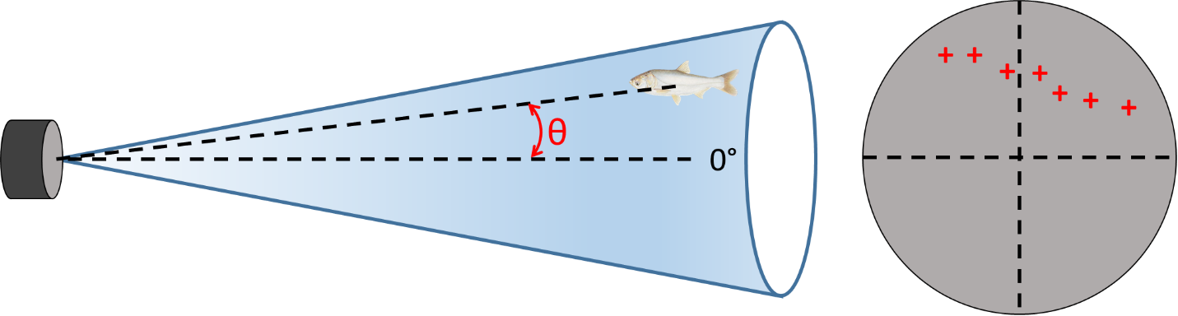
Figure 1. An example of how multiple listening surfaces on a split beam transducer could be used to track a fishes travel through the water column, providing information about distance, depth, and direction of travel.

DT-X Scientific Echosounder
The echosounder is used to control the sound wave transmission and interpret the returning sound waves. A data collection computer that is attached to the echosounder logs the data as it is being collected, and displays the echograms during surveys using the BioSonics program “Visual Acquisition” (VisAc).
The echosounder box has attachments for the following cables:
Transducer cable – you can connect a single transducer or use a multiplexing Y cable that can connect two transducers to the echosounder box. Mobile surveys typically use two transducers. Multiplexing means that the two transducers take turns sending out their sound waves to reduce interference between one another.
GPS cable – connects the echosounder to a GPS antennae for geo-referencing targets and mapping survey routes.
Ethernet cable – connects the echosounder box to the data collection computer, newer echosounders like the DTX-Extreme, can also connect to the work computer wirelessly.
Power cable – connects the echosounder box to a power source.

Calisphere
The calisphere is a solid tungsten carbide (WC) sphere (36.4 mm in diameter) of a known density that has a known target strength (TS, -39.8 dB; the strength of the return signal to the echosounder for the 200 kHz calisphere, which will vary slightly with fluctuations in water temperature). The calisphere is used to calibrate the hydroacoustic equipment.

Mechanical Rotator
Transducers are mounted on a mechanical pan/tilt rotator that is manufactured by Remote Ocean Systems (ROS). BioSonics acquires these stock rotators from ROS and reconfigures them to process BioSonics positional data. The rotator connects to a control box via a 25’ deck cable and from the control box to the field computer with a USB connection. The rotator can be controlled through the data collection computer and the program VisAc. This allows for adjusting the pan (left to right) and tilt (up and down) of the deployed transducer(s) to the angles specified for sampling (see the section “Setting Transducer Angles” below). A folder containing the software drivers necessary for operating the rotator may be obtained from BioSonics, or from the Region 3 Hydroacoustics Working Group. These drivers must be installed for the rotator to operate.

Field Computer
The FWS recommends a laptop computer that can be placed on a docking station for both portability and efficiency of setting up the required connections (power supply, Ethernet, USB cord for rotator control, USB for wireless mouse, optional display monitors etc.). The computer connects to the hydroacoustics gear (the echosounder) through an Ethernet port, or wirelessly, and has to be set to a specific, static IP address. This eliminates the possibility of obtaining access to the DOI network over a LAN connection. Connections could still be established over wifi with Pulse Secure, and there are options in which computers can be configured with two Ethernet ports, which would allow for the flexibility of having one set as a static IP address and the other port configured as a dynamic IP address for DOI access. In order to purchase a hydroacoustic field laptop that will not be connected to the DOI server, the computer must be granted a Security Waiver from the Regional Office IT department. BioSonics sells a ruggedized laptop preloaded with their operating software and ready to collect data. A ruggedized laptop is a good idea if you do not have an enclosed boat or anticipate needing to use the computer outside and exposed to the elements. Otherwise, a ruggedized laptop isn’t necessary and any computer that meets the minimum requirements is acceptable. Minimum computing requirements from BioSonics, Inc. are as follows:
- Operating System: Windows Vista or newer; Windows 7 or newer strongly recommended.
- Software: Visual Acquisition 6 or newer and the required drivers for rotator communication.
- Software Prerequisites: Requires Microsoft .NET framework. If you are running Windows Vista SP2, or Windows 7 or newer, the correct version of .NET is already installed on your computer.
- Additional Software Requirements: PDF reader (to view the User Guides)
- Communication: at least one wired Ethernet connector (RJ45) and one USB connector.
- Memory: at least 1GB required; at least 2GB strongly recommended
- Hard Drive: at least 50GB required; at least 250GB strongly recommended
- Display Resolution: at least 1024x768 - more is better
- CPU: 1 gigahertz (GHz) or faster 32-bit (x86) or 64-bit (x64) processor

Battery Back-up
A battery back-up is recommended for surveys that are powered by a gasoline generator, so that data collection can continue unimpeded if the generator needs to be refueled or runs out of gas during a survey. A recommended option is the CyberPower 1500PFCLCD Uninterruptible Power Supply (UPS) System which can be found on Amazon.

Research Vessel Requirements and Considerations
There is no minimum boat size requirement, but stability is a key consideration when selecting a boat for hydroacoustics sampling. The hull design may be more of a consideration than the size of the vessel when it comes to stability, with a preference toward catamaran-style hulls, tri-hulls, and flat-bottom boats provided they have a wide beam. Size should be a consideration, however, when it comes to weight limitations of the vessel (minimum crew of two, plus gear, generator and davit) and safety for rough water conditions typical of large rivers. Hydroacoustics sampling is typically limited to depths ≥ 1 m, so at a minimum you should have a boat that has a draft capable of maintaining 4-5 mph cruising speeds at 1 m depth. The FWS recommends that the boat have a cabin, which is for not only keeping the electronic equipment safe but is also for the crew’s comfort and safety. An air conditioner is also highly recommended, particularly if surveys may be conducted in areas of high invasive carp density. Carp jumping through open boat windows and damaging equipment is an actual danger, and a closed up boat cab can become hot and uncomfortable quickly under full sunshine, even in low to moderate temperatures. Specification information for hydroacoustics boats in the Region 3 fleet are available from the working group upon request.

Equipment Set-up
The hydroacoustic boat should have a davit crane for deploying the rotator and transducers. Transducers will be mounted to the mechanical rotator and davit via a custom mount (Figure 2). Connect the multiplexing cable to the transducers and the echosounder box. On the DTX-Extreme, there is only one port for attaching transducers. Older DTX echosounders have two ports, in which case, use port 1 with a multiplexing cable. Also connected to the echosounder box are, the GPS antennae, an Ethernet cord (which connects to the work computer), and a power cord, which will be run through a battery back-up system (Figure 3).
The mechanical rotator will have a control cable (Figure 4) which runs from the rotator to a control box. The control box has its own power supply cord (plug this into the battery back-up), and a USB cord that will run to the work computer for controlling the rotator. All equipment will be plugged into the battery back-up, which will be plugged into the generator. A Honda EU3000iS generator is recommended because they are among the most quiet on the market. Sound reduction is an important consideration when surveying invasive carp, which are hypersensitive to sound disturbance. Disturbances in the water could lead to gear evasion and reduced detection.
Mobile surveys utilize two hydroacoustic split-beam transducers (200 kHz; BioSonics, Inc.) which are horizontally oriented (side-looking) and offset in angle to maximize water column coverage. To illustrate the set-up process, we will use the two transducers owned by the La Crosse FWCO and described in the above section “Split-Beam Transducers” for example.

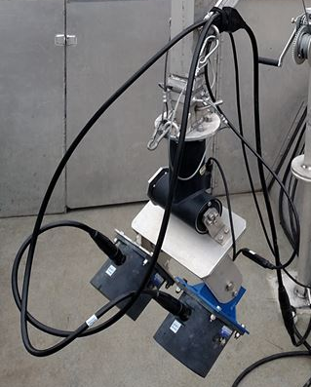
Figure 2. Two 200 kHz split-beam transducers with custom mount, attached to the mechanical rotator, with associated cables.
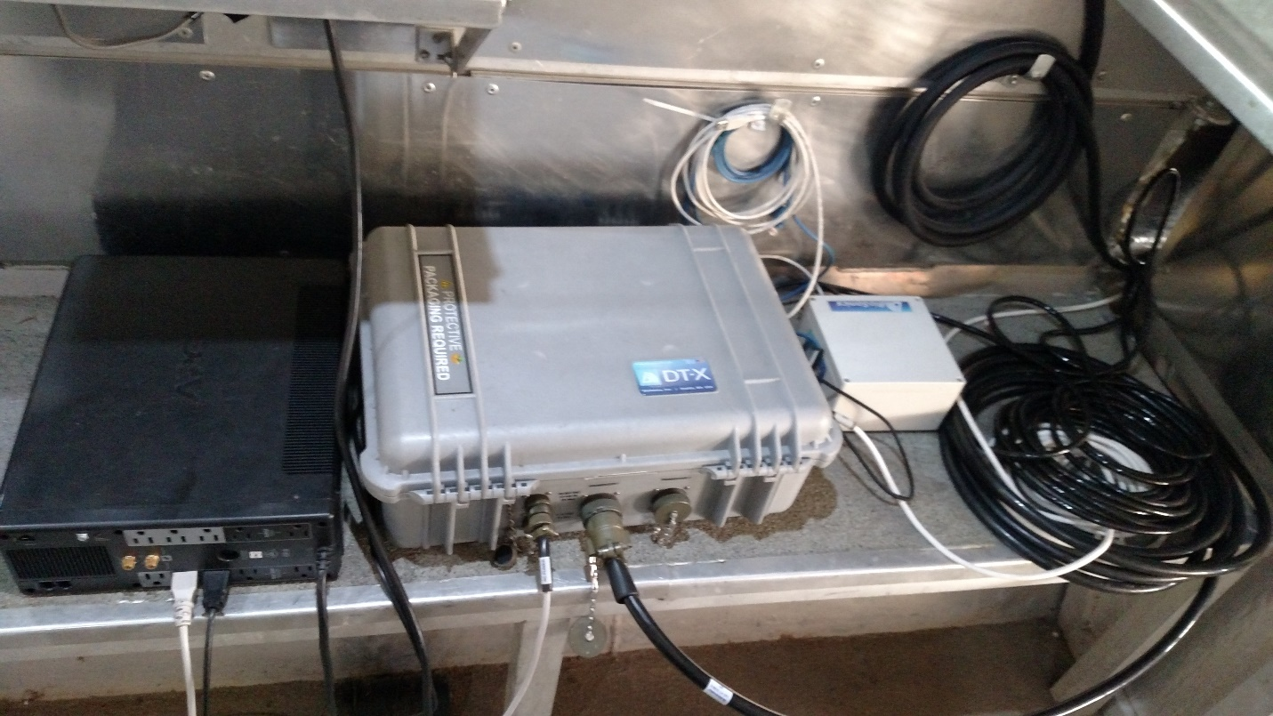
Figure 3. Battery back-up (left), DT-X Scientific echosounder (center) and rotator control box (right) with associated cables

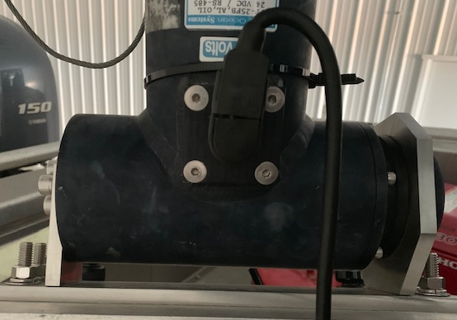
Figure 4. Cable attachment to the mechanical rotator. Although the cable may be equipped with a rubber strap to hold cable in place, also use zip ties for additional support to make sure the cable does not pull free during a mobile survey.

Setting transducer angles
To properly set your transducer angles for a side-looking survey, remember the water surface is at 0 degrees. To maximize water column coverage, the surface-looking transducer (CH 1: Frequency: 199 kHz; beam width: 6.6 degrees) would be positioned at -3.3 degrees (half of the beam width of CH 1), and the bottom-looking transducer (CH 2: Frequency: 201 kHz; beam width: 6.8 degrees) would be positioned below the beam of CH 1 (subtract the entire beam width of CH 1, (6.6 degrees) and half of CH 2 (3.4 degrees). Therefore, the down-looking transducer would be deployed at -10.0 degrees. The total beam angle coverage for these two transducers would be 13.4 degrees (Figure 5). The transducers are mounted on a custom mount which in turn, attaches to a mechanical rotator. The appropriate angles of the two transducers on the mount relative to one another, should be set prior to a survey (for our example, 6.7 degrees apart). Once the angles are set and tightened they should be checked before and during each survey to make sure they haven’t loosened and moved. As long as the transducers are correctly positioned relative to one another on the custom mount, the mechanical rotator can be used to properly orient the beams under the water surface and perpendicular to the boat.

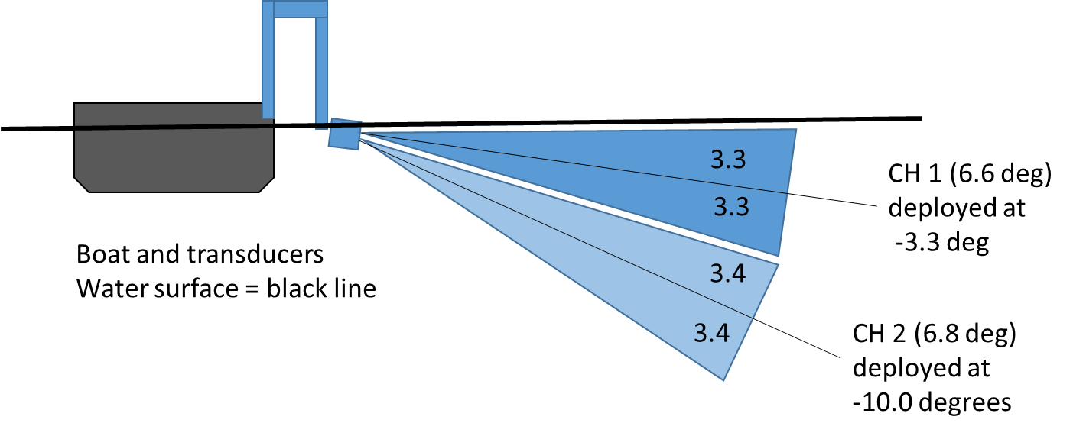
Figure 5. Schematic (not to scale) showing the transducer beam orientation in the water column during a mobile survey to maximize coverage.

Checking transducer angles
Turn on the generator and the battery back-up (all equipment should be plugged into the battery back-up). Turn on the DT-X echosounder, turn on the data collection computer, plug the ethernet cable from the DT-X (or in the DTX-Extreme, wirelessly if you prefer), and the USB from the rotator motor control box into the computer. Wait for the DT-X to make a beeping sound that indicates it has turned on and is ready (this takes about 1 minute). Open up the program Visual Acquisition and click the INIT button to initialize.
After initialization is complete, you will see the screen below. Click “OK”
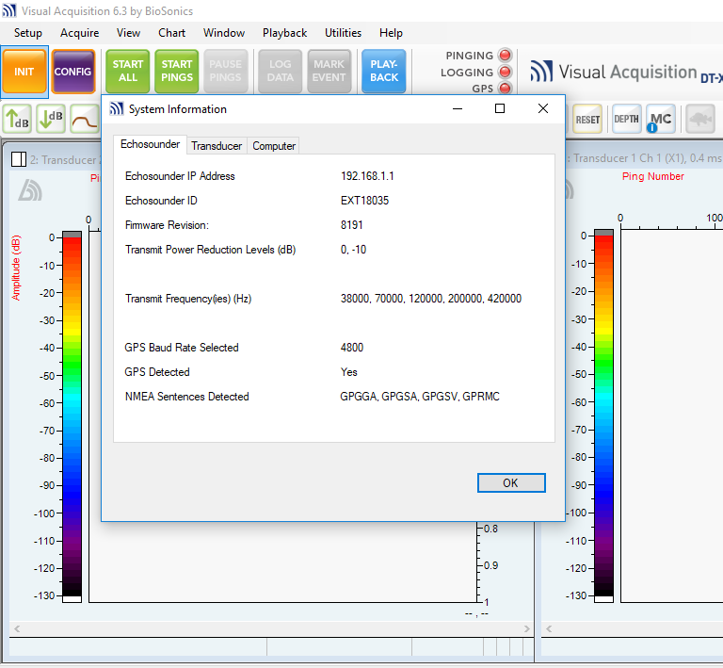
Next click the CONFIG button. The Configuration menu will appear, select “Transmit/Receive” and then select “Passive Listening” for each transducer.
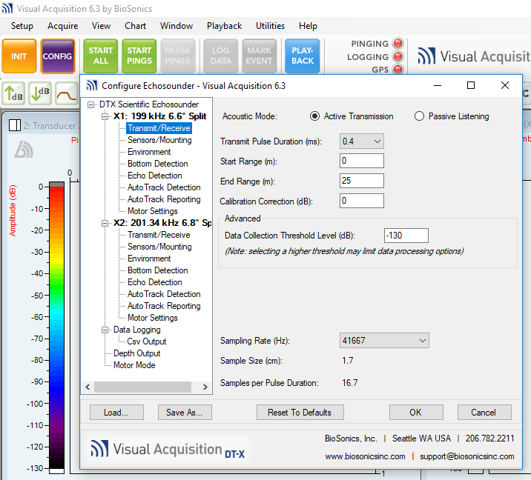
This means the transducer is only listening, and can be turned on while out of the water without being damaged. Never run the transducers out of the water while actively transmitting. It could cause damage. After both transducers are set to “Passive Listening” you can click START PINGS. Look to the bottom right of each echogram screen and look for the pitch or “P” value, which shows the angle of the transducer.
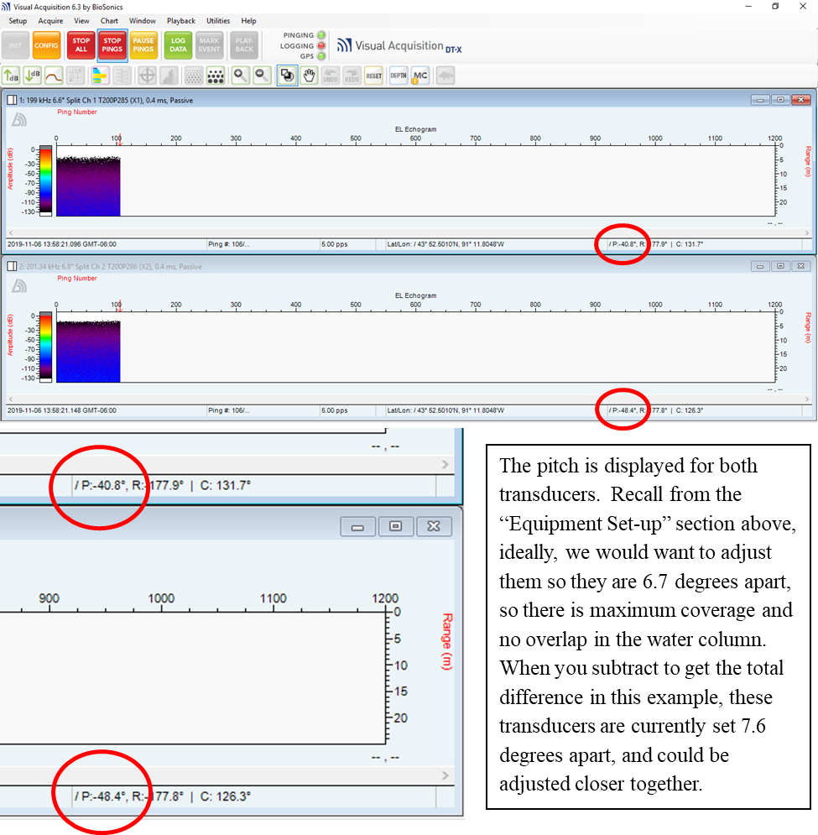

If the boat is on a trailer at a parking lot and motionless, you can check and adjust the angles without stopping the program. If you have an assistant, have one person monitor the pitch values while the other makes minor adjustments to the transducer mount. If you are on the water, it is difficult to make the calculation if the boat is rocking in the waves or current and the values keep fluctuating. In this scenario, click START PINGS and then STOP ALL, which will freeze the screen and allow you to do the math to determine the separation value. Make an adjustment as necessary, and then repeat the process to see if the values have improved. Repeat as many times as necessary until the angle separation is acceptable (no overlap, strive for the beams to be less than 1 degree apart). You are now ready to calibrate the equipment.

Transducer Calibration Settings and Calibration Methods
Transducers should be periodically calibrated on-axis following Demer et al. (2015). If surveys last multiple consecutive days in the same area under homogeneous environmental conditions, calibration may only be necessary once. If you are surveying in multiple navigation pools or different waterbodies during a week-long trip, consider calibrating separately for each area. Likewise, if after an initial calibration event, water temperatures within a pool change significantly, an additional calibration should be considered. Calibration should also be considered if a transducer is dropped, or damaged. The items needed for calibration include the calisphere, monofilament fishing line (~15 lb. test), Dawn dish soap, and an extendable aluminum utility pole at least 24’ long.
Anchor your boat to a dock or in a safe area out of the wind/wake/disturbance. If you have not already done so, start the computer, turn on your echosounder and open the VisAc program. Hit the initialize button as described above. Then ensure the following calibration settings are selected in Visual Acquisition in the CONFIG menu. Settings are the same for both the shallow and deep transducers, many settings do not need to be changed from default, and are not listed below – settings must be entered for each transducer separately, make sure the transducers are in the water before you begin pings/data collection:
DTX Scientific Echosounder
Specified Ping Rate: 5
Transmit Power Reduction Level: 0
X1 and X2:
Transducer Type/Mode: Split-Beam
Transmit/Receive
Acoustic Mode: Active Transmission
Transmit Pulse Duration: 0.4
Start Range (m): 0
End Range (m): 6 m (adjust this range to be just longer than the distance from the transducer to the calibration sphere, may vary depending on pole length).
Calibration Correction: 0
Data Collection Threshold (dB): (-130)
Sampling Rate: 41667

Sensors/Mounting
Transducer Depth: 0.4m (this will need to be measured and entered for your specific boat/gear setup)

Sensor Orientation: Side-Looking

Environment
Enter the current water temperature

Bottom Detection
Make sure the “Enable Bottom Detection” box is not checked

Echo Detection
Check “Enable Single Echo Detection” box
Echo Level Threshold: (-50)
Min Echo Length: 0.8
Max Echo Length: 1.2
Max SD of Split-Beam Angles: 10
Max Beam Compensation (dB): -6
Detection Endpoint: 0
Do not check “Disable echo detection is bottom lost”
Histogram Maximum: 0
Histogram Bin Width: 5
Histogram Interval (pings): 300

Data Logging
File Prefix: This is where you name the file - enter site/survey name
File Suffix: Leave blank

Calibration Steps
- BioSonics recommends that the transducers and calisphere be allowed 10-15 minutes in the water to adjust to the ambient water temperature prior to calibration.
- Soak the calibration sphere in a 1:4 solution of Dawn dish soap and water to reduce bubble formation on the sphere and monofilament cradle.
- Have the transducers oriented perpendicular to the boat as if you were surveying. Suspend the calisphere from the calibration pole with monofilament line and fully extend the pole so the calisphere is dangling in front of the transducers. Attempt to line up the calisphere in front of the transducers with the calibration pole, then secure the pole in place with a bungee cord or strap, or have someone hold it in place. (Figure 6).
- Make sure transducers are submerged and begin collecting data – hit Start All
- In Visual Acquisition, set the VIEW to Bullseye Chart to better determine the position of the sphere within the beam (Figure 7).
- Do not move the pole, instead use the mechanical rotator to make fine-scale adjustments to the transducer, find the calisphere, and center it in the bullseye.
- BioSonics recommends collecting 500 pings near the center of the acoustic beam/center of the bullseye, and at least 500 pings from each quadrant of the bullseye chart. The top of the echogram displays the ping number to reference during calibration. Use the rotator to collect pings in each quadrant.
- You will need to do this for each transducer. After collecting the necessary number of pings in the center and at each quadrant of one transducer, keep the calisphere anchored in place. Look at the pan/tilt values of the transducer that has the calisphere in its beam, and use the mechanical rotator to achieve similar pan/tilt values in the remaining transducer to help locate the calisphere. Once the remaining transducer locates the calisphere, repeat step 7.
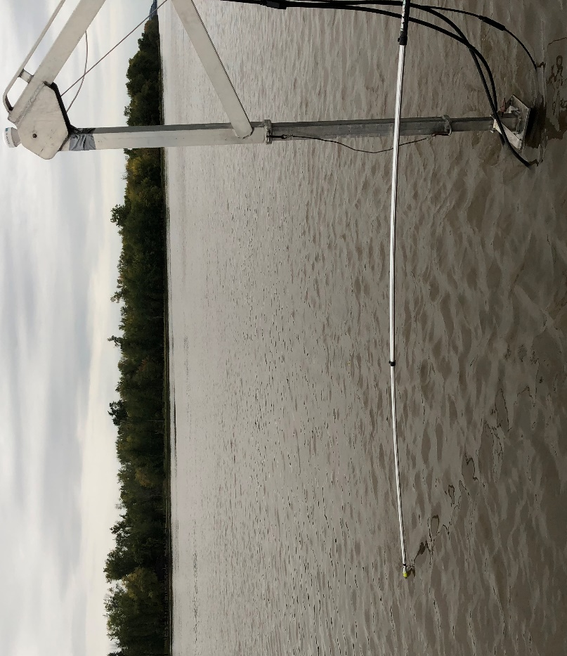
Figure 6. Suspending the calisphere in front of the transducers with an extendable utility pole for calibration.

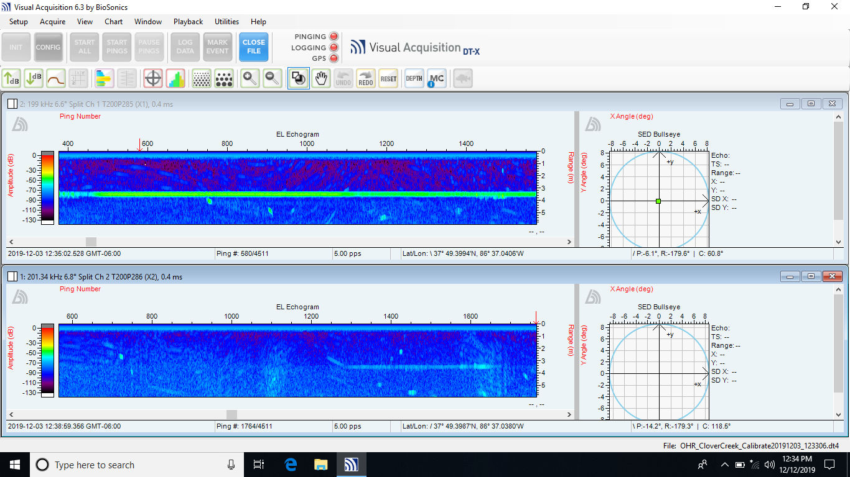
Figure 7. Echogram and bullseye chart showing the calisphere during equipment calibration. The calisphere is centered in the bullseye of the top echogram and not present in the other beam.

Transducer Mobile Survey Data Collection Settings and Methods
Prior to data collection, ensure the following settings are selected in Visual Acquisition. Settings are the same for both transducers – settings must be entered for each transducer separately:

DTX Scientific Echosounder
Specified Ping Rate (pings per sec): 5
Transmit Power Reduction Level: 0

X1 and X2:
Transducer Type/Mode: Split-Beam

Transmit/Receive
Acoustic Mode: Active Transmission
Transmit Pulse Duration: 0.4
Start Range (m): 0
End Range (m): 50 (This value can be increased or decreased depending on depth)
Calibration Correction: 0
Data Collection Threshold (dB): -130
Sampling Rate: 41667

Sensors/Mounting
Transducer depth (m): 0.4 m (this will need to be measured and entered for your specific boat/gear setup)
Sensor Orientation: Side-Looking

Environment
Enter the current water temperature
Fresh Water: box is checked
Reference Depth (m): 1

Bottom Detection
Make sure the “Enable Bottom Detection” box is not checked

Echo Detection
Make sure the “Enable Single Echo Detection” box is not checked

Data Logging
10 min file duration

Depth Output
Enable Depth Output: not checked

Data Logging
File Prefix: This is where you name the file - enter site/survey name
File Suffix: Leave blank

Adjustments to Configuration Settings in the Field
There is no standard value for transmit/receive End Range (m) during mobile surveys, and range may need to be adjusted from site to site, especially when switching macrohabitats. End Range should be great enough that the bottom is being captured. In a deep main channel site, the End Range may need to be extended out as far as 75 m. However, in a shallow backwater, the beams may be intersecting the bottom at 5 or 10 m away. In this case, you may want to adjust the End Range to 15 or 20 m to give a better real-time view of the echogram, and the targets that you are ensonifying. If you need to adjust the End Range during transecting, make the change in the transmit/receive configuration menu, slow down the boat, hit STOP ALL, and then START ALL.
In rough waters, if you are noticing interference caused by wave action, this can be mitigated somewhat by increasing the depth of the transducers. If you send them deeper, remember that you will want to increase the “Transducer Depth” in the Configuration menu accordingly.
Stopping and restarting data collection during a survey is sometimes necessary in order to change settings, avoid an obstacle, wait for disturbance to settle etc. Try to restart interrupted transects as close as possible to where you left off. Echoview will be able to splice all transect data files together for post-processing.

Exclusion Zones

Nearfield Zone
With the equipment described in this document, the calculated nearfield distance is approximately 0.5 m. Within this area, the sound waves produced by the transducer are not parallel and their intensity fluctuates, making it difficult to measure accurate target strength values. It is accepted practice to double the nearfield distance, effectively creating the near-field zone (1.0 m; Simmonds and Maclennan 2005; Figure 8). Data collected in the nearfield zone is excluded from all analyses in data post-processing. Beyond the nearfield, sound waves become nearly parallel, the beam is properly formed and target strength values are accurate.

Bottom Exclusion Zone
Where any portion of the beam hits the bottom, this is the beginning of the bottom exclusion zone (Figure 8). Depending on the angle of your beam and the bathymetry of where you are sampling, you may still “see” fish tracks on your echogram beyond where the beam intersects the bottom, but you won’t be able to accurately calculate the volume sampled. Therefore we exclude these targets from analysis in post-processing.

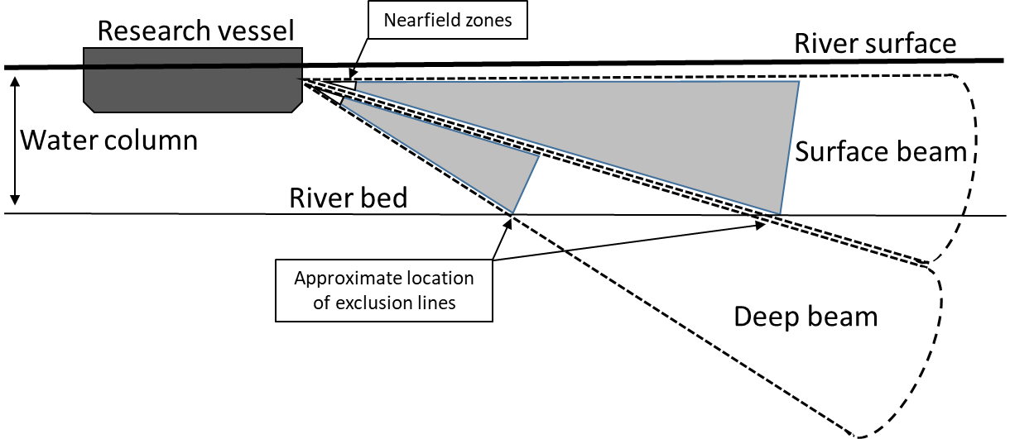
Figure 8. Diagram showing the nearfield and bottom line exclusion zones. The data that can be used in analysis is collected within the gray area.

Sampling Tips Important For All Basins
Survey methodology may differ significantly from sub-basin to sub-basin, but once established, should remain consistent over time. Beyond the echosounder settings that were presented above, there are a few other tips/considerations that should be followed in all of the basins.
- Survey data files should be separated by macro habitat types in the field as they are collected (e.g. MC, SC, BW, TRIB). It is easiest to delineate your macro habitat in your file name. For example, if a survey occurs on the main channel on the Mississippi River, Pool 18, at river miles 418-422, an appropriate file name might be: P18_MC_418-422…time stamp info….dt4. Every file produced will have a time stamp proceeding the file name that you chose, and all will end in .dt4

- For most applications, macrohabitat types will be analyzed independently, so you should not merge different macrohabitats into a single survey file. For example, do not start in the main channel and then survey into a tributary or side channel and then finish the main channel, all in one data collection file. This will make processing and analysis by habitat type much more difficult.

- Try not to collect data that you don’t intend to use. For example, main channel surveys on the Mississippi River consist of four transects. Collect data running up one shoreline, then hit “STOP ALL”. Cross to the other side of the river and hit “START ALL”, and a new file would then begin for the next transect. Configuration settings can remain untouched. The new transect would be named the same, but have a different time stamp. Start a new file for each of these four transects. All four can be pulled into Echoview and viewed and edited together as if it were a seamless survey. By making separate files you no longer have to deal with trying to delete messy data from turns, or unwanted data that was collected while crossing the river. Try and follow this suggestion in all sub-basins.

- When you are surveying, no matter where you are collecting data, the operator should be focused on driving the boat at a steady speed, minimizing turns, avoiding obstructions that could damage equipment, and regularly checking the VisAc screen to monitor the angles of the transducers and to check the three indicator lights for the echosounder: Pinging, Logging, and GPS (Figure 9). The lights can display as green, yellow, or red. Green means everything is working and logging properly, yellow means potential problems, but not necessarily anything that will hold up a survey. Sometimes on a cloudy day GPS may be yellow because there aren’t as many satellites available. Cruisetrack resolution may be lower, but data collection can proceed. PINGING and LOGGING always need to be green if you are conducting a mobile survey. Red at any of the lights indicates a problem that needs to be addressed before the survey can continue.

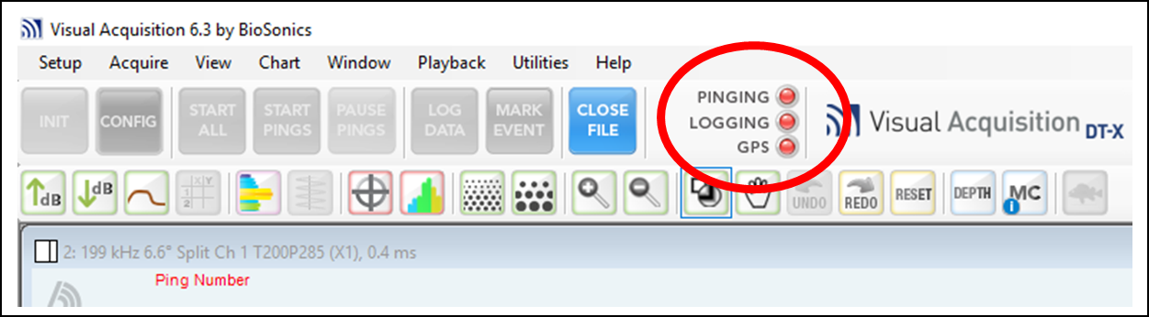
Figure 9. The program Visual Acquisition shows three indicator lights that will tell you the status of the surveys data collection. Green indicates data is being collected and logged, yellow indicates potential problems, red means proper data collection is not happening.

Survey Methods by Sub-Basin

Upper Mississippi River
Population assessment surveys are typically conducted during September and October at selected areas of the main channel, side channels, bays, and backwaters of the UMR. This time period has been selected because water levels are typically lower, concentrating fish in main channel border and side channel habitats where they will be more easily surveyed with hydroacoustic equipment. Secondly, fish are generally less motile at this time period reducing chances of double counting fish within or among pools, compared to the spring, when spawning cues can increase fish movement. High water levels associated with spring rainfall may also have high turbulence, increasing air bubbles in the water column that may negatively influence hydroacoustics estimates.
Approximately 35-40% of navigable main channel river miles are sampled in UMR pools of interest (e.g. if a pool were 10 miles long, we might transect four miles of the main channel). This is a product of available time and sampling logistics, but also aligns with minimum sampling effort in the lower pools of the Illinois River hydroacoustics monitoring program (Coulter et al. 2018). Main channel transects range from 2-5 miles in length, are evenly distributed throughout the pool and include the areas directly downstream of the lock and dam at the head of the pool and the area directly upstream of the lock and dam at the bottom of the pool. In addition, all accessible backwater habitats are surveyed, and about half of available and accessible side channel habitats are surveyed. In previous surveys on the UMR, the survey effort has ranged from 46-87% of overall backwater habitats, and 40-60% of side channel habitats, among pools. In the future a stratified random approach may be considered to select survey sites, with sampling effort distributed proportionally among available habitat types.
Transects on the main channel / main channel border consist of two transects along each bank. The first set of transects is conducted near shore at the 1 to 1.5 m depth contour with the transducers pointing out towards the thalweg. The next set of transects are located farther from shore trying to pick up where the beams from the first transect would have hit the bottom and viable data collection would have stopped (Figure 10). The Y-axis on the right side of the echogram shows you the distance out from the boat to which you are collecting data. When surveying the main channel, you are typically starting in shallow water and sending the beams into deeper water. Periodically check the distance value as you survey the first transect. If you are collecting data out to 50 m, use your GPS navigation screen to try and run your next transect about 50 m out from the first one. In areas where wing dikes extend out into the channel, operators should attempt to survey over the tops of the dike structures and maintain their course along the shoreline, provided water depths are adequate. If water levels are low enough such that the dikes are exposed or unnavigable, adjust the transect towards the thalweg to deeper water. In the UMR, river training structures such as wing dikes can have some of the best fish habitat and greatest concentrations of fish within the main channel. Dikes can also be silted in with depths insufficient to allow for hydroacoustic surveys. Depth is the key feature to consider in deciding whether to attempt to include the areas behind wing dikes and other navigation structures in a hydroacoustic survey. Other considerations include the overall value of the fish habitat, accessibility, how the data will be analyzed, and can the fish community in those areas be described through physical sampling. When surveying over wing dikes with unknown depth, try and first approach from the downstream side with the motor trimmed up, and/or lifted up with a jack plate if available. Consider depth-checking a few structures in a new area before even deploying your gear.
Side channels, backwater lakes, marinas, and other off-channel habitats require one transect that follows around the entire shoreline (Figure 10).
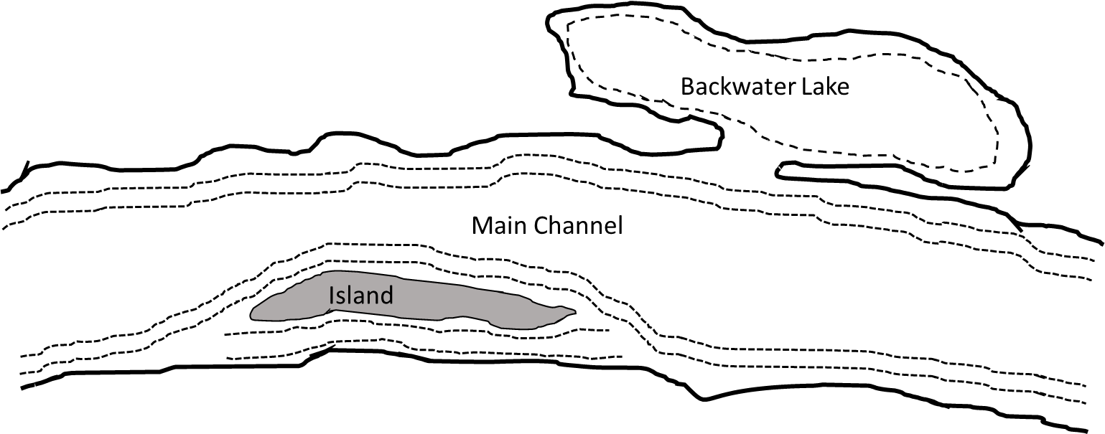
Figure 10. Example of survey transects in the Upper Mississippi River, two transects for each bank along the main channel, transducers pointing toward the thalweg; one transect on each bank for island side-channels and one transect following the shore for backwater lakes.

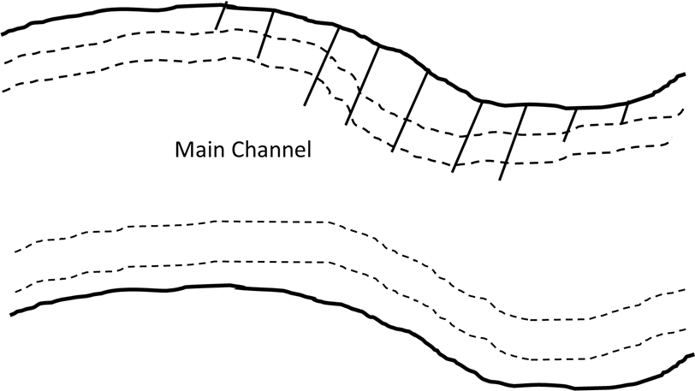
Figure 11. Example of survey transects on the Upper Mississippi River where wing dikes are present. Two transects for each bank along the main channel, transducers pointing toward the thalweg. If depths are sufficient, transects run over the dikes and as close to shore as depth allows.

Upper Illinois Waterway
Hydroacoustic surveys are typically conducted monthly between March and November in the main channel of habitats of Dresden Island, Brandon Road, and Lockport pools. These pool surveys were designed to monitor for the presence and abundance of large fishes, potentially either Bighead or Silver Carp, greater than -28.7 dB (theoretical side-aspect target strength of a 300 mm total length fish) within the upper Illinois Waterway. The hydroacoustic survey in Lockport Pool covers the area between the Hanson Material Services Corporation (HMSC) docking slip and Lockport Lock and Dam, a distance of approximately 6.5 km. The hydroacoustic survey in Brandon Road Pool covers the area between Lockport Lock and Dam and Brandon Road Lock and Dam, a distance of approximately 7.2 km. The hydroacoustic survey in Dresden Island Pool covers the area between Brandon Road Lock and Dam and Dresden Island Lock and Dam a distance of approximately 23 km. In Brandon Road Pool and Lockport Pool, surveys consist of a single transect along each shoreline, with the boat following the contour of the main channel edge while ensonifying water within the channel. In Dresden Island, surveys consist of a two transects along each shore, with the boat following the contour of the main channel edge for near-shore transects. The second set of transects are approximately 30 m inward and parallel to the near-shore transects. Four total transects are completed in Dresden Island Pool due to the increased width of the pool relative to Brandon Road Pool and Lockport Pool. Ideal transducer pitch angles are determined as described in the document above. For Illinois Waterway surveys, ideal transducer pitch angles are -3.2º and -9.6º below the plane of the water surface. Every transducer may have a slightly different beam width, and these angles correspond to the primary equipment used by the Wilmington sub-station in their surveys.

Chicago Sanitary Shipping Canal Electric Dispersal Barrier System
Hydroacoustic surveys are typically conducted every two weeks throughout the year, January through December, at the Electric Dispersal Barrier System (EDBS) in the Chicago Sanitary Shipping Canal (CSSC) near Romeoville, IL. These surveys are intended to determine the presence of fish with target strengths ≥ -28.7 dB (i.e., mean temperature-compensated side-aspect target strength of a 300 mm fish) within the vicinity of EDBS. Surveys consist of three replicate surveys consisting of an upstream transect (west side of CSSC channel) and downstream transect (east side of CSSC channel) using both side-looking split-beam hydroacoustic technology and side-scan sonar. These surveys sample the area between the northern end of the Hanson Material Services Corporation docking slip (~1.3 km below Romeo Road Bridge) and the Demonstration Barrier (~0.6 km above Romeo Road Bridge). For reporting purposes, Romeo Road Bridge is considered the dividing line for areas referred to as “within EDBS” and “below EDBS”. For the primary equipment used by the Wilmington substation, Carterville FWCO in their surveys, ideal transducer pitch angles for barrier surveys are -3.2º and -9.6º below the plane of the water surface.

Ohio River
Hydroacoustic surveys are conducted in the fall in the Ohio River main stem and tributaries from J.T. Myers pool up to the McAlpine pool. Fall is the best time to perform these surveys because water levels are more consistently low and fish are more concentrated. Additionally, this is when community sampling occurs which is used to inform hydroacoustics results.
Ohio River site selection will follow a standardized random sampling design for main channel and tributary sites. The main channel is further divided into two habitats, main channel border and mid-main channel, with transects in each habitat being 1-mile long. At least 35% of each main channel habitat will be sampled during each survey. Tributary surveys consist of transects extending 1-mile upstream from the confluence or until navigable waters end. At least five tributaries, when present, will be sampled in each pool. Tributary sampling will consist of one upstream and one downstream transect to collect data along each bank. Due to limited availability and high importance, all navigable side channels and backwaters will be sampled within each pool. To support the hydroacoustic sampling, state partners will collect community data during the same time period using gill nets and boat electrofishing. The Carterville USFWS office will also collect community data in the same pools using a dozer trawl (electrified trawl).

Site selection in the Ohio River Basin is based on multiple factors:
- Association with a tributary. Invasive carp utilize tributary habitat in the ORB to a high extent. The Ohio River invasive carp telemetry project has been assessing tributary usage for several years now, and the hydroacoustics program hopes to further examine habitat usage patterns.
- Availability of community data that is provided by state partners.
- Distribution and Accessibility. Sites were selected to be distributed throughout desired pools and have relatively low travel time from accessible boat ramps.
Each site consists of main channel and tributary transects. Unlike other large river systems, transducers are shore facing during main channel transects (Figure 12). The bathymetry of the Ohio River is not conducive to thalweg facing transects; fish habitat is concentrated on the shoreline. The main channel survey consists of two 4-mile transects, one of each bank. For tributary and side-channel surveys, the transducers face the thalweg (Figure 12). These surveys consist of two transects, one heading up the tributary as far as passable, or 1 mile, and the other heading back to the mouth of the tributary.
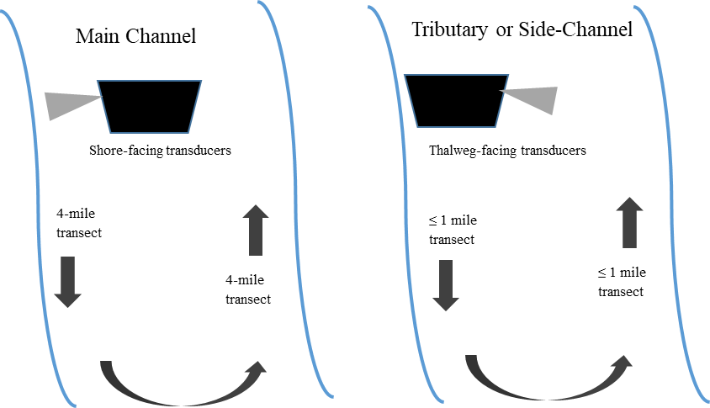

Figure 12. Transducer orientation for main channel versus side-channel and tributary hydroacoustic surveys in the Ohio River.

Sampling Large Backwater Lakes or Reservoirs During Removal Events
In addition to the large-scale fall population assessment surveys detailed above, the FWS also works with state partners to provide fine-scale pre- and post-harvest abundance estimates to evaluate large contracted harvest events. For better coverage of large backwater lakes or bays, consider planning out a transect grid (Figure 13). If the area has a relatively uniform depth, beam range can be estimated using the following equation, with (13.4) being the degrees of combined beam width for the example transducers, and (x) being depth:
Tan(13.4)= x / range
Therefore to survey a lake with a uniform depth of 5 m, range = 5/ Tan(13.4) = 21 m. The first transect would be collecting data approximately 21 meters out from the boat and therefore subsequent transects should be spaced at least 21 m out from each other (and aiming the same direction) so as to not resample any of the water column. However transects are planned, be consistent if multiple surveys are to be conducted at an area over time.
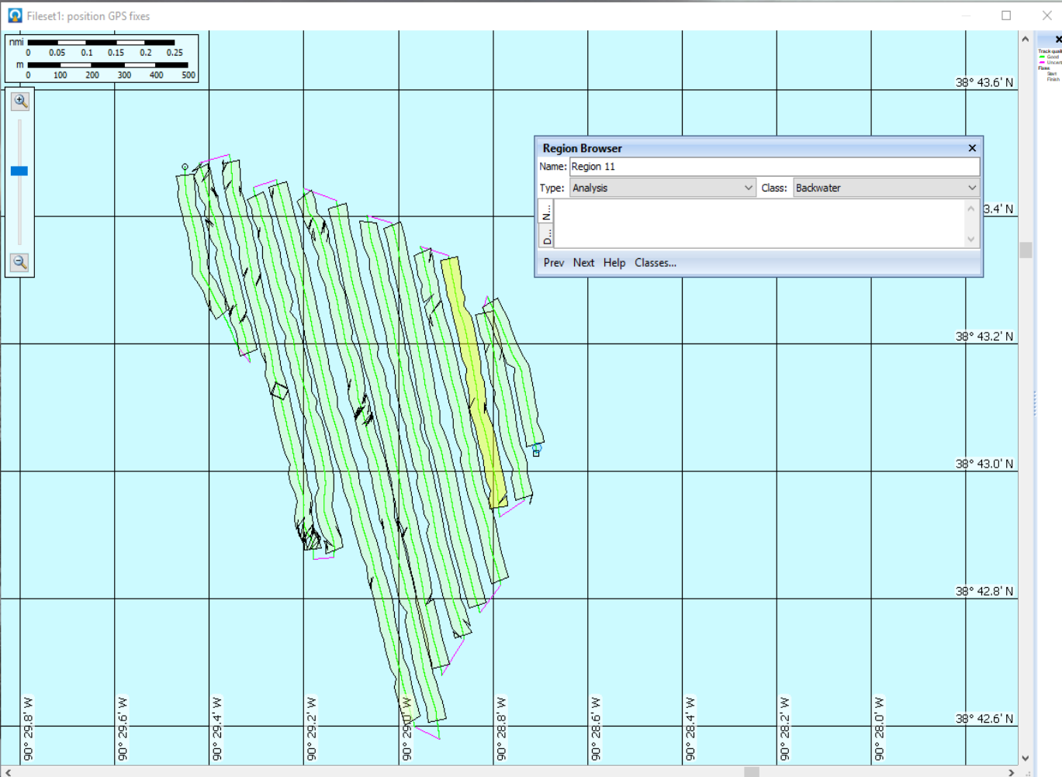
Figure 13. A transect grid developed for an invasive carp removal operation at Creve Coeur Lake, Missouri. Sampling was conducted pre- and post-harvest.

Physical Fish Sampling
Physical fish sampling is required to separate the overall fish community size distribution into species-specific distributions to inform hydroacoustics data. Standardized fishery-independent sampling data is generally preferred as it provides less biased data than fishery-dependent sampling, which often targets the largest fish. However, data from multiple sources can be pooled to help interpret hydroacoustic data (MacNamara et al. 2016; Coulter et al. 2018).

Gear types and amounts of required effort may differ among sub-basins with different habitats and varying densities of invasive carp. Most sub-basins will have diverse fish communities, and longitudinal gradients of invasive carp abundance (typically high to low density from downstream to up, within an invaded watershed) that may impact the effectiveness of various gears for collecting invasive carp. In biological sampling, all gears maintain some level of sampling bias. Including multiple sampling gears is one way to address gear bias, and standardizing a sampling program will theoretically hold any sampling bias constant, allowing population trends to be examined over time.

Sampling locations in a sub-basin should be allocated via a stratified-random sampling design that designates riverine pools or specific reaches as an upper-level strata, designates the dominate habitat features of those pools (e.g. main channel border, side channels, backwaters, wing dykes, etc.) as secondary strata, and distributes a proportional number of sampling locations randomly throughout the available habitat types. The number of sampling locations in each pool should be determined by the size of the pool or reach and will also reflect the density of the invasive carp population. A standardized physical sampling program to inform hydroacoustics should meet three important objectives: 1) low sampling variability, 2) high catch, and 3) an estimate of effort required to meet precision and catch objectives (Bonar and Hubert 2002). Metrics for assessing the achievement of these objectives have been established in literature. Low sampling variability is achieved and precision is high when relative standard error (RSE) of catch per unit effort (CPUE) is ≤ 25, and the catch objective is achieved when at least 100 stock-length target individuals are collected (Koch et al. 2014). If an RSE of 25 is not met, a power analysis using data collected in year-1, should be used to determine the target number of samples needed to achieve an RSE of 25. Results from the power analysis should inform future planning for standardized sampling. Recognize that it may not be possible to achieve invasive carp capture or RSE targets in areas of low-density.

For hydroacoustics, collected fish should be identified to species, enumerated, measured to the nearest mm (TL), and weighed to the nearest gram. Additional information from collected invasive carp may also be required to meet other management objectives (Fritts stock assessment Doc, National Invasive Carp Sampling Plan Vision Document).

Upper Mississippi River
Fishery-independent data in the UMR comes from sampling conducted by the USFWS and established state partner monitoring programs like the Illinois Natural History Survey’s extensive standardized electrofishing program called the Long-term Survey and Assessment of Large River Fishes in Illinois or the Long-term Electrofishing Program (LTEF). The program uses pulsed-direct current (DC) electrofishing to sample fish communities at randomly selected locations throughout pools 16-21 of the Mississippi River. The program operates on an annual sampling schedule but typically limits sampling to main channel border habitats. The IL Department of Natural Resources annually conducts similar complementary sampling in the same pools but in backwater and side channel habitats. The USFWS sampling program utilizes the electrified dozer trawl which has been shown to be more successful than standard electrofishing at the collection of invasive carp while also providing information on the overall fish community. Sites are selected through a stratified random sampling (SRS) design, with effort proportionally allocated among macrohabitat types based on availability.
Additional sources of fishery-independent data in the UMR that may be available for use in interpreting hydroacoustics data include fishery-dependent data from the invasive carp contracted removal program, administered by Dr. James Lamer of the INHS. The combination of sampling efforts by the aforementioned sources, provide the data necessary to inform hydroacoustic surveys in the UMR.

Upper Illinois River
Fishery-independent data in the Upper Illinois River primarily comes from electrofishing data collected by the USFWS Wilmington Substation and is supplemented by data collected as part of the Illinois DNR’s Multiagency Monitoring of the Illinois River for Decision Making (MAM) Program. In order to inform hydroacoustics, the USFWS Wilmington Substation conducts 15-minute electrofishing surveys through the Upper Illinois Waterway and collects length and weight data on up to 300 fishes per pool when possible. The MAM program conducts a similar amount electrofishing in the Upper Illinois Waterway and the data is accessible via the MAM database.

Ohio River
In the Ohio River Basin, physical fish data comes from state partner’s fish community sampling and miscellaneous catch data from removal programs. State partners include Kentucky Department of Fish and Wildlife Resources (KDFWR), the Ohio Department of Natural Resources (OHDNR), the Illinois Department of Natural Resources (ILDNR), the West Virginia Department of Natural Resources (WVDNR), and the Indiana Department of Natural Resources (INDNR). These agencies perform community sampling to monitor fish populations and this data has been used to inform hydroacoustics data and produce population density estimates.
Methods of capture include pulsed-direct (DC) electrofishing and gill-netting at established monitoring sites, which are in proximity to hydroacoustics survey sites. Community monitoring occurs in the fall, which also coincides with hydroacoustics surveys. All fish are enumerated, measured to the nearest mm (TL), and weighed to the nearest gram. Moving forward, if community sampling is being conducted purely for hydroacoustics purposes, only fish larger than 250 mm will be collected, enumerated, measured, and weighed. During the processing of hydroacoustics data, all fish targets that are smaller than 250 mm are excluded from analysis. Thus, the number, length, and weight of these fish is not necessary for hydroacoustics analysis and excluding them from community sampling expedites the processing of fish while in the field.

Hydroacoustic Data Management During Surveys
Raw Data Files
Visual Acquisition generates raw data files (.dt4 files) which include a timestamp. It is recommended that you enter a brief description of the survey location on the file name. All raw .dt4 files should be organized by sub-basin, pool or reach, and site (e.g. UMR/Pool 17/BW_Cleveland Slough). The UMR Pool 17 folder would have multiple survey site folders (one for each side channel, backwater or main channel survey conducted in Pool 17), all stored on the field computer. Files should be backed-up each day on an external hard drive after surveys are finished. There should be a separate folder within each survey folder that will contain the calibration files for that particular survey.

After the Survey: Data Post-Processing with Echoview

The USFWS Region 3 Hydroacoustics working group strives to stay up to date with the most recent version of Echoview software for data post-processing. USFWS offices starting a new hydroacoustics program should contact Wes Bouska at wesley_bouska@fws.gov or the Region 3 Hydroacoustics working group to obtain the most recent versons of the Echoview calibration analysis template and the mobile survey analysis template or .EV files. The analysis template follows the general methods reported in MacNamara et al. (2016). Single targets will be detected using parameter values from Parker-Stetter et al. (2009). Multiple targets from a single fish will be grouped using Echoview’s fish tracking algorithm to reduce the potential of over counting fish targets. The size of fish targets (total length; cm) will be estimated from mean acoustic target strength (dB) using a function specific to side-looking hydroacoustics (Love 1971).
Due to standardization of key survey attributes among sub-basins, the .EV file should work to process data from side-looking surveys across multiple sub-basins. While it is recommended to not make changes to the raw .EV template, the one exception would be to customize the location/geometry of the transducers and the GPS antennae, to that of your survey vessel. This can be accomplished by right clicking on “Research Vessel” in the dataflow window and selecting “Platform Properties”. Here you can specify the GPS position.
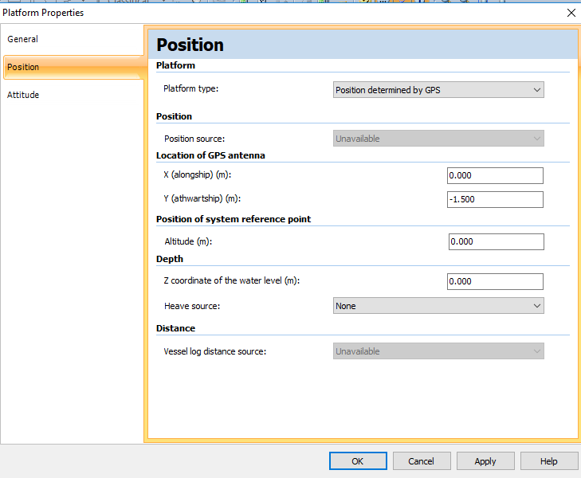
Next within the dataflow, right click on each transducer and select “Transducer Properties”, and enter the specific location of your transducers.
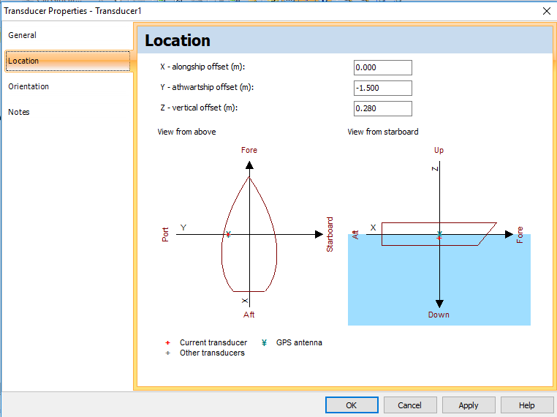
The analysis instructions below detail theoretical file storage locations that can be copied or modified as needed.

Calibration Instructions
How to analyze calibration data and apply a calibration offset, if needed, to collected survey data using Echoview.

Setup phase
- The data should already be divided up into folders by pool or reach, and further by separate survey locations. Each survey location folder should have a calibration folder with the .dt4 calibration files and a survey data file with the .dt4 files from the actual mobile survey.
  - Note that .rtpx files are created by Visual Acquisition but are not necessary and should be deleted to save hard-drive space
- Go to Microsoft Teams and the Hydroacoustics Working Group Team. Open the “Files” section and locate/open the folder named “Hydroacoustics analysis instructions and templates”. Next open the folder labeled “Calibration utilities”
- All calibration .dt4 files from your survey should be in a specific calibration folder, copy the contents of the “Calibration utilities” folder found on the Share drive (one file – “Calibration_updated.EV” and place a copy of this file into each of your survey calibration folders. The file from the “Calibration utilities” folder in the Teams filespace is the raw analysis template file so DO NOT make changes to it in Teams. Copy it into the calibration folders from your surveys and use/modify the copies. Always maintain a raw analysis template somewhere that you can apply to new surveys.

Calibration analysis
- Open up the survey folder you want to analyze and open the calibration folder for that survey. Next, open the “Calibration_updated.EV” file that you copied from the “Calibration utilities”. Your screen should look something like this:

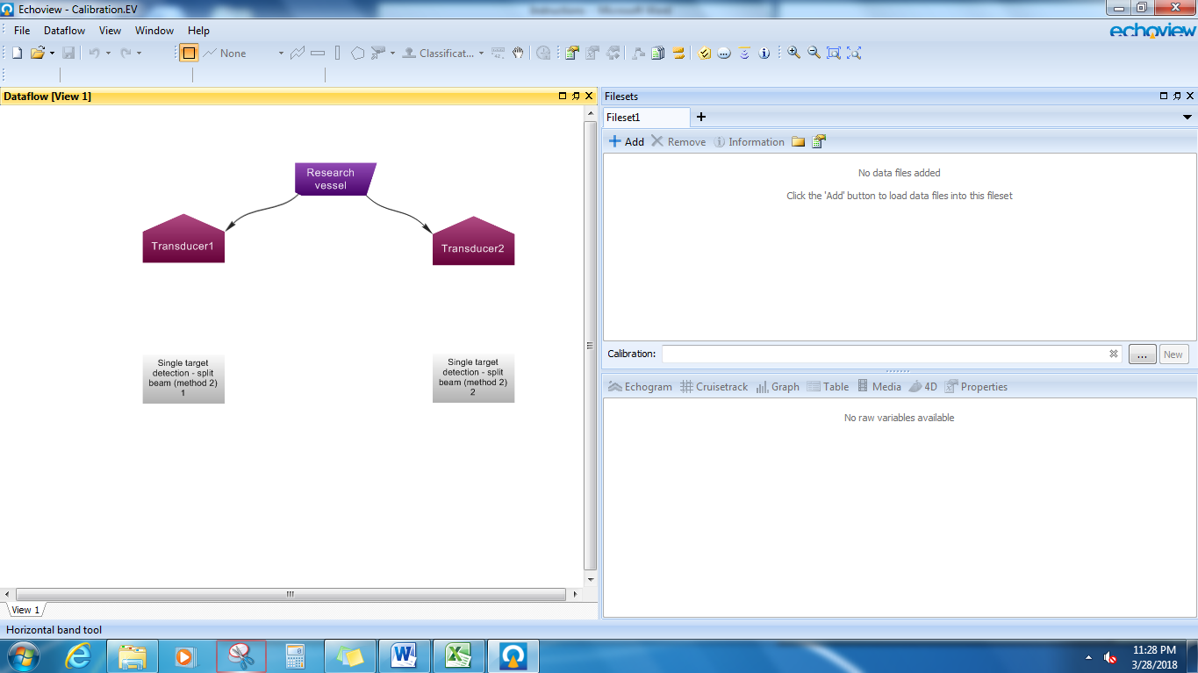

- Go back to the survey “Calibration” folder, select all calibration .dt4 files and drag them into the Filesets window; your screen should now look like this:
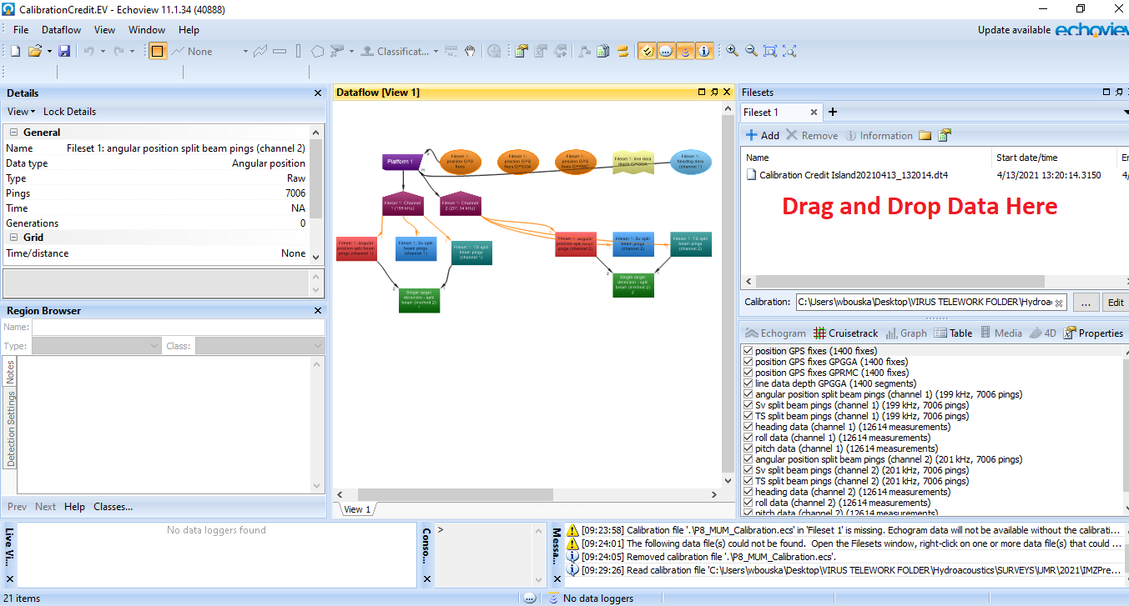

- Next we will create the .ecs file into which we can apply our calibration offsets. In the Filesets window for Calibration, click “new”.
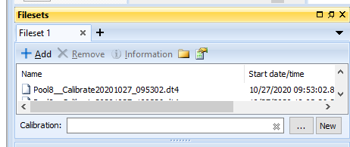

- Save the .ecs file in your survey folder where your raw .dt4 calibration files are located, and name it as appropriate.

- Open “Fileset1: TS split beam pings (channel 1)” and “Single target detection - split beam (method 2) 1” variables and stack them on top of one another. For each one, click on the echogram and then hit “Shift + A” to autosynchronize them (or click the watch button up in the toolbar for both windows). Scroll until you see the series of single target detections.

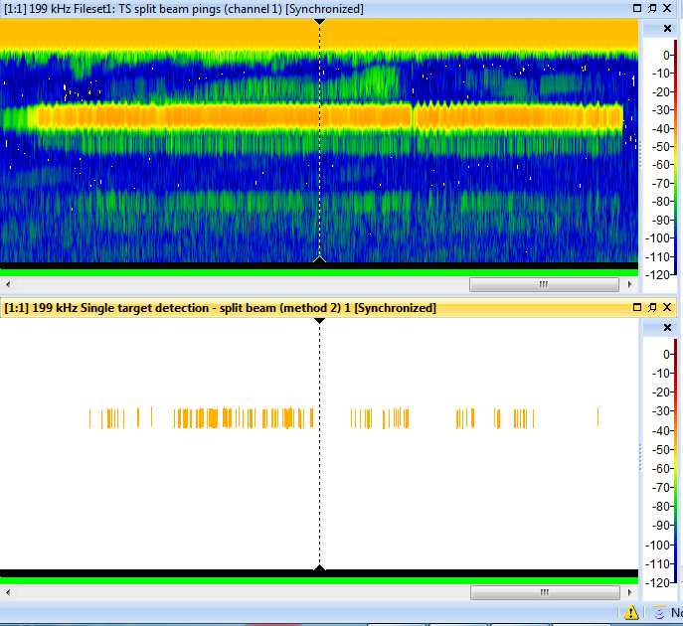

- Use the Rectangle tool to encompass all single target detections

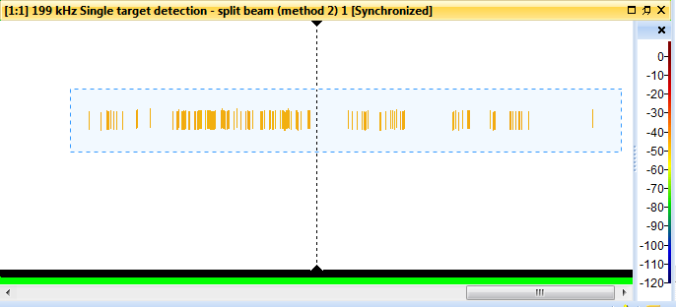

- Right click in the middle of this rectangle and click “Define Region” – Note: the region may not be visible until you complete the next step
- Open the Region Browser by pressing F4 if it did not already open automatically. For the region you just created (most likely “Region1”) make sure the Type is set to Analysis, and the Class will default to “Unclassified Regions”.
- If you wish to check the quality of your calibration data, highlight the calibration analysis region you just created and right click, and select “graph”. Four graphs may be of interest to you: “Angles” will show you all of your calisphere targets and how they orient within the different quadrants of the transducer. This can give you an idea of how well you performed your calibration, ideally you would want targets distributed throughout all quadrants of the bullseye. Other graphs you may wish to view include “Off-axis beam compensation”, “Minor-axis beam compensation”, and “Major-axis beam compensation”. More information about these graphs can be found in the Echoview help file. You will also be able to view these graphs once you open the Calibration Assistant.

- Next, to calculate the calibration offset values, highlight your calibration targets analysis region. Right-click and select “Calibration assistant” which will open as seen below.
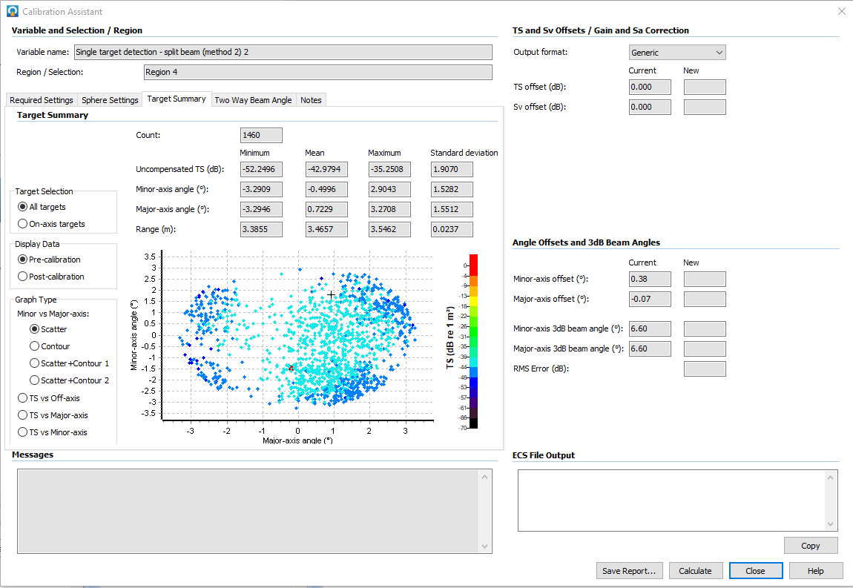

- In the Calibration Assistant window, click the “Required Settings” tab. Under measured Data, make sure the Sv fileset matches the transducer from which you are pulling your calibration data, and that your samples are integrated using “Transmitted Pulse Length”. The On-Axis definition section should be kept at the default setting of 0.5. Under the “Beam Compensation” section, make sure to select the “BioSonics” model, and in the “TS and Sv Offsets/Gain and Sa Correction” section, select Output format as “Generic”.
- If you wish to view statistics of the targets within the calibration region you may select the “Target Summary” tab. Detailed information about this tab can be found in the Echoview help menu. The two-way beam angle tab is not applicable to our calibration needs and no adjustments need to be made in that section.
- Click “Calculate”. Your calibration offset values for the first transducer (channel 1) will then be displayed in the ECS File Output box.

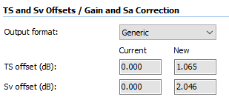

- Open up the calibration .ecs file you created in steps 3-4. You will enter the “CalibrationOffsetSv”, and “CalibrationOffsetTs” values into the area highlighted below. Delete the “#” in front of each setting that you are updating.
#========================================================================================#
# SOURCECAL SETTINGS #
#========================================================================================#

SourceCal (channel 1)
# AbsorptionCoefficient = 0.0176386 # (decibels per meter) [0.0000000..100.0000000]
CalibrationOffsetSv = 2.046 # (decibels) [-99.900..99.900]
CalibrationOffsetTs = 1.065 # (decibels) [-99.900..99.900]

- Repeat steps 5 through 14 for the second transducer (channel 2).

- Save the changes to your .ecs file by entering “Ctrl+S” or go to “File” and “Save”. Do not use “Save As” or it will change the file type to a .txt document that cannot be read by Echoview. If you do accidentally save this as a text file, you can rename it back to a .ecs file for use in echoview.

- Save and close the “Calibration.EV” file

- A calibration offset between 2 and 5 is acceptable but if the offset is consistently 5 or greater, the transducer(s) may need to be sent to BioSonics for recalibration. Calibration offset values less than 2 are very good, and indicate your equipment is functioning as intended.
- If you analyze your calibration data and find that it recommends offset values greater than 5, or much greater than what you normally calculate, be sure to consider whether there is an issue with the quality of your calibration data. For example, if I calibrated twice during a week of surveys, and my first calibration indicated offsets greater than 5 were needed, while my second calibration recommended offsets of 0.5 or 1, consider using only the data from the 2nd calibration and discarding that from the first.

Calibration analysis troubleshooting

- The series of single targets are so long that they cannot be viewed at the same time, making it impossible to draw a rectangle that encompasses them all. What should I do?

Option 1) Zoom out until you see all single targets and then create your region.
Option 2) As you are drawing your region with the rectangle tool, you can use the arrow buttons to progress through the echogram while still holding the mouse button down, highlighting the entire area of interest.
Option 3) You may be able to use the horizontal region tool to draw a horizontal region through the entire echogram, only use if only the calisphere targets can be included, and not if fish or other non-calisphere targets are within the region

- There are very few or no single targets being shown on the single target detection even though I can see the calibration sphere on the target strength variable. What should I do?

This would indicate that you conducted a poor calibration, and the calibration process needs to be repeated. Try calibrating in a calm area out of flow,

Analysis of the Main Channel and Off-Channel Survey Data

Setup phase
- The data should already be divided up into folders by pool or reach, and further by separate survey location. Each survey location folder should have a calibration folder with the .dt4 calibration files, and a survey data file with the .dt4 files from the actual mobile survey.
  - Note that .rtpx files are created by Visual Acquisition but are not necessary and should be deleted to save hard-drive space
- Go to Microsoft Teams and the Hydroacoustics Working Group Team page. Open the “Files” section and locate/open the folder named “Hydroacoustics analysis instructions and templates”. Next open the folder labeled “Mobile survey utilities”
- Copy the “Mobile survey analysis.EV” file from the “Mobile survey utilities” folder. This is the raw analysis template file so don’t make changes to it. Copy the “Mobile survey analysis.EV” file and then paste it into each survey data folder that you will need to analyze. Each survey data folder should contain the associated .dt4 files, the “Mobile survey analysis.EV” file, and the “Calibration_offset.ecs” file from the calibration steps above. You may name each .EV file specifically to match your survey file if you choose to do so.

Mobile survey analysis

Bring Data into Echoview
- Open your survey folder of interest and then open the “Mobile survey analysis.EV” file. If you copied the Calibration_offset.ecs file into this folder, it will automatically load as your Calibration file. You can click “Edit” to make sure the values are what you expect them to be (***note that the offset should be set to 0.00 for both transducers unless you calculated different values). Your screen should look something like this:

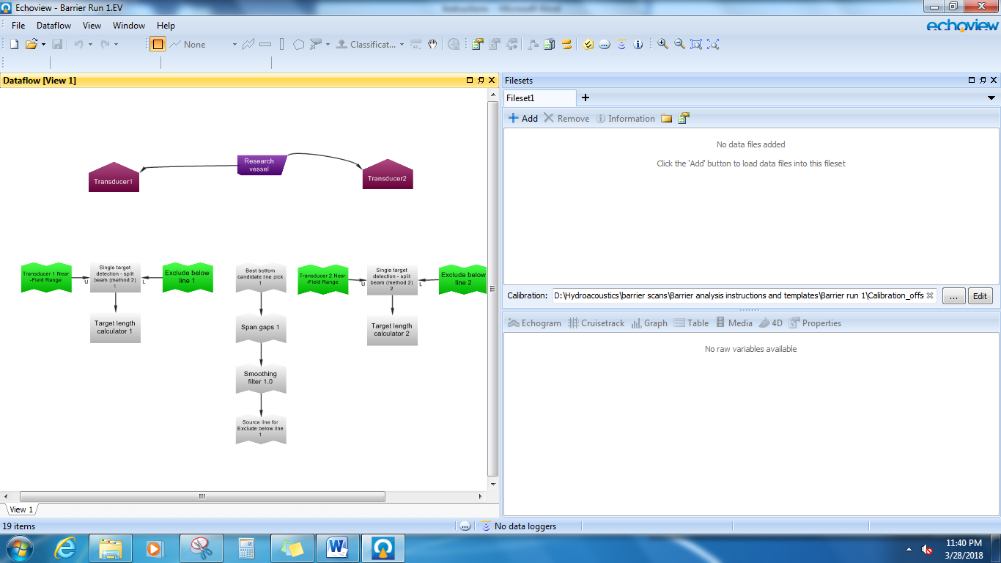
Edit
Note calibration file directory
Dataflow window

- Drag and drop all .dt4 files into the Filesets window pane (loading can take several minutes)

Check Transducer Orientation
- The analysis template pre-designates channel 1 and channel 2 transducers as either surface-looking or bottom-looking. However, if you switch the multiplexing cables in the field or when moving gear from one boat to another, they can get accidentally switched around. This can affect the nearfield exclusion line and other variables. It is good practice to double check your transducers are properly assigned. Open the “Fileset1: pitch data (channel 1) – Pitch” variable and visually determine the approximate average angle the pitch was maintained. From the “Setting transducer angles” section near the beginning of this document, the example transducers are deployed -3.3 and -10 degrees, respectively, below the plane of the water surface, and the average pitch should be close to one of those values.

- Right click the “Transducer 1” variable and go to Transducer properties. Click on the “Orientation” tab on the left side of the properties window. Under “Elevation” make sure this value matches the degrees below horizontal that was maintained (i.e., 90 + the negative number determined from step 3; result should be less than 90 degrees). If you need to change it, you may get a warning message, this can be ignored.

- If needed, repeat steps 3 and 4 for Transducer 2.

Identify Bottom Line and Exclusion Lines
- You should now identify your bottom line and near field exclusion line for each echogram, and then visually inspect the bottom line to make sure it correctly follows where the acoustic beam hits the bottom.

- Open “Fileset1: TS split beam pings (channel 1)”, then click the dropdown button on the Line and Surface editor and click “New Editable Line…”

- Under Destination, choose “Overwrite existing line” and select “Exclude below line 1”. Under Source, choose “Existing Line” and select “Source line for Exclude below line 1” from the drop-down menu. Make sure the Offset is set as below and the Visibility is “Visible on current echogram only”. Then press OK, and wait for Echoview to render the bottom line onto the echogram.

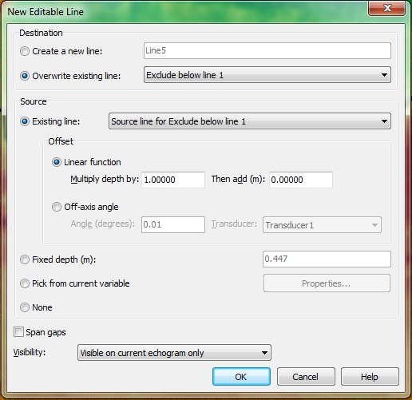

- Does the new bottom line look reasonable? If your survey was conducted under high flow or rough water conditions and there is a lot of interference on the echogram, the default settings on the analysis template may not render a very accurate bottom line. You may be able to adjust the bottom line pick settings and produce a better fitting line, but be careful not to adjust it too low such that you are trying to analyze targets that actually fall below the true bottom exclusion zone.
- If you want to try different settings for a better fitting bottom line, from the Dataflow window right click on “Best bottom candidate line pick 1” and select “Line Properties” and then “Best Bottom Candidate Line Pick”. See below for the default bottom line pick settings (below left) vs alternate/high disturbance settings (below right).
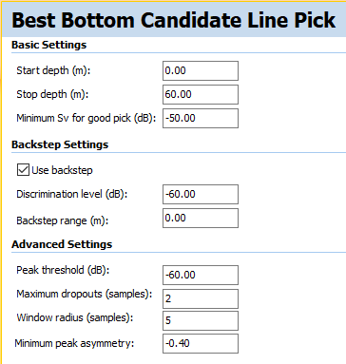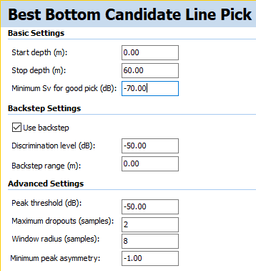
- The near-field exclusion line should have automatically been placed on the echogram but you will want to make sure it is in the right spot (if the transducer angles/channel order got switched in the field from the analysis template default, see steps 3-5 above, you will need to change the location of this line). Go back to your “Fileset1: TS split beam pings (channel 1)” echogram and determine if the “Transducer 1 Near-Field Range” line is at a range of 1 meter. Hover the mouse over the line (the straight line at the top of the echogram). The range (and depth) of your pointer is displayed in upper left corner as displayed below. If the line is not at a range (R) = 1.00m, move the pointer around and note the depth (D) where range (R) is at 1 meter.

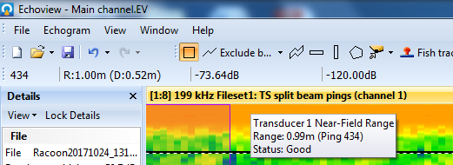

- If you need to change the range of the “Transducer 1 Near-Field Range” click the dropdown button on the Line and Surface editor and click “New Editable Line…”, choose to overwrite existing line to a fixed depth determined from step 9.

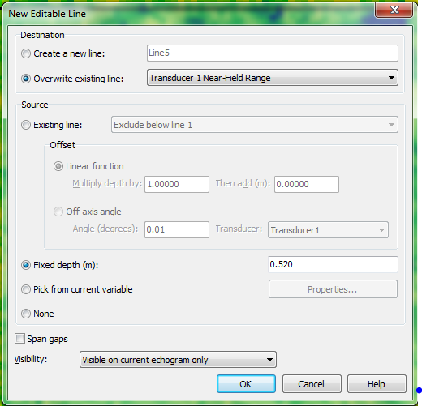

- Repeat steps 6-12 for “Fileset1: TS split beam pings (channel 2)” but this time you will be overwriting “Exclude below line 2” using “Source line for Exclude below line 2”

Edit the Bottom Line
- Next we need to review and check the bottom lines that were rendered onto each echogram. Open “Fileset1: TS split beam pings (channel 1)” and from the Line and Surface dropdown menu select “Exclude below line 1” as the active line to edit. Note: that you should read the help menu to learn how to edit lines by pressing F1 and searching for edit / lines under the Index tab. When editing a line, press ‘L’ to save the changes to the line that you made.

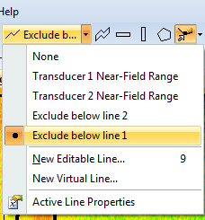
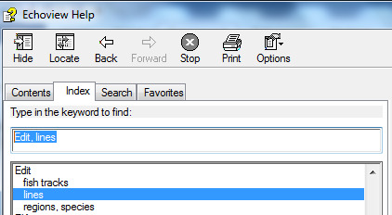

TS Thresholds
- Before you begin to examine your bottom line, you may want to adjust the display by changing to color scheme and/or applying a TS threshold to your echogram. This can be accomplished by pressing the plus and minus keys while viewing an echogram, or right clicking on the “TS Color Legend” which appears along the right side of the echogram, and allows you to enter a specific value. This step is based on user preference to better visually examine the data. Below are three examples of the same echogram at three different TS thresholds.
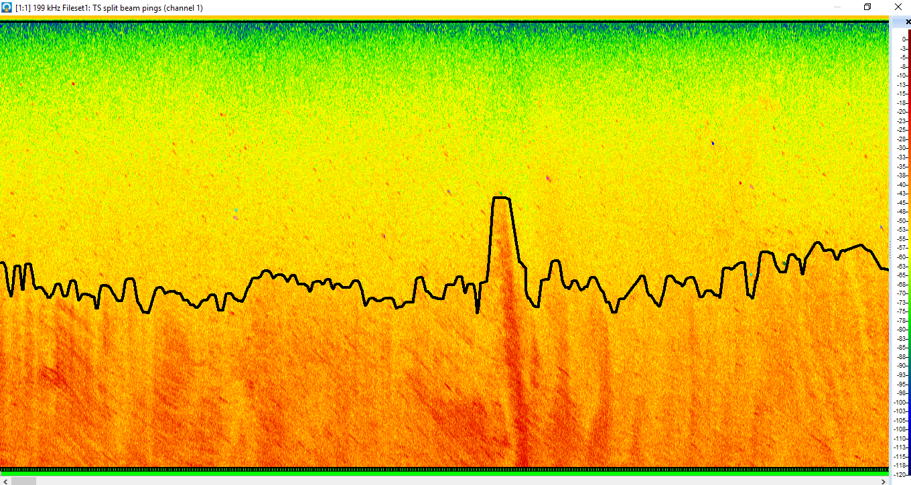
No threshold / -120 dB minimum
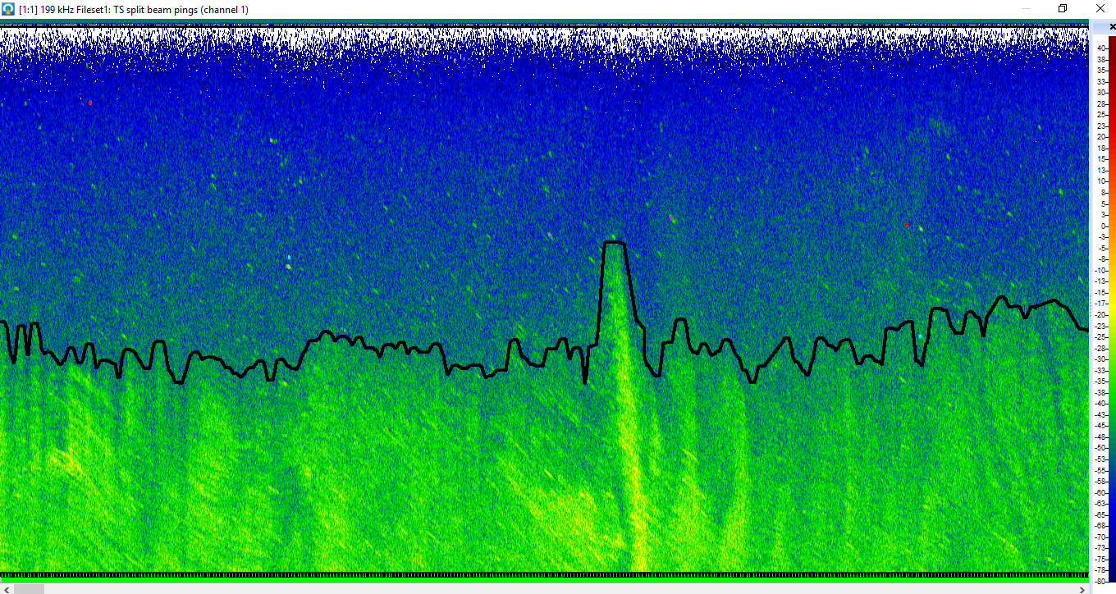
Threshold at -80 dB minimum
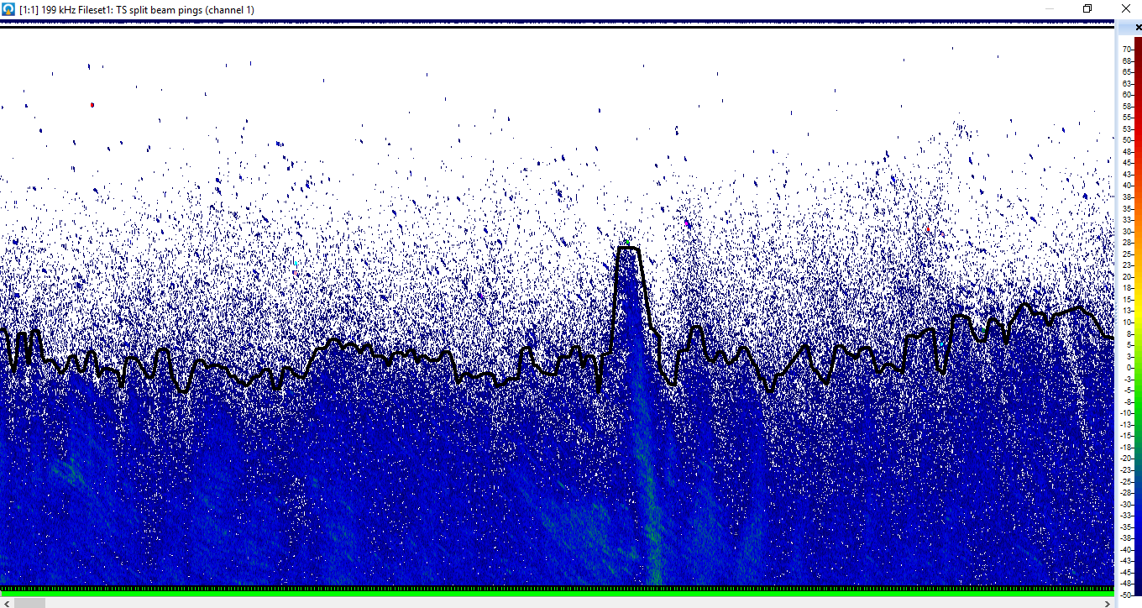
Threshold at -50 dB minimum

- After choosing your threshold preference, you can begin to examine the bottom line. Below is an example of a line that does not need to be corrected.
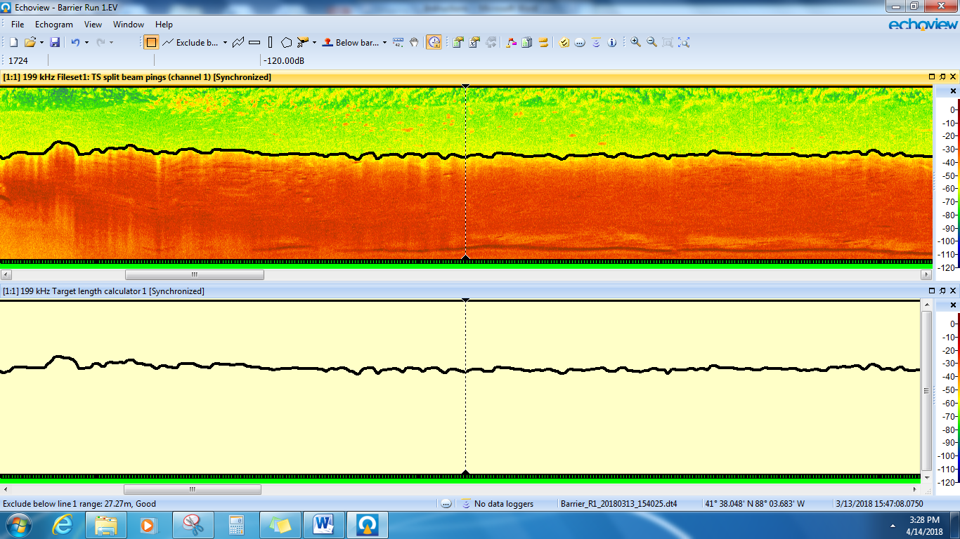
- Below is an example of a line that does need correction, because air bubbles caused the bottom picking algorithm to be inaccurate. Use your mouse to correct the line. Hold the left click and draw the corrected bottom, or left click a series of points along the correct bottom. Next hit “L” to update the line, or right click, and select “Update Active Line”.

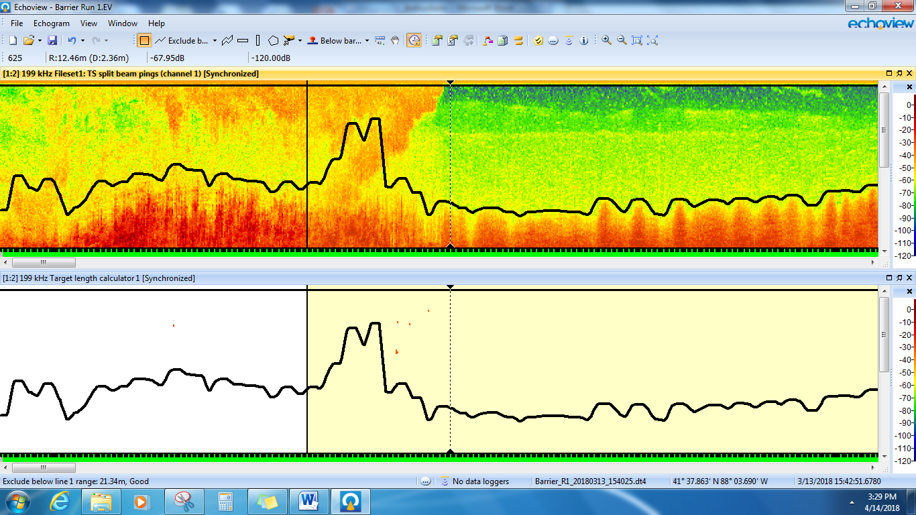

After correction (below)

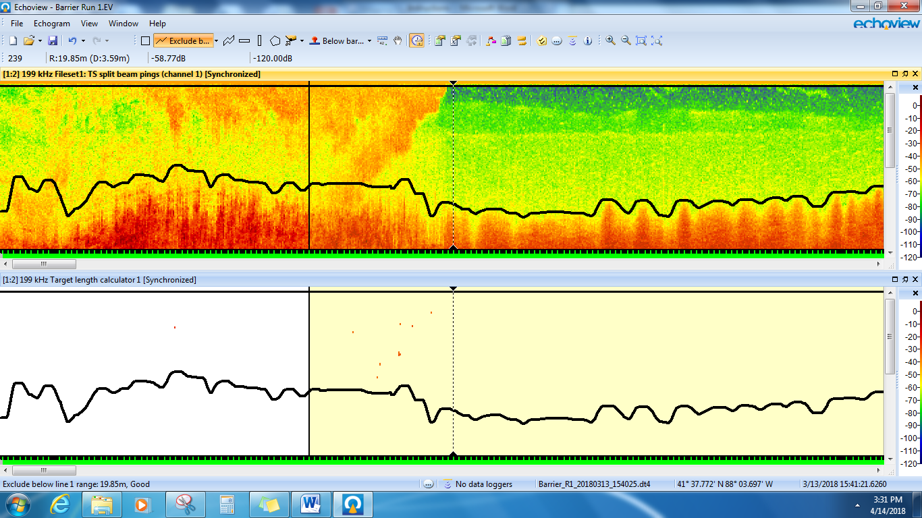

- Below is another example of a bottom line needing correction. Here a part of the beam may have been hitting an underwater dune or ridge and the other part of the beam was extending beyond that point, then the beam fully went past the partially obstructing dune. The red line indicates how the bottom line should be corrected in this example.
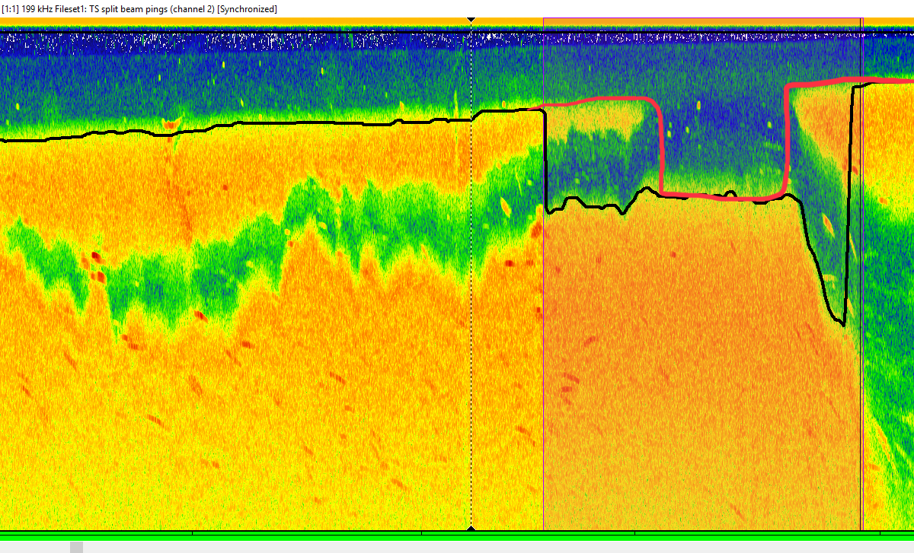

- Below is another example of a bottom line that should be redrawn because of some error in the line drawing function (top), and the line after correction (bottom).
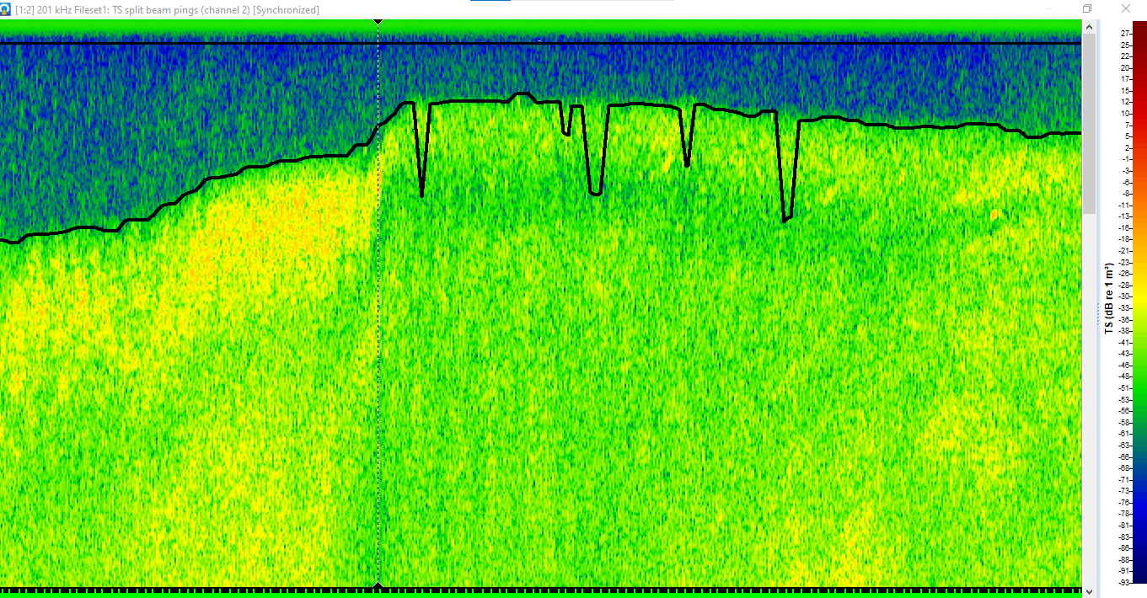
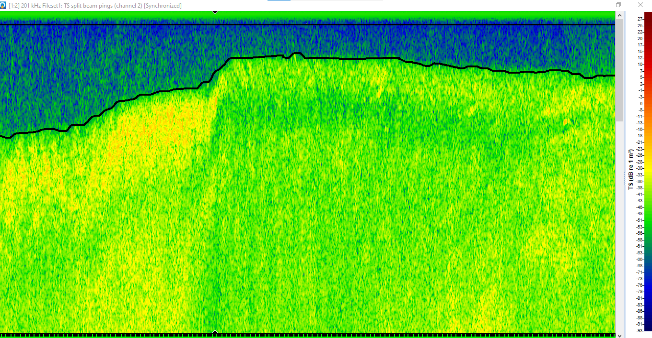

- Below is an example where the bottom line is drawn through a hump on the bottom but should be edited to go around instead (see blue line for the correction). You can tell this is a hump on the bottom and not a ball of baitfish because of the light green area directly below it – showing the hump is literally blocking the sound waves from going past it. There is another hump below and to the right (smaller dark red blob), that also shows a shadow effect of blocking the sound waves.
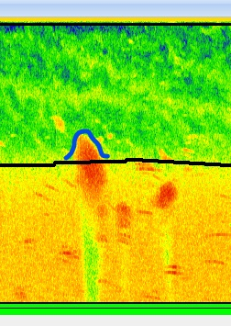
- After you have finished inspecting and editing the bottom line, repeat the bottom line inspection and correction steps for channel 2

Examine Echogram to Designate Regions of “Bad Data”
- After we have made our bottom line edits, we need to examine the echogram for areas of disturbance that could be creating false positives, or making it so that fish targets cannot be clearly defined.

Open “Fileset1: TS split beam pings (channel 1)” and “Target length calculator 1” from the Dataflow window and close all other windows to make it easier to make edits. Make sure you Autosynchronize both windows by clicking for each window (or pressing Shift + A for each window). The picture below was used as an example previously as a bottom line that needed to be edited. However, after the editing, the disturbance cloud is going to create some false positives that will need to be dealt with (see next step).

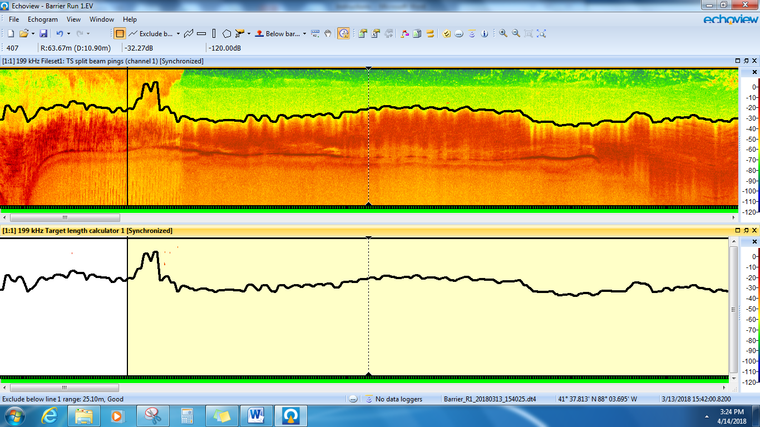

- You can see that removing the hump from step 21 would have resulted in additional false positives in the lower, “Target length calculator 1” window, that are clearly not fish (or at least we can say we can’t be confident that there are fish within this area of air bubbles).

- Therefore we would want to create a bad data region so these targets are excluded from the analysis. We can use the Polygon tool to create a region around the single targets in red and use our region browser to change the region type to Bad data (no data). Set the region class to “Bad data (Transducer1)” for anything related to transducer 1 and to “Bad data (Transducer2)” for anything related to transducer 2. Regions should be created around areas of ”Bad data” even when no false targets are apparent. The vertical band tool may also be used to designate regions of bad data, and may be more appropriate for large areas that extend from surface to bottom, like prop wash from a barge whereas polygons are suitable for smaller areas.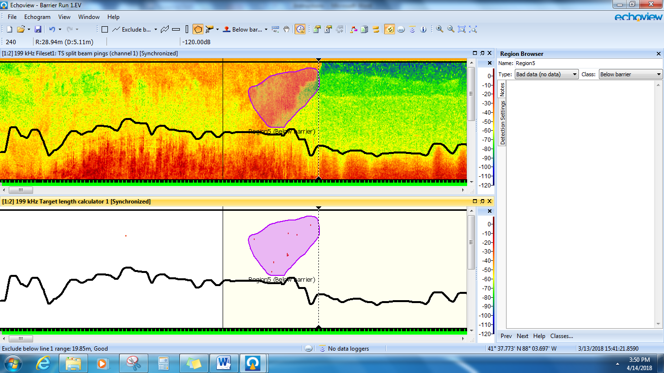

- Continue going through the entire echogram, editing the bottom line if necessary and using the region tool to exclude bad data. Repeat these steps for Transducer 2 / channel 2.

Setting Target Identification Parameters
- Next we will be identifying the targets within the echogram.

Open “Fileset1: TS split beam pings (channel 1)” from the Dataflow window and make sure the Details window is also open by clicking. Record the water temperature and frequency for the next step.

- Open the “Sonar calculator” Excel file located in the surveys “Calibration” folder and enter the water temperature and frequency from the previous step.

***Note that the temperature during the survey can be different from when the calibration was conducted before.

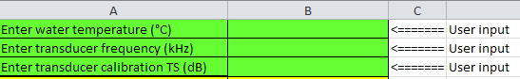

- From the Dataflow window right click “Single target detection - split beam (method 2) 1” and select “Variable Properties” , “Single Target Detection” and change the “TS threshold (dB)” to the “Side-aspect TS of 250 mm fish (dB)” value provided in the Sonar calculator (cell B9). Make sure all other values are set as follows. Click OK

NOTE: The above step is setting a length cut-off for the fish targets that you want to examine in your data. You are saying you want to ignore anything smaller than 250 mm. The 250 mm cut-off originates from the first Illinois River surveys and electric barrier surveys, and was reflective of what was the smallest invasive carp that was fully recruited to the physical capture gear, or smallest possible carp that could theoretically be that close to the barrier. For the FWS large, multi-pool Illinois, Ohio, Mississippi River invasive carp surveys, 250 mm is appropriate and is the standard cut-off that is applied. In the Upper Illinois Waterway, they now use a 300 mm cut-off.
Physical sampling might collect some YOY carp, but the smaller you set the cut-off, the greater the potential for false targets. Population modeling only looks at age-1 fish and older, so looking at fish significantly smaller than that threshold is not additive to that effort at this time. You can change the cutoff length in the Sonar calculator.xlsx by manipulating the formula in cell B9 “B7*LOG10(10*2.54)+B8” - change the “10” to whatever cutoff you want, in inches. This may be useful in certain circumstances, for surveys in novel habitats, areas where only large carp are present, where high flow or other disturbance may make identifying smaller targets problematic, or surveys where carp are not the species of interest. In the analysis process, the R-code allows the user to enter any cut-off length.

**NOTE – The max beam compensation (dB) is set to 6.00. A standard value for max beam compensation settings is still being debated. Also note that the Maximum standard deviation of the minor and major axis is set at 6.00 during side-looking surveys where fish orientation and swimming behavior increases the variability in sound directivity. The Great Lakes Standard Operating Procedure maximum standard deviation values for down-looking data is a recommended 0.6, because the estimated location of the target is much more precise as compared to side-looking data.

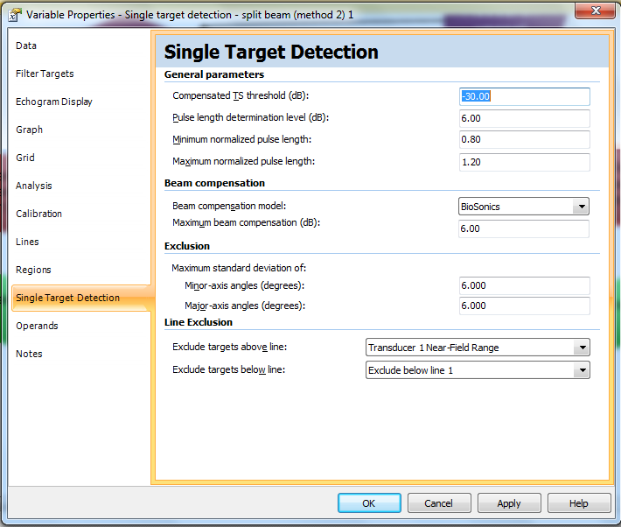

- From the Dataflow window right click “Target length calculator 1” and select “Variable Properties”, “Target Length” and change Factor A and Factor B values to the Factor A (side-aspect) and Factor B (side-aspect) values in the Sonar calculator (cells B7 and B8, respectively). Click OK.

***Note that Factor A should not change if Love’s maximum side-aspect equation continues to be used.
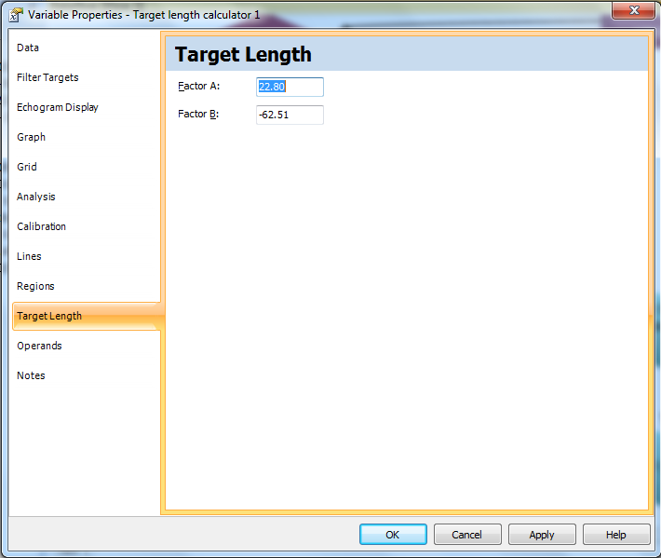

- Under “Lines” of the Variable properties for “Target length calculator 1” make sure that both “Transducer 1 Near-Field Range (Grid)” and “Exclude below line 1” are checked. Note: that you might have to set the “Active line” to “Exclude below line 1” to make the line visible on the echogram, which changes the line name to “Exclude below line 1 (Active)” as displayed below. Click OK

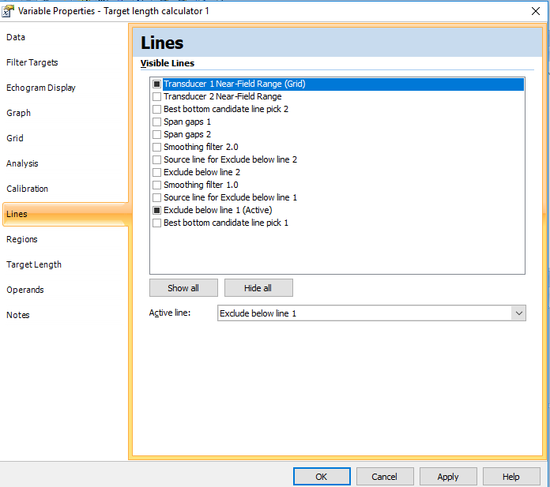

Next go to the “Analysis” tab of the Variable properties for “Target length calculator 1” make sure that your exclusions are appropriately set to exclude data above the line “Transducer 1 Near-Field Range (Grid)” and exclude below the line “Exclude below line 1”. Ensure your analysis settings are checked to “Set pings with bad line status on the exclude below line to no-data” and “Apply bad data regions”. Frequency distribution settings should be Min. TS -35.00, Max TS -10.00 and number of bins = 1. See below.
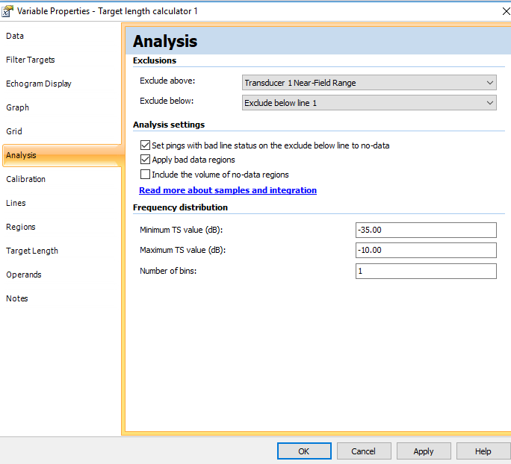

- Repeat these steps for Transducer 2 / channel 2

Detecting Fish Tracks
- From the Dataflow window open the “Fileset1: TS split beam pings (channel 1)”, “Target length calculator 1”, and the “Region Browser” window. Make sure the two echograms are synchronized.

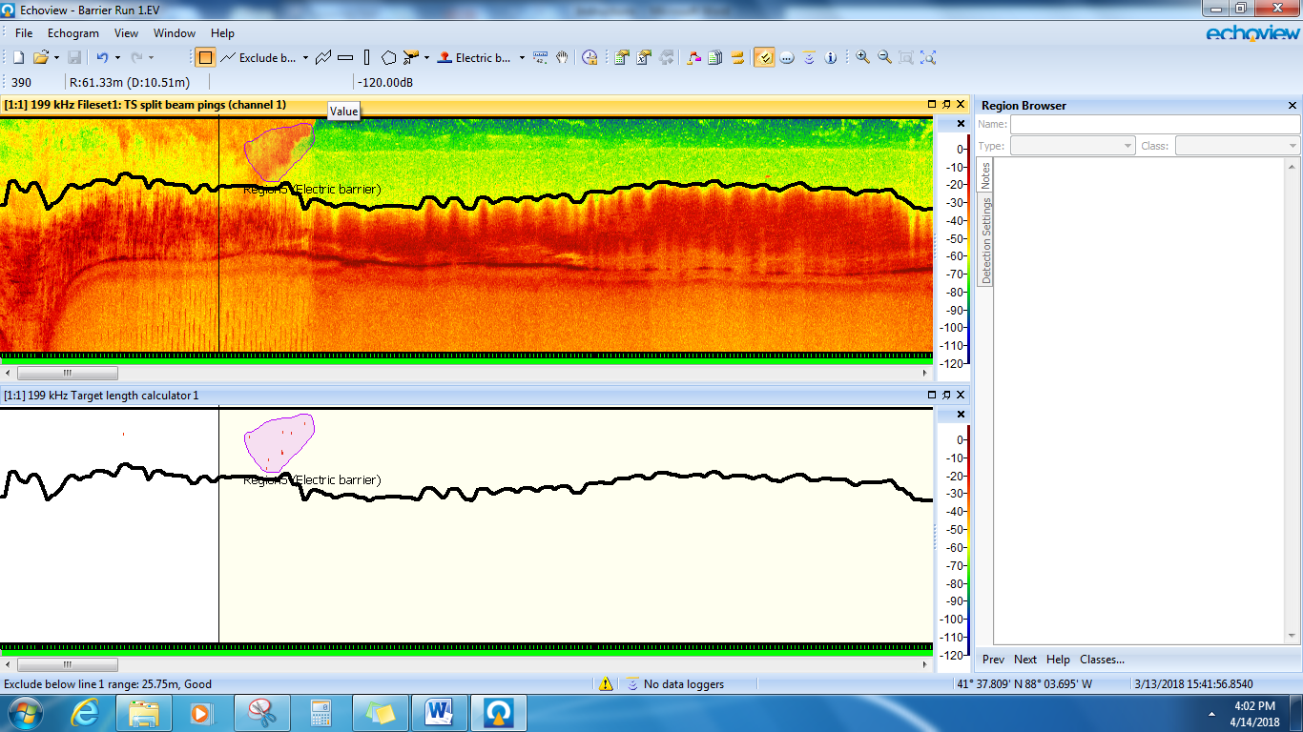

- Click the “Target length calculator 1” window and then click the Echogram menu dropdown. Select “Detect Fish Tracks”, change Assign class to “Fish track T1” and click “Detect”
- Use the “Next” and “Prev” buttons on the bottom of the Region Browser to scroll through all detected fish tracks to determine if they need edited.
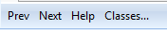
Does it look clearly like a single fish, or several fish on top of one another? A single stationary fish target will appear compact, while a fish moving with the boat and spending more time in the beam, may appear as a streak. A “fish track” can be made of one or two single targets, or a streak of made up of many targets.
Below is a survey image from the more down-looking transducer as it captures a school of fish. As you can see, some of the fish tracks look like long streaks (fish moving with the boat) and some are more compact (stationary fish or those moving the opposite direction as the boat). The more down-looking transducer is making a more direct contact with the bottom and thus the bottom is more defined in this echogram. You can see that although there appear to be many more fish in the echogram, only those that meet our filter criteria (>250 mm) and other single target detection parameters, are identified as fish tracks.
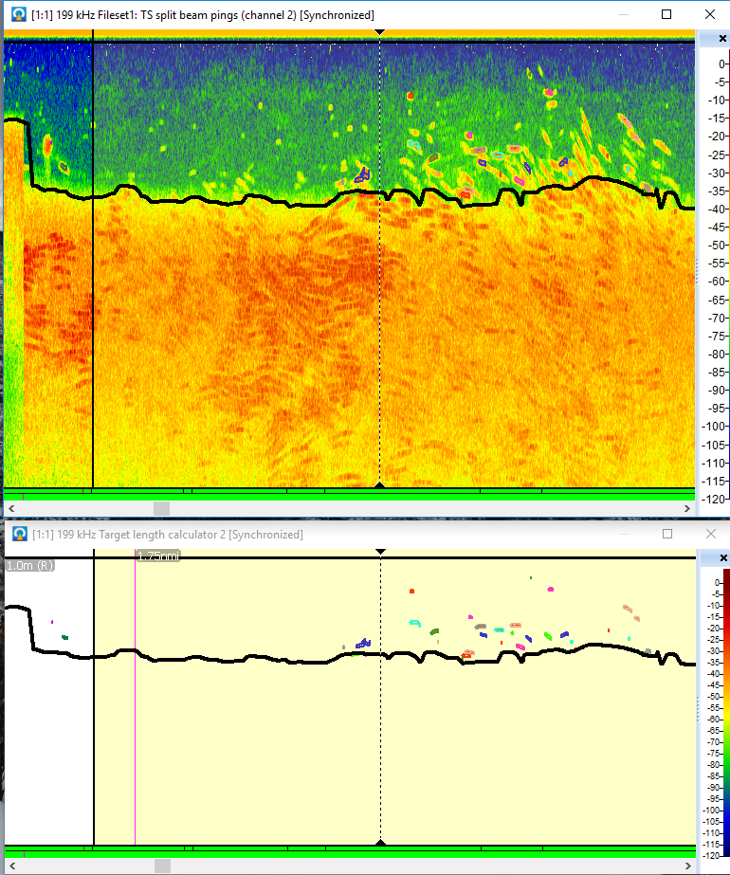
Next is the image from the surface-oriented transducer, synced at the same time for comparison. Remember the transducers are looking at different parts of the water column so these are different fish from the same school compared to the more downward-angled transducer. Notice also that because of the angle of the surface-looking transducer, contact with the bottom is less direct, occurs farther out, and the bottom is slightly harder to define with your eye. Below the black bottom line (where the lower edge of the beam first intersects with the bottom) the upper parts of the beam are still continuing on and picking up fish. However, because those fish are on the edges of the beam, the data isn’t good enough to accurately determine length, nor can we determine the volume sampled beyond the area of first bottom contact.
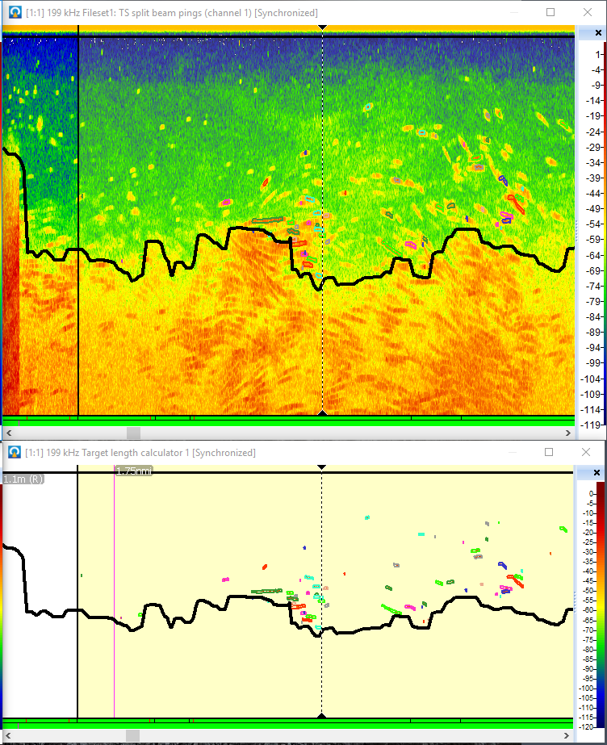

Editing Fish Tracks
- Below are two separate fish tracks that should have been identified as a single fish. We can merge them in the Target length calculator 1 window by having one of the fish track regions (the diamond shaped region on the fish) selected by left clicking on it, and then drawing a box only around the other fish track region you want to merge using the rectangle tool , right clicking the box we created, and clicking “Merge Fish Tracks”. Alternatively, if one track is selected, hover the mouse over the other track that is to be merged and use the keyboard shortcut, “Shift + M”.
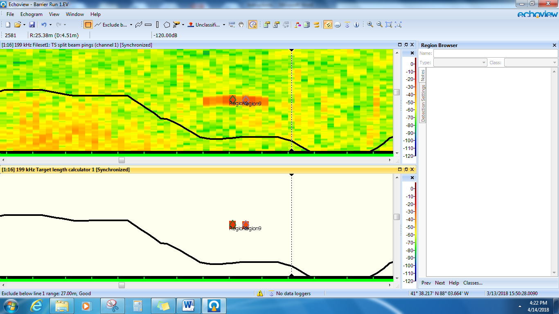

- We can also “Split Fish Track” when it is clear that there are two or more fish being treated as one, or sometimes portions of multiple different fish are incorrectly lumped together. Select the track that needs to be split and then right click on the segment where you want the split to occur. Hopefully it will split where you want it to. If not, you can undo the split and try again, or continue to split the track apart and then merge the appropriate areas as necessary. Below is an example of fish tracks that need to be split.

Some areas where a large school of fish is present may need extensive splitting and merging. Where two fish tracks are very close together and splitting is required, you have to be strategic about where you are splitting. It is very hard to merge a target with another if that target is also touching a different fish track that you want to remain separate. Merging and splitting fish tracks can be onerous and the program can be tricky to work with. Sometimes the program just deletes the fish tracks that you are attempting to merge, particularly if you draw the box around both the selected fish track and the additional fish track you want to merge with. If this happens, re-select the single targets using the tool and click “Create fish track from targets.”

- If a fish track needs to be deleted, like the one shown below, it is actually better to treat it as bad data (so it doesn’t get detected as a single target and wouldn’t get detected as a fish track again if you had to redo the fish track detection process for some reason). Click on the fish track to select it and change the region type to “Bad data” and set the class appropriately (i.e., “Bad data (Transducer1)” for transducer 1, and “Bad data (Transducer2)” for transducer 2). This fish track would be a candidate for deletion because it is not a clearly defined single target, it could be a ball of baitfish. A fish track that straddles both sides of the bottom line can still be used in an analysis, but only the targets from the track that are above the exclusion zone should be used.

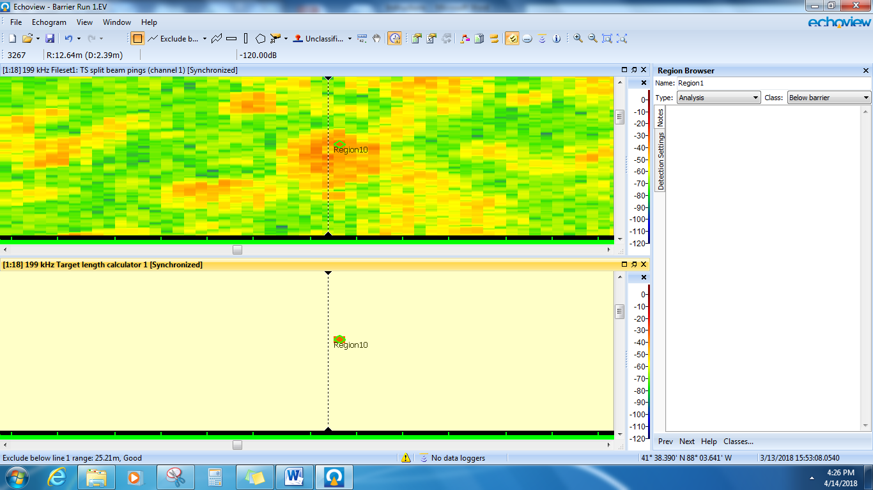

- Repeat these steps for Transducer 2 / channel 2.

Fish Track Detection Algorithm
- The parameters of the fish track detection algorithm were developed specifically for the IL and OH River surveys, and may still need to be adjusted for the UMR surveys, or additional sub-basins, to get the most accurate results. If you run the “detect fish tracks” algorithm and see lots and lots of tracks that need to be edited and redefined you may need to adjust the algorithm settings.

If you plan on adjusting the algorithm, the best course of action may be to first go through the file created by Echoview and manually fix all the fish tracks. Note how many tracks you have and save the file as its own .EV file. Now go back to the original, and make adjustments to the algorithm variables until the program selects a similar number of tracks as what you manually identified. If you successfully tweak the algorithm to better select your fish tracks for a particular water body, with less need for editing, you can save those new settings into a raw analysis template for that water body. It will probably never be perfect, and some degree of manually editing will be necessary.

Algorithm Adjustment
Open up the “Target length calculator” window, from the top menu select “Echogram”, from the drop down click “Detect Fish Tracks”, click “Properties”
Algorithm tab – the exclusion distance (m), may be the most sensitive to adjustments.
Weights tab – you can try to adjust the ranges for different track detection variables.
Track Acceptance tab – you may want to try and adjust the track acceptance max gap value

Setting up the Sampling Interval Prior to Exporting your Data
- Echoview will divide your survey into sampling intervals based off nautical river miles. You can set the interval length in Echoview by right clicking the target length calculator in the dataflow, selecting variable properties, grid, and then changing the value in the “Distance between grid lines (nmi) box”. You will have to do this for each transducer. For FWS administered pool-wide surveys in the Ohio and Upper Mississippi Rivers, 0.5-mile intervals are used for all sampled macrohabitats. In these sub-basins, Pools of interest were surveyed completely, and a re-sampling analysis was conducted to determine the most appropriate interval length. Hydroacoustic surveys in different sub-basins, or surveys with different objectives may require different interval lengths, or a separate re-sampling analysis.

Data Exporting
- For this step you only need to have “Target length calculator 1” open. Click on Echogram on the toolbar, then “Export >”, then “Analysis By Cells >”, then “Fish Tracks…”

- Select “Fish track T1” as the class to export. Save the file as “MC T1 FT” or your own site specific naming system (e.g. T1_FT_P19_BW_Carthage).

- Using “Target length calculator 1”, click on Echogram on the toolbar, then “Export >”, then “Analysis By Cells >”, then “Single Targets…”

- Save the file as “MC T1 ST” or your own site specific naming system (e.g. T1_ST_P19_BW_Carthage).

- Repeat these steps for “Target length calculator 2” and save using T2 instead of T1

- Data processing and export are now complete. Repeat all steps above for your next site or continue with data processing in R.

Understanding Exported Files From Echoview
You will have now exported several files from Echoview that will be used in your analysis. For each survey, each transducer will have two files; a fish tracks.csv file and a single target detection.csv file.

Fish Tracks .csv file
The first two columns show the region info. The echogram was divided into many regions during the processing steps above; bad data regions (areas of interference or clouds of silt and bubbles from propwash), and each fish track is also a region. On the fish tracks.csv file, only fish track regions are listed. If a fish track was designated during the review process as “bad data”, it is still in this file, and fish tracks that are located within designated areas of “bad data” such as an area delineated by a polygon, are also still in the file. You can tell which fish tracks are “bad data” because their value in the “Target_length_mean” column, and many of the other columns, will be -9999, or 9999. Also, the number of targets that makes up a fish track will be either “0” or “-1” for fish tracks that were designated as “bad data” or were within “bad data” regions. See “Special export values” in the Echoview help file for more information.
The most important columns that will be used in this file are the interval column, which shows you which sampling interval each fish track was found in (See step (41) about intervals above), and the “TS_mean” column, which is the mean target strength for each fish track. These will be used to calculate density and length of individuals. Each individual fish track gets its own line of data, the column “Num_targets” shows how many pings were made on the individual fish track. A fish track could be made of only one ping, or a Num_target value of “1”, or the track could be composed of several targets or pings that were grouped together and counted as one fish because they met certain criteria in Echoview. This export file also includes information about the time, the geolocation of the fish track, the targets range and depth, min, max, and mean target strength, approximate length of fish targets, and more.

Single Targets.csv file
This export file provides a line of data for each sampling interval, and a line of non-data for each interval that can be ignored. Information such as the start and stop time, and lat/long, is listed for each interval, as well as the number of single target detections in an interval, and descriptive data for the single targets. If there were three fish targets in interval 1 and those targets had 1 ping, 3 pings, and 2 pings, respectively, the number of single targets detected in interval 1 would be listed as 6, i.e. the total number of targets, regardless of the number of individual fish tracks. The most important column from this export file is “wedge_volume_sampled” which is an approximation of the sampled volume of water in cubic meters for each interval. This will be used to determine density (# / m³). The wedge volume estimate assumes a straight line of travel, uniform speed, and consistent ping rate. There are options in the settings that allow you to divide your echograms into “cells” splitting the echogram into layers or sections going away from the boat (horizontal lines on the echogram). In this case, the export will have a wvs value for each layer within the interval, and you will sum up all wvs values that have the same “interval” value.

Data Analysis and Reporting

Pairing Hydroacoustics with Physical Catch Data
How and if you wish to pair hydroacoustics survey data with physical catch data will depend on the objectives of the specific survey, and the availability of suitable physical capture data. For example, in the Chicago Sanitary Shipping canal, due to low densities of fish and the proximity to the electric barrier, physical capture data is not collected to inform hydroacoustic surveys and any large-bodied fish will be of interest and treated as a potential invasive carp. In other sub-basins, especially at the edge of the invaded range, physical sampling may not produce any captures of invasive carps, but the spatial distribution of large-bodied fish may still be useful for describing potential schools of invasive carp, or to direct other early-detection efforts.
Once physical capture data is available, and hydroacoustics data has been processed, analyzed and exported, it is time to combine the two, and set up the data for the final density analyses. First prepare the physical capture data, organizing by the pool or reach, habitat types and/or species that you will be analyzing (e.g. in the Mississippi River, Pool 16, you would have different physical catch data for side-channels, main channel, and backwaters, and would combine all the catch data for pool-wide estimates). Specifically, proportions of fish will be determined for each 1 cm length group from 25-120 cm TL. Length-specific proportions will then be used to categorize acoustically detected fish. Pool-specific length-weight regressions will then be used to estimate length-specific biomass for each species of interest, and density (numeric and mass) will be estimated. On the Illinois River, MacNamara et al. (2016), separated fish into three categories (Silver Carp, Bighead Carp, and other fish species).
R code may be adjusted to summarize your data however you want, providing density estimates for every species or combining fishes into groups for analysis. R code for this analysis was initially developed for the Illinois River by Dr. David Coulter (Southern Illinois University) and has been shared and adapted by members of the FWS working group for use in other basins. The code is well annotated and is available upon request, along with example input/output files, through the USFWS Region 3 Hydroacoustics Working Group.

R Analysis Instructions
Choose a location on your desktop or in the folder where your survey files are stored, and create
the folder “R Density Automation”. Within this, create two more folders: “Input Data” and
“Density Output”. In the R script, make sure the initial lines that describe the input and output
locations, match the file path to the “R Density Automation” folder. This will vary by computer
and username.

R Code Example:

##########VARIABLES TO SET BY THE USER########################

#Set working directory:
setwd("C:/Users/wbouska/Desktop/UMR post-processed hydrodata/Pool 16/MC_479-483/R Density Automation/Input Data/")

#Set folder path for Output Data to be written to:
output.folder = "C:/Users/wbouska/Desktop/UMR post-processed hydrodata/Pool 16/MC_479-483/R Density Automation/Density Output/"
#Set Site Name for Files & Output: site = "P16_MCB_479-483_" # Set site name: will be added to all output file names; should match start of input file names

Preparing Input Data files
All input files must be .csv files, and must be named exactly as written in the R code at line
“#Set Site Name for Files & Output”. As you go through different surveys and pull different
data into the R code, the input and output file lines will have to be manually changed each time.

Required Input Files:
- “…fish species” = A single column (text) listing the name of each species density that should be calculated. The name and order of this species list should match order of all other input files. There must be least one species name in this file. For example:
SVCP
BHCP
OTHER

2) “… fish tracks” = Contains the mean target strength of each fish track. Column 1 = shallow transducer: interval value each fish track is located within. Column 2 = shallow transducer: mean TS of each fish track. Column 3 = deep transducer: interval value each fish track is located within. Column 4 = deep transducer: mean TS of each fish track.

These values are exported from Echoview using: Echogram -> Export -> Analysis by cells -> fish tracks. Interval and TS listed in the exported file should be copied and pasted into this input file. Depending on how you edited your .EV file, you may need to filter your export file to remove any fish tracks from the list that have “0” or “-1” targets. These are fish tracks that were later designated as “bad data” or fell within regions subsequently designated as “bad data” after fish tracks were detected. If these tracks appear in the Echoview export file, they should be removed and not included in the “fish tracks” input file that will be used to calculate density.

One transducer will likely have more tracks than the other (typically the shallow or surface-looking transducer). For the transducer with fewer tracks, fill in all the blank cells with zeros for both columns. Fill these zeros down to where data from the other transducer stops. See example below:

int_199_ts | ts_199 | int_201_ts | ts_201
1 | -27.9629 | 1 | -29.3437
1 | -30.3135 | 3 | -29.8115
2 | -29.7843 | 0 | 0
3 | -30.0679 | 0 | 0

3) “… interval list” = This file states which intervals are paired together (for side-channel and main channel sites), and which strata they belong to (currently only main channel sites have more than one strata).
-Column 1 = Strata value (must be numeric. Example: 1 = nearshore, 2 = mid-main channel). There will be two strata for main channel transects where two sets of transects (nearshore and mid-channel), were conducted on each shoreline. At side-channels and backwaters, there will be just one strata

-Column 2 = ascending numbers starting with 1 for each strata. Repeats starting at 1 again, if a new strata begins.

-Columns 3 and 4 = lists which intervals get paired together within a strata. For main
channel and side channel sites, if there is an odd number of intervals, you must delete one
(preferably a short leftover interval at the end of the transect that has no fish targets). Pairing
the lone, odd interval with “zero” produces inaccurate outputs. At a backwater lake there
will be one strata, and intervals will not be paired with one another. At a backwater lake,
Column 3 will list every interval in the survey, and Column 4 will pair each of those intervals
with “0”.

Interval values and how they should be paired is determined by manually looking at the
echogram and cruisetrack map in Echoview. To do this, open up the .EV file of interest in
Echoview. Open up the “Target length calculator 1” and the “position GPS fixes” from your
data flow, and synchronize the two (click one window, hit shift-A, then the other window,
shift-A). The interval length that you set earlier will show up on the “Target length
calculator 1” screen. The example below shows the end of a side channel survey. Right
click on the Target length calculator screen and selected “Analyze cell”. An analysis results
window then appears, giving you all the important information from that interval, including
the interval number. In the example below, the side channel survey was made up of 26
intervals.

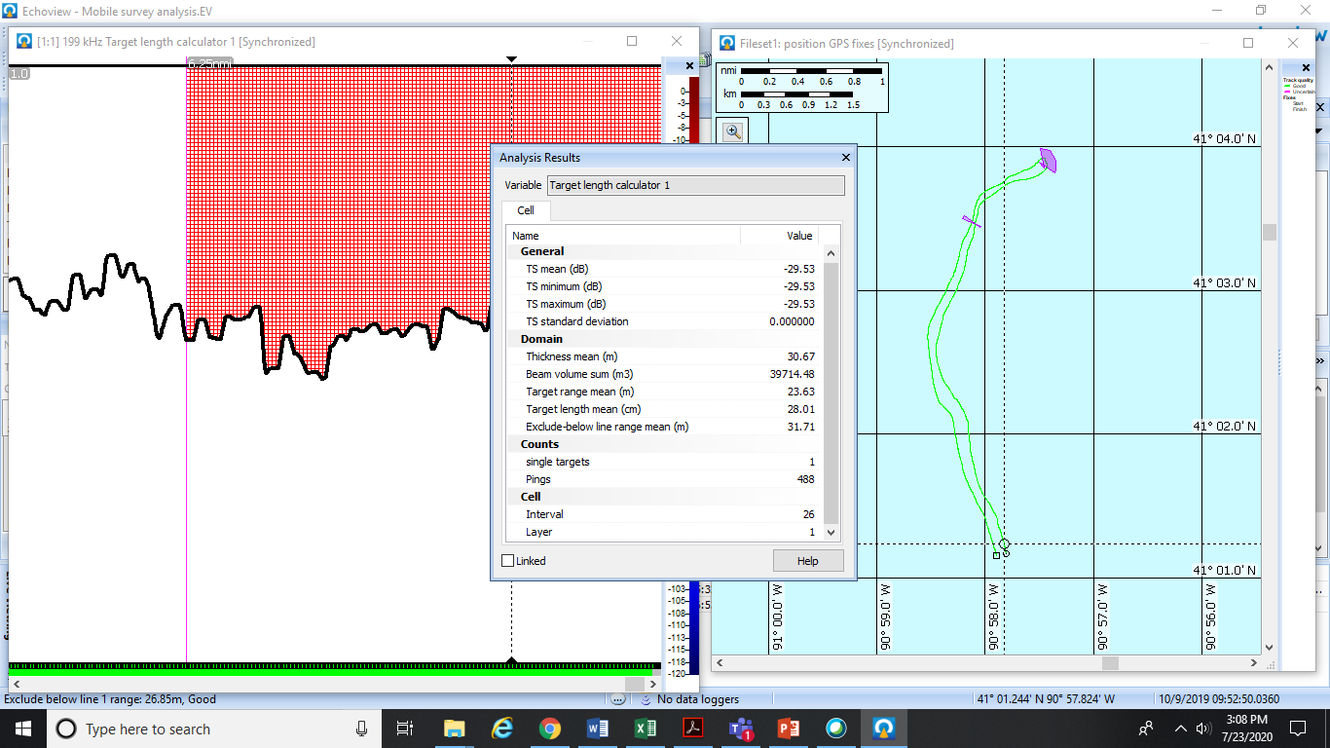

Interval numbering started at “1” at the beginning of the survey, with 13 intervals on one
shoreline, and 13 down the other. It may help to draw this out on paper to visualize the
pairing. The side channel interval.csv input file would appear as below:

strata | replicate | int_one | int_two
1 | 1 | 1 | 26
1 | 2 | 2 | 25
1 | 3 | 3 | 24
1 | 4 | 4 | 23
1 | 5 | 5 | 22
1 | 6 | 6 | 21
1 | 7 | 7 | 20
1 | 8 | 8 | 19
1 | 9 | 9 | 18
1 | 10 | 10 | 17
1 | 11 | 11 | 16
1 | 12 | 12 | 15
1 | 13 | 13 | 14

Interval pairing for a fictional main channel site with two strata is seen below:

strata | replicate | int_one | int_two
1 | 1 | 1 | 8
1 | 2 | 2 | 7
1 | 3 | 3 | 6
1 | 4 | 4 | 5
2 | 1 | 9 | 16
2 | 2 | 10 | 15
2 | 3 | 11 | 14
2 | 4 | 12 | 13

Interval pairing for a fictional backwater is seen below:

strata | replicate | int_one | int_two
1 | 1 | 1 | 0
1 | 2 | 2 | 0
1 | 3 | 3 | 0
1 | 4 | 4 | 0
1 | 5 | 5 | 0
1 | 6 | 6 | 0
1 | 7 | 7 | 0
1 | 8 | 8 | 0

- “… length-weight data” = Length-weight data from physical sampling is used to
estimate biomass density. This .csv file only includes species of interest, and must match species and order listed in input file #1 above. Important: the 2nd row must be numeric and manually entered, starting with “1” and going up for each species, so that length and weight of 1st species has 1’s, then 2’s for length & weight for next species. R will give you an error if this row is missing. Length must be in cm, and weight in grams. The data must be a completely filled in matrix without any blank cells. So, if one species has more observed values than the others, the other species with less data will need zeros filled in down to the last row of data ends. See example below:
SVCP | SVCP | BHCP | BHCP | OTHER | OTHER
1 | 1 | 2 | 2 | 3 | 3
60.3 | 3879 | 68 | 5500 | 47.4 | 1799
54.8 | 3042 | 63 | 4750 | 36.3 | 610
66.4 | 5500 | 59.2 | 1517 | 43.4 | 1269
65.7 | 4750 | 0 | 0 | 0 | 0
57.1 | 1517 | 0 | 0 | 0 | 0

5) “…proportional catch” = This input file divides the physical catch data into proportions by length. Each column is a species and each row is a length bin, starting at the minimum length that you want to examine (e.g. the Chicago barrier surveys have a length cut-off of 300 mm so those files would start at 30 cm and increase by 0.1 cm each row, stopping at 119.9 cm. Example: row 2 is for the 30 cm length bin; row 3 is 30.1 cm length bin, row 4 = 30.2 cm length bin…row 901 = 119.9 cm length bin). For the UMR and other surveys that have a 250 mm cut-off for fishes of interest, this file would start at 25 cm (row 2) and stops at 119.9 cm (row 947). The length bin values are not entered in this file but assumed. Rows are the same species in the same order as input file #1 above. Values in the cells are the proportion that each species comprises within each length bin (row) = i.e., species relative abundance for each 0.1 cm length bin. So, if the physical capture data includes no Bighead Carp, two Silver Carp, and one “OTHER” fish that are all 500 mm long, in the row that corresponds to 50 cm, there would be a “0” at the Bighead column, “0.66” at the Silver Carp column, and a “0.33” at the OTHER column. Any other fishes or groups being examined that were not present in that length category would be assigned “0”. These proportional species composition values need to be calculated manually or using “ProportionalCatch” R code. The R code is the easiest way to generate the proportional abundance matrix that is needed for density analysis. Hydroacoustics proportional catch R code is well annotated, the code and examples, are available from the USFWS Region 3 Hydroacoustics Working Group. See an example below:

SVCP | BHCP | OTHER
0 | 0 | 0
0 | 0 | 0
0 | 0 | 1
0 | 0 | 0
0.5 | 0.5 | 0
0 | 0 | 0
0 | 0 | 0
0.33 | 0.33 | 0.33

6) “… wvs” = Wedge/water volume sampled (wvs) in each interval for each transducer. Columns 1 & 2 = shallow transducer; columns 3 & 4 = deep transducer. Column headings should be irrelevant to code calculations (could be changed based on your transducer frequencies).
-Col 1 = interval for shallow transducer
-Col 2 = corresponding wvs for shallow transducer in each interval
-Col 3 = interval for deep transducer
-Col 4 = corresponding wvs for deep transducer in each interval

This data is exported in Echoview as: Echogram menu -> export -> analysis by cells -> single targets. If your echograms have “cells” (horizontal lines on the echogram) splitting the echogram into sections going away from the boat (i.e., going down the echogram), the export will have many wvs values for each interval, and all wvs values having the same interval, will be summed in the code. See an example below:

Interval | wvs_199 | Interval | wvs_201
1 | 0 | 1 | 0
1 | 15009.64 | 1 | 10212.2
2 | 0 | 2 | 0
2 | 14024.88 | 2 | 9113.024
3 | 0 | 3 | 0

Output
After running the script, make sure to look at output text in Console in R for error messages. If errors are reported, recheck input data files and fix mistakes as necessary. Files will be automatically exported to the “Density Output” folder that was described above. Also check the output file to make sure it makes sense. The output file will report species-specific densities as numerical density (Number / 1000 m³) and as biomass density (kg / 1000 m³). The number and type of species it calculates densities for, can be specified by the user, but must include at least one species.

The script automatically plots data being calculated for inspection by the user for quality control. This includes plots of input data on length-weight for each species, proportion of catch each species comprises by length bins based on input data, length-frequency distribution of fish targets, and species-specific estimates of length-frequency from hydroacoustic data. The script also has options, if specified by the user, to output separate .csv files of numerical density or biomass density by 0.1 cm length bins for each species.

Troubleshooting
Errors most likely indicate a problem with the input data, or how you wrote the input / output
working directory information in the R code. Check carefully that all .csv file names in your data input folder, start with the name exactly entered into the site name variable in the R script. Then check that file heading names and values entered, all match the instructions above. If still experiencing errors, check for extra spaces before or after column names in each input file.

The existing R code, and these analysis instructions, will work for individual survey sites. However, protocol and code for combining multiple side-channel, backwater, and main channel sites to produce a pool-wide estimate are still being developed.

Long-Term Hydroacoustic Data Management
Robust and secure data transfer, QA/QC, and archival solutions are still being developed to manage the quantity and quality of data that will be generated from hydroacoustics programs. Currently hydroacoustic field leads are responsible for the management and administration of these data resources. Survey data should be saved on the field computer during collection, and backed up on a thumb drive or external hard drive before leaving the field at the end of the day. Once back at the office, raw data is then backed up to the network server, and is also preserved on an external hard drive located in the office of the hydroacoustics field lead. Large river mobile hydroacoustic surveys can generate upwards of 200 GB of raw data each field season. As the FWS hydroacoustic sampling programs in Region 3 and beyond, continue to develop and compile more data, and as data management requirements change and evolve and technology advances, additional data storage solutions may be required or available, including cloud-based storage. Offices involved in hydroacoustics sampling need to develop a data management plan to ensure collected data is safe, accessible, and stored according to DOI policy. Please see the Service’s policy on establishing data standards at the following link: https://www.fws.gov/policy/274fw2.html

Considerations for Hydroacoustics Program Expansion
Provided below is an additional list of requirements, considerations, and questions for program managers and project leaders to consider before adopting or expanding a hydroacoustics program in new sub-basins. This list is not exhaustive and unique considerations may exist for specific areas that are not discussed below.
- What percentage of a sub-basin is required to be subsampled and where?
- Should subsampling be fixed or random?
- What type of macro-habitats need to be included in the surveys (e.g., main channel, backwater lakes, side channels, tributaries, harbors)
- What time of the year is it best to conduct hydroacoustics sampling (biological)? Same question for physical sampling.
- What time of the year is it feasible to conduct hydroacoustics sampling (reality)? Same question for physical sampling.
- What other sampling concerns may exist that have not been encountered before? Vegetation, turbulent water, large areas < 1 m depth are all viable concerns.
- Where will physical capture data come from? Will a FWCO be responsible for sampling particular areas with physical fish sampling gears?
- Which physical fish sampling gears should be used? How much do we know about the species and size selectivity of these various gears?
- How much spatial and temporal overlap of physical sampling is required in combination with hydroacoustics sampling?
- What role can partners/partnerships play? Can existing standardized monitoring programs be utilized? Can the USFWS be additive and not duplicative of these efforts?
- Can existing fish monitoring programs provide the supporting data necessary for the hydroacoustics program, could their sampling expand with funding assistance? (see IL NHS LTEF electrofishing program and the UMR hydroacoustics partnership)

Station-Level Staffing Considerations
At a minimum, the following staffing is necessary for hydroacoustics program implementation.
- Field station hydroacoustics lead - a fish biologist who, with assistance from the Region 3 Hydroacoustics Working Group, would be responsible for the implementation, coordination, and oversight of a hydroacoustics program with an emphasis on region-wide data standardization, QA/QC, and database management. This individual would also be responsible for coordinating with state, federal, and other partners through the sub-basin invasive carp partnerships.
- Additional staff to aid in field collection

Budgeting for Hydroacoustic Surveys
Beginning a hydroacoustics program requires a major upfront investment in equipment, as well as a commitment to equipment and software maintenance, and staff costs over time. The Region 3 Hydroacoustics Working Group began tracking equipment repair in FY20 to better understand and predict equipment maintenance costs over various applications over time. Operators should be careful in the field, work diligently to maintain equipment and try to avoid damage. Accidents can happen beyond the control of even the most mindful field biologist, and repair costs can sometimes be expensive. In the following section are estimates for annual sampling needs and cost estimates for Echoview data processing software and new BioSonics equipment. Please note these estimates may not reflect current prices. Contact the manufacturer for an updated quote.

Echoview Software Cost Estimates (quote from 2023)
Echoview Essentials: $8,980
Automation: $2,030
Advanced Operators: $8,980
Fish Tracking $2,540
Shipping and handling $110
Total: $22,640

Echoview maintenance and tech support (annual) $4,280

BioSonics Hydroacoustic Equipment Cost Estimates (quote from 2020)
Quote Date Expiration Date: 10/22/2020

Stock Number | Product Description | Quantity | Sales Price | Total Price
DTX-EXT | DT-X Extreme Autonomous Echosounder Surface Unit Includes:  - Visual Acquisition Software for data collection, playback and automated real-time target tracking  - Visual Aquatic Software for analyzing and editing of Single Echo Detection (SED) fish and other target tracks, plus mapping of Submerged Aquatic Vegetation (SAV), substrate type and bathymetry.  - Ruggedized System Transport Case | 1.00 | $16,272.04 | $16,272.04
DTSP-2006-MS | 200 kHz 6° DT-X Split Beam Digital Transducer with Metal Shell Bulkhead Connector and Integrated Orientation Sensor | 2.00 | $16,128.46 | $32,256.92
HPR-DTCA-25-MS | DT-X Extreme Digital Signal Deck Cable with Metal Shell Connectors, 25 Feet | 1.00 | $2,450.38 | $2,450.38
DT-MPWET2-MS | Multiplexing WET Digital 2-Transducer Cable with Metal Shell Connectors | 1.00 | $3,441.06 | $3,441.06
DTX-ROS-25 | Integrated, Dual-Axis Mechanical Rotator with Cable, 25 feet | 1.00 | $23,622.00 | $23,622.00
DTX-EXT-DGPS | Differential GPS Sensor, DT-X Extreme Assembly | 1.00 | $536.02 | $536.02
TARG-200 | 200 kHz Standard Calibration Sphere - 36.4MM | 1.00 | $610.68 | $610.68

Total Price Grand Total $79,189.10 GSA CONTRACT NUMBER: GS-24F-0034M; STANDARD LEAD TIME: 60 DAYS

Conclusion
Increasing expectations for the use of physical removals as a primary tool for invasive carp control will require significant scientific oversight and direction. Hydroacoustic surveys as part of a larger comprehensive stock assessment of invasive carp in the greater Mississippi River basin, will allow managers to more accurately evaluate and guide the long-term efficacy of control strategies such as physical removal efforts. Hydroacoustic survey data may also be useful to inform the selection of optimal locations for deterrents to upstream movement, and evaluate deterrent strategies. Estimates of pool-specific relative abundance generated by hydroacoustic and traditional sampling data also support invasive carp modeling efforts that serve as objective, data-driven decision support tools for informing management strategies.

Literature Cited and Important Texts for Review
Bonar, S.A. and W.A. Hubert. 2002. Standard sampling of inland fish: benefits, challenges, and a call for action. Fisheries 27:10-16.
Coulter, D.P., R. MacNamara, D.C. Glover, J.E. Garvey. 2018. Possible unintended effects of management at an invasion front: Reduced prevalence corresponds with high condition of invasive bigheaded carps. Biological Conservation 221: 118-126.
Demer, D.A., L. Berger, M. Bernasconi, E. Bethke, K. Boswell, D. Chu, R. Domokos, A, Dunford, S. Fassler, S. Gauthier, L.T. Hufnagle, J.M. Jech, N. Bouffant, A. Lebourges-Dhaussy, X. Lurton, G.J. Macaulay, Y. Perrot, T. Ryan, S. Parker-Stetter, S. Stienessen, T. Weber, and N. Williamson. 2015. Calibration of acoustic instruments. ICES Cooperative Research Report No. 326. 133 pp.
Koch, J.D., B.C. Neely, and M.E. Colvin. 2014. Evaluation of precision and sample sizes using standardized sampling in Kansas reservoirs. North American Journal of Fisheries Management 34:1211-1220.
Love, R.H. 1971. Measurements of fish target strength: a review. Fisheries Bulletin 69: 703-715.
MacNamara, R., D. Glover, J. Garvey, W. Bouska, and K. Irons. 2016. Bigheaded carps (Hypophthalmichthys spp.) at the edge of their invaded range: using hydroacoustics to assess population parameters and the efficacy of harvest as a control strategy in a large North American river. Biological Invasions 18: 3293-3307.
Parker-Stetter, S.L., L.G. Rudstam, P.J. Sullivan, D.M. Warner. 2009. Standard operating procedures for fisheries acoustic surveys in the Great Lakes. Great Lakes Fisheries Commission Special Publication 09-01.
Simmonds J. and Maclennan D. (2005) Fisheries Acoustics: Theory and Practice. Second edition, Blackwell Science. Fish and Aquatic Resources Series 10. (ISBN-10: 1-632-05994-X, ISBN-13: 978-0-632-05994-2).

