
U.S. Fish and Wildlife Service
Inventory and Monitoring Help Documentation

Instructions (SOP5) for Data Maintenance and Post-retrieval Procedures: Survey Protocol for Temperature and Stream Flow

IR 9&12 Aquatic Health and Climate Change Program

Version 1.0, September 2021

Survey Name: Aquatic Climate Change – Temperature and Stream Flow
Survey IDs: FF01RKTN00-035, FF01RLPO00-089, FF01RMLH00-125, FF01RWLP00-108, FF01RWMF00-084
ServCat Location: https://ecos.fws.gov/ServCat/Reference/Profile/132469
Created by: Sam Lohr
Software: Microsoft Excel
Contents
1. Introduction 2
2. Data Processing Steps 2
3. File Naming 2
Raw Data File Processing 2
Cleaned Data 3
4. Workbook Tab and Field Descriptions 4
5. Data Dictionary 5
6. Screenshots of Data Entry Screens 7
7. Data maintenance and Post-retrieval Procedures 8

- Introduction
This document provides instructions for the use of the Excel workbook to manage and summarize data generated by temperature loggers, and conduct screening and clean-up of suspect values (EPA 2014, see below).
The workbooks are based on annual templates (one for a 365-day year, another for a 366-day year) that consist of 16 worksheets.
- The first worksheet contains instructions (see README worksheet below),
- two are for data entry (i.e., data from logger files in text format–INPUT, information on a logger and data screening–INPUT COMMENTS), and
- the remainder summarize temperature data on a monthly basis

- Data Processing Steps

- The Date Time and Temperature fields from a logger file(s) are pasted into the appropriate fields of the INPUT worksheet on the record corresponding to date and time of the initial logger reading.
- The Date Time and Temperature fields are then visually scanned to ensure that they correspond to the Date and Time fields of the template.
- The year that the logger was deployed, logger serial number, and daily values from the last six days of the previous year (to calculate 7-day moving averages) are entered.
- The range, maximum, and minimum daily values for the annual summary and monthly summary worksheets can be inspected to identify spurious values and periods that temperature loggers deployed in water may have been dewatered (e.g., daily range > 10°C or water temperatures similar to those of the air in summer).
- The INPUT COMMENTS worksheet is used provide information on logger deployment and data clean-up conducted.
As a rule, all temperature records were deleted from the INPUT worksheet for entire days for which daily range exceeded 10°C in water, partial days (e.g., day of deployment/download), and days with a spurious value. Additional data screening and clean-up (e.g., EPA 2014) can be documented in other comments.
The full deployment of a temperature logger is expected to be up to five years, with an annual template file for each year.
Template Files:
CURRENT-365-Day Temperature Template.xlsx | Template Temperature Workbook summarizes temperature data from a logger (30 minute interval inputs) during a 365-day year (i.e., not a leap year) and allows data clean-up.
CURRENT-366-Day Temperature Template.xlsx | Template Temperature Workbook summarizes temperature data from a logger (30 minute interval inputs) during a 366-day year (i.e., a leap year) and allows data clean-up.
CURRENT-1HOUR-365 Day-template.xlsx | Template Temperature Workbook summarizes temperature data from a logger (60 minute interval inputs) during a 365-day year (i.e., not a leap year) and allows data clean-up.
CURRENT-1HOUR-366 Day template.xlsx | Template Temperature Workbook summarizes temperature data from a logger (60 minute interval inputs) during a 366-day year (i.e., a leap year) and allows data clean-up.

- File Naming

Raw Data File Processing
Annual temperature template files are saved in Excel using the year, location code, and logger S/N as the file name (e.g., 2020-MUDDSA01W-10563324.xlsx).
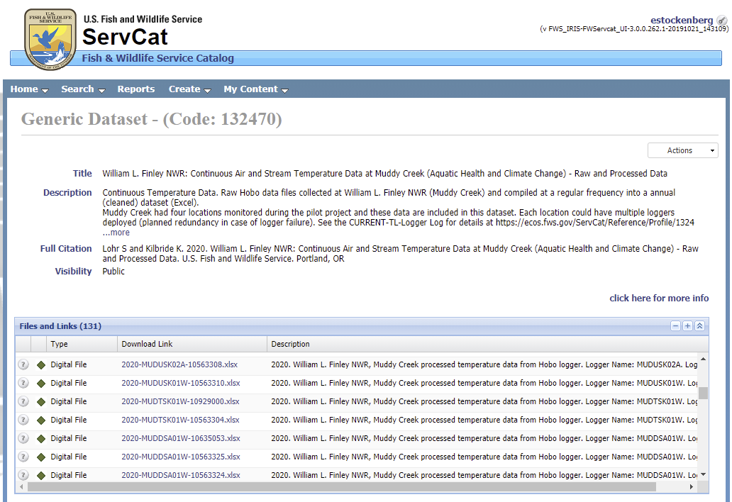
[Add more detail on file naming conventions and descriptions from ServCat SOP]

Cleaned Data
To generate a file of the entire deployment of a logger at a location, the Date Time and Temperature fields from the initial deployment are copied to a new Excel file to which fields from subsequent years are appended. These deployment files use logger S/N, years deployed, and “cleaned” as file names (e.g., 10563324_2015_2020_cleaned.xlsx), and are saved in both Excel and text formats.
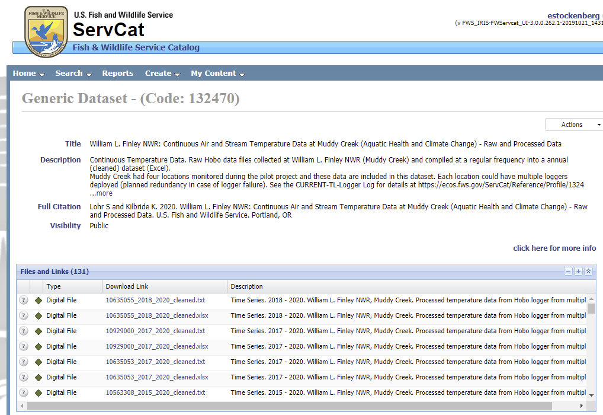
[Add more detail on file naming conventions and descriptions from ServCat SOP]

- Workbook Tab and Field Descriptions
README worksheet with instructions for use of Excel workbook to summarize temperature data from a logger during a 365-day year and allows data clean-up (CURRENT-365-Day Temperature Template.xlsx)*, with example entries for Muddy Creek.
365-Day Temperature Template.xlsx (mod. 2021-01-22 S. Lohr) Workbook summarizes temperature data from a logger during a 365-day year (i.e., not a leap year) and allows data clean up.
Download template workbooks from ServCat, here.
Each worksheet in the workbook is described below:
Tab | WORKSHEET | DESCRIPTION
1 | README | Instructions and descriptions.
2 | INPUT COMMENTS | Enter details about logger deployment and data clean up (i.e., whether partial days or dates on which logger was deployed or downloaded have been deleted, inspected and adjusted data for D_range>10C in water deployments, etc.).
3 | INPUT | Allows input of data (cells shaded green) and calculates several summary variables. Temperature must be recorded at 30-minute intervals, and data consist of date/time and temperature fields.  Export both fields as a txt or csv file from Onset software, and paste into columns C and D after matching the first record with the date and time in columns A and B.  Columns E-I are used to calculate daily values: mean, minimum, maximum, SD of mean, and range (max-min) based on the 48 records for each day. The Julian date, date (m/d), and the four daily values are reported in columns J-P.  Seven-day moving averages for daily mean, minimum, and maximum are reported in columns Q-S. To calculate these for data collected across two years, daily mean, minimum, and maximum of the preceding six days of the first year (i.e., December 26-31) are entered in cells V3:X8. The current year (second) and serial number of the logger are also entered.  Note that moving averages are based on fewer than 7 days following dates with missing or removed values in the preceding week.  Annual values are summarized in U12:AB22, and the number of days with data and number of days with daily range > 10 are reported, which can be used for data clean up.
4-15 | JAN-DEC | Each worksheet reports daily and seven-day moving average values for a month. The monthly mean, minimum, maximum, and SD of the daily and weekly values of each variable are calculated (rows after the last day of the month).  An intent of these sheets are to assist in review for potential suspect values (e.g., a high daily range) that should be omitted.
16 | MONTHLY SUMMARY | All monthly values (from worksheets JAN-DEC) are compiled for ease of generating figures.

*NOTE: This file is not to be used for leap years. A similar workbook (CURRENT-366-Day Temperature Template.xlsx) is used to summarize temperature data from a logger during a 366-day leap year. Two files to summarize temperature data recorded hourly also are available (CURRENT-1HOUR-365 Day template.xlsx and CURRENT-1HOUR-366 Day template.xlsx).

Onset data files (recording on the half hour and consisting of two fields--Date/time and temperature (C)) are exported as txt or csv files. Data for a year, or a portion of a year, are pasted into the worksheet to calculate:
Field | Definition
D_mean | daily mean temperature
D_min | daily minimum temperature
D_max | daily maximum temperature
D_sd | SD of the daily mean
D_range | difference of daily max and min
AWAT | average weekly average temperature (seven-day moving average of daily means)
AWMINT | average weekly minimum temperature (seven-day moving average of daily mins)
AWMT | average weekly maximum temperature (seven-day moving average of daily maxs)

- Data Dictionary
Excel Workbook, Annual Temperature Template.
(Note: Temperature logger files (*.hobo) are exported from HOBOware Pro in text format with records consisting of two fields, Date Time and Temperature, and then pasted into the Annual Temperature Template Workbook matching the first logger record with the corresponding Date (MM/DD) and Time (HH:MM) fields of the Template. Data entry can only be made in worksheet cells with green fill. Use appropriate template file for either a 365-day or 366-day year.)

Variable | Units | Description | Comments
Date Time | MM/DD/YYYY HH:MM | Date time recorded by temperature logger | INPUT worksheet, paste logger records
Temp (°C) | degrees C | Temperature recorded by temperature logger | INPUT worksheet, past logger records
Insert D_Values from previous year | degrees C | Daily mean, minimum, and maximum temperatures for December 26–31 of preceding year | INPUT worksheet, for moving average calculation through January 6 of current year, disregard if not applicable
Insert Current year | YYYY | Year logger data collected | INPUT worksheet, enter year
Logger S/N | text (8 numeric digits) | Serial number of temperature logger | INPUT worksheet, enter logger S/N
Julian Date | Integer | Day of the year | INPUT Worksheet, day of daily values
Date | MM/DD | Month and day | INPUT Worksheet, date of daily values
D_mean | degrees C | Daily mean temperature | INPUT Worksheet
D_min | degrees C | Daily minimum temperature | INPUT Worksheet
D_max | degrees C | Daily maximum temperature | INPUT Worksheet
D_sd | degrees C | SD of the daily mean | INPUT Worksheet
D_range | degrees C | Difference of daily maximum and minimum | INPUT Worksheet
AWAT | degrees C | Average weekly average temperature (seven-day moving average of daily means) | INPUT Worksheet
AWMINT | degrees C | Average weekly minimum temperature (seven-day moving average of daily mins) | INPUT Worksheet
AWMT | degrees C | average weekly maximum temperature (seven-day moving average of daily maxs) | INPUT Worksheet
Annual Summary | Degrees C | Annual mean, minimum, maximum, and SD of daily and weekly values | INPUT Worksheet
# Days (N) | Days | Number of daily records | INPUT Worksheet, changes after data clean up
#Days D_range > 10 | Days | Number of days range (daily max-min) > 10 degrees | INPUT Worksheet, changes after data clean up
Deployed in air | Y/N | Logger location in air | INPUT COMMENTS Worksheet
Deployed in water | Y/N | Logger location in water | INPUT COMMENTS Worksheet
Omitted data for dates of deployment and downloading | Y/N | Indicates whether all partial days were removed from INPUT worksheet | INPUT COMMENTS Worksheet, note data clean up performed
Omitted data for dates where D_range > 10 C | Y/N or N/A | Indicates whether data on dates with daily range greater than 10 C were omitted | INPUT COMMENTS Worksheet, note data clean up performed
Location description | Text | Note location details | INPUT COMMENTS Worksheet
Other comments | Text | Note logger condition, other data clean up performed on INPUT worksheet (e.g., omitted dates with spurious temperature values) | INPUT COMMENTS Worksheet

- Screenshots of Data Entry Screens

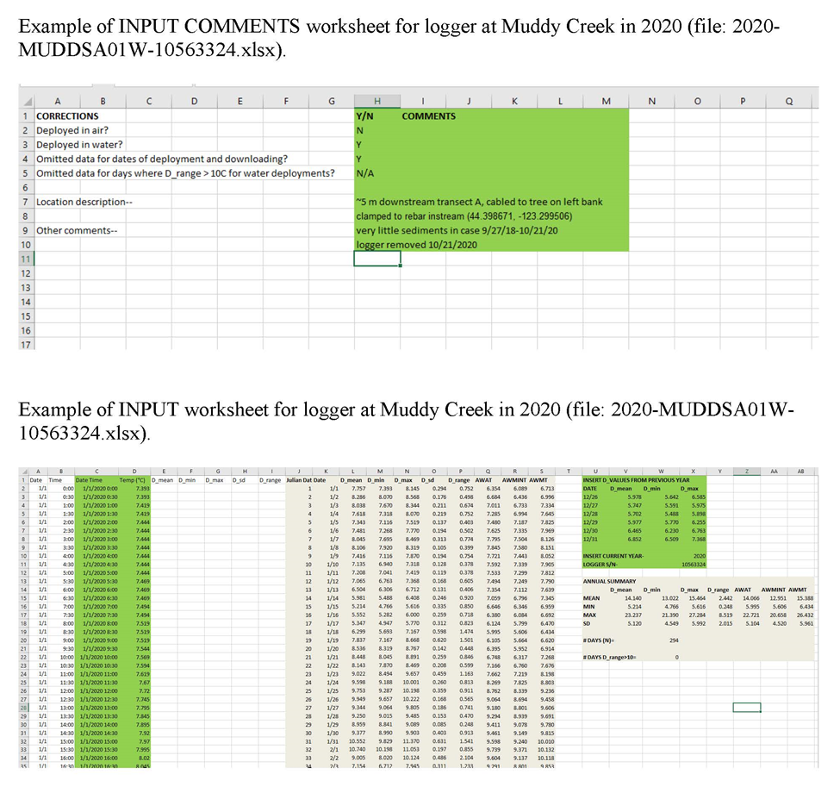

- Data maintenance and Post-retrieval Procedures
Methods for data maintenance and post-retrieval procedures (from EPA 2014).
Current data (after all annual updates are complete?) should be posted to the ServCat Project.
Maintain at least one year’s past backup, update Description to include prefix [OLD VERSION]
[Need more here]



