
U.S. Fish and Wildlife Service
Inventory and Monitoring Help Documentation

Instructions (SOP6) for Logger Tracking and Post-retrieval Procedures: Survey Protocol for Temperature and Stream Flow

IR 9&12 Aquatic Health and Climate Change Program
Version 1.0, September 2021

Survey Name: Aquatic Climate Change – Temperature and Stream Flow
Survey IDs: FF01RKTN00-035, FF01RLPO00-089, FF01RMLH00-125, FF01RWLP00-108, FF01RWMF00-084
ServCat Location: https://ecos.fws.gov/ServCat/Reference/Profile/132469
Created by: Sam Lohr
Software: Microsoft Excel

Contents
1. Introduction 2
2. Data Processing Steps 2
3. File Naming 2
4. Workbook Tab and Field Descriptions 2
5. Data Dictionary 5
6. Screenshots of Data Entry Screens 6
7. Data maintenance and Post-retrieval Procedures 6

- Introduction
This document provides instructions for the use of the Excel workbook to manage and summarize deployment, maintenance, and data retrieval information on individual temperature loggers.

- Each FWCO maintains copies of forms and logger files annually provided by NWRs (and posts these to ServCat), enters information from the Logger Deployment/Download Tracking Field Trip Form (SOP4, Form 4) into the Logger Log workbook, and
- Each FWCO conducts post-deployment an accuracy check on each logger retrieved from the field. Files from loggers are maintained in their original format (*.hobo) and also as text files (*.txt) using HOBOware Pro.

- Data Processing Steps
Each FWCO enters information from the Logger Deployment/Download Tracking Field Trip Form (Form 4) into the logger log workbook, which provides documentation of a logger’s history and conditions at the location of deployment. The workbook consists of a worksheet with instructions (README, see below), and a worksheet for each of the five sentinel sites.

FWCOs conduct a post-deployment accuracy check on loggers retrieved from the field (see SOP 2), and records data on the Logger Accuracy Check Form (Form 1) and results in the logger log workbook. Loggers that fail the accuracy check are retested. Loggers that fail the accuracy check twice are flagged. Their respective data files are inspected (i.e., relative to temperatures recorded with field thermometers during download events and files from other concurrently deployed loggers at the same location). Close correspondence in temperature readings between loggers and a field thermometer may indicate periods when files from the flagged logger may be suitable to contribute to generating a long-term time series, otherwise the files should be excluded and noted in the logger log workbook.

- File Naming
File names consist of the logger serial number, underscore, and number of the current downloaded file (e.g., 10563309_3.hobo, file for the third downloaded file for logger 10563309) followed by the extension of the file type (hobo, txt). These files are archived so that original data are preserved.
[Add more detail on file naming conventions and descriptions from ServCat SOP, with Figure for screenshot of ServCat Product page]

- Workbook Tab and Field Descriptions
Logger Log: README worksheet with instructions for use of Excel workbook to document deployment of temperature loggers at each sentinel site, with example entries for Bridge and Muddy creeks (CURRENT-Logger Log-2021-02-05.xlsx).
TL-Logger Log.xlsx (mod. 2021-02-05 S.Lohr)
Workbook to document deployment, downloading, and conditions of temperature loggers at each sentinel site. The following variables are entered on a worksheet for each of the five sentinel sites:
Variable | Description
Location | Nine character code describing site of logger deployment relative to the survey reach, consisting of:
 | -characters 1-3, abbreviation of stream name ("BRI"-Bridge Creek, "LPO"-Little Pend Oreille River, "MUD"-Muddy Creek, "MYR"-Myrtle Creek, "OME"-Omeara Creek),
 | -characters 4-5, logger site relative to survey reach ("US"-upstream, "DS"-downstream, "TS"-within survey reach),
 | -character 6, survey reach transect closest to the logger site ("A"-for upstream sites, "K"-for downstream sites, "A"….."K"-for within survey reach),
 | -characters 7-8, sequential numbers (e.g., "01", "02" to account for multiple sites upstream or downstream of the survey reach), use "01" for a single site,
 | -character 9, deployment type ("A"-deployed in air, "W"-deployed in water),
 | NOTE-other attributions of the site and deployment method are added below the location code (e.g., coordinates, distances, etc.).
Logger S/N | serial number of logger
Deploy Date | date that logger was deployed at the site
Deploy Time | time that logger was deployed (recommend using standard time for deployment and logger set-up, note in comments if standard time was not used)
Download Date | date of logger download
Download Time | time of logger download (recommend using standard time for deployment and logger set-up, note in comments if standard time was not used)
File Name | name of file downloaded, format is logger S/N, underscore, number of the current download (e.g., "10563310_1.hobo" for the first downloaded file, "10563310_2.hobo" for the second downloaded file, etc.)
Stream/Air Temperature | stream or air temperature taken with hand thermometer in vicinity of the logger at the time of the download (take temperature close as possible after logger records temperature)
Stream/Air Time | stream or air temperature taken with hand thermometer in vicinity of the logger at the time of the download (take temperature close as possible after logger records temperature)
Thermometer ID | record unique identifier of hand thermometer, which has passed an accuracy check
Comments | record events (e.g., delayed start date/time at deployment, logger removed, etc.) and observations (e.g., sediments in logger case, changes at site, additional temperature measurements, etc.)
Accuracy Check type | pre or post deployment check performed
Accuracy Check method | Multi- or single-point check performed
Accuracy Check result | Pass or fail accuracy check
Accuracy Check date | Date of accuracy check (last day if multi-point check performed)

NOTE: Each worksheet is structured so that a location and associated information is entered on rows in the "Location" field, deployment information of a logger is entered in appropriate fields on the next row, download information is sequentially entered in appropriate fields on the following rows. Data for additional locations are then added to a worksheet. Additional rows are inserted below records for a location and previously deployed loggers as new loggers are deployed. Intent is to produce a chronological record of logger deployment/download history at locations for each sentinel site. Accuracy check information is entered in the appropriate fields on the first two rows of a logger entry.

- Data Dictionary

Table 1. Excel Workbook, Logger-Log.
Variable | Units | Description | Comments
Location | text | Nine-character code for logger location | Include: coordinates, deployment method, landmarks
Logger S/N | text (8 numeric digits) | Serial number of temperature logger
Deploy date | MM/DD/YYYY | Date logger deployed at site
Deploy time | HH:MM | Time logger deployed at site | recommend standard time
Download date | MM/DD/YYYY | Date logger downloaded
Download time | HH:MM | Time logger downloaded | recommend standard time
File name | text | Name of file saved after downloading from shuttle to computer | filename format: logger S/N_download number.hobo (example 10563330_2.hobo is file for the second time logger 10563330 was downloaded while deployed at a location)
Stream/Air temperature | degrees C | Ambient water or air temperature measured near logger during visit
Stream/Air time | HH:MM | Time ambient water or air temperature was recorded
Thermometer ID | text | Code used to identify NIST-traceable field thermometer
Comments | text | Note condition of logger (e.g., evidence of dewatering, sediments in logger case, whether logger was removed)
Accuracy check type | text | Note type of accuracy check performed (pre-deployment or post-deployment)
Accuracy check method | text | Note method of accuracy check (single-point or multi-point
Accuracy check result | text | Result of accuracy check (pass or fail)
Accuracy check date | MM/DD/YYYY | Date of accuracy check

- Screenshots of Data Entry Screens
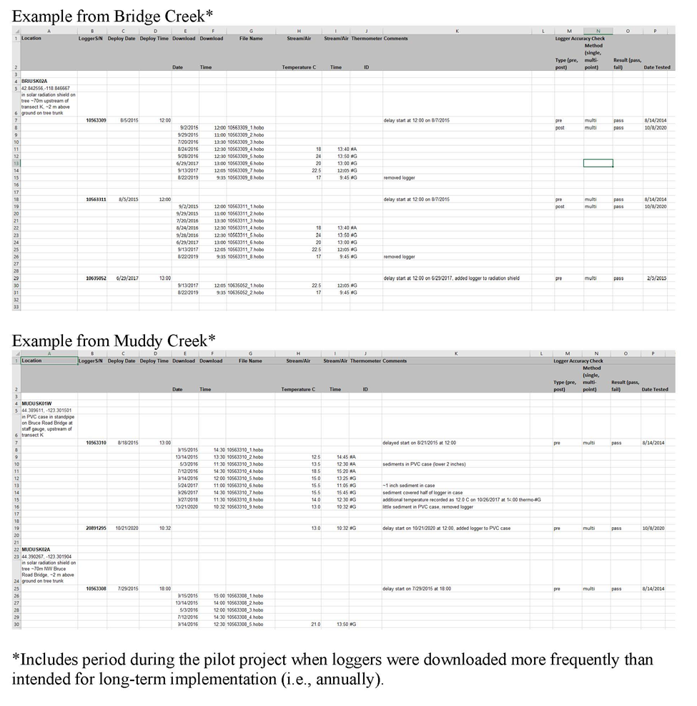

- Data maintenance and Post-retrieval Procedures
Current data (after all annual updates are complete?) should be posted to the ServCat Project.
Maintain at least one year’s past backup, update Description to include prefix [OLD VERSION]
[Need more here]

