NWR Monitoring Pilot Project: Instructions for Using the Access Database for Fish Data
(2017-03-06—SL)

The database file, “CURRENT-FILE_SL-NWRFishData-mod-yyyy-mm-dd.accdb”, is available on my shared Google drive under NWR Monitoring Pilot Project/Fish. It is the current “Master File” for fish data collected for the NWR monitoring pilot project. It will be updated with new data collected in the future, and the date when data were added will be placed in the file name. The name of the previous master file will be changed to “OLD-FILE*.accdb” and left on the google drive. The current file contains an additional field in the TripData table for “year” and revised queries to help check and summarize data compared to the earlier files.

For updating the file with new data, please download it and save it on your computer with a new name. For the new name, substitute your initials for mine (SL) and provide the current date. After entering and checking your data, upload your file back in the Fish folder on the Google drive so that I can add the new data to the master file.

Below is a brief description of the database structure, info about viewing database objects, instructions for entering data, and info about the queries.

Contents
Database Structure 2
Viewing Database Objects 4
Instructions for Entering Data 5
--1) Open the database and add sentinel site coordinates and comments 5
--2) View the descriptions of fields in each table 6
--3) Using the form to enter data 9
--4) Adding records and species 12
Using Queries 15

Database Structure

Access databases can consist of four types of objects: 1) Tables store data, 2) Queries sort, compile, and summarize data, 3) Forms allow data entry, editing, and viewing; 4) Reports present data or other information.

1. Basic structure of the NWRFishData database consists of four main tables (nested hierarchically as ordered below).

-“tlkpSentinelSite” contains data for each of the five sentinel sites (e.g., name, coordinates of transects A
and K, and comments) and has an ID number assigned to each (i.e., a key that allows
relational links among data in tables)

-“tblTripData” contains data for each trip to a sentinel site (e.g., date, year, water chemistry
values, primary electrofisher settings used, etc.)

-”tblElectrofishSubreach” contains data for each of the 10 subreaches electrofished (A-J
named for the downstream transect of each subreach; there is an additional
subreach named “UNK” in case subreach was not recorded for some fish (e.g.,
tallies over the entire sample reach). Data are electrofishing time and comments
pertinent to a subreach (e.g., if efisher settings varied, etc.).

-“tblFishData” contains data for fish (or other taxa) collected in each
subreach (i.e., species, total length, weight, and count; there also are three boxes to check yes/no for anomality, mortality, and if an individual was kept as a voucher specimen—default is set to no)
(“_tblLookUp” is a look-up table for lists like species names that we
can select from, used more for convenience, like ensuring consistent spelling, rather than containing data)

2. There also are a number of queries that sort and summarize data, and also calculate condition factor.

3. There is a form, with two subforms, for entering data into three of the tables. They follow the same nested structure as the tables:

-“frmTripData”
-”fsubElectrofishSubreach”
-“fsubFishData”

4. There is one report that displays the four main data tables. Each table lists all the fields within it and the relational links between tables are shown by lines between the keys (fields ending in “ID”).

Report—Relationships for SL-NWRFishData-mod-2016-12-08.accdb.

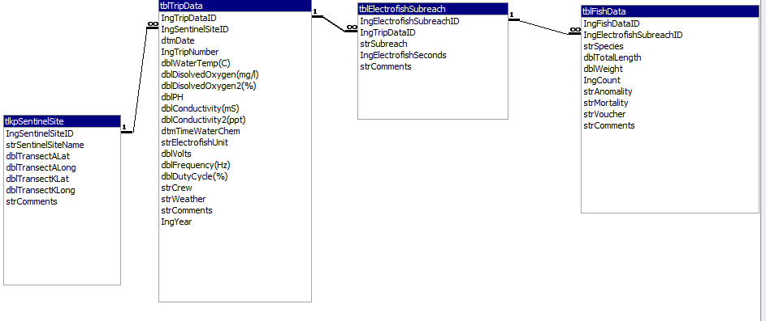

Viewing Database Objects

Because there are several options for viewing database objects, for which some may also allow objects to be changed, how to change views and those for basic uses of each object is worth noting.
311

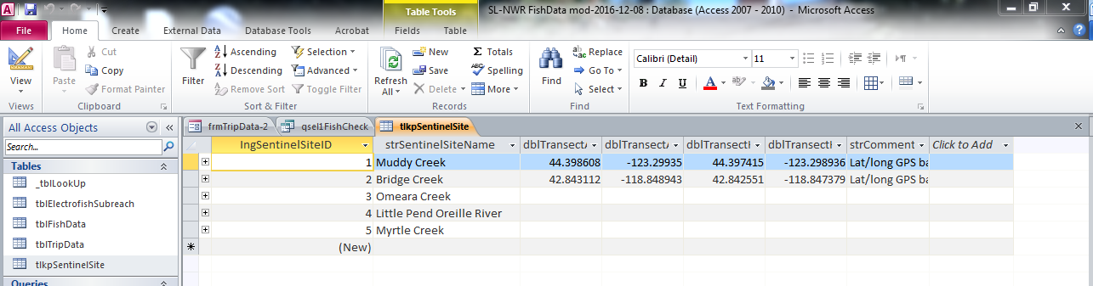
211
111

Once a database is open, objects can be opened by double clicking them from the list of All Access Objects at the left of the screen.

1. Open objects appear as tabs on the object bar with the active one highlighted.

2. Hitting the View icon will open a drop-down menu where a view option can be selected from a list.

3. Click the Home tab if the View icon is not displayed.

Views for basic uses of each type of object are:

Object | View | Basis use
Tables | Datasheet View | view, edit, and enter data
 | Design View | view/change descriptions and properties of fields
Form | Form View | enter/edit data in multiple tables at once
Queries | Datasheet View | view results of queries
 | Design View | setup and run queries
Reports | Design View | layout a report
 | Print Preview | make a hardcopy

Instructions for Entering Data

The instructions follow the basic steps needed to: 1) open the database and add sentinel site coordinates and comments; 2) view the descriptions of fields in each table; 3) use the form to enter data (essentially trip, subreach, and fish data); and 4) add records and species.

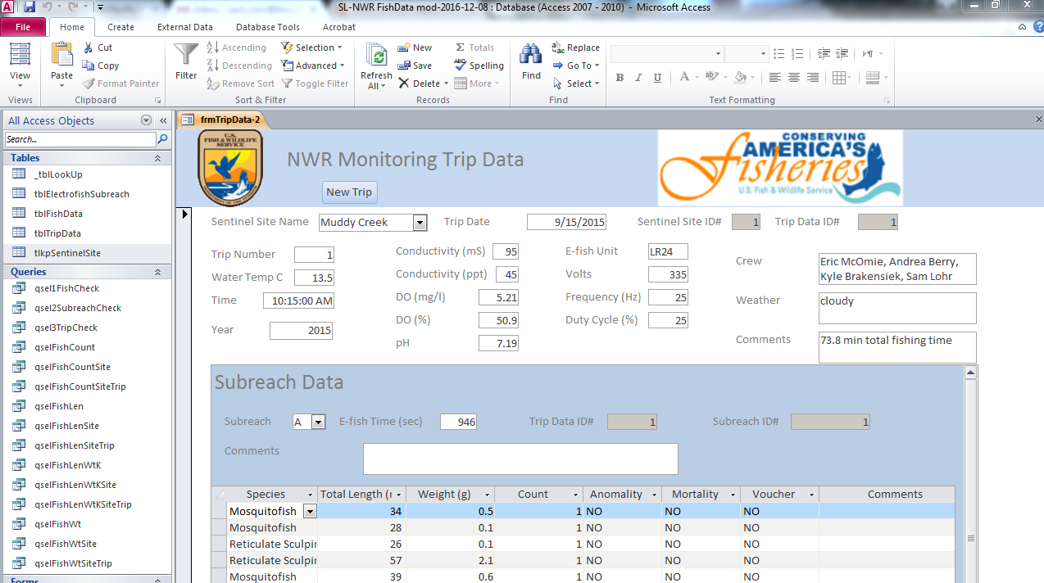
21
111

--1) Open the database and add sentinel site coordinates and comments

1. When the database is opened, note that form “frmTripData” appears in form view. Data for “tlkpSentinelSite” only needs to be entered once, so it was not included in the form. First step is to input data for the sentinel site you are working on into the table.

2. Double click on table “tlkpSentinelSite” to open the table.

211

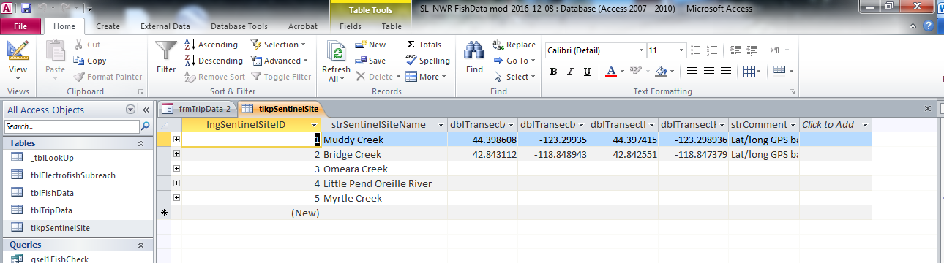
111

Table should be in datasheet view and data can be added in the fields of the record for your site. Like in Excel, the widths of the fields can be changed by highlighting the vertical bars separating fields and moving them with the mouse so that you can read field names, comments, etc. that are too long to be viewed when table is initially opened. DO NOT change values in the field “IngSentinelSiteID” or any fields ending in “ID” in other tables, they are keys and automatically set.

1. Add coordinates (decimal degrees) for transects A and K, and any comments (e.g., source of data—GPS, estimated from map, etc.) for your site.

2. Hit the Save icon to save the data that was entered. (Good idea to save often when working with the file.)

--2) View the descriptions of fields in each table

Switching “tlkpSentinelSite” to design view shows the data type and description for all the fields. See below.

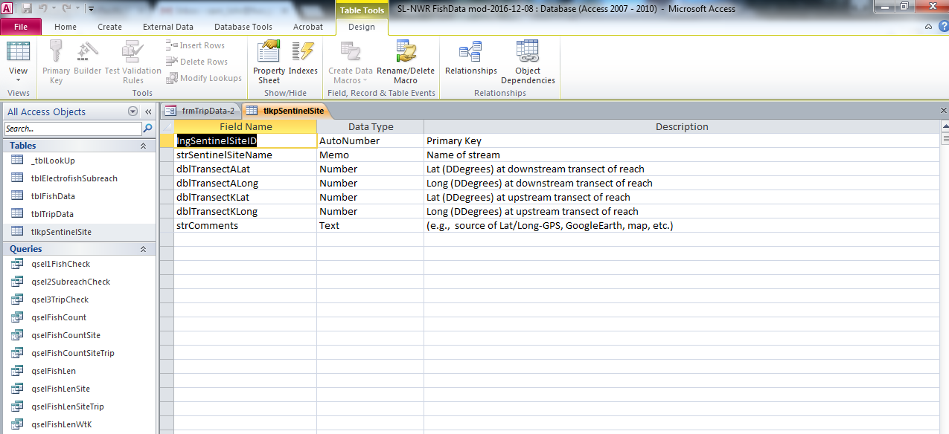

Before using the form to enter trip, subreach, and fish data, it would be good to review descriptions of fields in all the other tables--
- double click on each table from the list of Access Objects to open each table,
- it will open in datasheet view,
- change to design view and check out field descriptions (see below for each table).

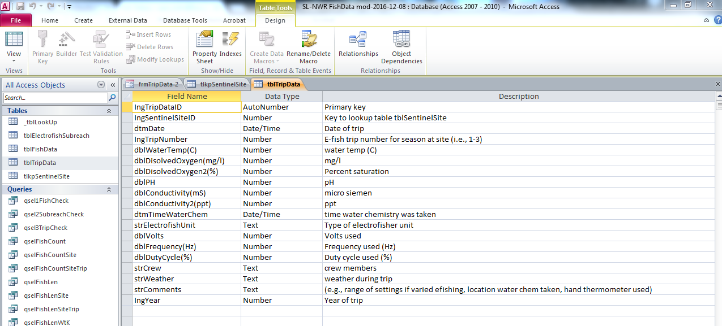

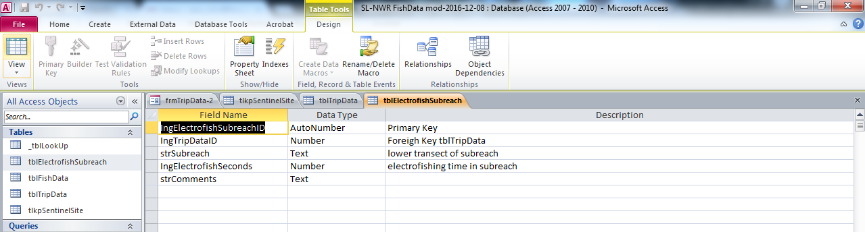

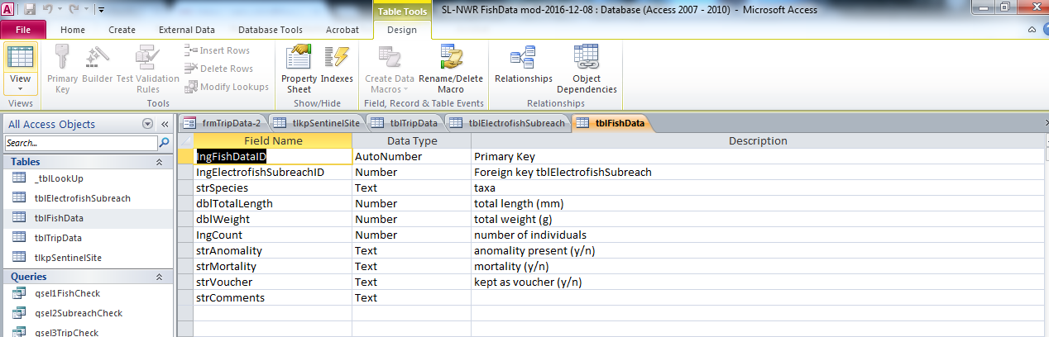

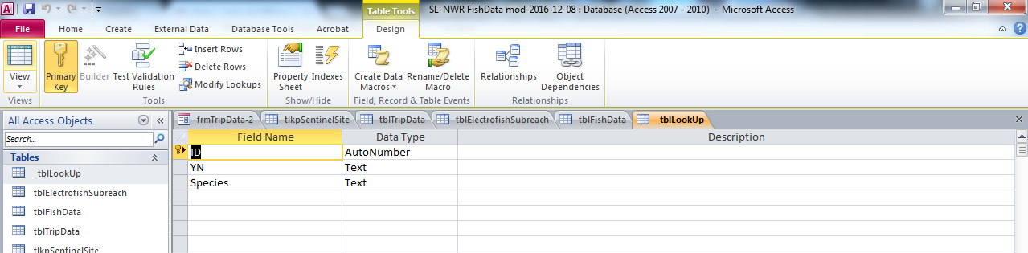

This is a lookup table that does not contain data associated with records per se, rather lists that are choices in combo boxes (pull down menus) in the form (e.g., Yes or No for whether an individual fish was a mortality; list of fish common names to select from to reduce typing a lot and potential for typos). (You can go to Design View from here and add any species that has not been entered yet. More on that under using the form.)

All the objects (tables and the form) listed as tabs on the object bar, just below the icons, are open. (Can go back and look at them more or close them by hitting the “X” on end to the tab bar.)

--3) Using the form to enter data

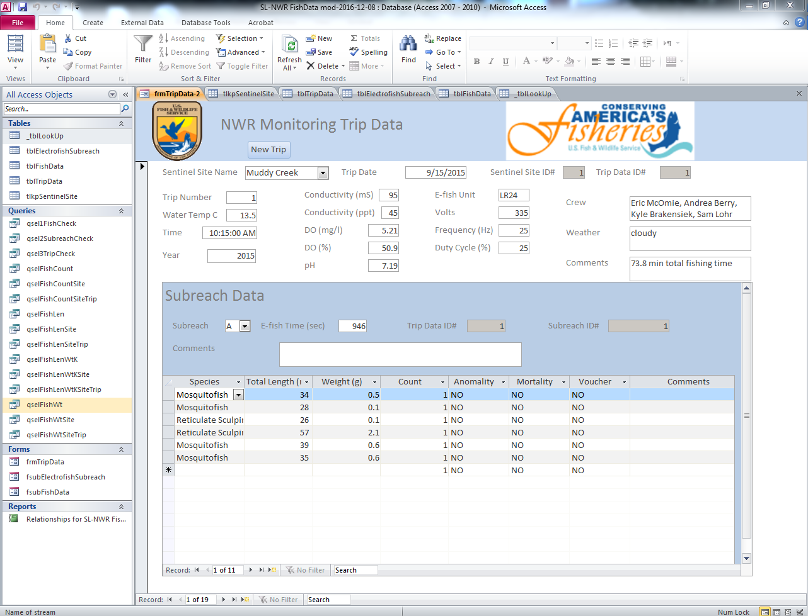
11
211
311
211
11

Above is the data entry form as it appears when first opened (in form view). Bracketed areas are:

1. Trip data, which are stored in the table “tblTripData”. Open boxes are for data entry (or Selection as for the combo box (a pull-down menu) for sentinel site name, choices are Bridge Creek, Little Pend Oreille River, Muddy Creek, Myrtle Creek, Omeara Creek), the shaded boxes are keys (automatically assigned values for tracking and are locked on the form, so we cannot change them)

2. Subreach data, which will are stored in the table “tblElectrofishSubreach”. Open versus shaded boxes same as above, just different fields. Subreach is a combo box with choices A-J and UNK (the catch-all if some fish were tallied without regard to subreach, e.g., for the entire reach).

3. Fish data, which are stored in the table “tblFishData”. This is setup in data sheet format for ease of data entry. There are combo boxes for species (adding species to the list is covered below) and anomality, mortality, and voucher (choices are yes or no, the default is set no). The default for Count (i.e., number of individuals) is set to 1.

The ovals enclose info about records for the tables (current record viewed relative to the total for associated tables):

1. Trip data, the example is showing the first of 19 records currently entered in the database (Muddy Creek on 9/15/2015 was the first trip entered).

2. Subreach data, 10 subreaches are sampled each trip (A-J) and an additional code was added to accommodate fish that we tallied for the entire sample reach but did not record their subreach. Subreach A, the first of 11 records is displayed.

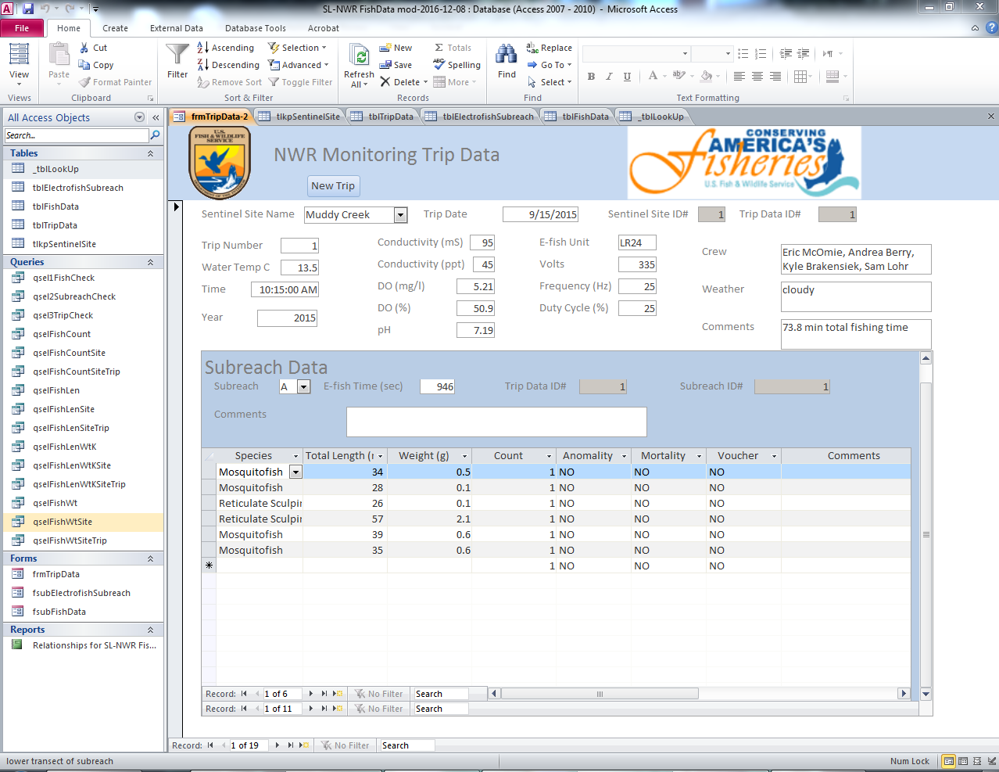
311

3. Fish data, fish records are being tracked, but the record counter is just out of view. They appear by pulling the scroll bar down (arrow next to the fish data). For the example, there are six fish data records for subreach A during the first trip to Muddy Creek.

Clicking on the arrows next to the records box allows you to move among records one at a time either forward or back, and also to the first or last record. The arrow with the yellow star shape next to it adds a new record to the table. Hitting the tab button moves the cursor across fields in a record. (A new record will not be added if you tab across fields without entering anything.)

--4) Adding records and species

Below are basic steps to add records for a new survey (i.e., trip), add a new species that has not been included in the data base, and also tallies.

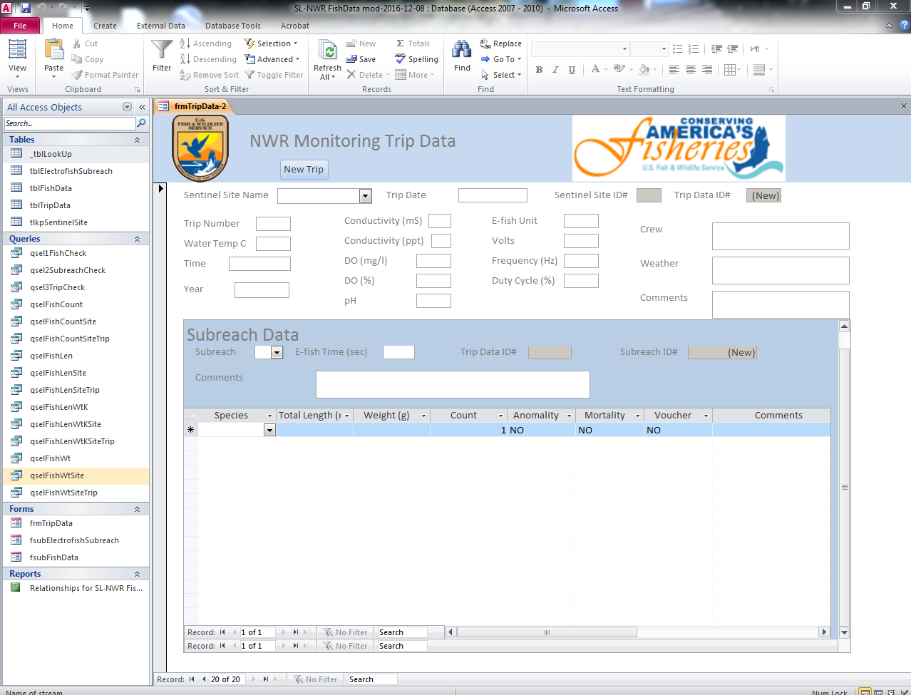
111
3211
211

1. Clicking on the “New Trip” button at the top of the form will add a new blank record to the TripData table.

2. The new trip record is number 20 of 20, and there are new blank records (1 of 1) shown for both the SubreachData and FishData tables associated with the new trip. Trip data can then be added in boxes on the top of the form; subreach A selected and fish data added.

3. When done with subreach A, hitting the arrow with the yellow star will add a new subreach record for which subreach B can be selected. Repeat this step until data has been entered for all subreaches. Good to save often.

If fish or other taxa were collected that do not appear in the species pull-down menu, follow the steps below.

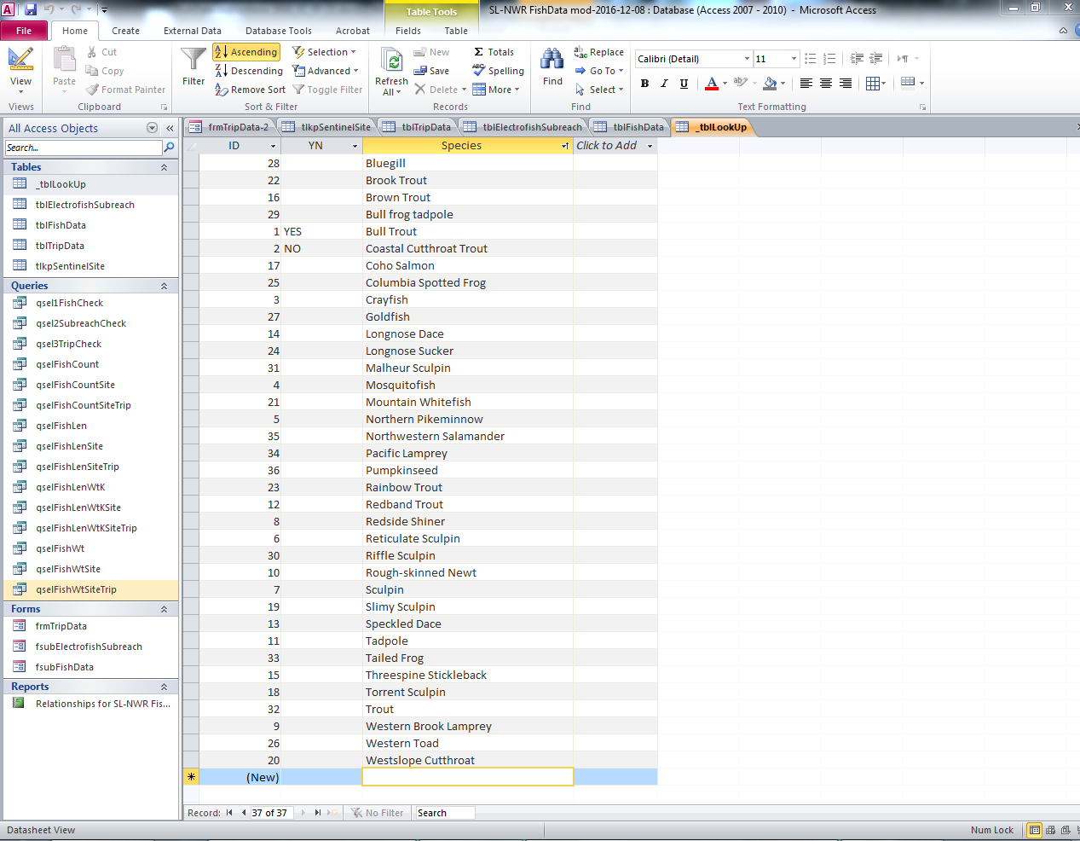
211
111

1. Open the look-up table (_tblLookUp) in datasheet view.

2. Enter the name of the taxa in a new record.

Sometimes fish are tallied in a subreach (i.e., length and or weight are not recorded). Below is an example of how these can be entered.

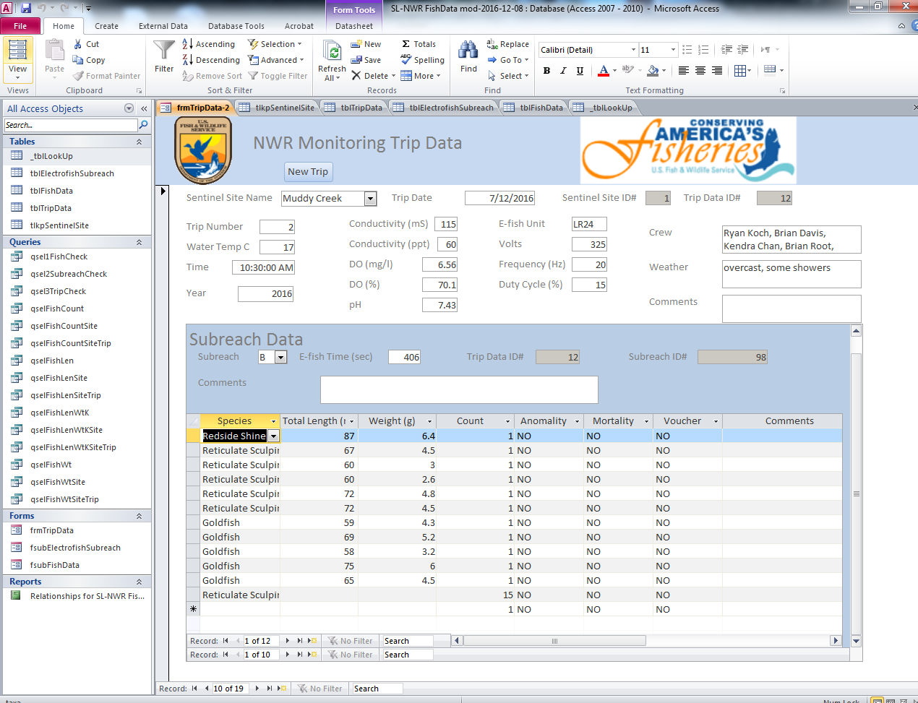
211
111

1. The tally of Reticulate Sculpin that were not measured or weighed is entered in the Count field. (If either length or weight were recorded, but not both, then a record should be entered leaving the missing variable blank for the individual.)

2. The number of mortalities, etc. if any, of those tallied can be entered in the Comments field.

Using Queries

Fifteen queries are presently saved that sort, summarize, and combine data, as well as calculate condition factor: Fulton’s K=(W/L³)*100,000. All the queries fall into five groups.

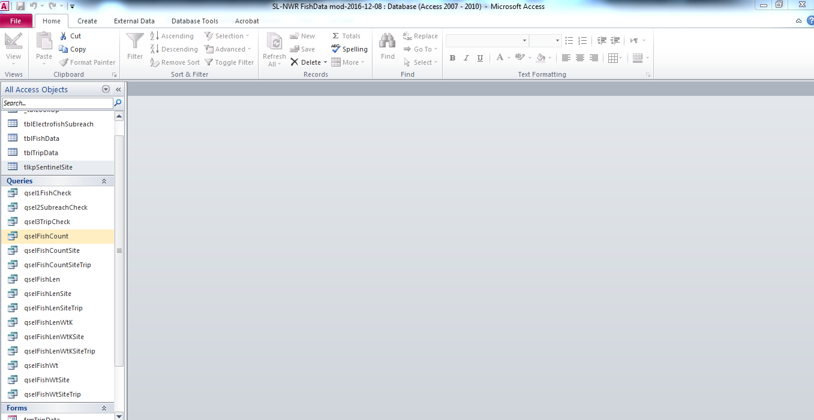
41
21
51
11
311

1. Group of queries combines and sorts data from multiple tables. Useful to export results to Excel files for data QA/QC (i.e., can see sentinel site, trip, subreach, and fish data all in single records) and then you can note where corrections need to be made in the database.
- qsel1FishCheck—used to check fish data.
- qsel2SubreachCheck—used to check subreach data.
- qsel3TripCheck—used to check trip data.

2. Group of queries sorts data to summarize counts of fish and other taxa.
- qselFishCount—used to sort fish count data.
- qselFishCountSite—sums fish counts by species among all trips to a sentinel by year.
- qselFishCountSiteTrip—sums fish counts by species for each trip to a sentinel by year.
(The remaining groups of queries follow the same approach used for fish counts—i.e., the first query in the group sorts data, the second query summarizes it by site for each year, and the third query summarizes it by trip to each site for each year. The second and third queries are performed on the results of the first.)

3. Group of queries sorts data to summarize fish length.
- qselFishLen—used to sort fish count and length data, only for records with length data.
- qselFishLenSite—reports the minimum, maximum, average, and standard deviation of fish length by species among all trips to a sentinel by year, including fish counts (n).
- qselFishLenSiteTrip— reports the minimum, maximum, average, and standard deviation of fish length by species for each trip to a sentinel by year, including fish counts (n).

4. Group of queries sort data to summarize fish length and weight, and calculate condition factor.
- qselFishLenWtK—used to sort fish count, length, and weight data, only for records with both length and weight data.
- qselFishLenWtKSite—reports the minimum, maximum, average, and standard deviation of fish length, weight, and condition factor by species among all trips to a sentinel by year, including fish counts (n).
- qselFishLenWtLSiteTrip— reports the minimum, maximum, average, and standard deviation of fish length, weight, and condition factor by species for each trip to a sentinel by year, including fish counts (n).

5. Group of queries sorts data to summarize fish weight.
- qselFishWt—used to sort fish count and weight data, only for records with weight data.
- qselFishWtSite—reports the minimum, maximum, average, and standard deviation of fish weight by species among all trips to a sentinel by year, including fish counts (n).
- qselFishWtSiteTrip— reports the minimum, maximum, average, and standard deviation of fish weight by species for each trip to a sentinel by year, including fish counts (n).

Double-clicking on individual queries will display their results in Datasheet View and will be automatically updated with any of the new data that have been entered. Below is an example showing the results of query qselFishLenSite, which has 43 records.

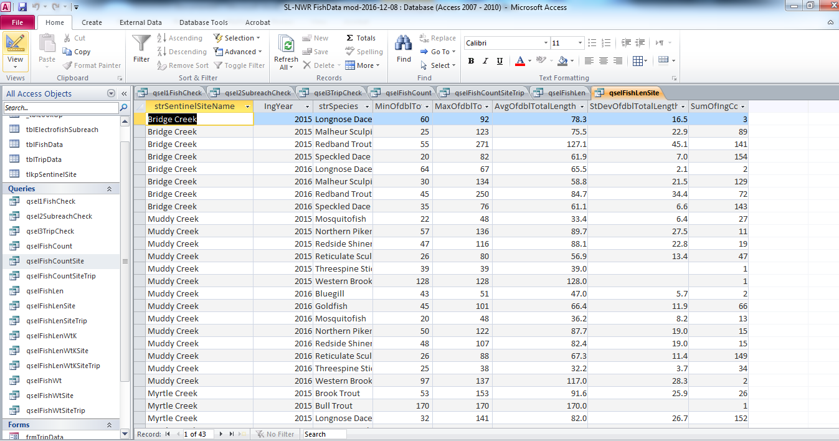

Switching to Design View allows you to see how a query is structured, and also change it. Examples of changes are if you are interested in seeing results for a specific sentinel site not all of them, particular years, or species. If you do change anything and want to keep it, please make sure to use the “Save Object As” option under the “File” menu and give the query a different name.

Below is qselFishLenSite in Design View

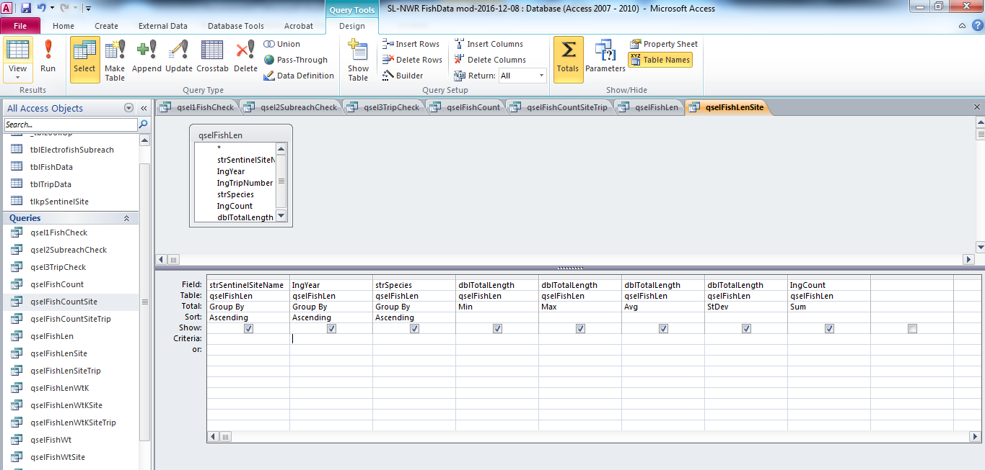

If I only wanted to see results for Muddy Creek, I would enter “=Muddy Creek” for Criteria under the strSentinelSiteName column and hit return. Then switch to Datasheet View.

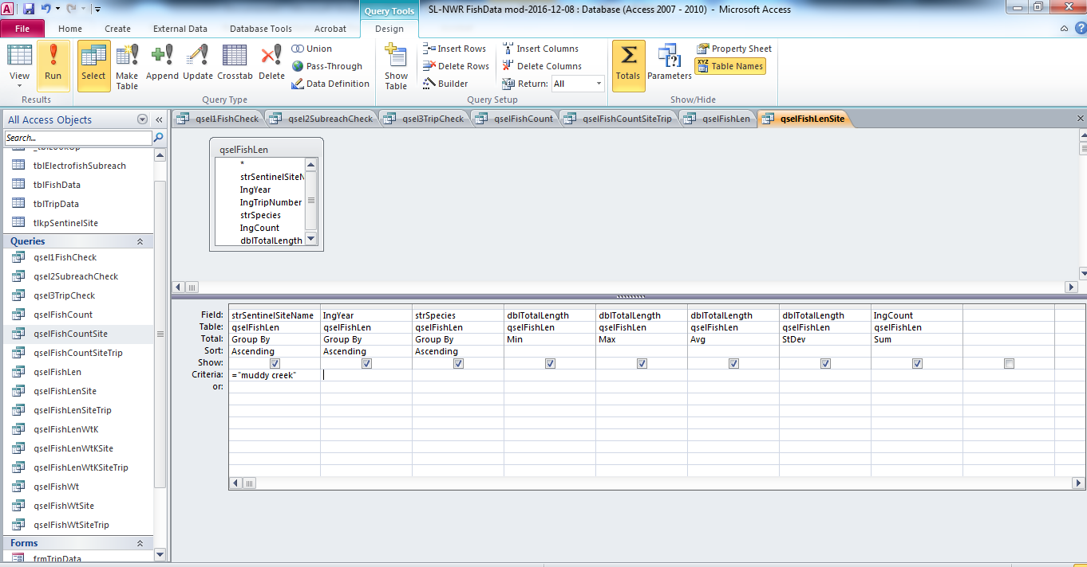

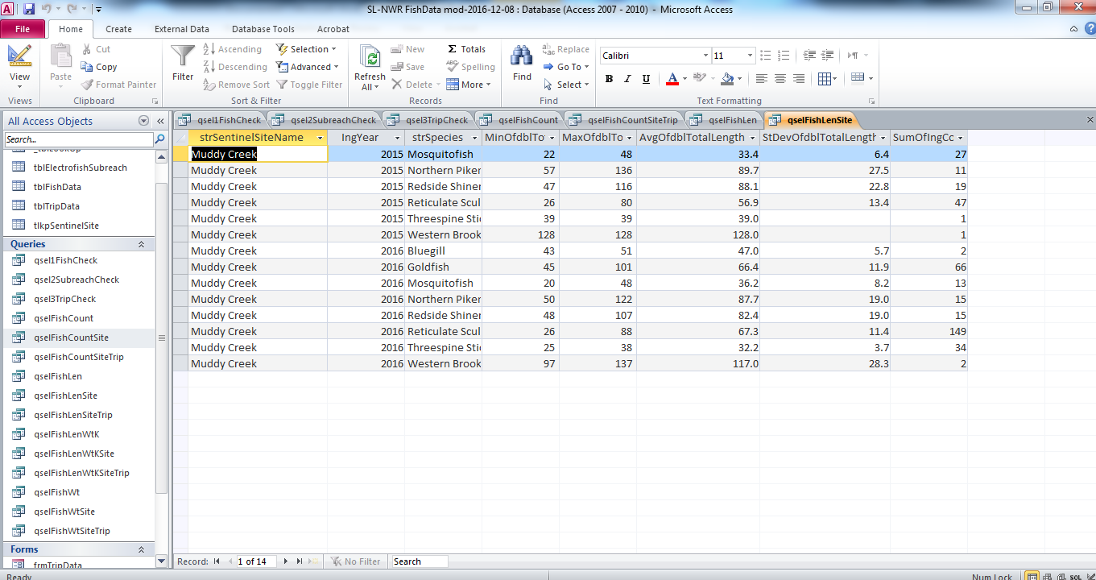

Only Muddy Creek results are reported now, which consist of 14 records. Results can also be exported or cut/pasted to Excel files.

