Seabird Colony Slide Catalog Database
Contents
Purpose and Background 2
Format and Software 2
Database Design 3
Main Form: Sites 4
Tables 4
CompleteData Table 4
Date_SlideSet 4
Lkp_Observers 4
Lkp_Comments 5
Lkp_CommentsNew 5
Sites 5
Slides 5
Data Entry Procedure 7
Backup Routine 11
Slide Labelling and Bar Coding 12
Slide labelling 12
Create the Barcode labels 12
Query the Database 12
Export the query results to an Excel file 14
Create the Labels 16
Prepare the slides to send to scanner 18
Slide boxes 18
File boxes 18
Scanner instructions 19
Specific of File Scanning 19

Purpose and Background
The USFWS has conducted aerial surveys to photograph surface-nesting seabird colonies annually within the Oregon Coast National Wildlife Refuge Complex (OCNWRC) since 1988 - 2009. These surveys were conducted by helicopter over two – three days in early- to mid- June, coincident with late incubation/early hatching of common murres. During each survey, photographs were taken at an oblique angle and at 260-330 m flying altitude by two photographers using 35 mm cameras and 100-400 mm lenses. More than 63,000 images from these surveys of Oregon and Washington seabird colonies were available only in 35 mm film slide format. The inevitable degradation of these slides, some of which are now nearly 40 years old, made conversion to a stable digital format critical in order to prevent loss of data.
A database was populated, and quality control checks performed on a catalog of all data associated with the slides. Slides were scanned to produce high-quality stable digital images. This reference includes a database the scanned images, associated metadata, and slide catalog number (barcoding for the purposes of NARA transfer).
59,727 of the 63,393 slides were scanned and saved as high-resolution images (2400 dpi) in .tiff format by a contracted third party. A relatively small number of slides (3,666 slides), discovered in early 2018, were scanned in-house at 5,000 dpi using a slide scanner (Pacific Image Powerslide 5000) purchased by the USFWS for this purpose.
Each slide was given a unique numerical identifier between 1 and 63,439 and this identifier was used to generate a slide label and file name in a standardized format: colony#_YYYY-MM-DD_unique slide number. Digital images of slides were saved within folders corresponding to the colony number prefix which in turn is based upon the degree of latitude and the USGS 1:250,000 topographic map number where the colony is located.
Data associated with the slides include the colony number, the date the photograph was taken, name of photographer, text written on the slide, comments on the condition of the slide, the number stamped on the slide by the developer (usually 1-36), creator of the record, date of record creation, information on corrections made to the database during the quality control process, and the archive location. The latitude, longitude, and name associated with each colony number within Oregon and Washington was added to the catalog as was the physical location of slides (slide and file boxes).
Format and Software
Microsoft Access 2010
Database Owner/Manager:
- USFWS – Shawn Stephensen

Database Editors:
- Nyssa Landres – Records 1 - 10434
- Rikeem Sholes – Records 10435 – 47304
- Karen Lange – QAQC Records 10435 – 47304
- Kirsten Bixler & Jessica Porquez – Records 47305 – 63439

Database Design
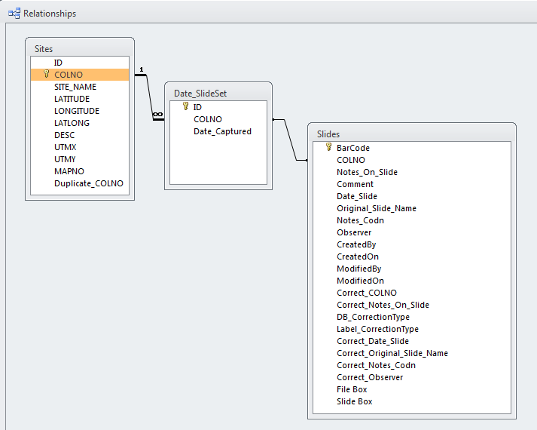

Main Form: Sites
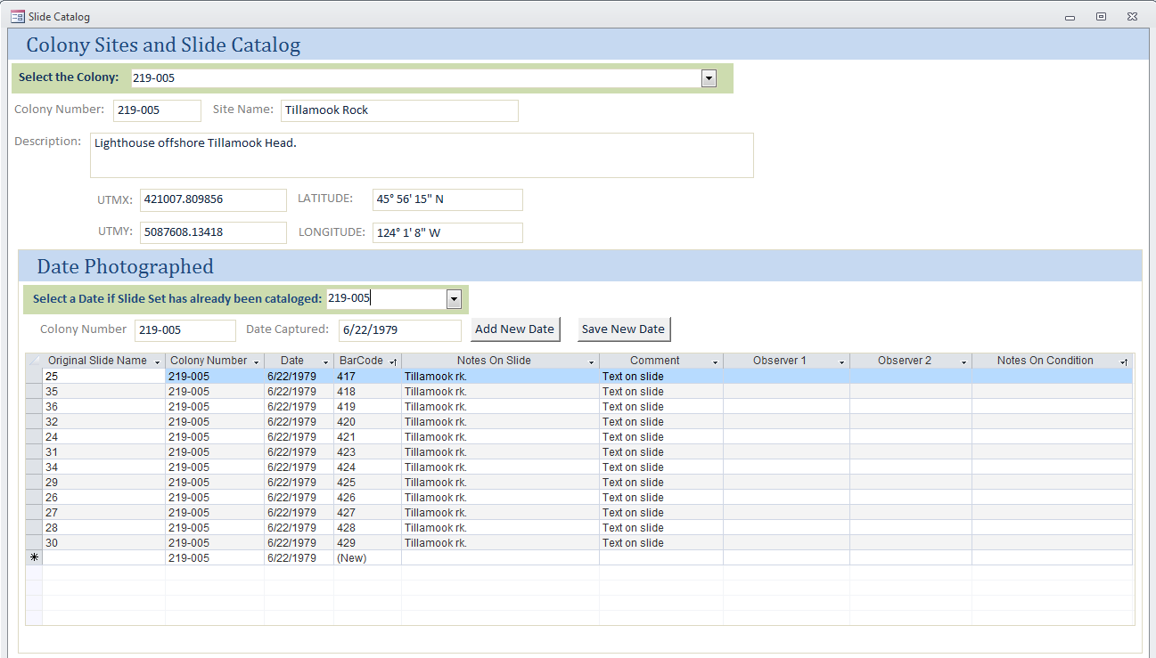
Slides Table
Date_SlideSet Table
Sites Table

Tables

CompleteData Table
Extracted from Shawn Stephensen’s Seabird Colony Database (2012).
This table was used to generate a unique list of seabird colonies. Fields to include the COLNO, SITE_NAME, LATITUDE, LONGITUDE, LATLONG, DESC, UTMX, UTMY, MAPNO. These attributes were added to a table called Sites. The Sites table is used as a lookup for data entry.
See query called CompleteData_UniqueColNo Query

Date_SlideSet
An accounting of the slides, date captured and colony. This table generates a set of records where each colony and date combination is unique. It is used as a lookup for entering the slide records.

Lkp_Observers
A unique set of observers, this table was generated by mining the CompleteData table. In general, the observer name is taken from the slide itself. Alternatively, if the slide has no observer name it can be identified through a cross check to the original CompleteData table. The Seabird Colony Slode Catlog only allows the entry of one observer, in the original CompleteData table more than one observer may be noted. We can use a query to join these values at a later date.
Note: This table needs to be cleaned up, it came from Shawn Stephensen’s legacy database and is not standardized.

Lkp_Comments
Standard set of comment types related to QAQC.

Lkp_CommentsNew
Standard set of comment types related to the slide media or cataloging anomolies.

Sites
Unique set of records with details of the colony sites. This table was generated from the CompleteData table. It is used as a lookup table for the data entry form.
Note: If a slide had an unknown colony, as was found in a few instances of marine mammal slides. A COLNO was generated (e.g. 999-999) and given a site name if written on the slide (e.g. Black Rock – Blanco Reef).
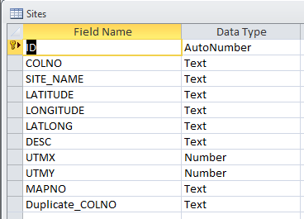

Slides
This is the full accounting of slides.
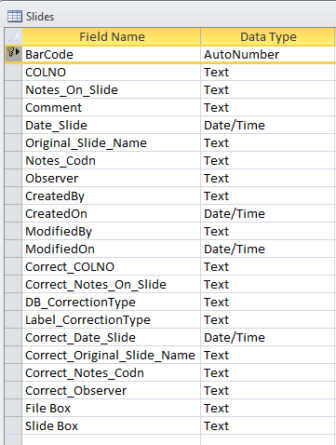

Slide Table Fields
BarCode – auotgenterated number. This also serves as the primary key.
COLNO – used to populate the colony number. If the slide has no text onit to indicate the colony, or if the colony ID does not match an option in the database. Consult with Shawn Stephensen to find out if it can be associated with a colony based on any other text written on the slide. If these is still not a way to match, give the colony an identifier 999-XXX, consult the databse and go in descending order from 999-999. DO NOT USE ‘Unknown’, if you use a repeated identifier like this it becomes harder to tease them apart. Give each set a unique identifier. To add a new colony or other identifier to the database go to the Sites table and describe. Once the new site is in the Sites table it will show up in the dropdowns.
Notes_On_Slide- field should capture any text written on slide. No quotes or prefixes required unless that is how it appears on the slide. Use this slide to capture each colony ID if the slide captures multiple colonies, also indicate Multiple Colonies in the Comment field.
Comment – field used to generally describe, elaborate, or qualify text on slide. Lkp_CommentsNew for controlled set of comments. Add new as needed to the lookup.
Date_Slide – YYYY-MM-DD format.
Original_Slide_Name – field used to capture any additional information on slide such as stamped slide number or other identifier on the slide frame. This is typically numeric but can also be alphanumeric.
Notes_Codn – field used to capture any notes on the condition of the slide. Such as damage, bad exposure, lack of metadata (text on slide).
Observer – field used to capture the observer. This is typically found on the slide but may also be crosschecked to CompleteData table if no observer is written on slide. This field is restricted to one observer. If more than one, use primary or first name in order as it appears. A query can always be created later to link the CompleteData table to the Slides table.
Created By – individual entering the records. Currently set to default to “Kirsten Bixler”
CreatedOn – date the record was created. Is set to automatically capture todays date.
ModifiedBy – person doing QAQC
ModifiedOn – date QAQC was performed
Correct_COLNO – QAQC corrected value
Correct_Notes_On_Slide– QAQC corrected value
DB_Correction Type - field used to generally describe, elaborate, or qualify error in data entry for the slide. Lkp_Comments for a controlled set of comments. Add new as needed to the lookup.
Label_CorrectionType- field used to generally describe, elaborate, or qualify error in labelling for the slide. Lkp_Comments for a controlled set of comments. Add new as needed to the lookup.
Correct_Date_Slide– QAQC corrected value
Correct_Original_Slide_Name– QAQC corrected value
Correct_Notes_Codn– QAQC corrected value
Correct_Observer– QAQC corrected value
File Box – File Box Archival box number
Slide Box – Slide Box Archival box number

Data Entry Procedure
- Select the Colony. The attributes such as colony number, site name, description, and coordinates will display automatically. Under the Date Photographed subform the first available date (recordset) will be shown for the colony.
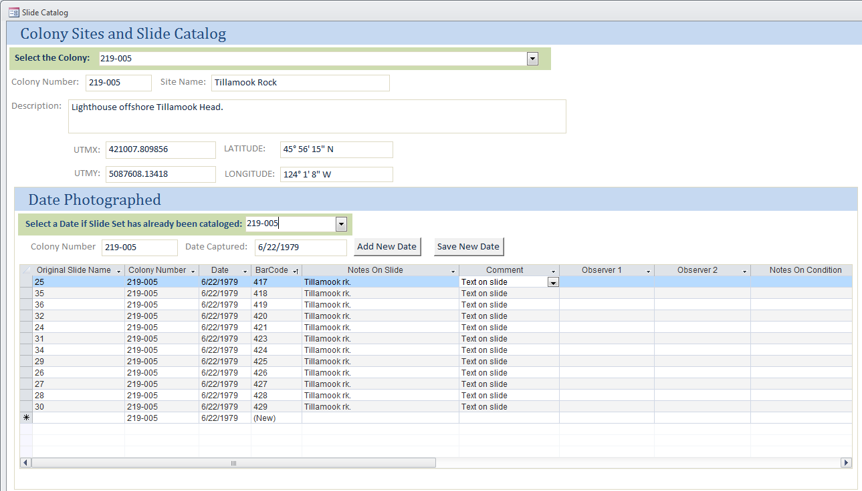
1
- Select the Date if the Slide Set has already been cataloged. This is an easy way to review what has been cataloged, but also to return to add additional slides for a given colony and date, if needed. Selecting an existing colony and date will display records that meet those criteria down below.
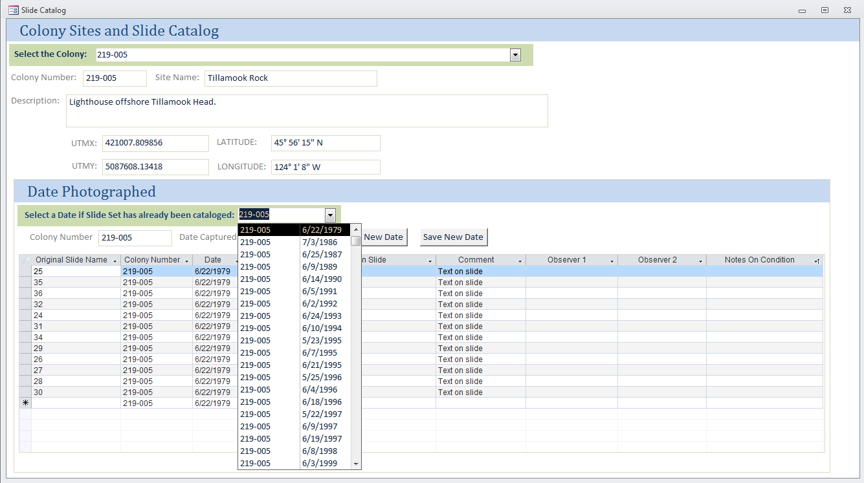
2
- If the slide set has not been cataloged click the Add new Date, type in the Date Captured and Click Save. This will add a date for the colony. That date will be used for the recordset to be entered down below.
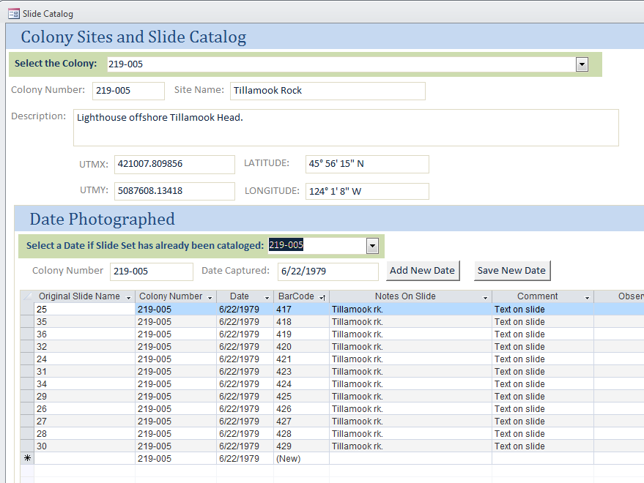
3
Once the Add New Date button is clicked, the Date Captured field will be cleared, use the calendar to select the new date. Click Save New Date and the date and colony will be added to the Date_SlideSet table. Begin adding slide records to the table below, notice the date will automatically be populated.
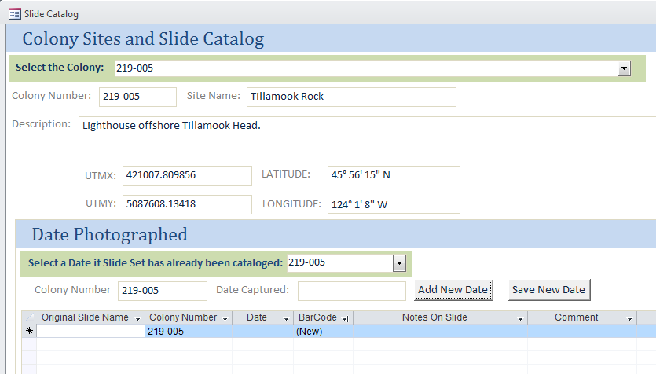
Calendar
- Add slide records. The Colony Number, Date, BarCode will automatically populate. Also the Created By and Created On fields will autopopulate in the table eventhough they are not shown on the form.
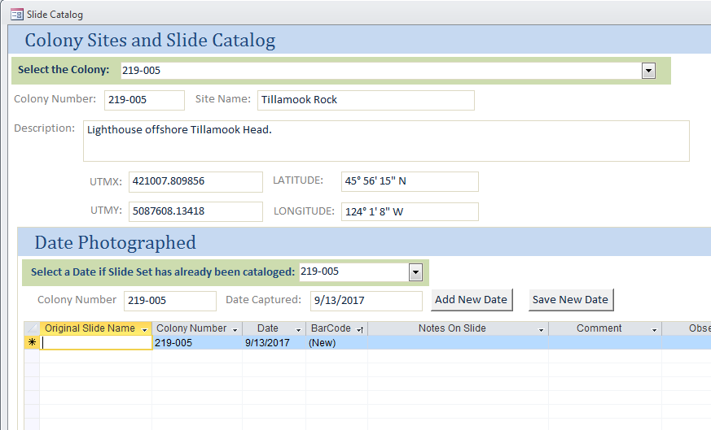
4
- A pop-up Zoom form can be accessed by using a double click on the Notes On Slide and otes On Condition fields. This pops up an expanded box for text entry. Type text and click Done. These fields are limited to 255 characters.
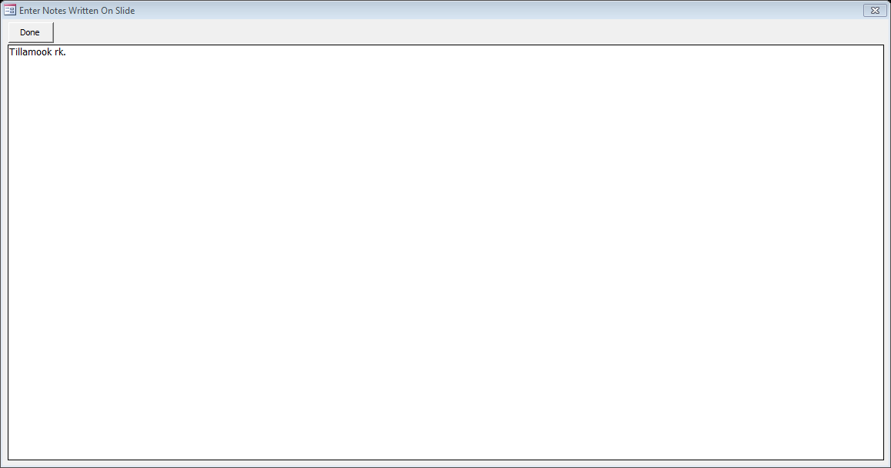

Backup Routine

INSTRUCTIONS TO BE WRITTEN

Slide Labelling and Bar Coding

Slide labelling
Each slide should be labelled with a barcode for error checking and archival. The barcode is included in the “Slides_Spreadsheet_xxxxxxxx” spreadsheet in the BarCode Print column. The barcode is a concatenation of the date and a unique identifier, using an underscore in between*. Place barcode on back side of slide so as not to cover any of the original text.
Example: YYYY-MM-DD_#####
BarCode Print | Title | Date | Unique ID | File Name | Slide Box | File Box
1992-06-02_10435 | 270-000.1 | 1992-06-02 | 10435 | 270-000.1_1992-06-02_10435 | 1 | 1
1992-06-02_10436 | 270-000.1 | 1992-06-02 | 10436 | 270-000.1_1992-06-02_10436 | 1 | 1
1992-06-02_10437 | 270-000.1 | 1992-06-02 | 10437 | 270-000.1_1992-06-02_10437 | 1 | 1
1992-06-02_10438 | 270-000.1 | 1992-06-02 | 10438 | 270-000.1_1992-06-02_10438 | 1 | 1
1992-06-02_10439 | 270-000.1 | 1992-06-02 | 10439 | 270-000.1_1992-06-02_10439 | 1 | 1

Create the Barcode labels

Query the Database
- Open the Microsoft Access ‘SlideCatalog_SeabirdColony_XXXXXXXX’ Database
- Open ‘Slides Spreadsheet_Labels_New’ Query

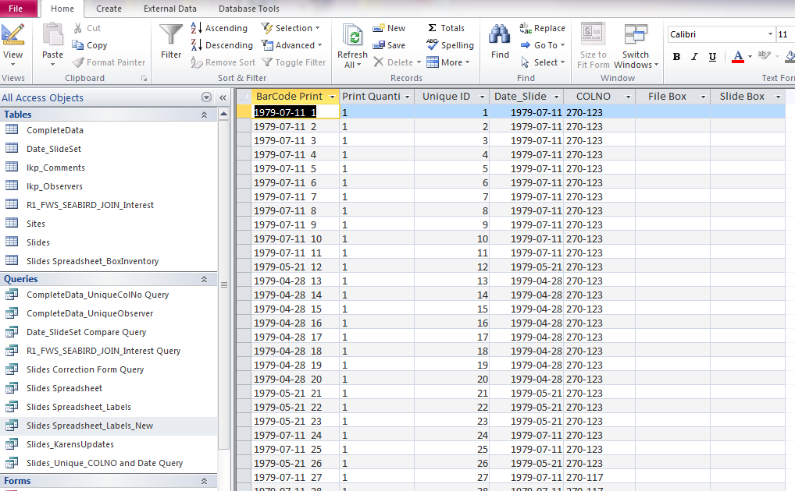

- Switch to ‘Design View’
  - Right click on title bar of query to open Design View , or
  - In the top left corner of the page you will find the ‘View’ Icon. Click on this to reveal a drop-down menu. Choose ‘Design View’.

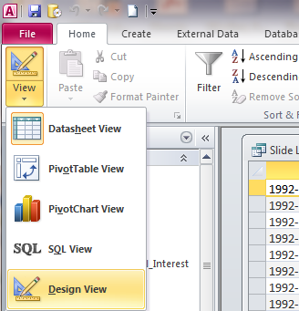

  - Adjust the parameters in the ‘Unique ID: BarCode’ column to the range of slides you need to print: “Between ##### And #####”

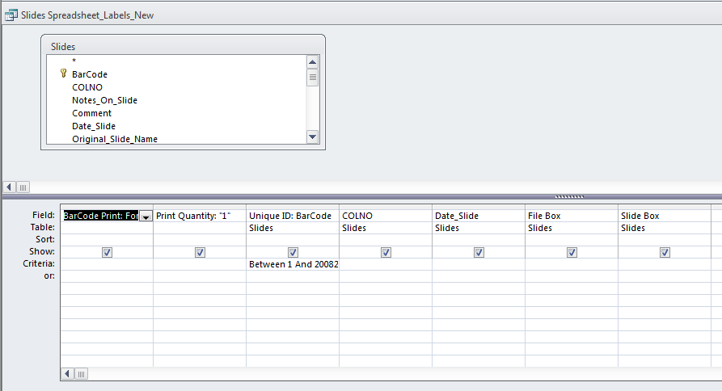
  - Return to ‘Datasheet View’ to view the results of the Query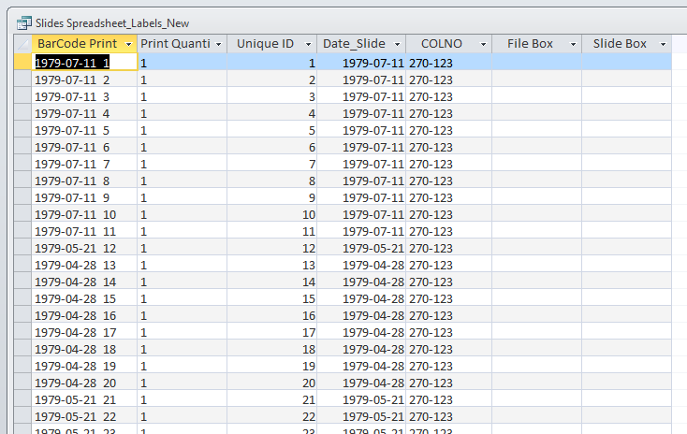

Export the query results to an Excel file
- Click on the ‘External Data’ tab at the top of the page
  - Double click on the Excel icon. The ‘Export – Excel Spreadsheet’ dialog box will open.
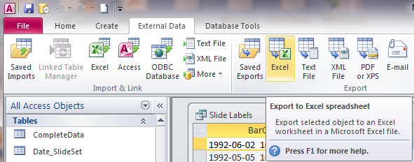
- Save the file format as .XLS (97-2003). Save the file with a meaningful name. Check the box to ‘Export data with formatting and layout’.
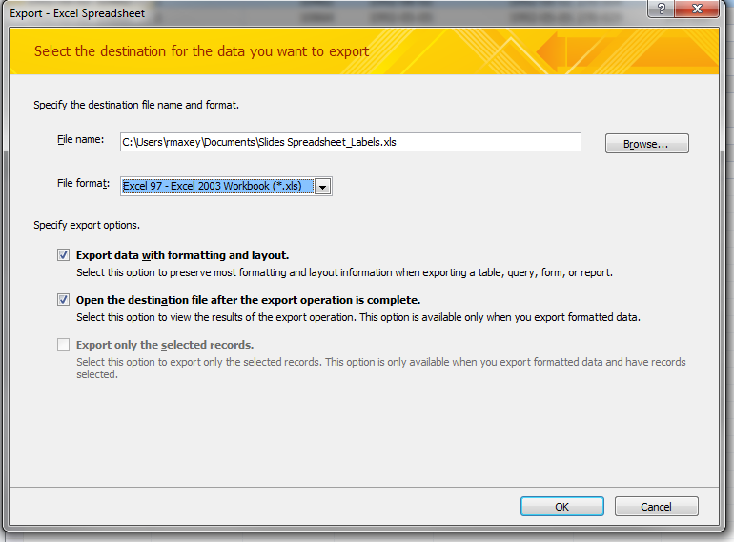
- Open the Excel workbook. Rename the sheet ‘Sheet1’.

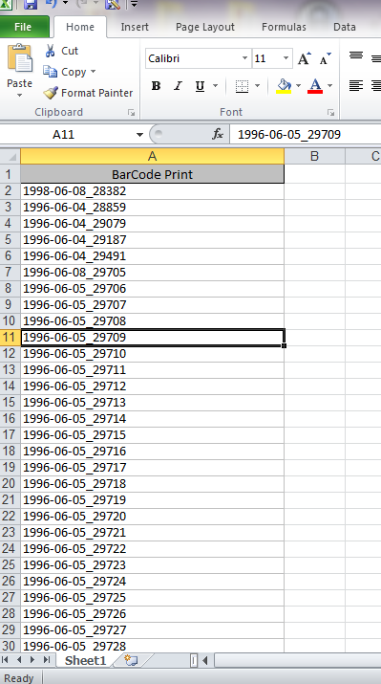

- Delete all columns except the Barcode Print column.
- Save as a Text (Tab delimited) (*.txt) File.

Create the Labels
- Open XBL Barcode Generator Program.
- Select Input Mode of ‘Multiple Line Text’ from the drop-down menu.
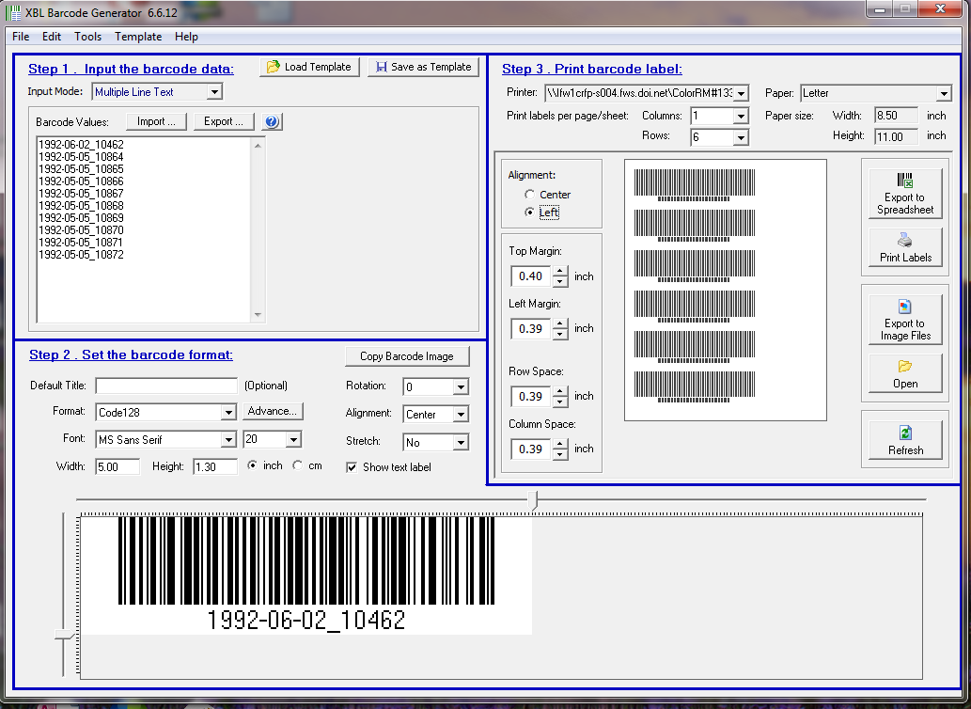
- Click ‘Import’ and navigate to the file.
- Settings for ‘Step 2. Set the barcode format’ should be as shown in the screenshot. We will not utilize Step 3 for our process so you can ignore that block.

- Go to the ‘File’ menu and select ‘Insert barcodes to MS Word, Excel file and Avery label templates’.

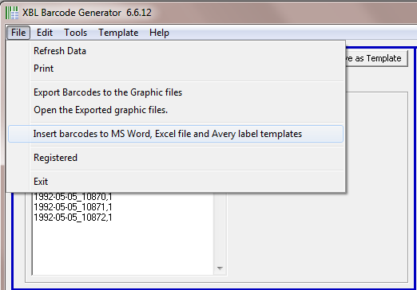

- Select the option to ‘Insert barcode to a specified Word / Excel templates file’. Then click ‘Next’.
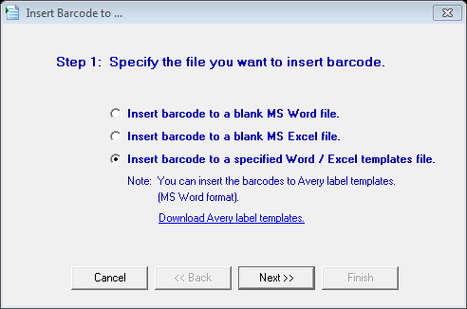
- Click on ‘Specify’ and browse to the Avery template. (Note: this document can’t be open when you run the barcode generator).

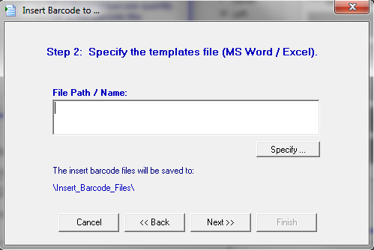

- Choose ‘No blank rows’ and ‘1 blank column’.
- For third option, ‘Before the text’ is fine.
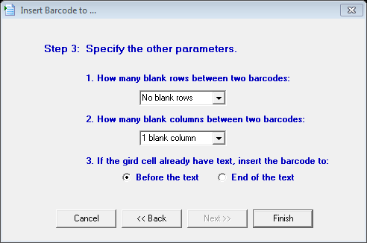
- Click Finish. The Avery document will open in Word (it may be several separate pages) and automatically insert the barcodes into each label.
- Print the labels on Avery #5167 Address Label sheets.
- Apply labels to corresponding slides.

Prepare the slides to send to scanner

Slide boxes
After barcode labelling, the slides should be placed in slide boxes (approximately 200slides/box). Slides are ordered in each slide box using consecutive ascending numbering by the Unique ID. Each slide box should be numbered in the top left hand corner. We have used slide box numbers 1-216, so new slide box numbers should start at 217 (as of 9/11/2017).
The outside of each Slide Box should be labelled across the top, and on the side of the inside box, with the start and end Unique ID numbers of the slides within.
Slides should be placed in continuous numerical order by the unique ID in the slide box. If an ID number is missing, for example a record is deleted and the slide ID column includes a skip of a number or number range, to be noted both on the slide box and in the spreadsheet.
On the outside of each slide box, the start of the range is marked on the end of the box with an “S” (for start) and the end of the range with an “F” (for finish).

File boxes
Eighteen Slide boxes fit into a File Box. The File boxes should also be numbered. We have used file box numbers 1-12, so new file box numbers should start at 13 (as of 9/11/2017).
A summary spreadsheet is provided, called “Slide Box Inventory_xxxxxxxx”. This catalogs the slide boxes for inventory/reference purposes.

Scanner instructions
For the scanning work, the spreadsheet called “Slides_Spreadsheet_xxxxxxxx” has records of each individual slide which includes details about the file box # and slide box # for each slide.
Each slide when scanned should receive the “Filename” as provided in the spreadsheet.
The File Name is a concatenation of the Title_Date_Unique ID
- Example: Colony#_YYYY-MM-DD_#####
- File names may include period characters (.). If this is an issue, periods can be replaced with dashes, but a period is preferred.
  - Example: Colony#.###_YYYY-MM-DD_##### changed to Colony#-###_YYYY-MM-DD_#####
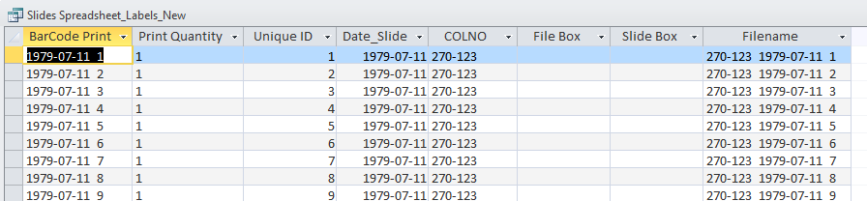
Currently we are labelling the slide media with a label of date and unique ID. But going forward the scanner will use the Unique ID to name the digital file with the colony included.
Slides 10435 – 42816; the file names are currently reflecting only the unique ID. A process can be developed to rename these digital files. This is a result of the QAQC error checking that found the digital names were including errors in the database. New digital file names will be developed and the digital files processed to include their full Colony_Date_UniqueID. In the meantime, the database is to be used to query the ID range or slides needed for analysis.
A copy of the spreadsheet, queried to the slides prepped for scanning, is to be provided to the contractor providing the scanning service.

Specific of File Scanning
Each slide should be scanned at 2400 and in a TIF format.
Slides will be returned to the archival boxes in the order they were provided.
Images to be clipped without any of the carrier cardboard/plastic
Clipped image must include the entire extent of the slide film.
Images will be delivered on an external hard drive provided by the USFWS.
As much as practical; no warping, skewing, or dust in the image.

