U.S. Fish and Wildlife Service: Region 6
Scanning Project: Using the Mountain-Prairie
Photograph Catalog Spreadsheet
Gregory Brill July 12, 2018

The R6 Scanning Project has placed all metadata for its Mountain-Prairie Photograph Catalog on an excel spreadsheet that consists of 15 columns, and a total of 16,145 items, processed between 2010 and 2018. The spreadsheet is designed to function similar to a relational database. Columns represent distinct fields containing overlapping information. Because of the sheer volume of information, photo searches should be launched by sorting one or more fields. Sorting multiple fields will typically yield the best results.
Sort by State
All items may not initially show up in keyword searches of certain fields. Selecting a State from the dropdown menu on column C will ensure that all keyword queries in other fields show up. Once you have singled out a state, keyword searches on the Title/Caption (column H) or Key Descriptive Words (column I) fields should be productive. You might also want to refine your search by selecting a Year/Year Range (column F).

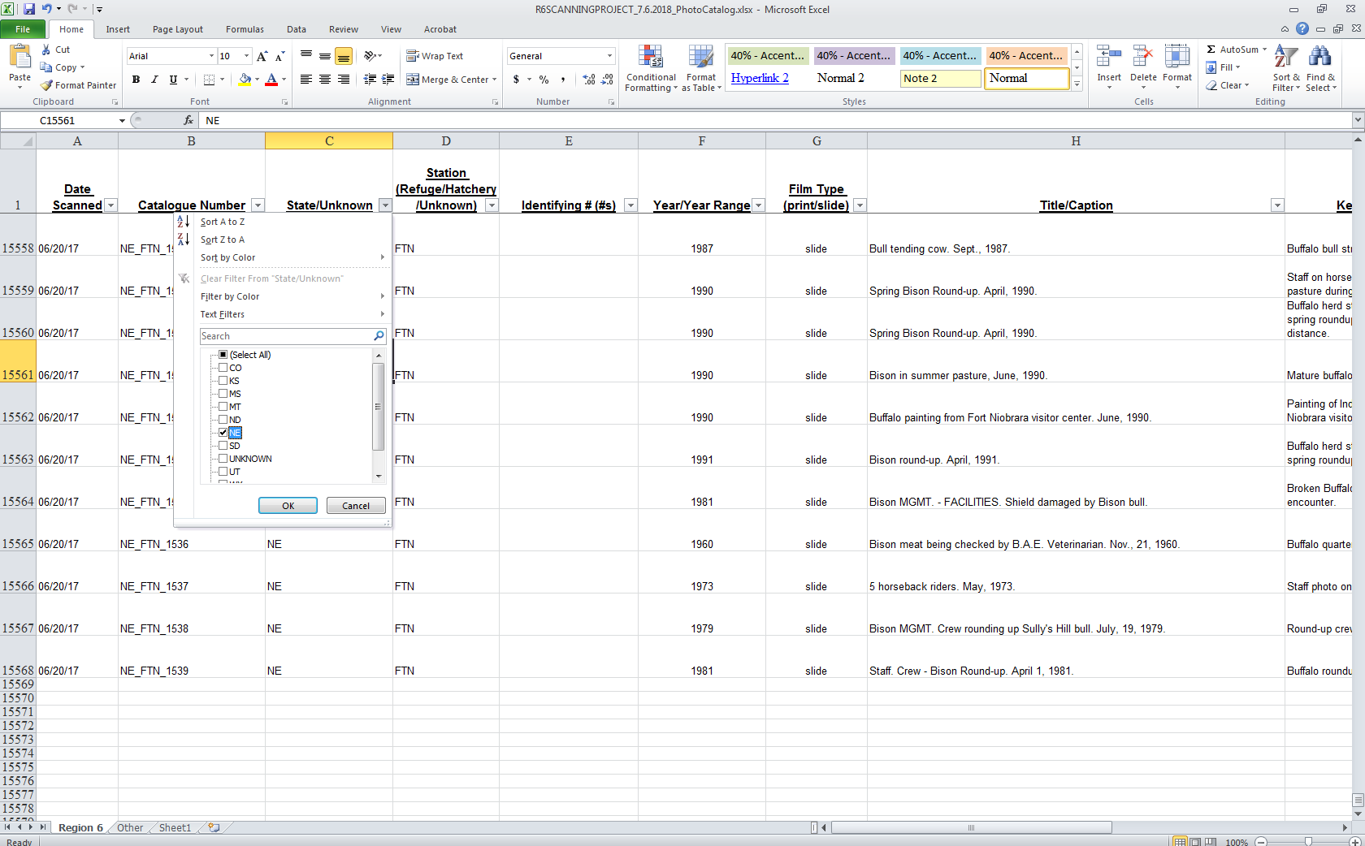
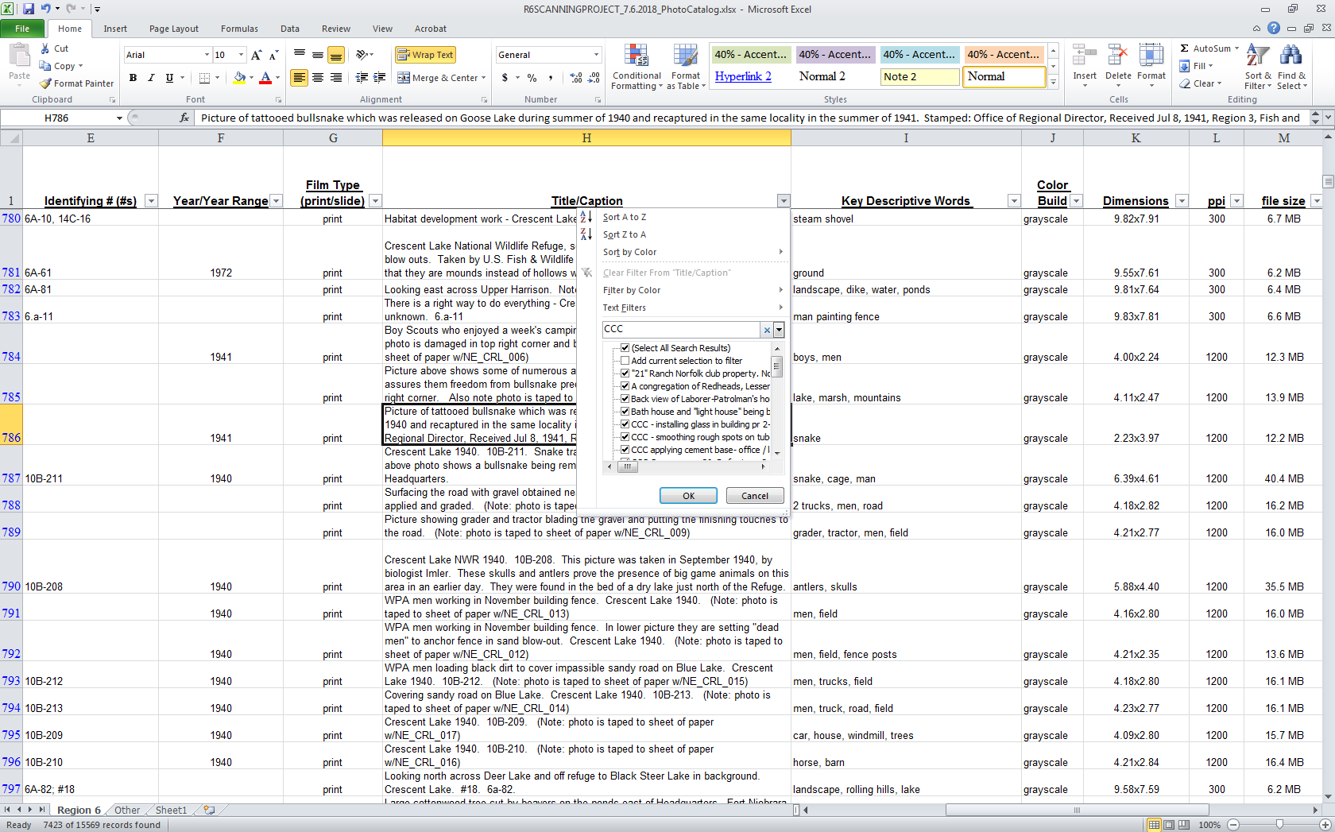

Sort by Station
If you are searching for photographs from a specific Region 6 station (refuge, hatchery, or related Wetland Management District) you may want to launch your search by selecting a three-letter code from column D. Singling out a station will yield narrower results than selecting a state. In some cases, you may want to refine your search further by entering keywords into the Title/Caption (column H) or Key Descriptive Words (column I) fields, or by selecting a Year/Year Range (column F). A list of three-letter station codes is included as an appendix.

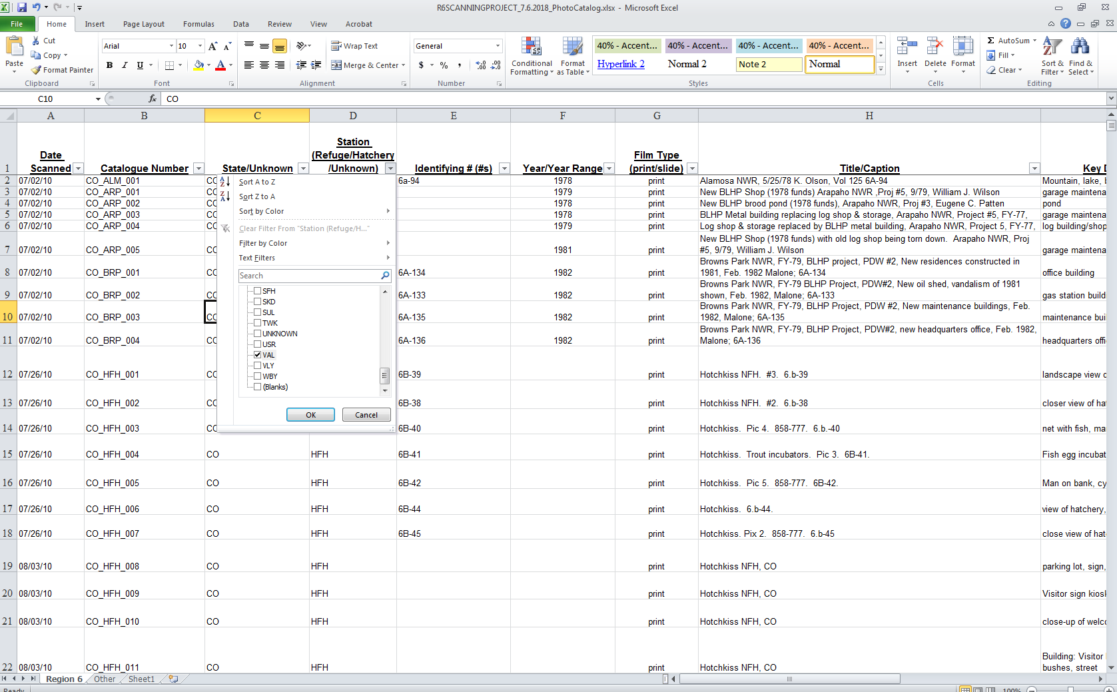
Sort by Year Range
If you want to search all states and stations for specific items, one of the best ways to sort the spreadsheet is by year range. To do this, uncheck all items in the Year/Year Range field (column F) and then manually check all years within your range.

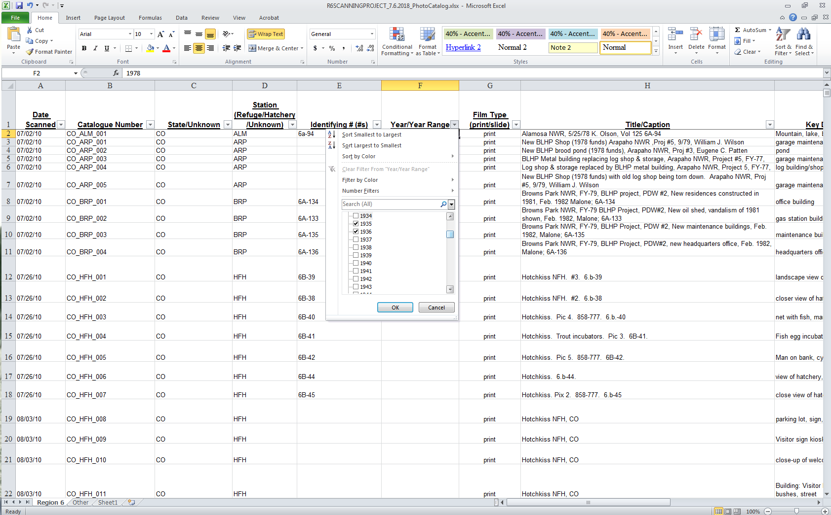

Request TIFF Files From the Catalog
All items on the spreadsheet were assigned a three-tier catalog number that can be found in the Catalog Number field (column B). All TIFF files for cataloged images (except a small number of copyrighted photographs) are available to Service personnel and the general public by request. Please make requests to:
Mark Madison, Ph.D.
U.S. FWS Historian
National Conservation Training Center
U.S. Fish and Wildlife Service Museum/Archives
698 Conservation Way
Shepherdstown, WV 25443
304 876-7276 (o)
mark_madison@fws.gov

Appendix: Three-Letter Codes for Region 6 Stations Included on the Spreadsheet
Audubon National Wildlife Refuge and Wetland Management District (North Dakota) – ADB
Alamosa National Wildlife Refuge (Colorado) – ALM
Arrowwood National Wildlife Refuge (North Dakota) – ARD
Arapaho National Wildlife Refuge (Colorado) – ARP
Bozeman National Fish Hatchery (Montana) – BFH
Browns Park National Wildlife Refuge (Colorado) – BRP
Bear River Migratory Bird Refuge (Utah) – BRR
Bowdoin National Wildlife Refuge and Wetland Management District (Montana) – BWD
Creston National Fish Hatchery (Montana) – CFH
Charles M. Russell National Wildlife Refuge (Montana) – CMR
Crescent Lake National Wildlife Refuge (Nebraska) – CRL
Devils Lake Wetland Management District (North Dakota) – DLW
Ennis National Fish Hatchery (Montana) – EFH
Fish Springs National Wildlife Refuge (Utah) – FHS
Fort Niobrara National Wildlife Refuge (Nebraska) – FTN
Gavin’s Point National Fish Hatchery (South Dakota) – GPF
Hotchkiss National Fish Hatchery (Colorado) – HFH
Hailstone National Wildlife Refuge (Montana) – HLS
J. Clark Salyer National Wildlife Refuge and Wetland Management District (North Dakota) - JCS
Jackson National Fish Hatchery (Wyoming) – JKF
Lake Andes National Wildlife Refuge and Wetland Management District (South Dakota) – LAN
Lacreek National Wildlife Refuge and Wetland Management District (South Dakota) – LCK
Leadville National Fish Hatchery (Colorado) – LFH
Lee Metcalf National Wildlife Refuge (Montana) – LMC
Lost Trial National Wildlife Refuge (Montana) – LST
Medicine Lake National Wildlife Refuge (Montana) - MDL
Madison Wetland Management District (South Dakota) – MDW
Monte Vista National Wildlife Refuge (Colorado) – MTV
National Bison Range (Montana) – NBR
National Elk Refuge (Wyoming) – NER
North Platte National Wildlife Refuge (Nebraska) – NPL
Ouray National Wildlife Refuge (Utah) – ORY
Quivira National Wildlife Refuge (Kansas) – QVR
Red Rocks Lake National Wildlife Refuge (Montana) – RRL
Sand Lake National Wildlife Refuge and Wetland Management District (South Dakota) – SDL
Saratoga National Fish Hatchery (Wyoming) – SFH
Seedskadee National Wildlife Refuge (Wyoming) – SKD
Sullys Hill National Game Preserve (North Dakota) – SUL
Tewaukon National Wildlife Refuge and Wetland Management District (North Dakota) – TWK
Upper Souris National Wildlife Refuge (North Dakota) – USR
Valentine National Wildlife Refuge (Nebraska) – VAL
Valley City National Fish Hatchery (North Dakota) – VLY
Waubay National Wildlife Refuge and Wetland Management District (South Dakota) – WBY

