Southeast Region Inventory and Monitoring Network FY12
Proposed Project

Title:
Development of a robust monitoring tool for aquatic species: applications of molecular techniques to imperiled herpetofauna of the Southeastern US

Contact:
Anna McKee, PhD Candidate
USGS Georgia Water Science Center
3039 Amwiler Rd. Suite 130
Atlanta, GA 30360
Email: amckee@usgs.gov
Phone: 770.903.9163

Daniel Calhoun, Hydrologist
USGS Georgia Water Science Center
3039 Amwiler Rd. Suite 130
Atlanta, GA 30360
Email: dcalhoun@usgs.gov
Phone: 770.903.9144

William Barichivich, Wildlife Biologist
USGS Southeast Ecological Science Center
7920 NW 71st Street
Gainesville, Florida 32653
Email: wbarichivich@usgs.gov
Phone: 352.264.3491

Collaborators:
Stephen Spear, Assistant Conservation Scientist
Orianne Society
579 Highway 441 South
Clayton, GA 30525
Email: sspear@oriannesociety.org

Caren Goldberg, Research Scientist
University of Idaho
Department of Fish & Wildlife Sciences
P.O. Box 441136
Moscow, ID 83844-1136
Email: cgoldberg@uidaho.edu

Travis Glenn, Associate Professor
College of Public Health, Environmental Health Science
152 Environmental Health Science Building
University of Georgia
Athens, GA 30602-2102
Email: travisg@uga.edu

Participating Station(s):
St. Marks National Wildlife Refuge (SMNWR)
James Burnett, Refuge Manager
1255 Lighthouse Road
P.O. Box 68
St. Marks, FL 32355
Phone: 850.925.6121
Email: saintmarks@fws.gov

Okefenokee National Wildlife Refuge (ONWR)
Sara Aicher, Wildlife Biologist
Route 2, Box 3330
Folkston, GA 31537
Phone: 912.496.3331
E-mail: Sara_Aicher@fws.gov

Lower Suwannee National Wildlife Refuge (LSNWR)
Larry Woodward, Deputy Refuge Manager
16450 NW 31st Place
Chiefland, FL 32626
Phone: 352.493.3151
Email: Larry_Woodward@fws.gov

Additional Potential Sample Locations
Lake Wales Ridge National Wildlife Refuge
Polk and Highlands Counties, Pelican National Wildlife Refuge Complex
1339 20th Street
Vero Beach, FL 32796
Phone: 772.562.3909 x 275
E-mail: lakewalesridge@fws.gov

Eufala National Wildlife Refuge
367 Highway 165
Eufaula, AL 36027-8187
Phone: 334. 687.4065
E-mail: eufaula@fws.gov

Apalachicola National Forest
11152 NW State Route 20
Bristol, Florida 32321
Phone: 850. 643.2282

Ordway-Swisher Biological Station
245 Mason Rd.
Melrose, FL, 32666
Phone: 352.475.2300
Email: osbs@ifas.ufl.edu

Eglin Air Force Base
eDNA research contact: Caren Goldberg, Research Scientist, University of Idaho
307 Boatner Rd.
Eglin Air Force Base, FL 32542
Phone: 208.885.7742
Email: cgoldberg@uidaho.edu

Project Category:
Resource monitoring

Project Summary (Purpose):
The southeastern United States has undergone major habitat alteration, most notably the conversion of longleaf pine (Pinus palustris) forest to other species of intensive planted pine and to extensive center-pivot agriculture. Concurrent with the loss of longleaf pine ecosystem has been the loss of associated seasonally ponded, isolated wetlands, which contribute significantly to the biodiversity of the region (Kirkman et al. 1999, Kirkman et al. 2012). These wetlands are generally ephemeral, preventing the establishment of predatory fish populations and providing important habitat for a number of species endemic to the longleaf pine–wiregrass ecosystems, including four imperiled and declining amphibian species: the flatwoods salamanders (Ambystoma cingulatum and A. bishopi), gopher frog (Lithobates capito), and striped newt (Notophthalmus perstriatus).
The overarching goal of the National Wildlife Refuge System is to protect a range of species diversity and their habitats for the benefit of current and future generations. Several National Wildlife Refuges (NWRs) within the boundaries of the South Atlantic Landscape Conservation Cooperative contain some of the limited remaining and restored longleaf pine forest of the southeastern US. Inventory and monitoring of flatwoods salamander, gopher frog, and striped newt presence within National Wildlife Refuges with known historic and/or current records of target species presence is essential for understanding how effective these refuges have been in terms of supporting populations of these, and other, threatened aquatic species. Additionally, in circumstances where locally extirpated endemic species have been reintroduced to refuges, the ability to detect species presence at breeding sites over the long-term is essential for effective adaptive management.
Standard field methods for detecting the presence of larvae and adults of these species in depressional wetlands generally require capturing individuals with dipnets, funnel traps, and/or minnow traps. Given certain aspects of the life histories of the target amphibian species (e.g., small population sizes, cryptic behavior or nocturnal activity, and high variation in annual reproductive success; Bevelhimer et al. 2008; Dodd and LaClaire 1995; Palis 1995) these techniques can be time consuming, disruptive to habitats, and at times, impossible. These techniques also can carry with them the possibility of the transfer of pathogenic organisms among habitats when biosecurity efforts are not successful.
A molecular method has recently been demonstrated to work for detecting contemporary freshwater species presence in aquatic systems by amplifying species-specific DNA (environmental DNA; eDNA) from water samples (Ficetola et al. 2008; Goldberg et al. 2011; Jerde et al. 2011; Thomsen et al. 2012; Stephen Spear, unpublished data). This method has great potential to assist with the inventory and monitoring of threatened, pond-breeding amphibians in the southeastern US, as the primary extent of the field component is water filtration. The successful application of this method would provide an easy, cost-effective, non-invasive technique to detect presence of pond-breeding amphibian species of conservation concern.
Current Status:
This project will include two components – eDNA marker development, and a pilot study to determine the effectiveness of the developed markers to detect target species presence in the aquatic environment.

Objectives:
(1) Develop species-specific eDNA markers from the species’ mitochondrial DNA sequences.
(2) Test the effectiveness of the designed markers to detect presence of target species from water samples

Describe landscape implications/linkages for this project:
Detection of species presence with eDNA markers could be used to estimate wetland occupancy rates, when compared to traditional sampling techniques, which could be used to estimate relative habitat suitability (Bradford et al. 2003; Sergio et al. 2003). Occupancy estimates could also be used as response variables for landscape predictor models, which could be developed to predict additional potential locations of target species presence, or to help determine relative suitability of potential reintroduction sites.

List project leader(s) supporting this effort?
James Burnett, Refuge Manager
North Florida Refuge Complex
1255 Lighthouse Road
P. O. Box 68
St. Mark’s, Florida 32355
Phone: 904.925.6121 x30

Project Plan
Cost:
Requested funds for the project from FWS total $46,382. An itemized breakdown of the costs is included in Table 1 (column titled FY2013-FWS).

Is there match available and being used? If yes, please describe?
USGS In-Kind funds that will be used to support this project total $30,038. An itemized breakdown of the In-Kind support is included in Table 1 (column titled FY2013-USGS In-Kind), the source of which is the USGS Amphibian Research Monitoring Initiative (ARMI) program.

Is this something where you can complete work in a year, specifically provide a final report of project deliverables by September 2013, OR will there need to be follow up?
Assuming no major climatic events prevent target species from breeding during the 2012-2013 breeding season, this project can be completed within a year and a final report will be provided in September 2013. In the event that the target species do not breed over the period of the study, a report of the marker development and eDNA marker testing on samples from captive populations will be submitted in September 2013, with a follow up report pertaining to results from the field test component completed and submitted following target species breeding events and lab processing and analysis of water samples.

Can you do the follow up without any additional regional funding?
All analyses will be completed during FY2013 and all report material will be in review status by the end of the 2013 fiscal year. All data and report material will be submitted to FWS upon review and approval. No additional funds will be requested for any work involved in the review process.

Project Implementation and Protocols
Who is the lead/coordinator?
Anna McKee (GWSC), Daniel Calhoun (GWSC), and William Barichivich (SESC) will coordinate and lead the project.

What protocol (if appropriate) will you use? Please attach/insert at end of this proposal if lengthy.
We will use the protocol outlined in Goldberg et al. 2011, with minor modifications to water sample collection and filtration (David Pilliod, Personal Communication), and modifying the eDNA amplification to a quantitative realtime PCR method.

Marker Development
We will use sequences from GenBank, and sequence additional samples if necessary to obtain DNA sequences of target species from across their ranges. For each species, quantitative realtime PCR primers and probes will be designed using Primer Express® (Applied Biosystems) primer design software. Primers and probes will be BLASTed (i.e., compared) against GenBank to ensure non-target syntopic species are unlikely to be cross amplified, possibly resulting in false positives. Primers and probes of all target species will be BLASTed in combination with each other to ensure no non-target species would be amplified in a multiplex format.

eDNA Collection, Isolation, and Amplification
To test the effectiveness of these markers to detect target amphibian species presence in the field, we will collect 250 mL water samples from each study wetland each visit and extract the DNA from them as described in Goldberg et al. 2011. Water samples will be filtered in the field using a flow-through filter and with a peristaltic pump and cellulose nitrate filter paper. Filters will be preserved, individually in 2 mL tubes, in 95% ethanol. DNA from water filters will be extracted with a Qiagen DNeasy Tissue and Blood Kit (Qiagen, Inc.), with the addition of a QIAshredder (Qiagen, Inc.) after an overnight digestion with Proteinase K. We will use an initial PCR recipe as follows: 5µL 2x QuantiTect PCR Master Mix, 0.5µL 10x primer master mix (8 µM per primer, 4 µM for probe), 2.5µL eDNA, and 1.4µL RNase-free water, 0.4 µL 10x exogenous control, 0.2 µL 50x exogenous control, totaling 10µL reaction volume. Our initial PCR protocol will be: 95ºC for 15 minutes; 50 cycles of 94ºC for 60 seconds and 60ºC for 60 seconds. Modifications will be made both the PCR recipe and PCR protocol as necessary for optimization.

Study Sites and Experimental Design
Study wetlands will be determined after consultation with refuge personnel (e.g., managers and/or wildlife biologists) and state herpetologists (i.e., John Jensen, Georgia; Kevin Enge, Florida). Breeding events of each target species generally coincide with significant rain events during specific months of the year (i.e., gopher frog: January – April; Flatwoods salamander: October – November; and striped newt: November – March). Environmental DNA has been demonstrated to persist in water up to two weeks after a species is no longer present (Thomsen et al. 2012). To maximize our chance of detecting species, we will collect water samples within two weeks following significant rain events from selected wetlands on a monthly basis (weather permitting) during the breeding seasons of target amphibian species (from mid-October 2012 through April 2013). Traditional sampling techniques (e.g., dip-netting) will selectively be utilized to confirm the presence of the targeted species in the habitats in which water sampling is undertaken. Refuges with historic records of all three species will be visited across the breeding seasons of all species, whereas refuges with historic records of one species will be visited across the breeding season of that species.

Captive Populations
Additionally, we will contact facilities with captive populations of flatwoods salamanders, gopher frogs, and/or striped newts about obtaining water samples from their habitat enclosures that have been exposed to adult and/or larval specimen. These samples will be used as a backup for testing eDNA markers in the event that wild populations of target species do not breed during the time frame of the proposed study. Organizations with captive populations of at least one target species who have confirmed cooperation with this project include the Jacksonville and Memphis Zoos (contacts: Dino Ferri, Jacksonville Zoo; and Steve Reichling, Memphis Zoo).

Who will conduct the work?
Water collection and filtering will be conducted by Anna McKee, Daniel Calhoun, and William Barichivich, as trained by Stephen Spear (Orianne Society) and Caren Goldberg (University of Idaho), with additional assistance from refuge personnel if necessary. Molecular work will be conducted primarily by Anna McKee, with methodological support from Stephen Spear and Caren Goldberg.

Where will the work take place?
Molecular work will be conducted in Dr. Travis Glenn’s lab and Dr. Erin Lipp’s lab in the Environmental Health Sciences building at the University of Georgia in Athens, Georgia. Marker development will be conducted in Dr. Glenn’s lab, whereas DNA isolation from water samples and amplification of eDNA will be conducted in Dr. Lipp’s lab, which is used solely for low-quantity DNA sources. No DNA from amphibians has previously been handled in this room.

As permitted by breeding patterns of target amphibians, water samples will be collected from participating National Wildlife Refuges (see Table 2 and Figure 1 for proposed study locations). The identification of wetlands at National Wildlife Refuges will be selected upon consultation with refuge managers and wildlife biologists. Approximately seven wetlands (six with expected presence and one negative control) will be selected for sampling at refuges where all three target species have historically been present (SMNWR and ONWR; Table 2), and five wetlands (four with expected presence and one negative control) will be selected for sampling at refuges where only one species has historically been found (LSNWR; Table 2).

If samples are to be collected, who will assess/identify samples?
Water samples will primarily be collected by Anna McKee, Daniel Calhoun, and William Barichivich, with assistance from refuge personnel if necessary.

Where will the samples reside?
Samples will reside in a -80°C freezer in the Environmental Health Science building at the University of Georgia.

Data Management and Analysis
Who will enter the data?
Anna McKee will be responsible for ensuring data collected from quantitative realtime PCR runs are stored on the USGS server.

Where will the data be stored?
Data and results from molecular processing and analyses will be stored on USGS servers until the point at which the report receives USGS Director’s Approval and the data will be transferred to FWS in electronic form in any format chosen by FWS to be most beneficial for subsequent usage.

How and when will the data be analyzed?
Data assimilation and analysis will occur simultaneously with testing of the eDNA markers and eDNA amplification (Table 3). Analysis will be ongoing through the fiscal year and early release of selected material will be possible on a provisional basis to meet Service needs as they arise.

A report of activities will be required September 2013– who is responsible for this submission?
A team approach will be taken in the production of the report which will commence as soon eDNA marker development is completed. The layout of the report will begin simultaneously with onset of each project component to ensure that the goal of a timely delivery of the data to FWS is met. Lead authors on the final product will be Anna McKee, Daniel Calhoun, and William Barichivich.

Table 1. Requested funds to USGS Science Centers for FY2013.
 | FY2013-USFWS | FY2013 – USGS In-Kind | Total
Salaries  Georgia Water Science Center (GWSC)  Geneticist  Hydrologist  Southeastern Ecological Science Center (SESC)  Wildlife Biologist | $19,168  $0  $7,687 | $19,168  $6,869  $0 | $38,336  $6,869  $7,687
Supplies:  Water filtration  Marker development  DNA isolation and amplification | $800  $4802  $9924
Total Equipment and Supplies | $15,526 |  | $15,526
Travel &Transportation  GWSC  SESC | $3201  $800 | $4002 | $7,203  $800
Total Project Costs  GWSC  SESC | $37,895  $8,487 | $30,038  $0 | $67,933  $8,487
Combined Costs | $46,382 | $30,038 | $76,420

Table 2. Region 4 National Wildlife Refuges where species records indicate historic and/or contemporary breeding populations.
Refuge | Flatwoods Salamander | Gopher Frog | Striped Newt
St. Marks | X | X | X
Lower Suwannee |  | X
Okefenokee | X | X | X

Table 3. Proposed work schedule.
 | 2012 |  |  | 2013
 | Oct | Nov | Dec | Jan | Feb | Mar | Apr | May | Jun | Jul | Aug | Sep
eDNA marker development
Study wetlands selected
Contact organizations with captive populations of target species
Sample Okefenokee NWR and St. Marks NWR wetlands
Obtain water samples for captive populations
Sample Eufala NWR and Lower Suwanee NWR wetlands
DNA isolation and amplification from water samples; data compilation
Data assimilation and analysis
Final report preparation
Final report submitted for review

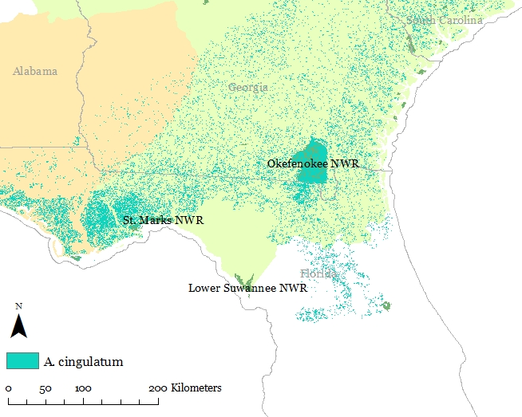
- Flatwoods salamander
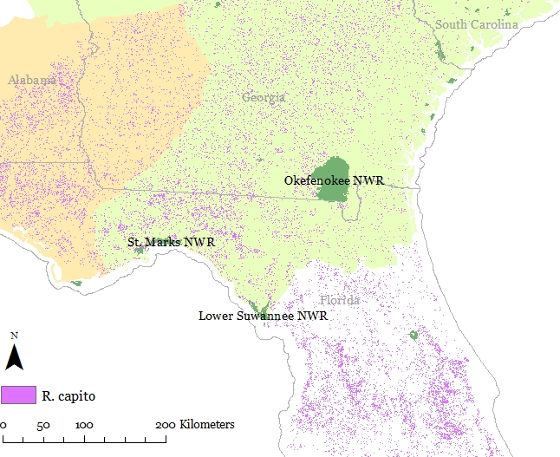
- Gopher frog
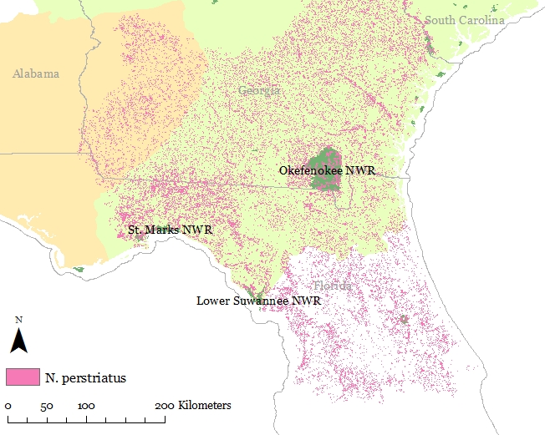
- Striped Newt

Figure 1. Map of proposed National Wildlife Refuges for inclusion in the study, and US Geological Survey Gap Analysis expected species distribution maps for the a) flatwoods salamanders, b) gopher frog, and c) striped newt.

Literature Cited
Bevelhimer, M. S., D. J. Stevenson, et al. (2008). "Annual surveys of larval Ambystoma cingulatum reveal large differences in dates of pond residency." Southeastern Naturalist 7(2): 311-322.
Bradford, D. F., A. C. Neale, et al. (2003). "Habitat patch occupancy by toads (Bufo punctatus) in a naturally fragmented desert landscape." Ecology 84(4): 1012-1023.
Dodd Jr, C. and L. LaClaire (1995). "Biogeography and status of the striped newt (Notophthalmus perstriatus) in Georgia, USA." Herpetological Natural History 3(1): 37-46.
Ficetola, G. F., C. Miaud, et al. (2008). "Species detection using environmental DNA from water samples." Biology Letters 4(4): 423-425.
Goldberg, C. S., D. S. Pilliod, et al. (2011). "Molecular detection of vertebrates in stream water: a demonstration using rocky mountain tailed frogs and Idaho giant salamanders." PloS One 6(7): e22746.
Kirkman, L., S. Golladay, et al. (1999). "Biodiversity in southeastern, seasonally ponded, isolated wetlands: management and policy perspectives for research and conservation." Journal of the North American Benthological Society 18(4): 553-562.
Kirkman, L. K., L. L. Smith, et al. (2012). "Is species richness congruent among taxa? Surrogacy, complementarity, and environmental correlates among three disparate taxa in geographically isolated wetlands." Ecological Indicators 18: 131-139.
Palis, J. (1997). "Distribution, habitat, and status of the flatwoods salamander (Ambystoma cingulatum) in Florida, USA." Herpetological Natural History 5(1): 53-65.
Sergio, F. and I. Newton (2003). "Occupancy as a measure of territory quality." Journal of Animal Ecology 72(5): 857-865.
Thomsen, P. F., J. O. S. Kielgast, et al. (2012). "Monitoring endangered freshwater biodiversity using environmental DNA." Molecular Ecology 21(11): 2565-2573.

The use of trade, product, or firm names in this proposal is for descriptive purposes only and does not imply endorsement by the U.S. Geological Survey.

