FY 2015 Annual Report: Year 3 of 2013 Cooperative Recovery Initiative Project

- Project Title: The Return of Big River Endangered Freshwater Mussels

- Is your project completed?: No

- Interim or Final?: Interim

- Project Summary: The goal is to establish two to four new populations of at least 100 individuals of endangered freshwater mussel species on or near the Ohio River Islands National Wildlife Refuge (NWR). In order to accomplish that goal, four species of mussels (clubshell [Pleurobema clava], orange-foot pimpleback [Plethobasus cooperianus], purple cat’s paw pearlymussel [Epioblasma obliquata obliquata], and spectaclecase [Cumberlandia monodonta]) were targeted for a combination of recovery activities, such as translocation of adults, propagation and culture of juveniles, and stocking of tagged juveniles into the watershed. The expectation was that not all species can be worked with in a given year due to confounding weather, water conditions, availability of host fish, etc., so a successful outcome is considered to be two to four new populations.

- Lead Region: 5

- Other Participating Regions: 3 and 4

- National Wildlife Refuge(s) Involved: Ohio River Islands NWR, Region 5, (PA, WV, and KY)

- Any Private Lands Involved?: No

- All FWS Programs Involved: Refuges, Fish and Aquatic Conservation, and Ecological Services (in 3 Regions)

- Project Contacts:
Patricia Morrison, Refuge Biologist, Ohio River Islands NWR, 304-375-2923 x 124, patricia_morrison@fws.gov

Barbara Douglas, Senior Endangered Species Biologist, West Virginia Field Office, 304-636-6586 x 19, barbara_douglas@fws.gov

Cooperators: Ohio River Islands NWR, White Sulphur Springs National Fish Hatchery (WSSNFH), Northeast Fishery Center, West Virginia Field Office, West Virginia Division of Natural Resources (WVDNR), Pennsylvania Fish and Boat Commission, Pennsylvania Field Office, Ohio Field Office, Columbus Zoo/OSU Mussel Conservation Facility, Kentucky Field Office, Kentucky Department of Fish and Wildlife Resources’ Center for Mollusk Conservation (KY CMC), Tennessee Fish and Wildlife Resources Agency (TWRA), Lewis Environmental Services, Minnesota Field Office, Miami University of Ohio.

- Project Data Table: see attached spreadsheet.

- Explanations and Justifications: As of the close of 2015, the cooperators on this project have established and begun monitoring five new populations of two species of endangered mussels. A total thus far of 3252 tagged northern riffleshell (Epioblasma torulosa rangiana), a congener species to the purple cat’s paw, have been stocked at four sites; three in the mainstem Ohio River, and one site in the Kanawha River. The northern riffleshell are being utilized as an indicator of likely survival of future purple cat’s paw stockings, since they are so closely related. Juveniles of both species are in culture at WSSNFH and KY CMC. Although no purple cat’s paw have yet been stocked, cooperators have successfully propagated this species for three years in a row, but they are still too small and not numerous enough to stock out into the wild. In addition, 3665 tagged clubshell have been stocked at five sites – three in the Ohio River mainstem and one site each in the Little Kanawha River and Middle Island Creek. Juveniles of this species are currently in culture at KY CMC. Attempts were made at captive propagation of orange-foot pimpleback and spectaclecase in 2015, but no juveniles resulted. Lessons learned hold promise for 2016 work. Monitoring of the new populations showed very encouraging results and thousands more tagged mussels were added in 2015 (see Table 1).

Table 1. Results of 2015 monitoring of sites stocked in 2013 and 2014 with PIT tagged endangered mussels.

Species and Metrics | Site Locations
Species and Metrics | Ohio River at Greenup | Ohio River Buckley Island | Ohio River Muskingum Island | Little Kanawha River at Annamoriah | Middle Island Creek at Falls Mills | Kanawha River at Falls
Northern riffleshell
# stocked | 100 | 100 | 100 | Not historic species here | Not historic species here | 100
# detected in 2015 | 52 | 69 | 23 | Not historic species here | Not historic species here | 27
% detected | 52% | 69% | 23% | Not historic species here | Not historic species here | 27%
# dead | 0 | 2 | 0 | Not historic species here | Not historic species here | 7
# added in 2015 | 326 | 570 | 916 | Not historic species here | Not historic species here | 0
Clubshell
# stocked | 50 | 100 | 100 | 44 | 105 | Not historic species here
# detected in 2015 | 7 | 99 | 36 | 36 | 88 | Not historic species here
% detected | 14% | 99% | 36% | 82% | 84% | Not historic species here
# dead | 0 | 0 | 0 | 0 | 1 | Not historic species here
# added in 2015 | 1214 | 716 | 520 | 355 | 470 | Not historic species here

- High resolution photos of Target Species:
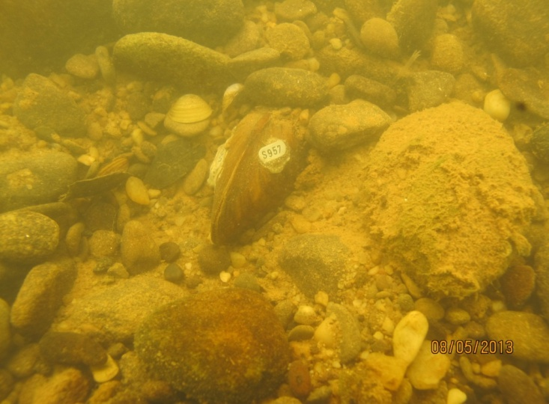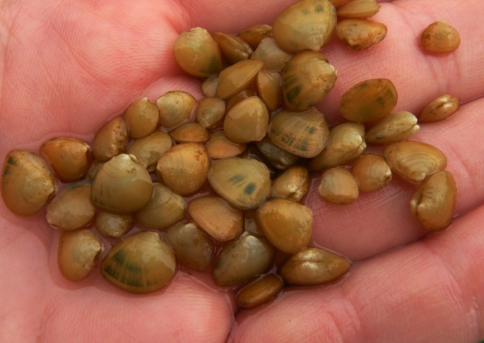

Tagged clubshell back in its historic home, the Ohio River. Juvenile clubshells in captive rearing, to be stocked soon!
Photo by Janet Clayton, WVDNR. Photo by Rachel Mair, USFWS.

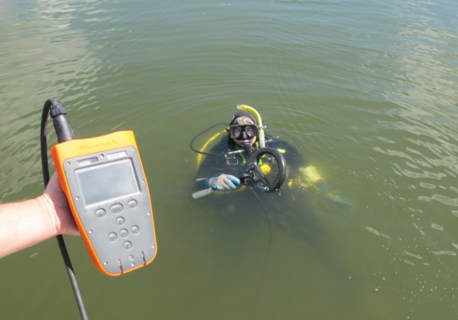
WVDNR biologist Janet Clayton operating PIT tag reader
underwater to monitor tagged mussels in the Ohio River.
Photo by Patricia Morrison, USFWS.

